LOCAL PLATFORM VALIDATION

Multi-Household Pipeline
Validation Report
Five households | Fifteen simulated energy assets | End-to-end evidence
5  Households | 15  Devices | 30  Telemetry messages | 120  Semantic readings
100%  Completion rate | 80  SLM-primary mappings | 10  Fallback mappings | 0  Dropped readings

Validated outcome
The final two-update-per-device run completed with 120 unique semantic and IEEE records, zero drops, zero duplicate rows, zero processing errors, and no real device execution.

Validation run: mh-20260720071954
Environment: Local Docker Compose, Kafka, TimescaleDB, Ollama Phi-3 Mini, and Next.js customer console
Prepared: 20 July 2026

1. Executive Summary
This validation assessed whether the AD-FLEX local architecture could support multiple households at the same time without changing the existing business workflow. Five households were created, each with a Shelly Plug, an Enode / Easee EV charger, and a heat pump. Every simulated asset had a unique device and household identity, an independent update interval, changing values, and proper timestamps.
The final run submitted 30 telemetry messages through the security gateway and produced 120 normalized readings. Every reading reached semantic storage and IEEE 2030.5-style storage. No message or reading was dropped, no duplicate semantic or IEEE row was recorded, and no processing error occurred. The end-to-end completion rate was 100%.
Local Phi-3 Mini was called for all 120 readings. Eighty mappings passed as SLM-primary, ten known readings used deterministic fallback, and thirty were safely marked unmapped after failing configured guardrails. These rejected outputs remained visible and auditable without stopping the pipeline.
Business interpretation
The platform handled the intended production-style demonstration reliably. The main scale-up constraint is local serial model inference, not gateway acceptance, Kafka delivery, or database insertion.

2. Test Configuration
Configuration item | Measured setup
Households | 5
Energy assets | 15 total; 3 per household
Device types | 5 Shelly Plugs, 5 Enode / Easee EV chargers, 5 heat pumps
Updates | 2 per device
Update interval range | 322-1382 ms
Ingress | Security gateway POST /telemetry with local API key
Semantic model | Local Ollama phi3:mini, SLM primary
Validation | Deterministic SAREF4ENER guardrails and fallback
Event and data services | Kafka, PostgreSQL/TimescaleDB, MQTT
Control mode | Approval plus mock dispatch; no real device execution
Customer application | Next.js console at http://localhost:3000

All 15 devices produced two distinct telemetry samples and two ordered, unique timestamps. Shelly values covered active power, voltage, current, and cumulative energy. EV charger values covered charging state, charging power, and delivered energy. Heat-pump values covered room temperature, target temperature, operating mode, flow temperature, and power usage.

3. Validation Procedure
Step | Procedure | Evidence
1 | Build and start all Docker Compose services | 18 containers running; zero restarts
2 | Check service, Kafka, TimescaleDB, and Ollama readiness | Health checks passed; phi3:mini listed
3 | Create five households and fifteen independently seeded devices | Unique IDs and 322-1,382 ms intervals
4 | Send two telemetry updates per device through the gateway | 30 of 30 requests accepted
5 | Wait for semantic and IEEE storage | 120 unique rows at each stage
6 | Run DSO signal and approval workflow | Proposal 89 reached ready_to_dispatch
7 | Verify mock dispatch and device API translation | 1 mock row and 3 device command rows
8 | Run dataspace export | Minimized, pseudonymized 100-record summary
9 | Publish a separate MQTT message | 1 raw and 4 rows at each reading stage
10 | Open the customer console with Playwright | 15 final-run devices and Phi-3 primary status visible

4. Runtime Results

Delivery and persistence
Metric | Result | Assessment
Telemetry generated / accepted | 30 / 30 | Pass
Raw telemetry rows | 30 | Pass
Normalized readings | 120 | Pass
Semantic rows / unique | 120 / 120 | Pass
IEEE rows / unique | 120 / 120 | Pass
Duplicate semantic / IEEE rows | 0 / 0 | Pass
Dropped messages / readings | 0 / 0 | Pass
Processing errors | 0 | Pass
Overall completion rate | 100% | Pass

Latency and throughput
Metric | Minimum | Average | Maximum
Gateway response | 10.56 ms | 13.04 ms | 17.30 ms
Raw database insert | 7.08 ms | 10.02 ms | 18.92 ms
Semantic queue-to-persist | 2.22 s | 112.86 s | 222.26 s
Raw-to-IEEE completion | 2.24 s | 112.87 s | 222.26 s

- Gateway input burst: approximately 7.143 telemetry messages per second.
- Observed end-to-end telemetry completion: 0.133 messages per second.
- Observed semantic/IEEE reading completion: 0.531 readings per second.
- Measured workflow uptime: 233.4 seconds, including DSO, dispatch, dataspace, and evidence collection.
- Semantic latency includes queue waiting behind serial local model inference; it is not pure model execution time.

Semantic mapping outcomes
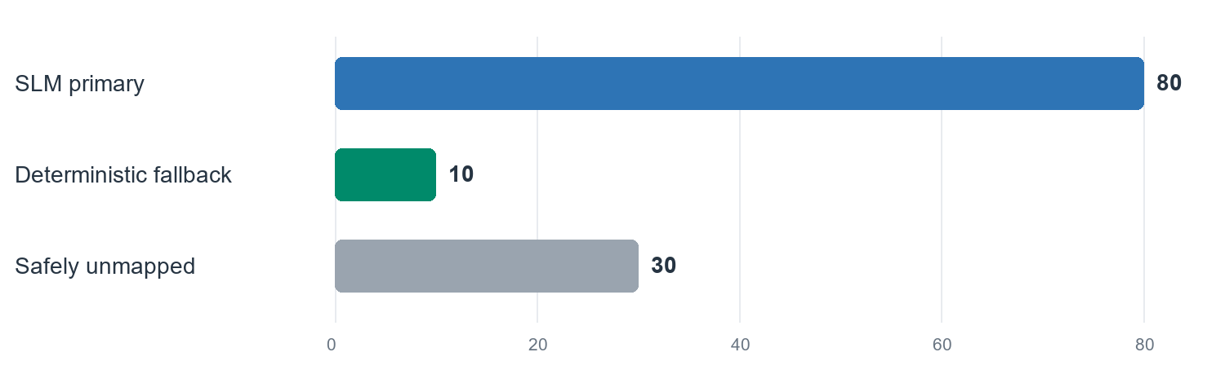
Figure 1. Final-run semantic outcomes across 120 readings.
Source | Confidence | Count | Share
SLM primary | High | 53 | 44.2%
SLM primary | Medium | 27 | 22.5%
Deterministic fallback | High | 10 | 8.3%
Safely unmapped | Low | 30 | 25.0%

Database and workflow evidence
Evidence area | Measured result
Security gateway audit | 35 run-specific rows
Dispatch command | 1 row; proposal 89
Approval audit | 3 rows
Mock dispatch audit | 1 row; no_real_execution=true
Device command audit | 3 rows; no_real_execution=true
Dataspace export audit | 1 row in validation window
Dataspace response | 100 records; minimized and pseudonymized

Resource observations
Component | CPU snapshot | Memory snapshot
Kafka | 0.86% | 571 MiB
TimescaleDB | 0.02% | 99.29 MiB
Zookeeper | 0.22% | 176.8 MiB
Semantic connector | 2.24% | 37.75 MiB
Security gateway | 2.04% | 29.93 MiB
Highest sampled application CPU | 2.35% | Dataspace export

Resource values are point-in-time Docker samples and should not be interpreted as peak utilization.

5. Pipeline Observations

Security Gateway
Accepted every authenticated telemetry request. Average response time was 13.04 ms. Correlation IDs and safe request metadata were audited.

Kafka Digital Spine
Delivered all telemetry and downstream events. The final run had no coordinator error, offset replay, or detected drop.

Processing Engine
Expanded 30 device payloads into exactly 120 normalized readings.

Semantic Connector
Called local Phi-3 Mini for every reading, applied deterministic validation, and stored all accepted, fallback, and unmapped outcomes.

Phi-3 Mini
Was available locally and produced 80 guardrail-approved SLM-primary mappings. Local serial inference was the principal latency contributor.

TimescaleDB
Stored all run-specific telemetry, semantic, IEEE, approval, dispatch, device-command, gateway, and export evidence. Historical queries returned all five households and fifteen devices.

IEEE 2030.5 Translator
Created 120 simplified IEEE 2030.5-style rows. The implementation remains a translator foundation and is not certified.

Approval Workflow
Enforced proposed to reviewed to approved to ready-to-dispatch transitions.

Mock Dispatch
Created one simulated result with no_real_execution=true.

Device Command Translator
Created three simulated device-specific results for Shelly, Enode / Easee, and heat pump adapters.

Customer Dashboard
Displayed live SLM status, final-run device IDs, storage, security, dispatch, and dataspace information. Desktop and mobile checks passed.

Dataspace Export
Returned a 100-record minimized and pseudonymized summary without raw private payloads.

Customer Console Evidence
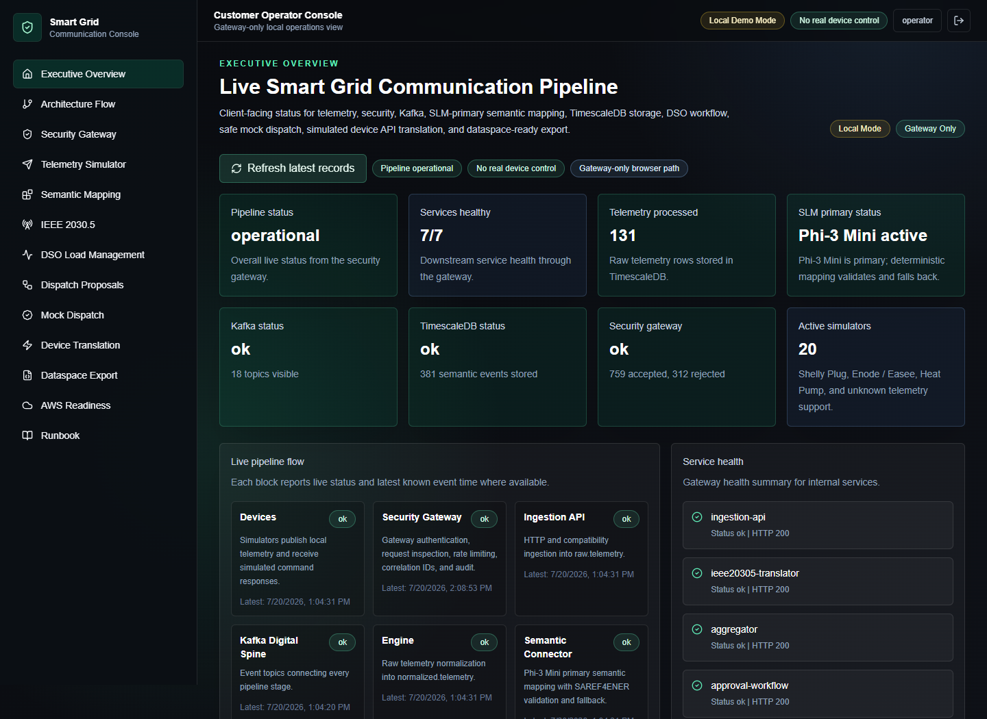
Figure 2. Live customer console overview after the multi-household run.

6. Scalability Assessment
The local architecture successfully handled the intended five-household workload. Concurrent gateway intake, Kafka delivery, normalization, persistence, protocol translation, approval, mock dispatch, device API translation, dataspace export, and dashboard visibility all remained operational. The final run completed with zero drops, zero duplicate semantic/IEEE rows, and zero processing errors.
The main bottleneck is local serial semantic inference. The gateway accepted the input burst quickly, raw inserts averaged 10.02 ms, and application container resource samples remained modest. Queue-to-semantic latency increased because 120 readings waited behind a single local model consumer.
Recommended next scale step
Introduce bounded semantic concurrency, model warm-up, partition-aware consumers, per-inference latency metrics, and expanded deterministic coverage for device state codes before increasing the household count.

Finding Resolved During Validation
An initial diagnostic run produced one duplicate semantic/IEEE row when a 30-second local model timeout exceeded KafkaJS's default consumer session and triggered offset redelivery. The semantic consumer now uses a configurable 120-second session and enforces a session at least 30 seconds longer than the SLM timeout. The final 120-reading run produced no duplicates and no coordinator errors.

7. Limitations
Current implemented local platform | Future production deployment
Five-household, fifteen-device controlled demonstration | Progressive tests with larger household populations and sustained durations
Single local Phi-3 Mini instance | Horizontally scalable inference workers, warm pools, and model observability
Local API key and Docker networking | Production identity, mTLS, secrets management, private networking, and WAF
Simplified IEEE 2030.5-style translator | Formal interoperability testing and certification where required
IDS/ENERSHARE-ready export foundation | Real connector, identity, contract negotiation, and external publication
Mock dispatch and simulated device APIs | Real device credentials, consent, operator controls, safety certification, and rollback
Point-in-time resource samples | Continuous CPU, memory, tracing, queue, and SLO monitoring
Basic ontology coverage for state codes | Expanded deterministic/SAREF4ENER mappings and governed vocabulary

8. Conclusions
The AD-FLEX local pipeline successfully supported approximately fifteen simultaneously represented energy assets across five households. Two independent updates from every device were accepted, normalized, semantically processed with local Phi-3 Mini first, validated, stored, translated, and exposed to the customer console. The complete safe load-management path and dataspace export also completed.
The final result was 30 of 30 telemetry messages accepted, 120 of 120 unique semantic and IEEE records stored, zero dropped messages, zero dropped readings, zero duplicate rows, zero processing errors, and 100% end-to-end completion. No real household device was controlled.
Final assessment
The architecture is ready for larger controlled local testing. Semantic inference concurrency and ontology coverage should be improved before substantially increasing the workload or moving toward production deployment.

Appendix A. Reproduction Commands
cd C:\Users\Mani\Desktop\Github\IOT-PIPELINE
powershell -ExecutionPolicy Bypass -File .\scripts\start-demo.ps1 -Build
powershell -ExecutionPolicy Bypass -File .\scripts\check-health.ps1
powershell -ExecutionPolicy Bypass -File .\scripts\run-multi-household-validation.ps1 -Households 5 -Cycles 2
cd .\apps\customer-console
npm run build
npm run start
npm run smoke:multi-household

Appendix B. Evidence Locations
- Machine-readable results: docs/demo-assets/multi-household-validation-results.json
- Dashboard screenshot: docs/demo-assets/multi-household-dashboard.png
- Technical report: docs/multi-household-scalability-validation-report.md
- Validation runner: scripts/run-multi-household-validation.js
- PowerShell wrapper: scripts/run-multi-household-validation.ps1

