Constraints: Rules that restrict the values that can be inserted into a field.
Types of constraints
Integrity: define primary and foreign keys
Value: specify values or ranges of values that can be inserted

Constraint Levels:
Table constraint- Restricts the value of a field with respect to all other table records
Example: primary key value must be unique for each record
Column constraint- Restricts values in a specific column
Example: values in an S_GENDER field must be ‘M’ or ‘F’

Constraint ID values:
Primary key: pk
Foreign key: fk
Check condition: cc
Not NULL: nn
Unique: uk
EX: s_id NUMBER(6)

Types of table constraints:
Primary Key:
CONSTRAINT student_s_id_pk PRIMARY KEY
Can also be defined after all table field definitions are completed.
EX: CONSTRAINT constraint_name
PRIMARY KEY (field1, field2)

Foreign Key:
Can only be defined after field is defined as a primary key in another table

-Unique
Table constraint
Specifies that a non-primary key field must have a unique value
CONSTRAINT consultant_c_email_uk UNIQUE (c_email)

Types of value constraints:
Restricts data val ues that can be inserted in a field
-Check condition: restricts to specific values
Example: s_gender (M or F)
CONSTRAINT my_students_s_gender_cc
CHECK (s_gender = ‘M’) OR (s_gender = ‘F’)
-Not NULL: specifies that a field cannot be NULL
Example:
CONSTRAINT my_students_s_dob_nn
NOT NULL
-Default: specifies a default value that is inserted automatically
Example:
s_state CHAR(2) DEFAULT ‘WI’

Viewing a table’s structure
DESCRIBE table_name;

Composite Key:
create table try(t_id varchar(3), reg varchar(20), primary key(t_id,reg));

SQL for weak entity table try in relation with string enitity airplane:
create table try(t_id varchar(3), reg varchar(20), foreign key(reg) references airplane(req_num),primary key(t_id,reg));

Strong and Weak entities:
- In a relational database, a weak entity is an entity that cannot be uniquely identified by its attributes alone; therefore, it must use a foreign key in conjunction with its attributes to create a primary key. The foreign key is typically a primary key of an entity it is related to.
- In entity relationship diagrams a weak entity set is indicated by a bold (or double-lined) rectangle (the entity) connected by a bold (or double-lined) type arrow to a bold (or double-lined) diamond (the relationship). This type of relationship is called an identifying relationship.

Cardinality ratio constraint
Specifies the number of relationship instances an entity can participate in

Cardinality has two meanings:
- when the word cardinality is used in the context of data modeling, it simply refers to the relationship that one table can have with another table. These relationships include: many-to-many, many-to-one/one-to-many, or one-to-one – whichever one of these characteristics a table has in relationship with another table is said to be the cardinality of that table.
- In SQL, the cardinality of a column in a given table refers to the number of unique values that appear in the table for that column. So, remember that the cardinality is a number. For example, let’s say we have a table with a “Sex” column which has only two possible values of “Male” and “Female”. Then, that “Sex” column would have a cardinality of 2, because there are only two unique values that could possibly appear in that column – Male and Female.
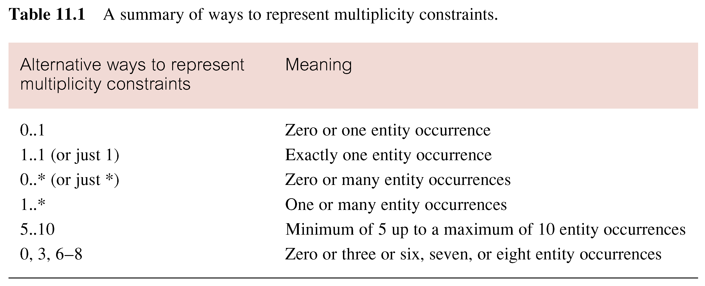

Multiplicity is made up of two types of restrictions on relationships: cardinality and participation.

Cardinality - Describes maximum number of possible relationship occurrences for an entity participating in a given relationship type (1,4), (1,N) ...
Participation- Determines whether all or only some entity occurrences participate in a relationship (optional/mandatory).
Cardinality is at most and participation is at least

Difference between char and varchar

Value | CHAR(4) | Storage Required | VARCHAR(4) | Storage Required
'' | ' ' | 4 bytes | '' | 1 byte
'ab' | 'ab ' | 4 bytes | 'ab' | 3 bytes
'abcd' | 'abcd' | 4 bytes | 'abcd' | 5 bytes
'abcdefgh' | 'abcd' | 4 bytes | 'abcd' | 5 bytes

Above when not using strict mode
Values in char are of fixed length
Values in VARCHAR columns are variable-length strings

