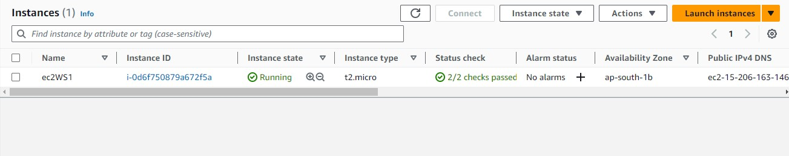
AWS EC2 with Custom AMI, EBS, and User Data
Task 1 :
- Launched an Instance

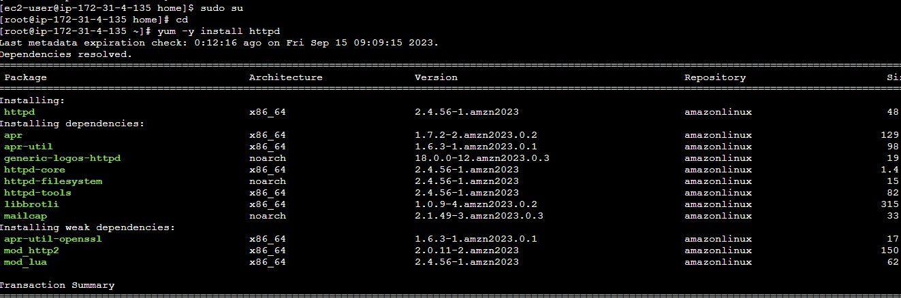
Task 2 :
- Installed Apache webserver (httpd)

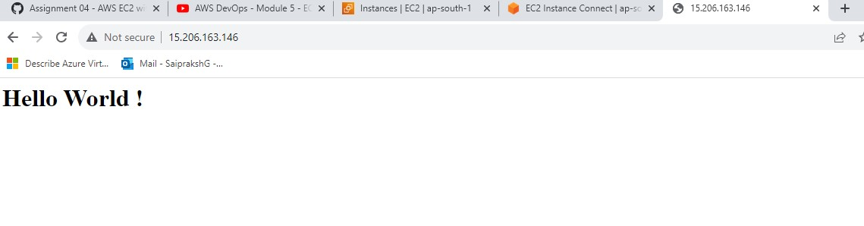
Created a Simple HTML page and displayed in public address by adding security rules and using systemctl commands

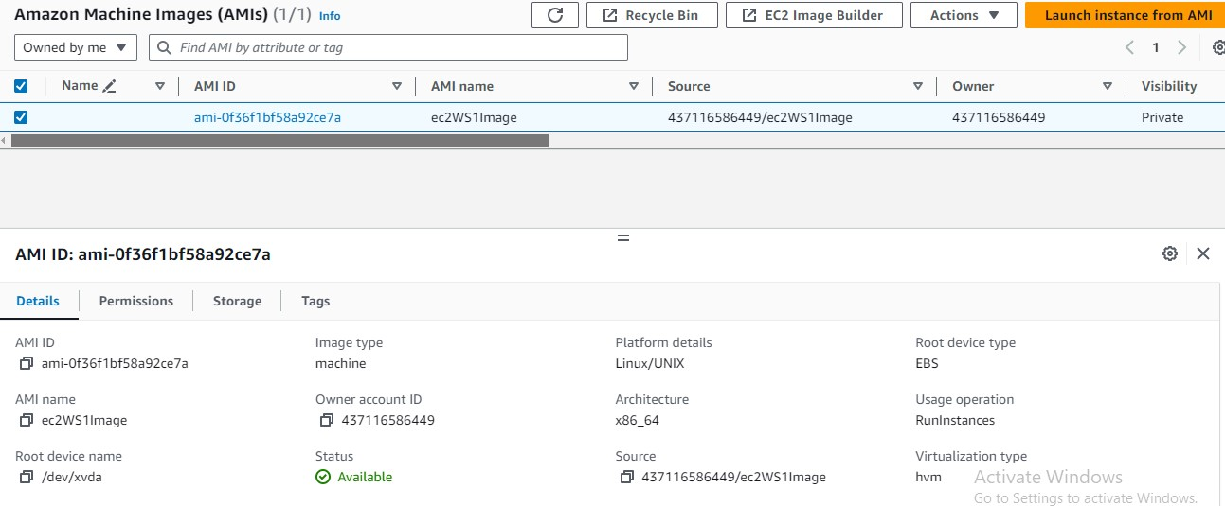
- Created an AMI using ec2WS1 Instance.

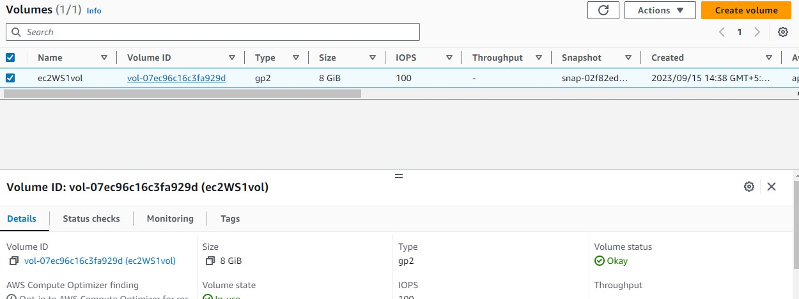
Task 3: Create and Attach an Elastic Block Storage (EBS) Volume
- EBS volume is created of size 8GiB
- Attached to ec2WS1 instance.

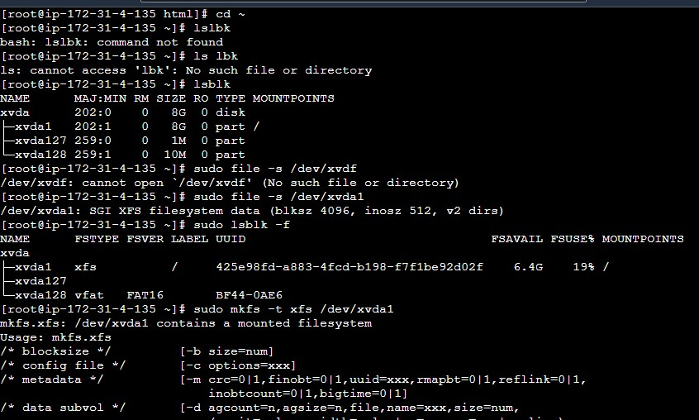
- Formatting the EBS volume

Task 4 : User Data
#!/bin/bash yum -y install httpd systemctl enable httpd systemctl start httpd
mv /var/www/html/index.html ~/var/www/html/index.html
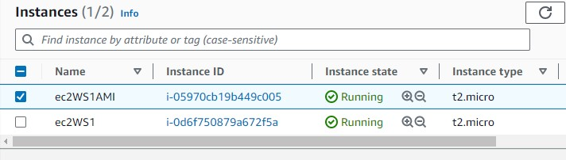
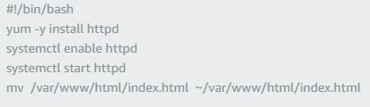
Task 5: Launch EC2 Instances with User Data
- Launched 2 instances using AMI
- Configured user data

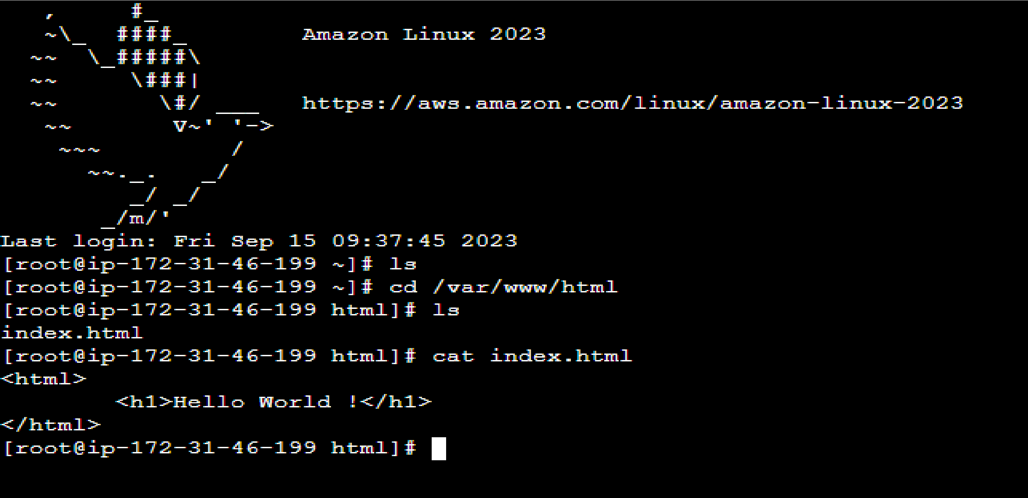
- Accessed the AMI web server

