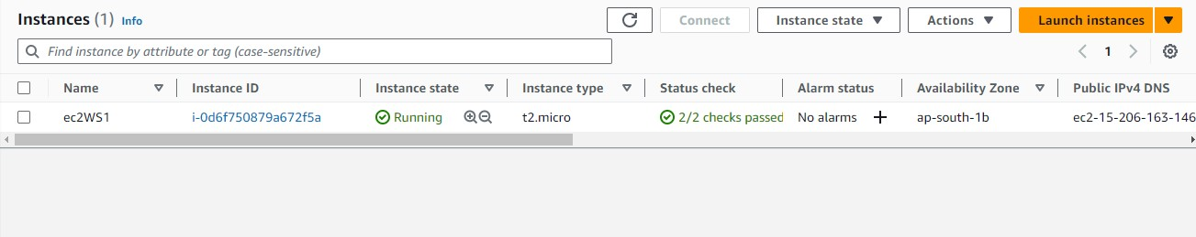**AWS EC2 with Custom AMI, EBS, and User Data**

Task 1 :

1. Launched an Instance

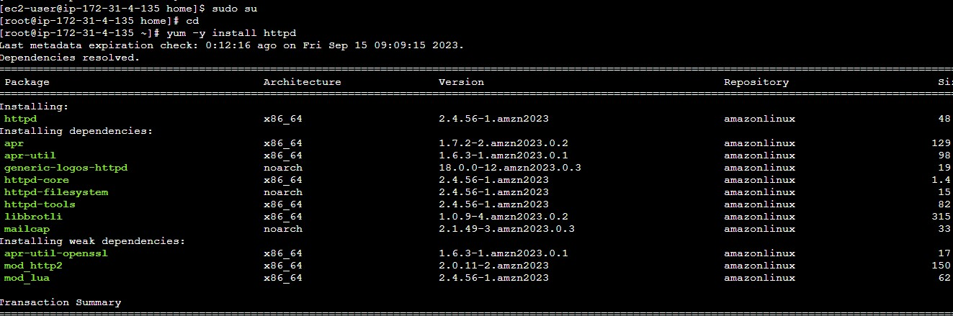Task 2 :

1. Installed Apache webserver (httpd)

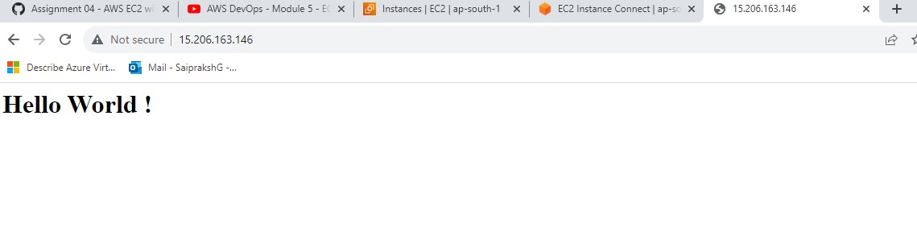Created a Simple HTML page and displayed in public address by adding security rules and using systemctl commands

1. 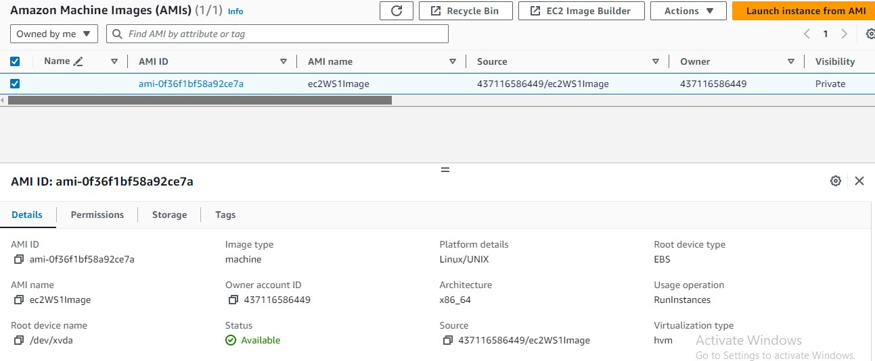Created an AMI using ec2WS1 Instance.

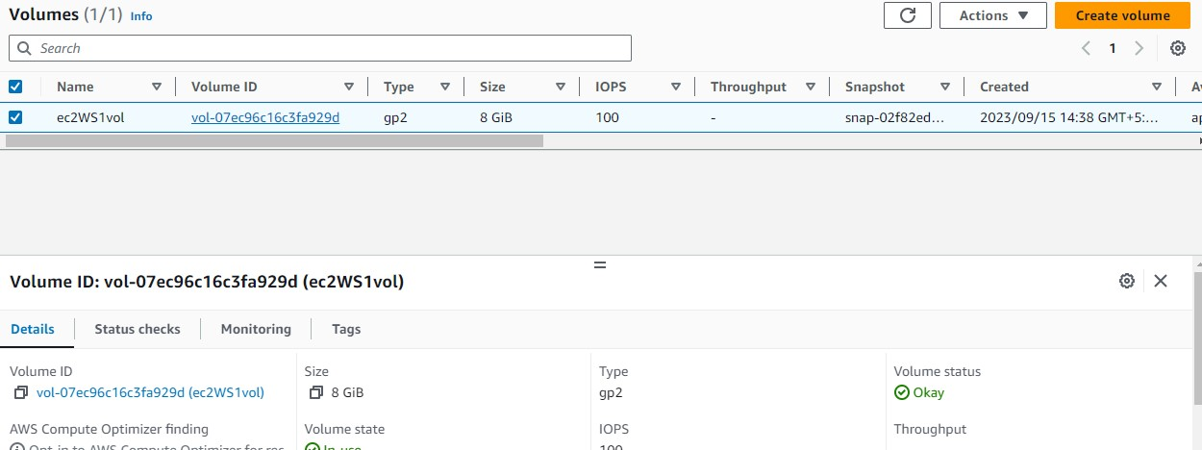**Task 3: Create and Attach an Elastic Block Storage (EBS) Volume**

1. EBS volume is created of size 8GiB
2. Attached to ec2WS1 instance.
3. 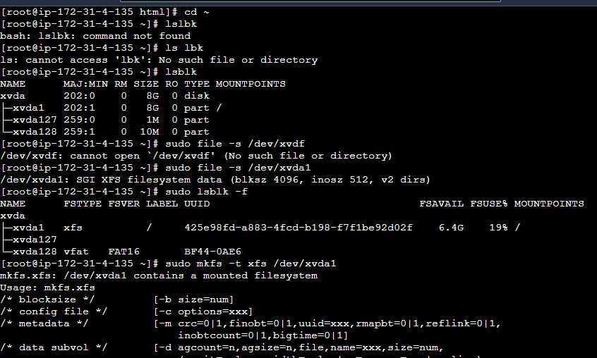Formatting the EBS volume

Task 4 : User Data

#!/bin/bash yum -y install httpd systemctl enable httpd systemctl start httpd

mv /var/www/html/index.html ~/var/www/html/index.html

**Task 5: Launch EC2 Instances with User Data**

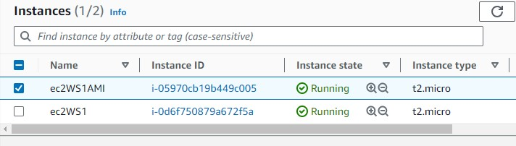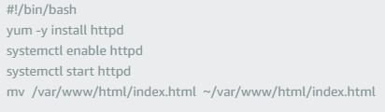

1. Launched 2 instances using AMI
2. Configured user data
3. 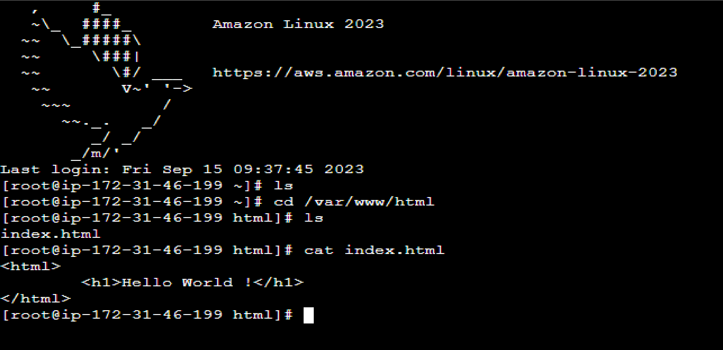Accessed the AMI web server