WEEK 3 – ADVANCED DATA ANALYSIS AND VISUALIZATION
Logistics Data Analyst Internship
Week 3 | Logistics Data Analyst Internship

Objective
To conduct exploratory data analysis, calculate descriptive statistics, examine logistics relationships, produce useful visualizations and convert analytical patterns into business insights.

1. Dataset for Analysis
The simulated dataset contains 1,000 shipment observations with delivery time as the main outcome and variables representing shipment volume, distance, transportation cost, warehouse load, weather risk, traffic and shipping mode.

2. Exploratory Data Analysis
print(df.describe())
print(df["shipping_mode"].value_counts())
print(
df.groupby("shipping_mode")["delivery_days"]
.agg(["count", "mean", "median", "std"])
)
print(df[[
"shipment_volume", "distance_km", "transport_cost",
"warehouse_load_pct", "weather_risk", "traffic_index",
"delivery_days"
]].corr())

3. Visualization 1 – Delivery-Time Distribution
A histogram is used to understand the center, spread and tail behavior of delivery time. This helps determine whether most shipments meet a service target or whether a long tail of delays exists.

4. Visualization 2 – Shipping Mode Comparison
A bar chart compares average delivery time by shipping mode. It helps management evaluate whether premium shipping modes provide meaningful speed improvements.

5. Visualization 3 – Distance vs Delivery Time
A scatter plot examines whether longer distances are associated with longer delivery durations. A strong relationship would support geographic segmentation and route-planning analysis.

6. Python Visualization Code
import matplotlib.pyplot as plt
plt.hist(df["delivery_days"], bins=25)
plt.xlabel("Delivery days")
plt.ylabel("Number of shipments")
plt.title("Delivery-Time Distribution")
plt.show()
df.groupby("shipping_mode")["delivery_days"].mean().plot(kind="bar")
plt.ylabel("Average delivery days")
plt.show()
plt.scatter(df["distance_km"], df["delivery_days"], alpha=0.35)
plt.xlabel("Distance (km)")
plt.ylabel("Delivery days")
plt.title("Distance vs Delivery Time")
plt.show()

7. Analytical Insights
- Delivery-time distributions help establish realistic service thresholds.
- Shipping-mode comparisons support service and cost decisions.
- Distance analysis supports route and regional planning.
- Traffic and weather can be used as operational risk indicators.
- Warehouse load can be monitored as a potential contributor to delay.
- EDA findings should guide feature engineering for predictive modeling.

8. Business Recommendations
- Create a weekly logistics KPI dashboard.
- Monitor delivery-time distributions by region and shipping mode.
- Investigate warehouses with consistently high load and delivery time.
- Compare transportation cost with service improvement.
- Use geographic and time-based analysis to identify recurring bottlenecks.

9. Expected Week 3 Deliverables
- EDA statistics.
- Three logistics visualizations.
- Python visualization code.
- Business interpretation.
- Operational recommendations.

10. Week 3 Conclusion
Week 3 transforms cleaned data into understandable evidence. Visualization makes operational patterns easier to communicate and provides the analytical foundation for predictive modeling in Week 4.
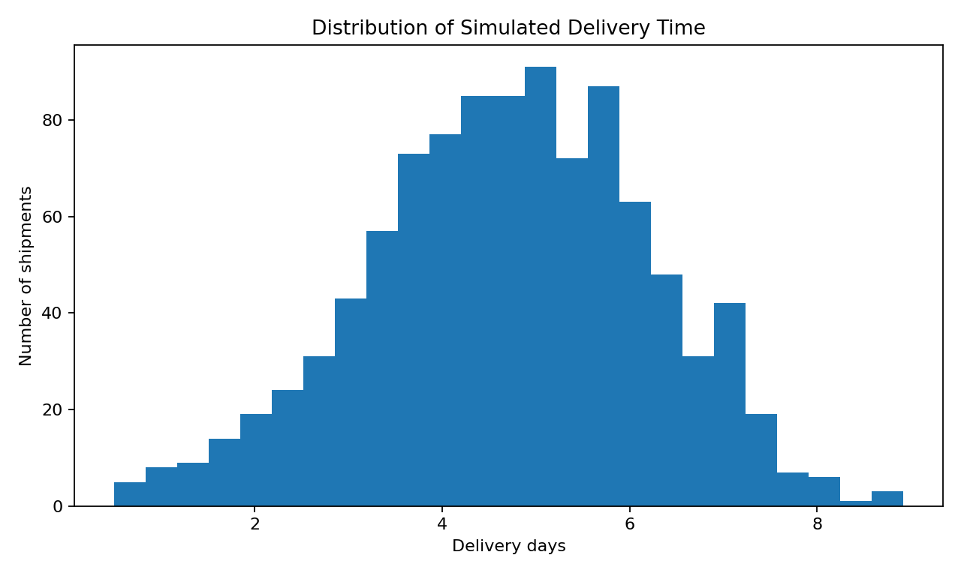
Figure 1: Simulated delivery-time distribution.
The distribution helps identify the typical delivery duration and the presence of unusually long delivery times.
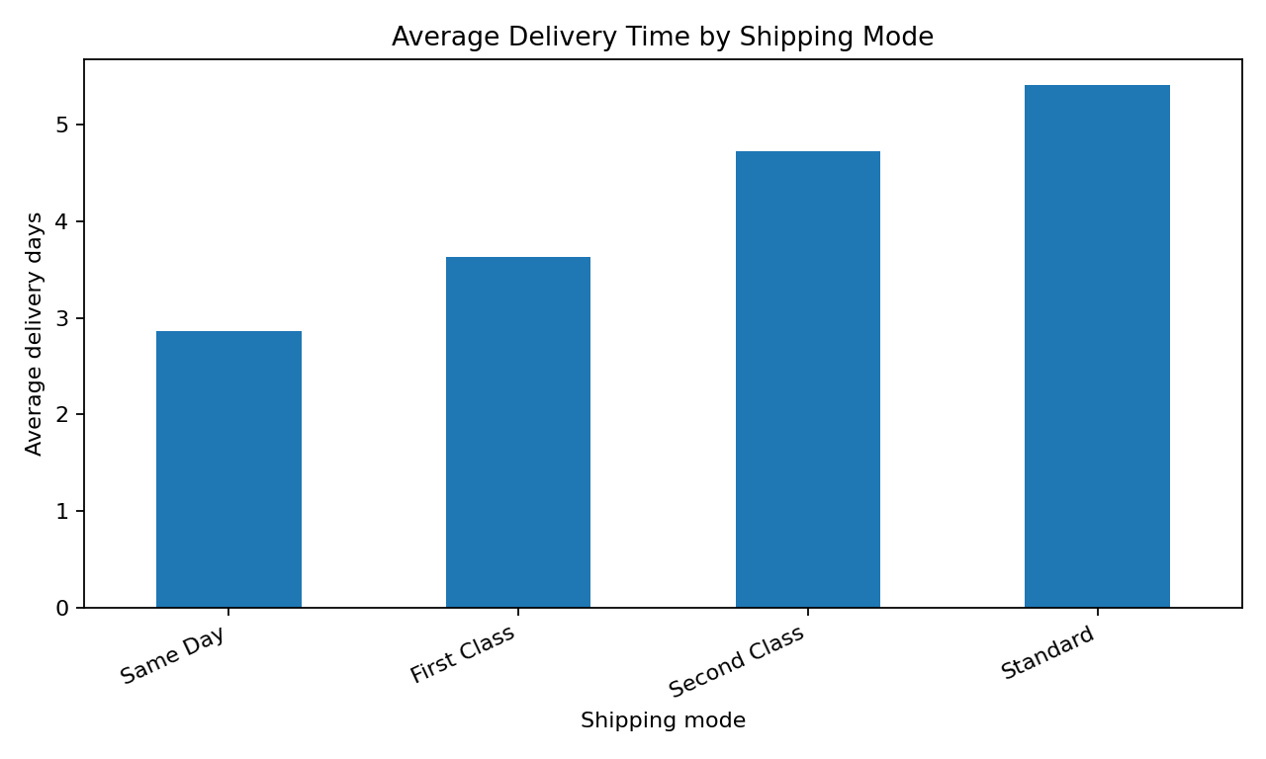
Figure 2: Simulated average delivery time by shipping mode.
The comparison helps evaluate the service benefit of different shipping modes.
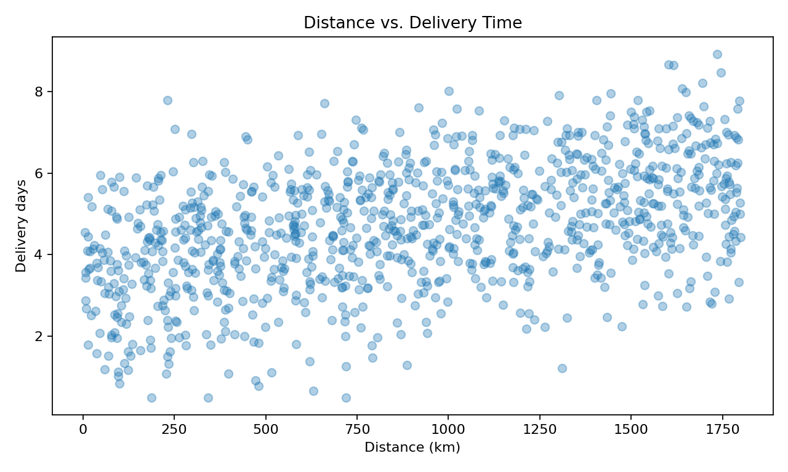
Figure 3: Simulated distance versus delivery time.
The relationship helps assess whether geographic distance is a useful predictor of delivery duration.

