**Module-2**

**1.Try to create user details form.**

**<!DOCTYPE html>**

**<html>**

**<head>**

**<title></title>**

**<style>**

**.container{**

**text-align: center;**

**background: #808000;**

**margin-left: 100px;**

**margin-right: 100px;**

**padding-left: 15px;**

**padding-right: 15px;**

**justify-content: center;**

**cellspacing:20px;**

**}**

**.main{**

**position: center;**

**cellspacing:20px;**

**}**

**.btn{**

**background-color: black;**

**color:white;**

**border-radius: 15px;**

**margin:15px;**

**padding:10px;**

**width:120px;**

**}**

**h2{**

**padding-left: 150px;**

**padding-right: 150px;**

**text-align: left ;**

**margin-right:50px;**

**}**

**fieldset{**

**background: #ADFF2F;**

**}**

**label{padding-right: 100px;}**

**input{**

**border-radius: 10px;**

**width: 20%;**

**}**

**#r{**

**display: flex;**

**}**

**</style>**

**</head>**

**<body>**

**<h1 align="center">User Detail Form</h1>**

**<div class="container">**

**<form class="main">**

**<h2>Step 1:Yours Details</h2>**

**<div>**

**<div >**

**<fieldset ><label>Name</label>**

**<input type="text" class="form-control" name="" placeholder="First and Last name"></fieldset>**

**</div>**

**<div>**

**<fieldset><label>Email</label>**

**<input type="mail" name="" placeholder="manisha618@mail.com"></fieldset>**

**</div>**

**<div>**

**<fieldset>Phone**

**<input type="number" name="" placeholder="4475000000"></fieldset>**

**</div>**

**</div>**

**<h2>Step 2:Delivery address</h2>**

**<div>**

**<fieldset>Address**

**<textarea></textarea></fieldset>**

**<fieldset>Post code**

**<input type="number" name="" ></fieldset>**

**<fieldset>Country**

**<input type="text" name="" ></fieldset>**

**</div>**

**<h2>Step 3:Card details</h2>**

**<div >**

**<fieldset id='r'>Card type**

**<input type="radio" name="" >VISA**

**<input type="radio" name="" >AmEx**

**<input type="radio" name="" >Mastercard</fieldset>**

**<fieldset>Card number**

**<input type="number" name="" ></fieldset>**

**<fieldset>Security code**

**<input type="number" name="" ></fieldset>**

**<fieldset>Name on card**

**<input type="text" name="" placeholder="Exact name as on the card"></fieldset>**

**</div>**

**<button class="btn">BUY IT!</button>**

**</form>**

**</div>**

**</div>**

**</body>**

**</html>**

**Output:-**

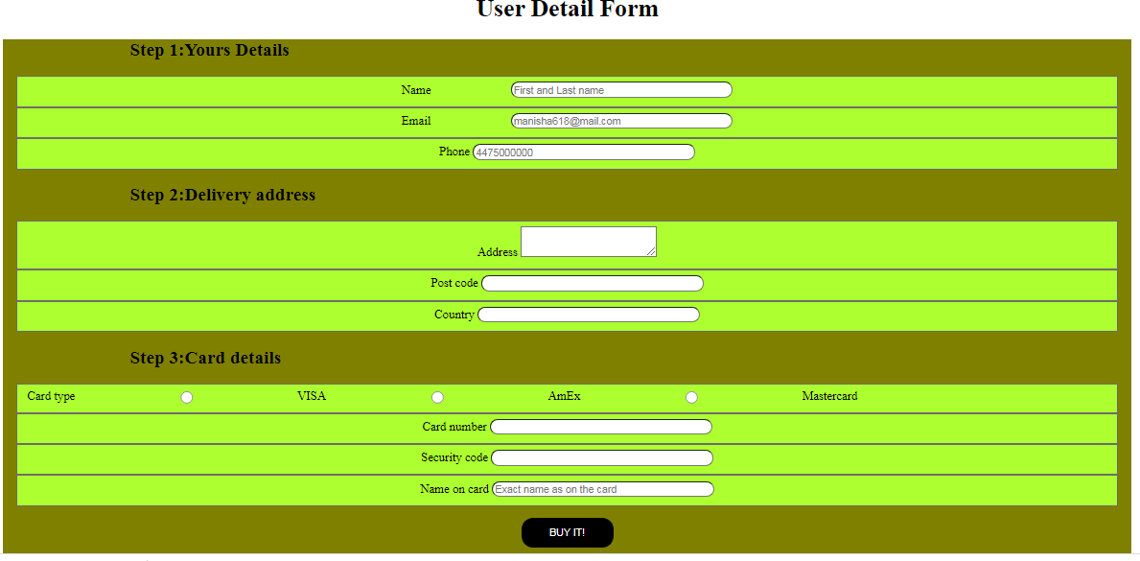

**2.Create manage profile.**

<!DOCTYPE html>

<html>

<head>

<link rel="stylesheet" href="https://cdn.jsdelivr.net/npm/bootstrap@4.3.1/dist/css/bootstrap.min.css" integrity="sha384-ggOyR0iXCbMQv3Xipma34MD+dH/1fQ784/j6cY/iJTQUOhcWr7x9JvoRxT2MZw1T" crossorigin="anonymous">

<link rel="stylesheet" href="https://cdnjs.cloudflare.com/ajax/libs/bootstrap/5.2.0-beta1/js/bootstrap.min.js">

<title></title>

<style type="text/css">

*{

margin: 0;

padding: 0;

box-sizing: border-box;

}

.container{

width: 100%;

height: 100%;

background-color: purple;

}

.row{

display: inline-flex;

flex-flow: row;

background-color: white;

padding:10px;

margin: 10px;

margin-left: 30px;

margin-right: 30px;

margin-top: 20px;

margin-bottom: 20px

}

.col{

border-color: black;

border: 10px;

}

img{

border-radius: 45px;

height: 200px;

margin: :30px;

}

.col3{

display: inline-flex;

flex-flow: column;

}

.row1{

display: inline-flex;

flex-flow: row;

}

</style>

</head>

<body>

<div class="container">

<div class="row">

<div class="col-3" align="center"><br/><br/>

<img src="img1.jpg" width="120px" ><br/><br/>

Manisha<br/>manisha618gmail.com<br/>

</div>

<div class="col-3 col-sm-6 ">

<h2>Profile Setting</h2>

<div class="row">

<div class="col-3 col-sm-6 ">

Name

<input type="text" class="form-control" placeholder="Enter Name" >

</div>

<div class="col-3 col-sm-6">

Surname

<input type="text" class="form-control" placeholder=" Surname" >

</div>

</div>

<div class="col-3 col-sm-12">

Phonenumber

<input type="number" class="form-control" placeholder="Enter Phone number" >

</div>

<div class="col-3 col-sm-12">

Address

<input type="text" class="form-control" placeholder="Enter Address" >

</div>

<div class="col-3 col-sm-12">

Email ID

<input type="text" class="form-control" placeholder="Enter email id" >

</div>

<div class="col-3 col-sm-12">

Education

<input type="text" class="form-control" placeholder="Education" >

</div>

<div class="row">

<div class="col-3 col-sm-6">

Country

<input type="text" class="form-control" placeholder="Country" >

</div>

<div class="col-3 col-sm-6">

State

<input type="text" class="form-control" placeholder="Enter State" >

</div>

</div>

<div class="col-3 col-sm-12" align="center">

<button class="btn btn-primary" type="submit">Save Profile</button>

</div>

</div>

<div class="col3 ">

<div class="row1">

<div class="col-3 col-sm-6">

<br/><br/>

<label >Edit Experiance</label>

</div>

<div class="col-3 col-sm-8">

<br/><br/>

<input type="button" value="Experiance">

</div>

</div>

<div>

<div class="col-sm-12"><br/>

Experiance in designing

<input type="text" class="form-control" placeholder="Enter Experiance">

</div>

<div class="col-sm-12"><br/>

Additional Details

<input type="text" class="form-control" placeholder="Enter Additional Details ">

</div>

</div>

</div>

</div>

</div>

</body>

</html>

**Output:-**

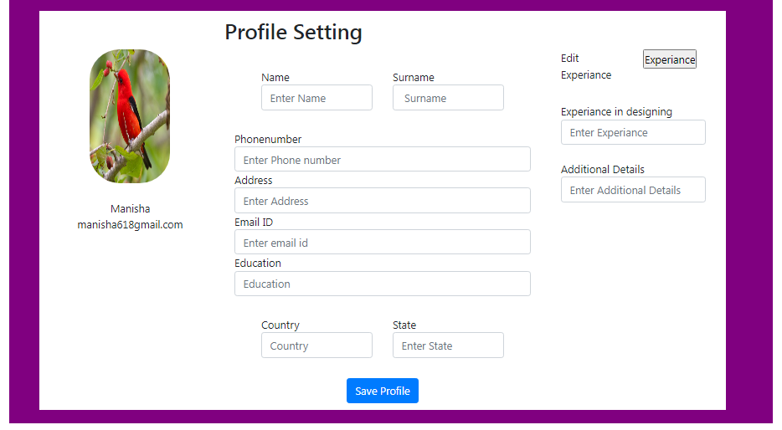

**3.Create product listing page.**

**<!DOCTYPE html>**

**<html>**

**<head>**

**<link rel="stylesheet" href="https://cdn.jsdelivr.net/npm/bootstrap@4.3.1/dist/css/bootstrap.min.css" integrity="sha384-ggOyR0iXCbMQv3Xipma34MD+dH/1fQ784/j6cY/iJTQUOhcWr7x9JvoRxT2MZw1T" crossorigin="anonymous">**

**<link rel="stylesheet" href="https://cdnjs.cloudflare.com/ajax/libs/bootstrap/5.2.0-beta1/js/bootstrap.min.js">**

**<link rel="stylesheet" href="https://cdnjs.cloudflare.com/ajax/libs/font-awesome/4.7.0/css/font-awesome.min.css">**

**<title></title>**

**<style>**

**.container{**

**background-color: gray;**

**}**

**.col-6{**

**background-color: white;**

**width: 800px;**

**padding: 30px;**

**margin: 45px;**

**}**

**img{**

**padding: 10px;**

**width: 160px;**

**height: 200px;**

**float:left;**

**}**

**.btn{**

**margin: 10px;**

**}**

**.checked{**

**color:orange;**

**}**

**</style>**

**</head>**

**<body>**

**<div class="container">**

**<div class="row">**

**<div class="col-6 col-sm-5" >**

**<img src="https://images.unsplash.com/photo-1511385348-a52b4a160dc2?ixlib=rb-1.2.1&ixid=MnwxMjA3fDB8MHxzZWFyY2h8MXx8bGFwdG9wJTIwY29tcHV0ZXJ8ZW58MHx8MHx8&auto=format&fit=crop&w=500&q=60" alt="">**

**Product1 code/name here<br/>Product1 category<br/>$199<br/>A short product description here<br/>**

**<button type="button" class="btn btn-danger">Add to cart</button>**

**<button type="button" class="btn btn-primary">More info</button><br/>**

**Star Rating**

**<span class="fa fa-star checked"></span>**

**<span class="fa fa-star checked"></span>**

**<span class="fa fa-star checked"></span>**

**<span class="fa fa-star"></span>**

**<span class="fa fa-star"></span>**

**</div>**

**<div class="col-6 col-sm-5" >**

**<img src="img2.jpg">**

**Product1 code/name here<br/>Product1 category<br/>$199<br/>A short product description here<br/>**

**<button type="button" class="btn btn-danger">Add to cart</button>**

**<button type="button" class="btn btn-primary">More info</button><br/>**

**Star Rating**

**<span class="fa fa-star checked"></span>**

**<span class="fa fa-star checked"></span>**

**<span class="fa fa-star checked"></span>**

**<span class="fa fa-star"></span>**

**<span class="fa fa-star"></span>**

**</div>**

**<div class="col-6 col-sm-5" >**

**<img src="img3.jpg" alt="">**

**Product1 code/name here<br/>Product1 category<br/>$199<br/>A short product description here<br/>**

**<button type="button" class="btn btn-danger">Add to cart</button>**

**<button type="button" class="btn btn-primary">More info</button><br/>**

**Star Rating**

**<span class="fa fa-star checked"></span>**

**<span class="fa fa-star checked"></span>**

**<span class="fa fa-star checked"></span>**

**<span class="fa fa-star"></span>**

**<span class="fa fa-star"></span>**

**</div>**

**<div class="col-6 col-sm-5" >**

**<img src="img4.jpg"alt="">**

**Product1 code/name here<br/>Product1 category<br/>$199<br/>A short product description here<br/>**

**<button type="button" class="btn btn-danger">Add to cart</button>**

**<button type="button" class="btn btn-primary">More info</button><br/>**

**Star Rating**

**<span class="fa fa-star checked"></span>**

**<span class="fa fa-star checked"></span>**

**<span class="fa fa-star checked"></span>**

**<span class="fa fa-star"></span>**

**<span class="fa fa-star"></span>**

**</div>**

**</div>**

**</div>**

**</body>**

**</html>**

**Output:-**

