User Manual for Selenium Framework

**Introduction**

This is the handbook which provides the user about the different points which are related to framework which has been created in java.  
Pagefactory is used to drive the entire framework.

The usecase starts with user registering the details on Mercury tours website and ends with booking review form.

Following are the individual steps for the above usecase.

1. User lands on registration form of Mercury tours website
2. User completes the registration details
3. User signs it with the username and password entered in registration page.
4. User enters basic details like return type,date/city of travel
5. User selects the airlines both for departure and arrival.
6. User fills the form with his personal and financial details.
7. Booking review form is shown and booking is completed.

**Pre-requisites for creating the framework**

Following softwares are required for creating a framework

* Java Development Kit(JDK latest version)
* Java Runtime Environment(JRE latest version)
* Intellij Utimate Edition
* Maven(Bundled in Intellij)
* POM.xml for maven dependencies
* Corresponding browser specific driver.exe(chrome,gecko)
* Atleast one browser with latest version(chrome,firefox)
* TestNG.xml(for running the tests)

**Framework coding conventions**This frameworkfollows following coding conventions.

All conventions follow simple english nouns for better readability.

* Folders-lower case letters
* Class names-Upper case letters
* Package names-lower case letters
* Variables-lower camel case letters
* Methods-lower camel case letters
* Constants-upper case letters

**Framework folder structure**

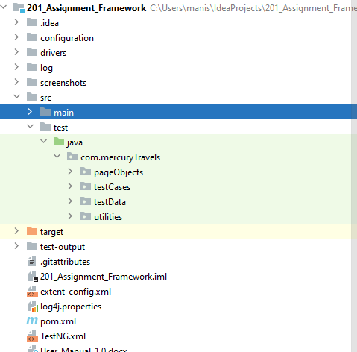

Below are the details which describes the folder structure

1. Configuration  
   This folder holds the properties file which are nothing but key value pairs.  
   These properties are used only once and read by files in utility folder.
2. Drivers  
   This folders contains all the browser specific driver .exe files for each browser implementation.
3. Log  
   This folder contains log files which records all logging information during execution
4. Screenshots  
   This folder records all screenshots for all failed testcases.
5. PageObjects  
   This folder contains page elements and action methods for each page being implemented.
6. Testcases  
   This folder contains actual testcases for each usecase step.
7. Baseclass  
   This page contains one time initalisation of driver script and helper functions which can be used in all testcases.
8. Test Data-This folder contains all excels which are used to drive the test case execution.
9. Utilities-This folder contains all files which assists the framework.  
   They are reusable functions which are available globally.
10. Test-Output  
    This folder contains all extent reports for entire test suite execution.  
    The reports are not overwritten but appended in the format Date+Timestamp.
11. POM.xml  
    This xml contains jar dependencies and their version which can be downloaded from maven repository.These dependencies are required to perform project tasks.
12. TestNG.xml  
    This xml contains details about execution environment and test cases to be executed.