GLOBAL ELECTRONICS RETAILER
Business Intelligence & Analytics Project
Sales Performance • Product Profitability • Customer Behaviour • Geographic Analysis • Delivery Operations

Tools & Technologies
Python • Pandas • Power BI • DAX • CSV
Project Workflow
Business understanding → Data audit and cleaning → Data modeling → Analysis → Dashboarding →
Recommendations
Prepared as a portfolio project using the Global Electronics Retailer dataset.

Executive Summary
This project analyzes the Global Electronics Retailer dataset to evaluate sales performance, product profitability, customer behavior, geographic performance, and delivery operations using Python and Power BI.
The analysis identified Computers as the leading category in total sales and profit, while Music, Movies and Audio Books recorded the highest category-level profit margin (approximately 60%). The United States was the strongest market in total sales and profit, while Canada recorded the highest profit margin. Offline stores generated higher total sales and profit than the online store, with reported offline profit margins reaching approximately 62%, compared with around 58% online.
Sales generally declined toward April before recovering in subsequent months, although this pattern should be validated further before being treated as a confirmed seasonal effect. Customer analysis showed broadly similar contributions from male and female customers. Customers aged 75 and above generated the highest total sales and profit among age groups, while customers under 30 represented a smaller segment with broadly comparable average spending.
Delivery analysis suggested that average delivery time fell from approximately seven days in 2016 to four days in 2021.
However, delivery dates are only listed for online stores as it is required there.

Project Objectives
- Assess overall sales, profit, and profitability trends.
- Compare product categories, brands, and top-selling products.
- Evaluate geographic and online/offline channel performance.
- Explore customer behavior by gender and age group.
- Review monthly sales patterns and available delivery-time data.
- Translate findings into practical business recommendations.

Data & Preparation
The project used the Customers, Sales, Products, Stores, and Exchange Rates datasets, supported by a data dictionary. Initial auditing checked table dimensions, data types, missing values, duplicates, key uniqueness, and data consistency.
Python and Pandas were used at the start of the workflow to inspect, clean, transform, and validate the data. Cleaned datasets were exported as CSV files and then imported into Power BI for modeling, analysis, and visualization. Meaningful missing values—particularly missing delivery dates and the online store's inapplicable store area—were retained rather than filled with invented values.

Methodology & Tools
Stage | Approach | Tools
Business understanding | Defined objectives and business questions in a BRD. | BRD / documentation
Data audit & cleaning | Inspected quality, corrected data types and cleaned fields; exported cleaned files. | Python, Pandas, CSV
Data modeling | Created table relationships and a dedicated date table. | Power BI
Analysis | Built measures for sales, cost, profit, margin, orders, growth, AOV, ranking, and delivery time. | DAX
Reporting | Created interactive report pages with KPIs, charts, and slicers. | Power BI

Power BI Dashboard — Executive Overview
This page summarizes headline KPIs and provides an overview of monthly sales trends, sales by country, sales by category, and report filters.
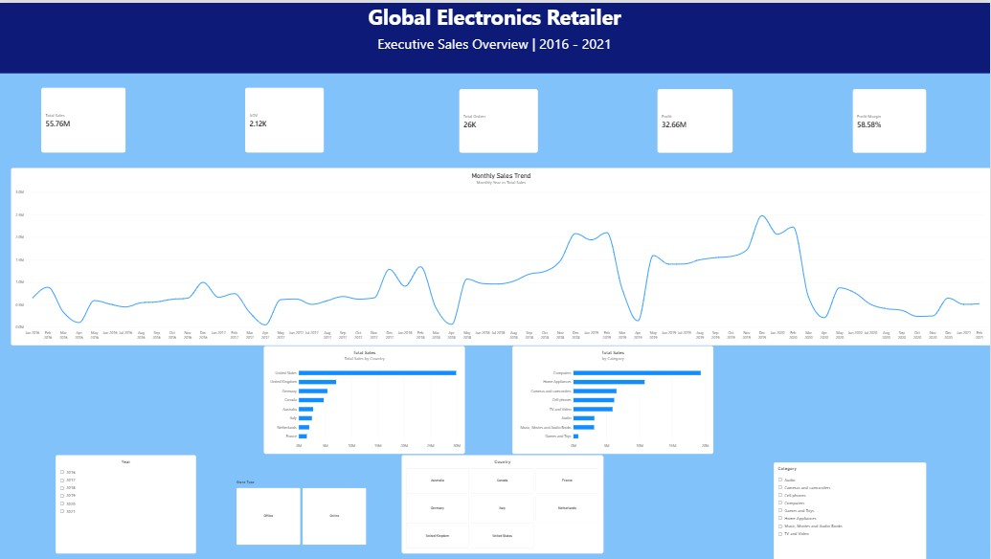
Figure 1. Executive Sales Overview, 2016–2021. Values shown are from the submitted dashboard screenshot.

Power BI Dashboard — Product & Customer Analysis
This page compares top products by sales, category-level profit margins, sales by gender, and sales by customer age group, with year and country filters.
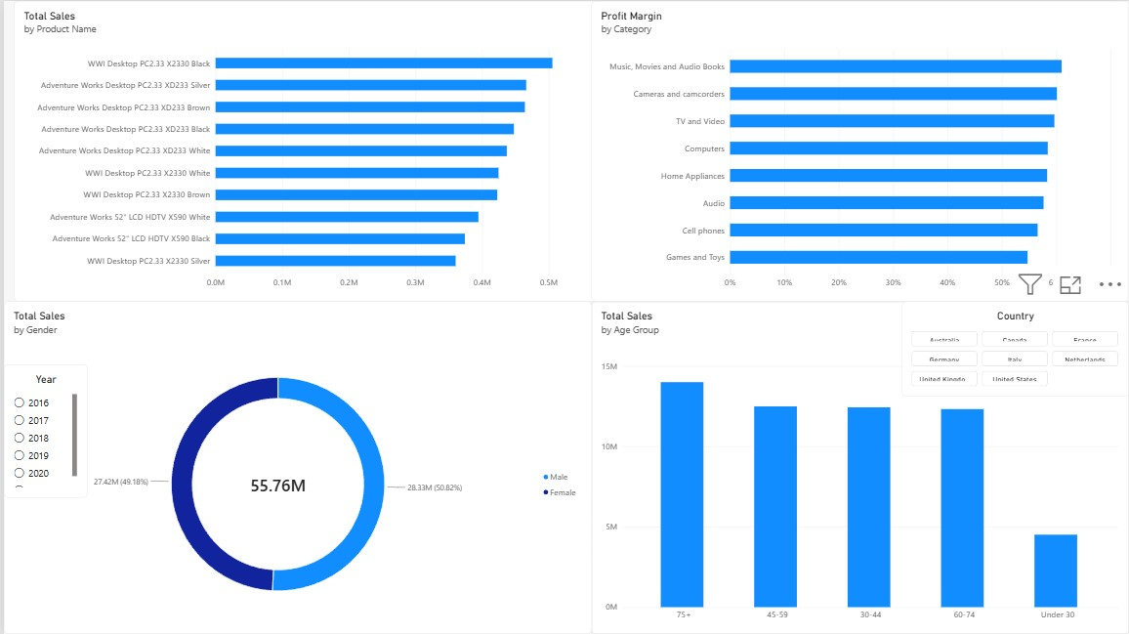
Figure 2. Product and Customer Analysis dashboard.

Business Insights & Recommendations

Product Performance
Findings
- Computers lead in total sales and total profit among categories.
- Music, Movies and Audio Books has the highest reported category profit margin, at approximately 60%.
- Proseware has the highest reported brand-level profit margin.
Recommendations
- Maintain effective inventory and product management for Computers.
- Investigate whether high-margin categories and brands can be expanded profitably.
- Evaluate total profit alongside profit margin before changing product investment.

Geographic Performance
Findings
- The United States has the highest total sales and profit and the largest customer base.
- Canada has the highest reported profit margin among countries.
Recommendations
- Continue supporting customer retention and sales in the US.
- Investigate the product mix, pricing, and costs associated with Canada's higher margin.

Sales Channel Performance
Findings
- Offline stores generate higher total sales and profit than the online store.
- Reported offline profit margins reach approximately 62%, compared with around 58% online.
- Offline average order value is approximately 0.10K higher than online.
Recommendations
- Continue supporting strong offline performance.
- Review online product mix, promotional strategy, and operating costs to identify improvement opportunities.
- Track sales, profit margin, and average order value separately by channel.

Customer Behavior
Findings
- Male and female customers contribute almost equally to sales and profit.
- Customers aged 75 and above generate the highest total sales and profit among age groups.
- Customers under 30 represent a smaller segment, while their average spending is broadly similar to older groups.
Recommendations
- Maintain balanced customer strategies across genders.
- Explore purchasing patterns among customers aged 75 and above.
- Test acquisition campaigns for younger customers and measure the results.

Sales Trends
Findings
- Sales and year-over-year sales show an overall increasing trend.
- Sales tend to decline in the early months, reaching a low around April, then recover.
- April 2021 is unavailable; January is the lowest-sales month among the available months in 2021.
Recommendations
- Investigate potential drivers of the early-year decline.
- Consider targeted campaigns during weaker periods.
- Validate the pattern across additional periods and with business context before treating it as established seasonality.

Delivery Performance
Findings
- Average delivery time reportedly decreased from about seven days in 2016 to four days in 2021.
- Monthly average delivery time is approximately 4.3–4.8 days.
- Delivery dates are only applicable for orders made from online stores.
Recommendations
- Investigate the apparent delivery-time improvement.

Limitations & Validation Notes
- The early-year sales pattern is an observed trend, not proof of a causal seasonal effect.
- The findings and approximate figures in this report reflect the analysis and dashboard results provided for the project; they should be rechecked against the underlying model before external or operational use.
- The product price and cost fields are in USD in the source model, so sales/profit calculations based on those fields represent USD-denominated estimates.

Conclusion
This project demonstrates an end-to-end analytics workflow: data auditing and cleaning with Python, followed by data modelling,S DAX-based analysis, and interactive reporting in Power BI. The dashboards reveal differences in product profitability, geographic performance, channel contribution, customer segments, and monthly sales trends. The recommendations provide starting points for deeper business investigation, while explicit data-quality limitations help ensure that conclusions are interpreted responsibly.
Portfolio note: Include the cleaned-data workflow and relevant Python notebook/script in the project repository alongside the Power BI file, screenshots, BRD, and this report.

