SUMMER TRAINING REPORT

On

**BLOGGER’S HOUSE**

2019-20

Training held at

**NETPARAM Technologies Pvt.**

**Ltd.**

IT Division CDAC

Submitted by Submitted to

**MANISH CHAUHAN&RASHMI PAL Mr. NISHANT SINGH**

**INDEX**

1.Introduction to Project

2.Literature Review

3.WHY TO CHOSE

4. Project Metadata

5. Activity Block Diagrams

6. Future Scope

**INTRODUCTION**

BLOGGER HOUSE IS A BLOGGING SITE IN WHICH PEOPLE CAN EASILY INTERSACT WITH THE DIFFERENT PEOPLE AROUND THE WORLD AND CAN SHARE THEIR EXPERIENCES AND VIEWS.

**LITERATURE REVIEW**

**For Animations**

* [**https://getbootstrap.com/docs/4.3/getting-started/introduction/**](https://getbootstrap.com/docs/4.3/getting-started/introduction/)
* [**https://www.w3schools.com/html/**](https://www.w3schools.com/html/)
* [**https://www.w3schools.com/css/**](https://www.w3schools.com/html/)
* <https://www.fullstackpython.com/django.html>

**METHODOLOGY**

**EXISTING SYSTEM:**

* **Criminal activities.**
* **Religious fight, now mainly used for dirty politics**
* **Making nonsense and ill mannered video.**

**proposed system:**

* **Blogger house will help the people to get connect with each other and help each other.**
* **This System will be most usefull in searching the best healthy content.**
* **This will help in sharing the knowledgeable content which can children easily use**

**PROJECT DATA**

**TECHNOLOGY USED:**

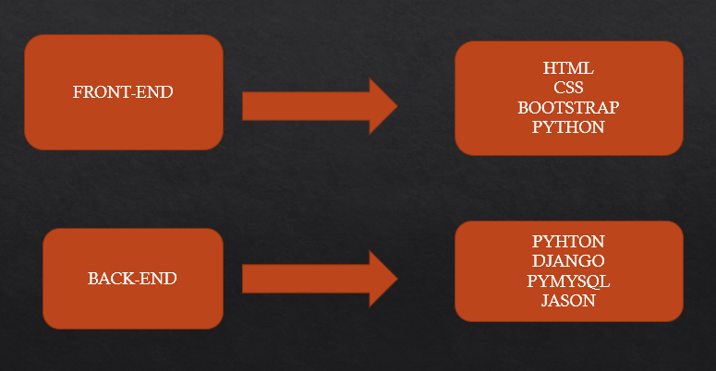

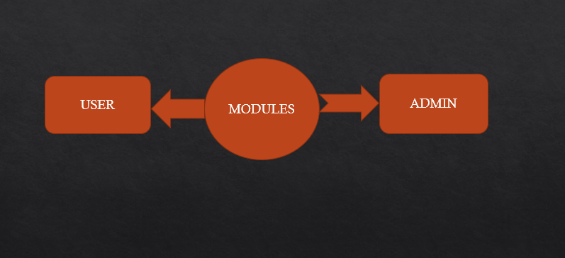

**NEED OF PROJECT**

* **The need of this kind of project is increasing day by day.**
* **As our youth is getting involved in nonsense type activity and making country’s future insecure .**
* **This kind of site help us to get more connected to the people easily and person can easily convey their emotions .**

**ADVANTAGES**

* **EASY CONNECTIVITY:- People can easily connect with each other and can convey their feelings and good knowledge content.**
* **Free from adult: This site will be free from adult content so that kid can also excess it easily.**
* **Free from graphical content: this site will have no graphical content and plus will be away from business promotion.**
* **Online Information:- A good automated information gathering site the best one stop of everything.**

**DISADVANTAGES**

* **When server is down, accessibility is may not be possible.**
* **Not possible to communicate with each other physically.**
* **We can only know the person through this mean we cant know what phase that person is going.**

**FUTURE SCOPE**

* THE SCOPE OF THIS KIND OF SITE WILL BE KEEP INCREASING DAY BY DAY.
* Blogs are informal articles written for the purpose of showing thought leadership and expertise on a topic. They are a great way to generate fresh content on a website and provide a catalyst for email marketing, social media promotion to drive search traffic to your website.
* THESE KIND OF WEBITE WILL HELP THE COUNTRY TO UNITE AND STAY AWAY FROM WAKE NEWS.