|  |
| --- |
| **Business Analytics in Practice**  **Applied Project**    **By: Matthew Hiebler, Mostafa Eid, Rahul Roy, Manish, Mayu**      **Table of Contents** |

**1. Title Page                                                                                                                   1**

**2. Table of Contents                                                                                                           2**

**3. Executive Summary                                                                                                        3**

**4. Organisation and Project Background                                                                4**

**5. Introduction                                                                                                                    5**

**6. MD Model                                                                                                                  5**

**7. Personas                                                                                                                         6**

**7.1 – Chris McCandles                                                                                           6**

**7.2 – Sarah McPhee                                                                                                9**

**7.3 – Lisa Johnston                                                                                             13**

**8. Visual Answers**

**8.1 – Chris McCandles                                                                                           7**

**8.2 – Sarah McPhee 10**

**8.3 – Lisa Johnston                                                                                             14**

**9. Lessons Learnt/Conclusion                                                                                           16  10. Log Contribution                                                                                                 17**

**Executive Summary**

This applied project was commissioned in an effort to display the ability to design three personas that represent different groups of users who work in the same industry in dealing with endangered species. These personas all share different perspectives which would give the project value through diversity. These were the personas of Lisa Johnston who is a senior wildlife management officer. Chris McCandles who works for a not for profit wildlife protection charity and Sarah McPhee who is an owner of a retail chain of exotic animal artifacts and medicine. Research was then performed into the personas to come up with three non-trivial questions that would be answered using the DV application.

 Following this step analysis and data harvesting was conducted in order to help design a single multidimensional model of the data set. After the model was designed, the data was imported into Tableau in order to create visual answers using the data visualisation features to answer the questions for all three personas. These visual answers for Sarah showed that wildlife importation had dropped dramatically from 2014 to 2015 in both China and Japan with exportation in Asian countries also dropping about 20million from 2014 to 2015. Lisa’s answers displayed a huge decline in the import and export report for 3 years from 2013 to 2015 of products such as skins, teeth, trophies and tusks.

In conclusion we discovered that because of the inclusiveness of our personas we were able to add value to the project by gaining the insights of many different communities and disciplines within the organisation therefore making our DV application highly valuable. Through our research we can conclude that there has been a drastic drop in wildlife importation and exportation within the past 3years ranging from 2012 to 2015.

**Organisation and Project Background:** The business of this particular organisation is that of dealing with endangered species.  Specifically, the import and export trade of endangered species, as there is of course international concern and efforts to ensure that various species continue to survive, and where possible in captivity make them flourish.   The reason that this project was initiated was to create three different types of users, then from this we would be able to use business analytics and data visualization in any context, including organisational, industry wide or societal.  The three users we have created all reflect a different perspective, as they are at different parts of the trade, i.e. wildlife manager, Retailer of exotic animal artifacts & a wildlife protection charity.  There is value in our particular project as it provides a diversity of views upon which our project will yield the most valuable insights.

**Introduction:**

Throughout the course of this applied project, we will be showing a Visual atlas of the import and export trade in Endangered Species.  This Visual atlas will also take into account the decision-making needs of three different design personas.   The design personas that we have is Chis McCandles who works with a not for profit with a wildlife protection charity.  We then have Sarah McPhee is a retail chain owner of Exotic Animal Artifacts/medicine.  We also have Dr Lisa Johnston who is a Senior Wildlife management officer at Nairobi.   The reason our project has value for different communities of users is that it is inclusive of many different disciplines and diversity that are related to the plight of endangered wildlife.  We have people who are trained doctors having their valuable insight considered, people involved in the charity sector for wildlife protection and people who purchase artifacts to ultimate give money to the sector to function.  Ultimately the diversity of viewpoints and collective knowledge and contributions obtained provide a true diversity of consideration, thereby making our DV application highly desirable.

**MD Model**

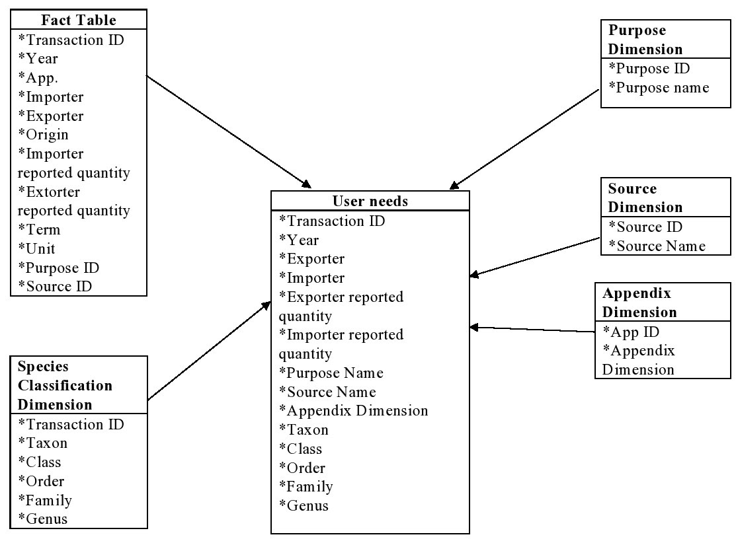

|  |  |
| --- | --- |
| **Persona** | **Chis McCandles** |
| **Role** | **Not for profit – wildlife protection charity** |
| **Context of work** | **A conservation biologist who is currently working as a field biologist in Alaska. Has immense knowledge in biology and has excellent written, communication and analytical skills.** |
| **Key activities** | **-        Currently studying on the impact of oil spills on marine life.**  **-        He looks into technical reports that people have made in order to make a comment on the impact of a certain development on wildlife and also recommend changes in existing protection around wildlife.**  **-        His frustrations include loss and degradation of habitat, climate change, chemical and biochemical pollution, logging and poaching.** |
| **DV Questions** | **Three questions Chris McCandles would use the system to answer or demonstrate.**  **Question 1: Which is the most exported species and their sources?**  **Question 2: Which category does the exported species belong to and for                                                                                                                                                              what purpose are they exported?**  **Question 3: Who is the largest exporter and importer with respect to category of  species and their sources?** |

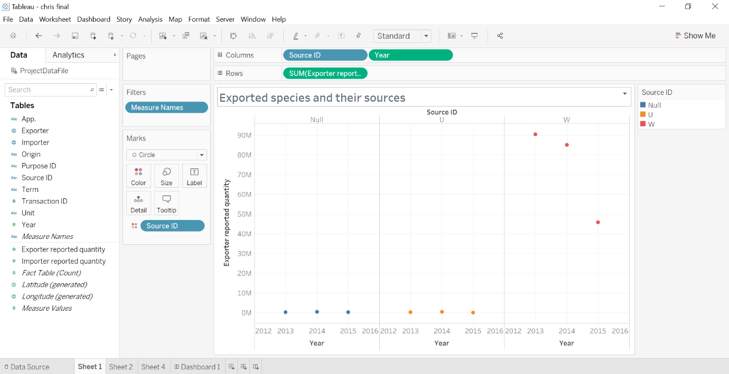

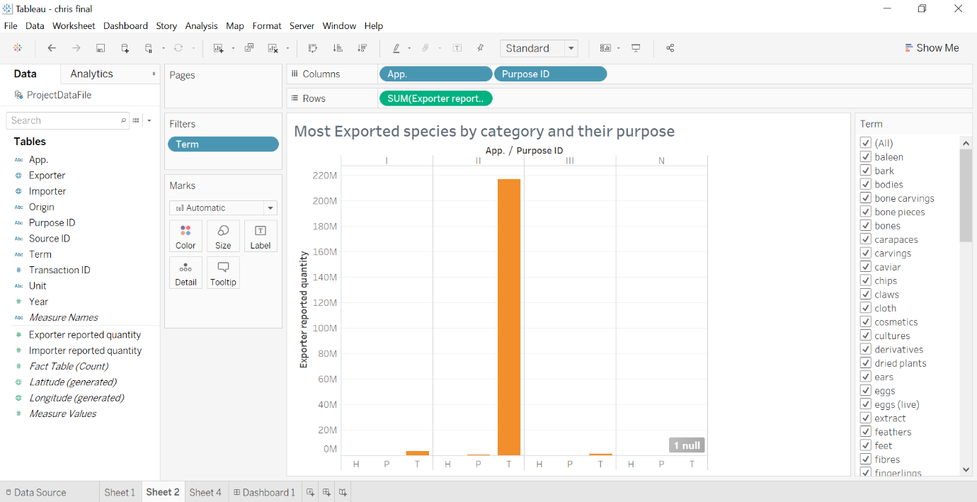

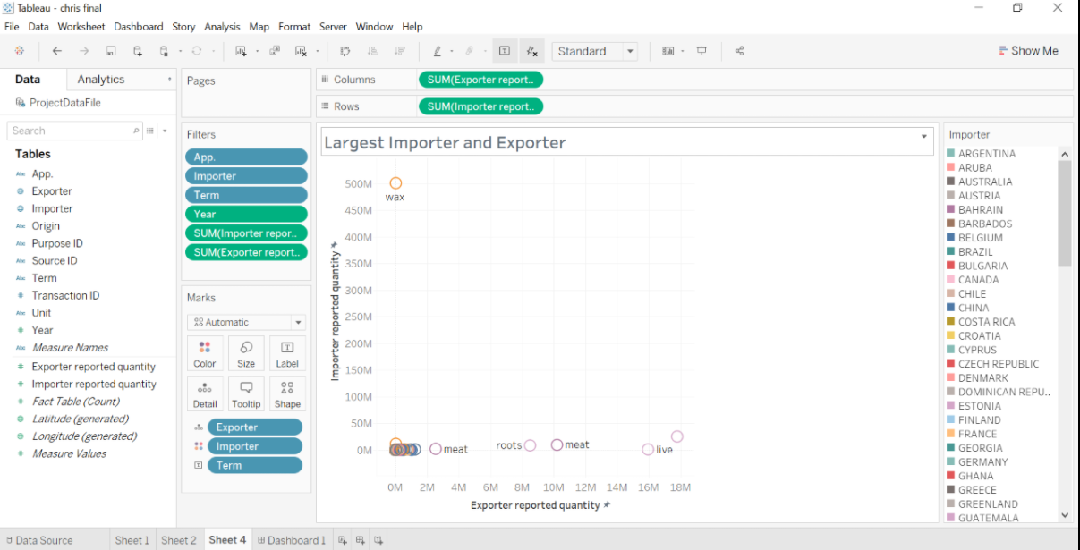

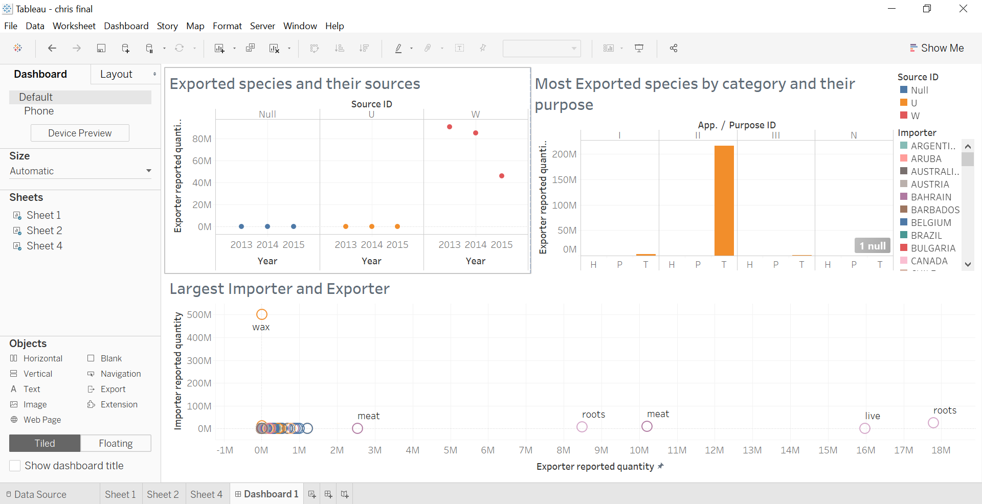

|  |  |
| --- | --- |
| **Persona** | **Retailer Sarah McPhee** |
| **Role** | **Retail Chain Owner of Exotic animal artifacts/Medicine** |
| **Context of work** | **Sarah opened 5 stores in 2015 across Asia in Japan & China, that specialise in animal/plant artifacts and exotic parts that are used for medical purposes. She purchases her goods from recognised dealers and trusts they are collected ethically.** |
| **Key activities** | **She wants to get a better understanding of the ethical collecting methods and welfare of the wildlife after reading a few articles on the impact of humans on wildlife. She’s concerned that her role could potentially be playing a pivotal role in the chances some wildlife could become extinct. She’s also concerned for her business and wants to make sure that she’s operating within the legal boundaries.** |
| **DV Questions** | **Question 1: How much products were imported into Japan & China in 2015 vs the previous year? And what percentage of it was from known sources?**  **Question 2: Have the numbers for importation for wildlife products increased in 2015 vs the previous years?**  **Question 3: Sarah’s business has been booming, she sources her products locally and in other Asian countries. She’s very interested to know if the export quantity in the Asian region has been impacted since she went into business?** |

1. 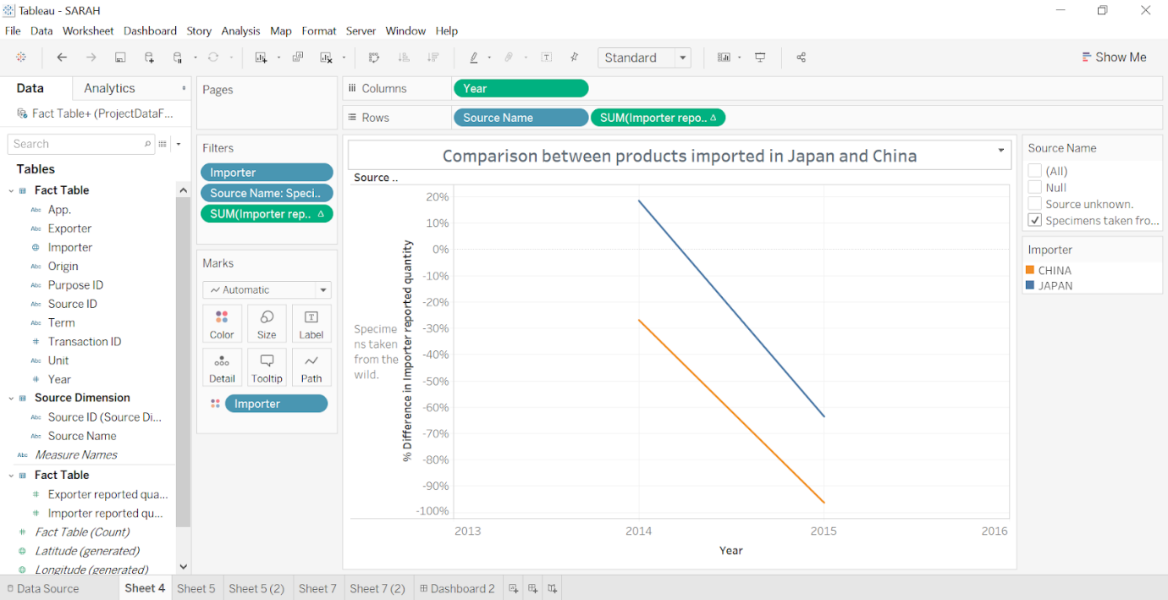

* 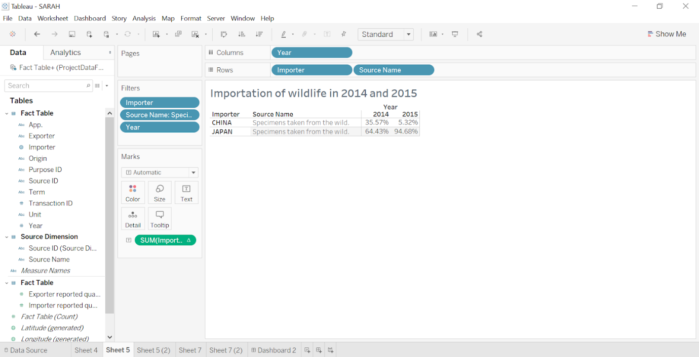
* 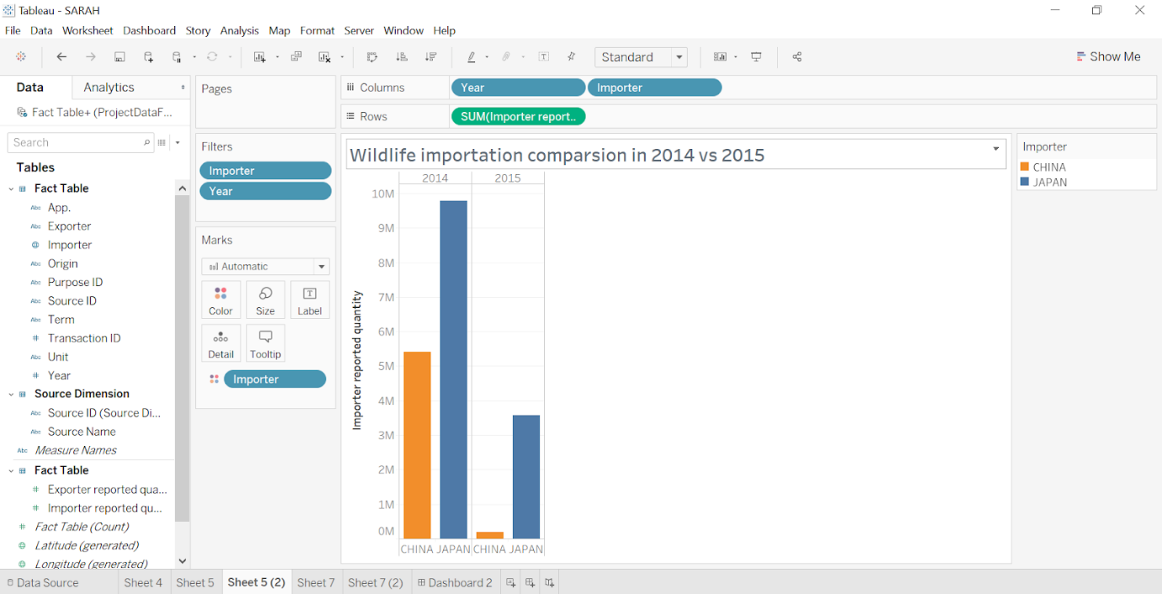

1. 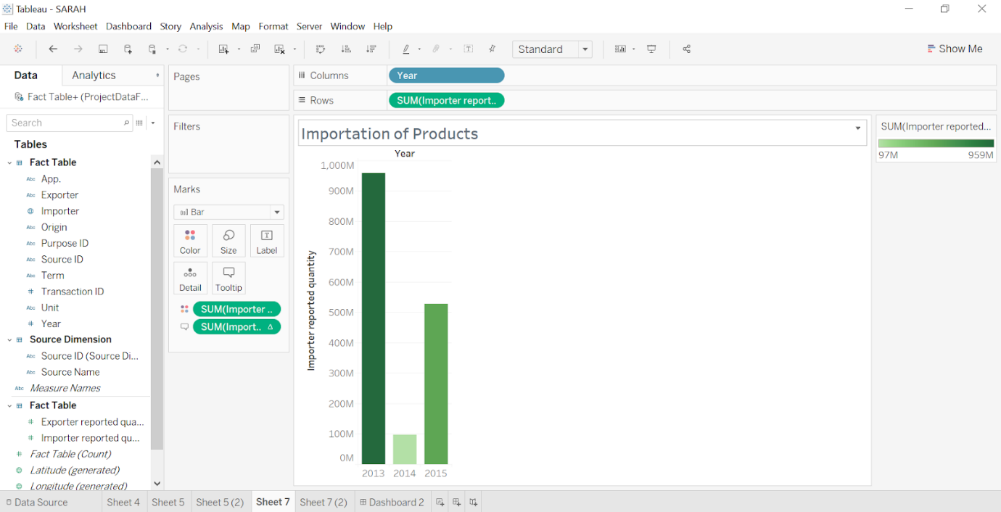

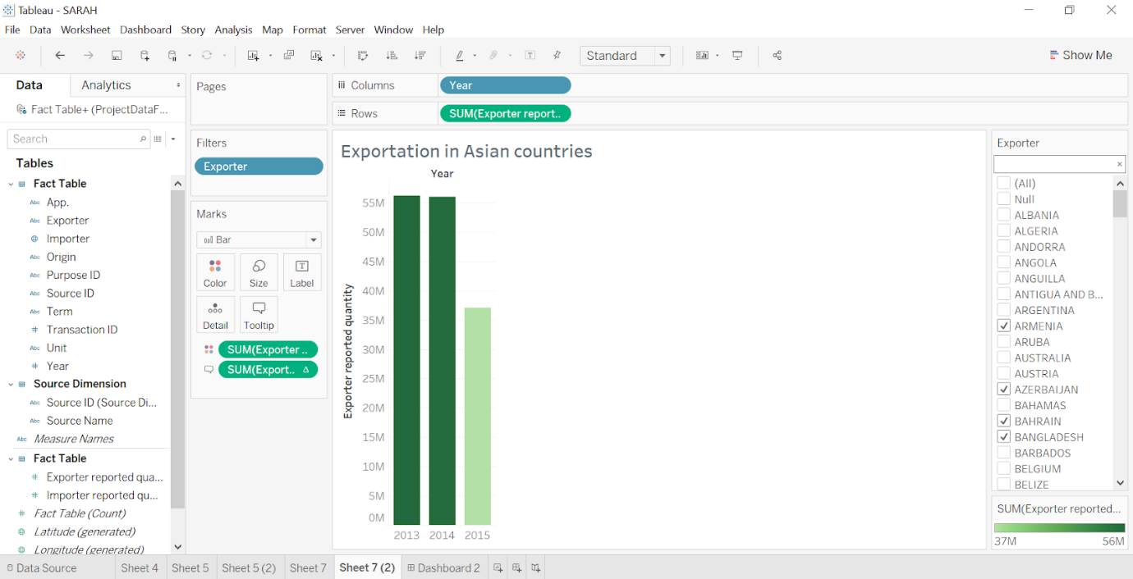

**Dashboard for Sarah**

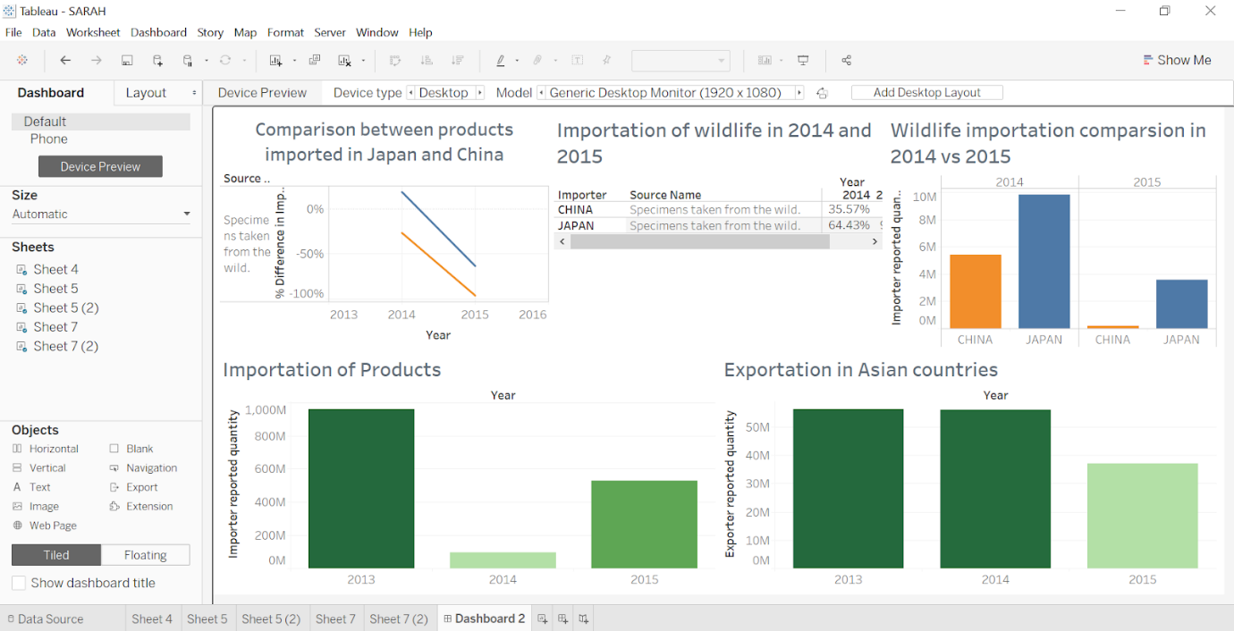

|  |  |
| --- | --- |
| **Persona** | **Dr Lisa Johnston** |
| **Role** | **Senior Wildlife management officer at Nairobi** |
| **Context of work** | **·         Provide direction and advice on wildlife management and conservation**  **·         Lead the team in developing wildlife management strategies that embrace a long-term view about land use choices including on reconciling conservation with; the expansion of agriculture; population growth.**  **·         Lead in informing and influencing land use choices through better understanding of multiple threats to wildlife.**  **·         Lead in establishing Wildlife Economy as a legitimate and effective land use option.**  **Lisa is in the heart of Kenya, a continent where illicit wildlife trade is high.** |
| **Key activities** | **Dr. Johnston is concerned that without the right education and guidance, illegal export activities of wildlife will continue to grow in her country and continent. She wants the world to take a stand and reduce demand for domestic wildlife sourcing of African animal.** |
| **DV Questions** | **Question 1: The growth/decline of wildlife imports and exports globally over the last 3 years, and which countries are the largest exporters and importers? Specifically, the impact to Africa?**  **Question 2: Which continent has the biggest percentage increase, when it comes to the importation of animal parts (tusks, teeth, skin & trophy)**  **Question 3: What percentage of the overall animal numbers have been reintroduced into the wild from either captivity or personal use?** |

**1.**

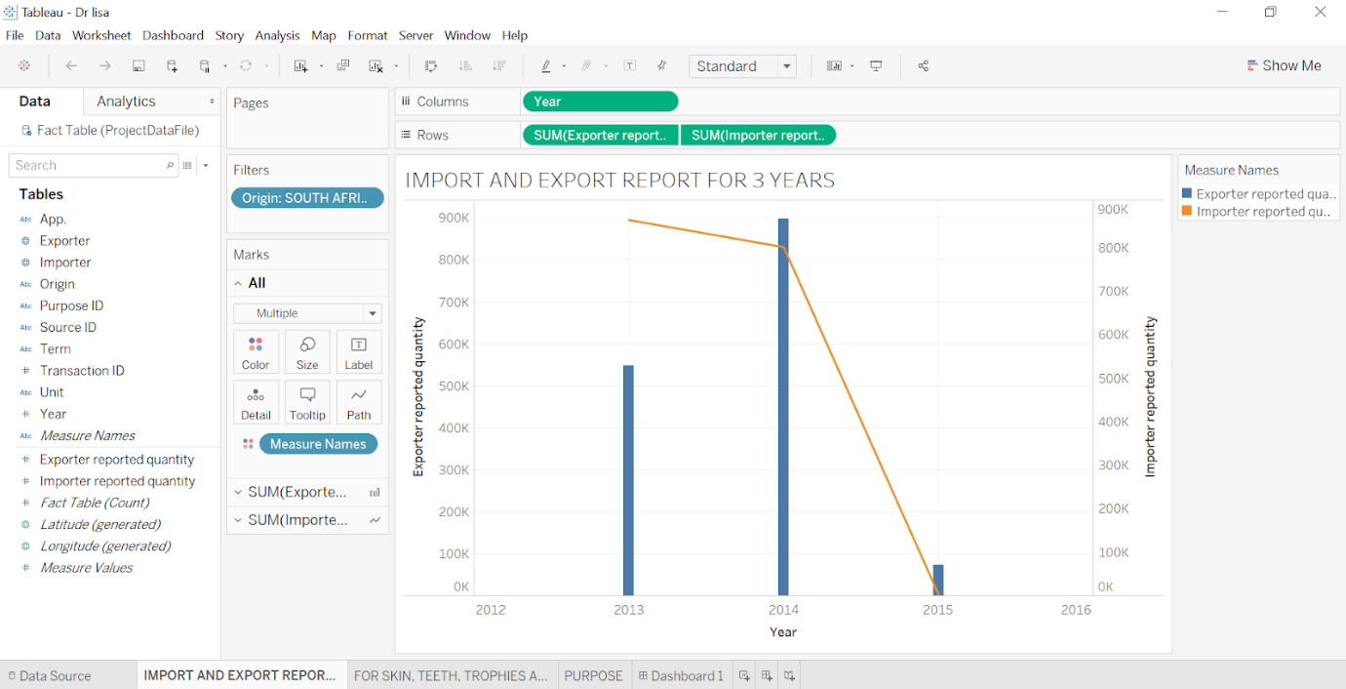

**2.**

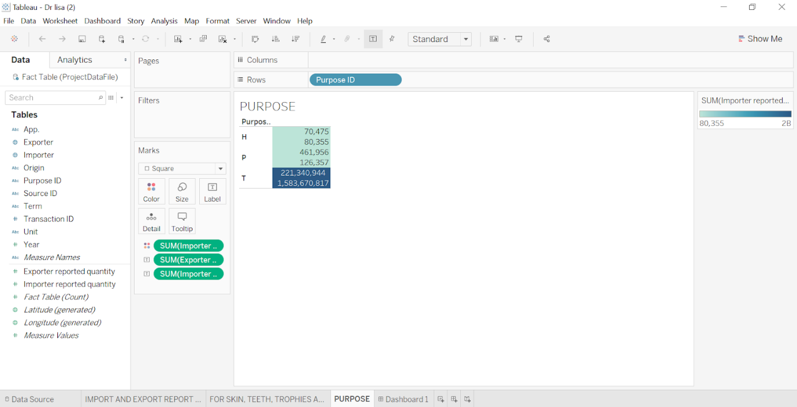

**3.** 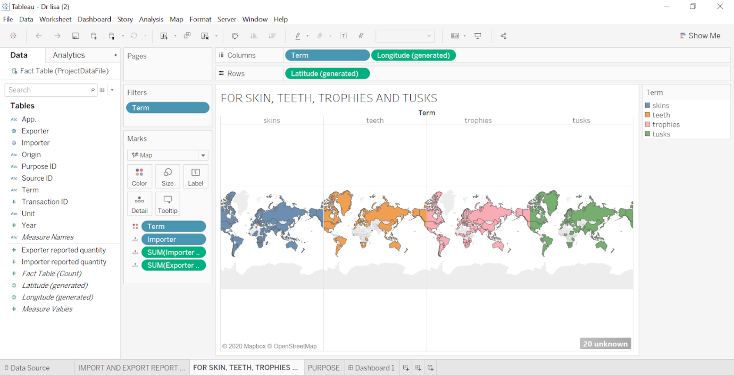

**Dashboard for Dr. Lisa**

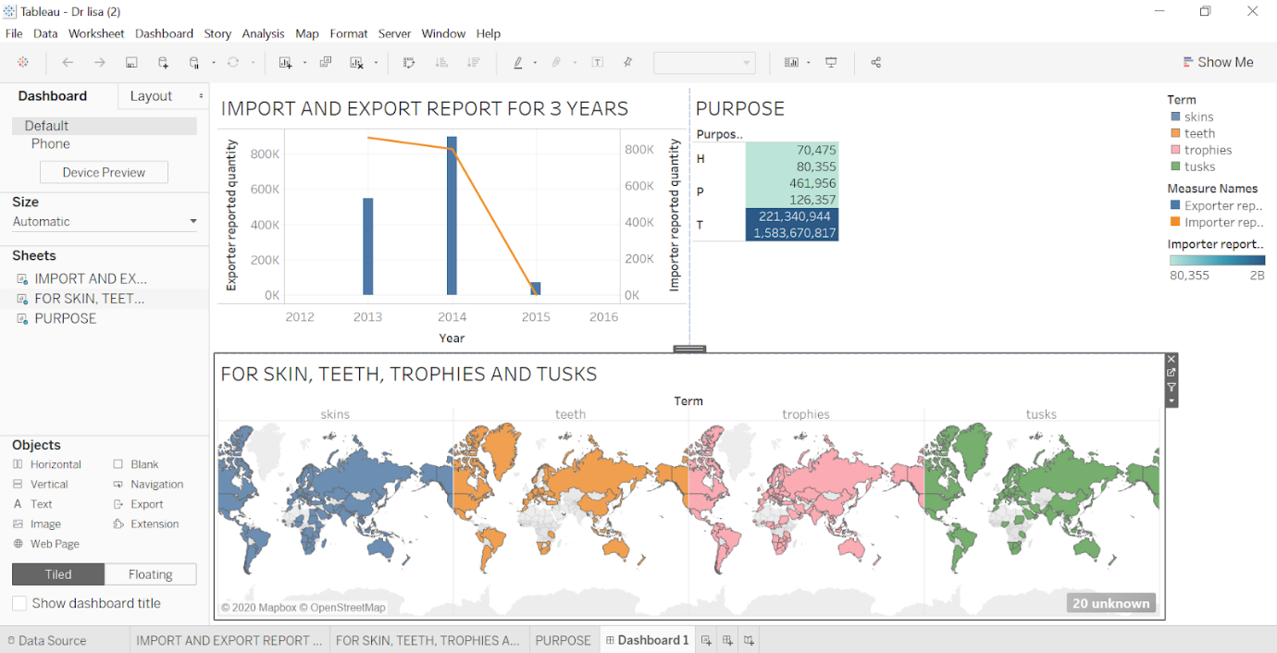

**Lessons learnt/ conclusion:**

The lessons learnt for this project was the challenge of coming up with new personas that were realistic and yet relevant.    There was difficulty in coming up with non trival questions, as the questions asked can provide key insights that ultimately reveal important pieces of information.  Another key lesson learnt was that in the event that any of Personas were not realistic, it would have resulted in us having incorrect data, thereby reducing our ability to provide Key insights.   In conclusion, we were able to create three different personas, one who is Chis McCandles who works with a not for profit with a wildlife protection charity.  We then have Sarah McPhee is a retail chain owner of Exotic Animal Artifacts/medicine.  We also have Dr Lisa Johnston who is a Senior Wildlife management officer at Nairobi.   The content of their personas included information such as the role, context of work, key activities and DV questions.  The non-trivial questions we were able to ask them all individually were very considered and ultimately would have provided great insights that would be able to formulate a sophisticated and comprehensive answer.  We have been able to provide a multi-dimensional model which provides a comprehensive reflection of all important considerations for user needs**.** The Visual answers clearly demonstrate that we were able to utilise software systems in order to respond to a question for each individual persona that was correct and appropriate.

**Contribution Log:**

