**PURBANCHAL UNIVERSITY**

**Biratnagar Nepal**



A Project report on

**“Futsal Booking System”**

In the partial fulfillment for the requirement of the 1st Semester Project-I (subject code- BIT) in the completion of **Bachelor of Information Technology (BIT)** degree at **KIST college** **of Information Technology**, under **Purbanchal University.**

|  |  |
| --- | --- |
| **Submitted By: -** | **Submitted To: -** |
| 1. **Manish Dhungana** |  |
| 1. **Rohan Mishra** | **Purbanchal University** |
| 1. **Santosh kumar Yadav** |  |

**Under the Guidance of**

**Mr. Prawesh Dhungana**

**Lecturer, BIT**

**KIST COLLEGE OF INFORMATION AND TECHNOLOGY KAMALPOKHARI, KATHMANDU NEPAL**

**KIST COLLEGE OF INFORMATION AND TECHNOLOGY KAMALPOKHARI, KATHMANDU NEPAL**



**CERTIFICATE**

This is to certify that the project work entitled **“Futsal Management System”** is carried out by **Manish Dhungana (5400), Rohan Mishra (5423), Santosh Kumar Yadav (),** bona fide students of **KIST COLLEGE OF INFORMATION AND TECHNOLOGY** in partial fulfillment for the award of **BACHELOR IN INFORMATION AND TECHNOLOGY** of the **PURBANCHAL UNIVERSITY, BIRATNAGAR NEPAL**, during the year **2021-2022**. It is certified that all corrections indicatedfor internal assessment have been incorporated in the report submitted in the department library. The project report has been approved, as it satisfied the academic requirements in respect of the project work prescribed for the said degree.

The details of the students are as follows: -

|  |  |  |
| --- | --- | --- |
| **NAME** | **REGISTRATION NO.** | **SYMBOL NO.** |
| Manish Dhungana  Rohan Mishra  Santosh Kumar Yadav |

Course Semester: - 1st Semester

Subject: - Project-I

Subject Code: - BIT ()



Mr. Deepak Khadka

Program Coordinator, BIT

**KIST COLLEGE OF INFORMATION AND TECHNOLOGY KAMALPOKHARI, KATHMANDU**

**Examiner’s Certification**

The Project Report

On

**“Futsal Booking System”**

**Developed by**

**Manish Dhungana**

**Rohan Mishra**

**Santosh Kumar Yadav**

Is approved and is acceptable in qualify form.

**Internal Examiner**

Name:

Designation:

**External Examiner**

Name:

Designation:

**ACKNOWLEDGEMENT**

It is with greatest satisfaction and euphoria that we are submitting our project report entitled **“FUTSAL BOOKING SYSTEM”.** We have completed it as a part of the curriculum of **PURBANCHAL UNIVERSITY.**

We also take this opportunity to express a deep sense of gratefulness to our **BIT Coordinator Mr.** **Deepak Khadka** and **BIT Lecturer Mr. Prawesh Dhungana** for their amiable support, valuableinformation and guidance which helped us in completing this task throughout its various stages. We are indebted to all members of **KIST College,** for the valuable support and suggestion provided by them using their specific fields’ knowledge. We are grateful for their cooperation during the period of our project.

Finally, we would also like to express our gratefulness towards **Purbanchal University** for designing such a wonderful course structure. It will help us to get more knowledge in the field of Information Technology & help us to have a bright future in the field of technology.

We hope our university will accept this attempt as a successful project.

Last but not the least, our sincere thanks to our parents, teaching and non-teaching staffs of our college and also my friends.

**Manish Dhungana (5400)**

**Rohan Mishra ()**

**Santosh Kumar Yadav ()**

**STUDENT’S DECLARATION**

We hereby declare that the project report entitled “**FUTSAL BOOKING SYTEM**” is a result of our own work. If we are found guilty of copying any other report or published information and showing as our original work, we understand that we shall be liable and punishable by **Purbanchal University**.

We further certify that this Project submitted in partial fulfillment of the requirement for the award of Bachelor in Information Technology (**BIT**) of the **Purbanchal University** is our original work and has not been submitted for award of any other degree or other similar title or prize.

|  |  |  |  |
| --- | --- | --- | --- |
| S.N. | Name | Registration No. | Symbol No. |
| 1 | Manish Dhungana |  |  |
| 2 | Rohan Mishra |  |  |
| 3 | Santosh Kumar Yadav |  |  |

**TO WHOM IT MAY CONCERN**

This is to certify that Mr. Manish Dhungana, Mr. Rohan Mishra and Mr. Santosh Kumar Yadav of Bachelor in Information Technology (BIT) has studied as per the curriculum of BIT 1st Semester and completed the project entitled “**Futsal Booking System”**.This project is the original work of Mr. Manish Dhungana, Mr. Rohan Mishra and Mr. Santosh Kumar Yadav and was carried out under the supervision of Mr. Prawesh Dhungana as per the guidelines provided by Purbanchal University and certified as per the student’s declaration that project “**Futsal Booking System**” has not been presented anywhere as a part of any other academic work.

The detail of the student is as follows:

Name of Students : Manish Dhungana

Rohan Mishra

Santosh Kumar Yadav

Semester : 1st

Subject Code : BIT

Project Title : **Futsal Booking System**

…………………………….

Mr. Deepak Khadka  
Program Coordinator, BIT  
KIST College of Information Technology

**TABLE OF CONTENTS**

Contents

ABSTRACT 1

1 INTRODUCTION 2

**SYSTEM REQUIREMENTS** 5

**ALGORITHM** 6

**FLOWCHART** 7

**CONCLUSION** 9

**FUTURE SCOPE** 9

**SOURCE CODE** 10

**REFERENCES** 21

ABSTRACT

Futsal Booking System (FBS) is developed to give an efficient system to the Futsal Court management. In the existing system, customer needs to come to the futsal court to make a booking. However, by using FBS, they can make the online booking anywhere and anytime. This system is covering online booking for customer and online system for staff. This system is for the customers to booking court and view court availability via online system. Based on the existing system, all the booking data, equipment data, staff profile and others will be stored manually in a log book. This is dangerous because the probability the data will be lost or damage is high. So, Futsal Booking System is also developed for all the booking and management data can be stored in database which will be more secure.

1 INTRODUCTION

1.1 Introduction

The system named as “Futsal Booking System”. It is divided to the two main services which are to support online management system and to give confirmation message to the customer.

Nowadays, futsal has become one of the major sports in many countries. It is being one of the favorite sports among teenagers, adult and kids, including mans and woman. That is why we can see a lot of futsal court has been opened everywhere. As in ABC Futsal Club, many other futsal courts today still use the manual booking system. This system is quite unfriendly to the user. By using the current system, users need to call or come to the futsal club by themselves to check the availability and to book the court which is wasting their time if the court is not available. Sometimes, there are happens the clashing when the booking data is not organized nicely. The booking data of the current system will be stored manually and it has a high probability that the data might lose or broken. Besides that, there are still so many lackage of using the current booking system. The other problem is the management of court resources and staffs. Though the number of staffs and resources are not as big as other company, but they are still need to be organized systematically since the staffs need to work until 6 A.M every day. That is why, the system is need to be replaced with a new system which is more systematic and user friendly.

1.2 OBJECTIVES

The main aim of this project is to design, develop a system which would assist the people who love to play futsal and futsal court owner. The overall objectives of the project are:

1. To develop a C-based system of futsal court booking.

2. To saved or record all booking data information in a file-based system which is more secure.

3. To provide the fast and convenient customer services.

1.3 FEATURES

The features are: -

1 Can book futsal court through the program.

2 Can check the information of the booking itself.

3 Can verify the information itself.

4 Can handle booking date.

5 Can manage rules and regulations.

6 Can manage booking information

**SYSTEM REQUIREMENTS**

Following hardware and software requirement should be met for flawless running of this system:

**Hardware:** Hardware is the collection of physical parts of a computer system. This includes the

computer case, monitor, keyboard, and mouse. It also includes all the parts inside the computer

case, such as the hard disk drive, motherboard, video card, and many others. Computer hardware

is what you can physically touch.

RAM: 256 MB

Hard Disk: 200MB or above free space available

Processor: Intel Pentium III or higher

**Software:** Software is a set of instructions, data or programs used to operate computers and

execute specific tasks. It is the opposite of hardware, which describes the physical aspects of a

Computer.

OS: Windows 7 or Higher

Applications: Turbo C compiler.

**ALGORITHM**

Step 1: Start.

Step 2: Shows Main menu.

**FLOWCHART**

Flowchart is a diagram that represents workflow or process.

**CONCLUSION**

**FUTURE SCOPE**

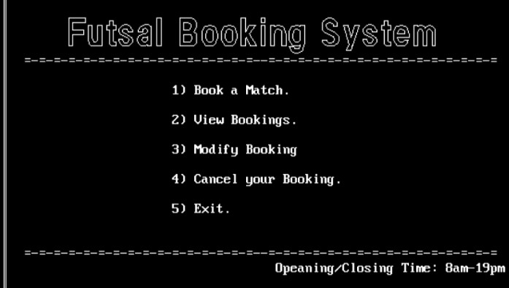

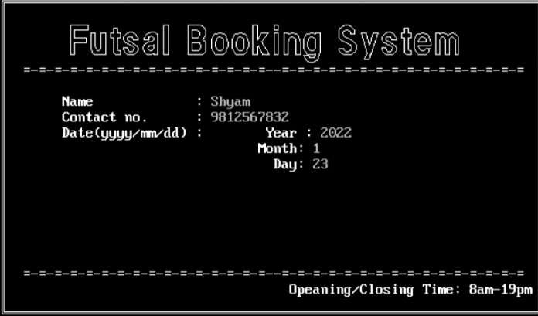

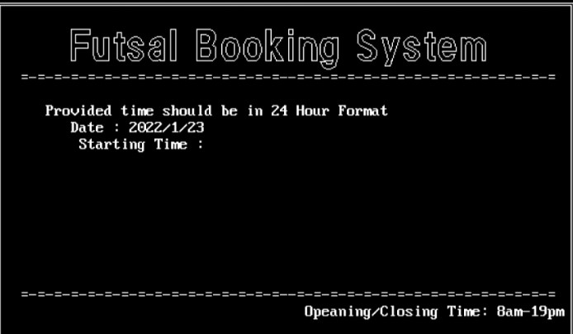

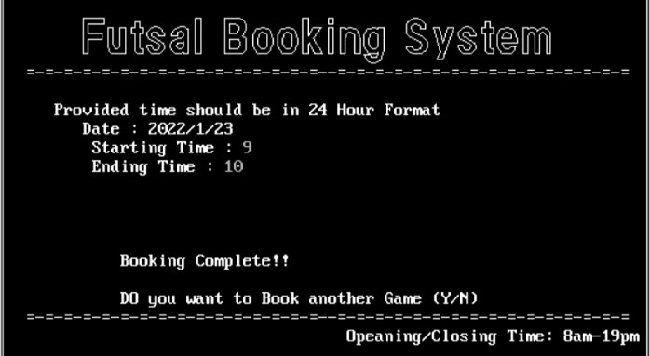

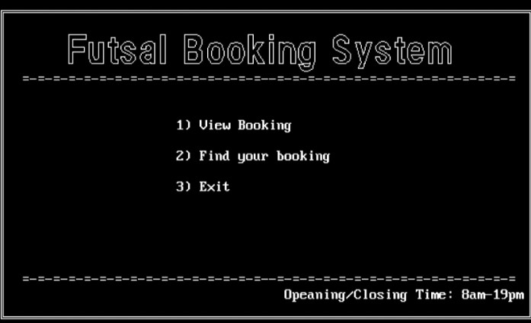

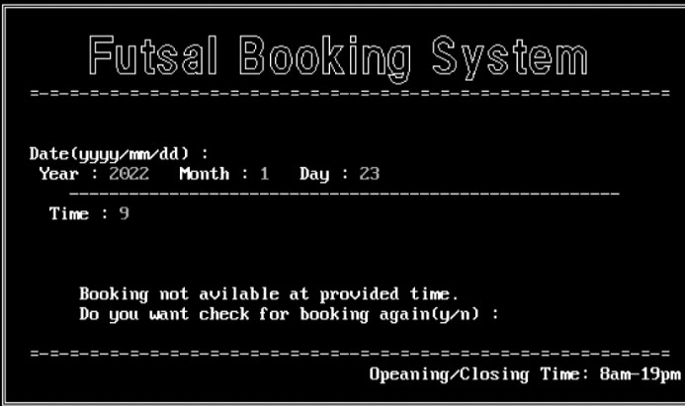

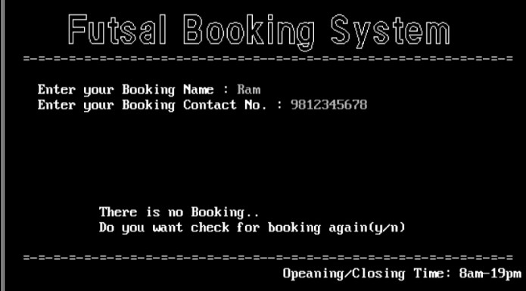

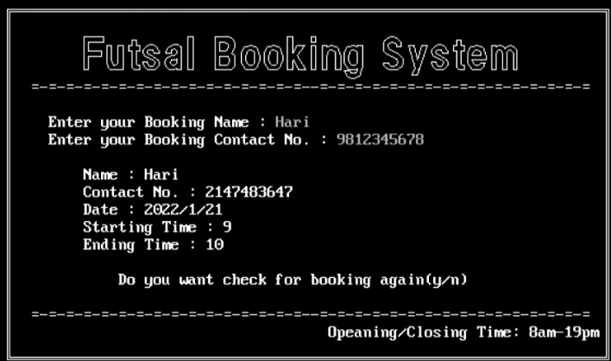

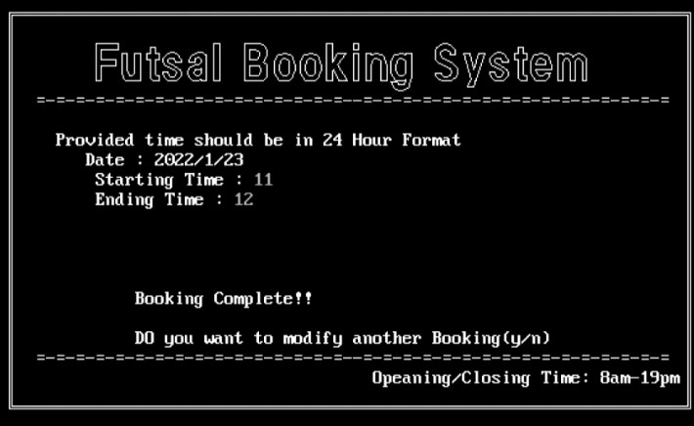

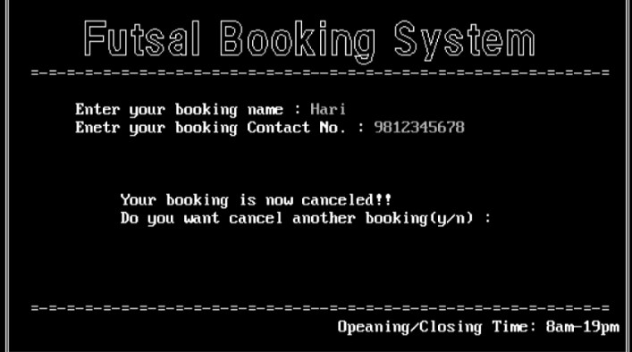

**SOURCE CODE**

#include<stdio.h>

#include<conio.h>

#include<stdlib.h>

#include<graphics.h>

#include<string.h>

struct booking_Details{

char name[40];

long int num;

int stime;

int etime;

struct booking_date{

int year;

int month;

int day;

}d;

}detail;

void menu();

void menu_start();

void booking();

void find_booking(void);

void view_booking(void);

void cancel_booking(void);

void modify_booking(void);

void main()

{

menu_start();

}

//Menu layout 1

void menu_start()

{

int choice;

int gd = DETECT,gm;

initgraph(&gd,&gm,"c:\\TURBOC3\\BGI");

menu();

settextstyle(1,HORIZ_DIR,4);

delay(500);

gotoxy(30,12);

printf("1) Book a Match.\n");

gotoxy(30,14);

printf("2) View Bookings.\n");

gotoxy(30,16);

printf("3) Modify Booking");

gotoxy(30,18);

printf("4) Cancel your Booking.\n");

gotoxy(30,20);

printf("5) Exit.");

choice = getche();

booking(choice);

//getch();

closegraph();

}

//Menu layout end

//UI Interface

void menu()

{

rectangle(50,80,600,400);

rectangle(52,82,598,398);

delay(500);

settextstyle(10,HORIZ_DIR,3);

outtextxy(90,90," Futsal Booking System");

delay(500);

gotoxy(10,10);

printf("=-=-=-=-=-=-=-=-=-=-=-=-=-=-=-=--=-=-=-=-=-=-=-=-=-=-=-=-=-=-=-=");

gotoxy(40,24);

printf(" Opeaning/Closing Time: 8am-19pm");

gotoxy(10,23);

printf("=-=-=-=-=-=-=-=-=-=-=-=-=-=-=-=--=-=-=-=-=-=-=-=-=-=-=-=-=-=-=-=");

}

//UI Interface end

void booking(ch)

{

char another;

int option,i;

int gd = DETECT,gm;

initgraph(&gd,&gm,"C:\\TURBOC3\\BGI");

switch(ch)

{

case '1':

{

FILE *fp1;

int i,recsize,year1,month1,day1,time1,stime,flag=0;

char c;

fp1 = fopen("c:\\TURBOC3\\BIN\\futsal\\dat.txt","rb+");

if(fp1 == NULL)

{

fp1 = fopen("c:\\TURBOC3\\BIN\\futsal\\dat.txt","wb+");

if(fp1 == NULL)

{

printf("File not found!!");

}

}

recsize = sizeof(detail);

fseek(fp1,0, SEEK_END);

another = 'y';

while(another == 'y')

{

flag:

cleardevice();

menu();

fflush(stdin);

gotoxy(15,12);

printf("Name : ");

gets(detail.name);

fflush(stdin);

gotoxy(15,13);

printf("Contact no. : ");

scanf("%ld",&detail.num);

fflush(stdin);

gotoxy(15,14);

printf("Date(yyyy/mm/dd) : \t");

printf("Year : ");

scanf("%d",&detail.d.year);

fflush(stdin);

gotoxy(39,15);

printf("Month: ");

fflush(stdin);

scanf("%d",&detail.d.month);

gotoxy(39,16);

printf(" Day: ");

fflush(stdin);

scanf("%d",&detail.d.day);

if(detail.d.year <=2021 || detail.d.month < 1 || detail.d.month > 12 || detail.d.day < 1 || detail.d.day > 30){

printf("Invalid Date!!, Refill the Form.");

goto flag;

}

time:

cleardevice();

menu();

gotoxy(12,12);

printf("Provided time should be in 24 Hour Format");

gotoxy(15,13);

year1 = detail.d.year;

month1 = detail.d.month;

day1 = detail.d.day;

printf("Date : %d/%d/%d",year1,month1,day1);

gotoxy(16,14);

printf("Starting Time : ");

scanf("%d",&detail.stime);

fflush(stdin);

gotoxy(16,15);

printf("Ending Time : ");

scanf("%d",&detail.etime);

fflush(stdin);

if(detail.stime < 8 || detail.stime > 19 || detail.etime < detail.stime || detail.etime > 19 || detail.etime < 8)

{

printf("Invalid Time!! Refill the Form.");

i = getche();

goto time;

}

time1 = stime;

// fwrite(&detail,recsize,1,fp1);

rewind(fp1);

while(fread(&detail,recsize,1,fp1)>0);

{

if(detail.d.year == year1 && detail.d.month == month1 && detail.d.day == day1 && time1 >= detail.stime && time1 <=detail.etime)

{

flag = 1;

gotoxy(15,20);

printf("Booking not avilable at provided time.");

gotoxy(15,21);

printf("Do you want check for booking again(y/n) : ");

c = getche();

if(c=='y' || c=='Y')

{

goto time;

}

else

{

fclose(fp1);

menu_start();

}

}

}

if(flag == 0)

{

fwrite(&detail,recsize,1,fp1);

gotoxy(20,20);

printf("Booking Complete!!");

fclose(fp1);

i = getche();

menu_start();

}

gotoxy(20,22);

printf("DO you want to Book another Game (Y/N)");

another = getche();

tolower(another);

}

menu_start();

break;

}

case '2':

{

search_menu:

cleardevice();

menu();

gotoxy(30,13);

printf("1) View Booking");

gotoxy(30,15);

printf("2) Find your booking");

gotoxy(30,17);

printf("4) Exit");

option = getche();

switch(option)

{

case '1':

{

view_booking();

break;

}

case '2':

{

find_booking();

break;

}

case '3':

{

menu_start();

break;

}

default:

{

gotoxy(28,20);

printf("Invalid choice!!");

i = getche();

goto search_menu;

}

}

}

break;

case '3':

modify_booking();

break;

case '4':

cancel_booking();

break;

case '5':

exit(0);

break;

default:

{

menu_start();

}

}

getch();

closegraph();

}

//------------------Find Booking------------------

void find_booking()

{

FILE *fp2;

int flag=0,i;

long int unum;

char uname[50];

fp2 = fopen("c:\\TURBOC3\\BIN\\futsal\\dat.txt","rb");

if(fp2 == NULL)

{

printf("File not found!!");

exit(0);

}

cleardevice();

menu();

gotoxy(12,12);

printf("Enter your Booking Name : ");

gets(uname);

fflush(stdin);

gotoxy(12,13);

printf("Enter your Booking Contact No. : ");

scanf("%ld",&unum);

fflush(stdin);

while(fread(&detail,sizeof(detail),1,fp2) >0)

{

if(strcmp(uname,detail.name)==0 && unum == detail.num)

{

flag = 1;

gotoxy(16,15);

printf("Name : %s",detail.name);

gotoxy(16,16);

printf("Contact No. :%ld",detail.num);

gotoxy(16,17);

printf("Date : %d/%d/%d",detail.d.year,detail.d.month,detail.d.day);

gotoxy(16,18);

printf("Starting Time : %d",detail.stime);

gotoxy(16,19);

printf("Ending Time : %d",detail.etime);

i = getche();

menu_start();

}

}

if(flag == 0)

{

gotoxy(20,20);

printf("There is no Booking..");

i = getche();

menu_start();

}

fclose(fp2);

}

//--------------------View Booking-------------------

void view_booking()

{

FILE *fp3;

int flag3=0,time,i;

int year2,month2,day2;

char c;

again:

fp3 = fopen("c:\\TURBOC3\\BIN\\futsal\\dat.txt","rb");

if(fp3 == NULL)

{

printf("File not found!!");

exit(0);

}

cleardevice();

menu();

gotoxy(10,11);

printf("Date(yyyy/mm/dd) : ");

gotoxy(10,12);

printf(" Year : ");

scanf("%d",&year2);

gotoxy(25,12);

printf("Month : ");

scanf("%d",&month2);

gotoxy(35,12);

printf(" Day : ");

scanf("%d",&day2);

gotoxy(14,13);

printf("-------------------------------------------------------");

gotoxy(12,15);

printf("Time : ");

scanf("%d",&time);

while(fread(&detail,sizeof(detail),1,fp3)>0);

{

if(detail.d.year == year2 && detail.d.month == month2 && detail.d.day == day2 && time >= detail.stime && time <=detail.etime)

{

flag3 = 1;

gotoxy(15,20);

printf("Booking not avilable at provided time.");

gotoxy(15,21);

printf("Do you want check for booking again(y/n) : ");

c = getche();

if(c=='y' || c=='Y')

{

fclose(fp3);

goto again;

}

else

{

fclose(fp3);

menu_start();

}

}

}

if(flag3 == 0)

{

gotoxy(20,21);

printf("Booking avilable at provided Time.");

i = getche();

menu_start();

}

fclose(fp3);

}

//-----------------Cancel Booking-------------------

void cancel_booking()

{

FILE *fp4,*fp5;

long int unum1;

char uname1[50],c;

c_again:

fp4 = fopen("c:\\TURBOC3\\BIN\\futsal\\dat.txt","rb+");

if(fp4 == NULL)

{

fp4 = fopen("c:\\TURBOC3\\BIN\\futsal\\dat.txt","wb+");

if(fp4 == NULL)

{

printf("File not found!!");

}

}

fp5 = fopen("c:\\TURBOC3\\BIN\\futsal\\tmp.txt","rb+");

if(fp5 == NULL)

{

fp5 = fopen("c:\\TURBOC3\\BIN\\futsal\\tmp.txt","wb+");

if(fp5 == NULL)

{

printf("File not found!!");

}

}

cleardevice();

menu();

gotoxy(15,12);

printf("Enter your booking name : ");

gets(uname1);

fflush(stdin);

gotoxy(15,13);

printf("Enetr your booking Contact No. : ");

scanf("%ld",&unum1);

fflush(stdin);

while(fread(&detail,sizeof(detail),1,fp4)>0)

{

if(strcmp(uname1,detail.name)!=0 && unum1 != detail.num)

{

fwrite(&detail,sizeof(detail),1,fp5);

}

}

fclose(fp4);

fclose(fp5);

remove("c:\\TURBOC3\\BIN\\futsal\\dat.txt");

rename("c:\\TURBOC3\\BIN\\futsal\\tmp.txt","c:\\TURBOC3\\BIN\\futsal\\dat.txt");

gotoxy(20,17);

printf("Your booking is now canceled!!");

gotoxy(20,18);

printf("Do you want cancel another booking(y/n) : ");

c = getche();

if(c=='y' || c=='Y')

{

goto c_again;

}

else

{

menu_start();

}

}

//---------------Modify Booking-------------------

void modify_booking()

{

FILE *fp6;

int recsize,year3,month3,day3,i,mflag = 0;

long int unum2;

char uname2[50],c;

c_again2:

fp6 = fopen("c:\\TURBOC3\\BIN\\futsal\\dat.txt","rb+");

if(fp6 == NULL)

{

fp6 = fopen("c:\\TURBOC3\\BIN\\futsal\\dat.txt","wb+");

if(fp6 == NULL)

{

printf("File not found!!");

}

}

cleardevice();

menu();

recsize = sizeof(detail);

gotoxy(15,12);

printf("Enter your booking name : ");

gets(uname2);

fflush(stdin);

gotoxy(15,13);

printf("Enter your booking Contact No. : ");

scanf("%ld",&unum2);

fflush(stdin);

while(fread(&detail,sizeof(detail),1,fp6)>0)

{

if(strcmp(uname2,detail.name)==0 && unum2 == detail.num)

{

mflag = 1;

flag:

cleardevice();

menu();

fflush(stdin);

gotoxy(15,12);

printf("Name : ");

gets(detail.name);

fflush(stdin);

gotoxy(15,13);

printf("Contact no. : ");

scanf("%ld",&detail.num);

gotoxy(15,14);

printf("Date(yyyy/mm/dd) : \t");

printf("Year : ");

scanf("%d",&detail.d.year);

gotoxy(39,15);

printf("Month: ");

scanf("%d",&detail.d.month);

gotoxy(39,16);

printf(" Day: ");

scanf("%d",&detail.d.day);

if(detail.d.year <=2021 || detail.d.month < 1 || detail.d.month > 12 || detail.d.day < 1 || detail.d.day > 30)

{

printf("Invalid Date!!, Refill the Form.");

goto flag;

}

time:

cleardevice();

menu();

gotoxy(12,12);

printf("Provided time should be in 24 Hour Format");

gotoxy(15,13);

year3 = detail.d.year;

month3 = detail.d.month;

day3 = detail.d.day;

printf("Date : %d/%d/%d",year3,month3,day3);

gotoxy(16,14);

printf("Starting Time : ");

scanf("%d",&detail.stime);

fflush(stdin);

gotoxy(16,15);

printf("Ending Time : ");

scanf("%d",&detail.etime);

fflush(stdin);

if(detail.stime < 8 || detail.stime > 19 || detail.etime < detail.stime || detail.etime > 19 || detail.etime < 8)

{

printf("Invalid Time!! Refill the Form.");

i = getche();

goto time;

}

// stime = detail.stime;

// etime = detail.etime;

fseek(fp6,-recsize,SEEK_CUR);

fwrite(&detail,recsize,1,fp6);

gotoxy(20,16);

printf("Booking Complete!!");

gotoxy(20,17);

printf("Do you want modify another booking(y/n) : ");

c = getche();

if(c=='y' || c=='Y')

{

goto c_again2;

}

else

{

menu_start();

}

}

}

if(mflag == 0)

{

gotoxy(20,20);

printf("There is no Booking..");

printf("Do you want modify another booking(y/n) : ");

c = getche();

if(c=='y' || c=='Y')

{

goto c_again2;

}

else

{

menu_start();

}

}

}

//END OF PROGRAM

**REFERENCES**