Maharaja Surajmal Institute of Technology



Project

Report

IT -1(7th semester) Morning Shift

Submitted To: Ms. Jyoti Khurana

Submitted By: Manish Kumar [ 01115007719 ]

**Introduction**

Node.js Introduction-

Node.js is open, [cross-platform](https://en.wikipedia.org/wiki/Cross-platform), [back-end](https://en.wikipedia.org/wiki/Front_end_and_back_end) [JavaScript](https://en.wikipedia.org/wiki/JavaScript) [runtime environment](https://en.wikipedia.org/wiki/Runtime_system) that runs on the [V8 engine](https://en.wikipedia.org/wiki/V8_(JavaScript_engine)) and executes JavaScript code outside a [web browser](https://en.wikipedia.org/wiki/Web_browser). Node.js lets developers use JavaScript to write command line tools and for [server-side scripting](https://en.wikipedia.org/wiki/Server-side_scripting)—running scripts server-side to produce [dynamic web page](https://en.wikipedia.org/wiki/Dynamic_web_page) content before the page is sent to the user's web browser. Consequently, Node.js represents a "JavaScript everywhere" paradigm, unifying [web-application](https://en.wikipedia.org/wiki/Web_application) development around a single programming language, rather than different languages for server-side and client-side scripts.

Though .js is the standard [filename extension](https://en.wikipedia.org/wiki/Filename_extension) for JavaScript code, the name "Node.js" does not refer to a particular file in this context and is merely the name of the product. Node.js has an [event-driven architecture](https://en.wikipedia.org/wiki/Event-driven_architecture) capable of [asynchronous I/O](https://en.wikipedia.org/wiki/Asynchronous_I/O). These design choices aim to optimize [throughput](https://en.wikipedia.org/wiki/Throughput) and [scalability](https://en.wikipedia.org/wiki/Scalability) in web applications with many input/output operations, as well as for [real-time Web](https://en.wikipedia.org/wiki/Real-time_Web) applications (e.g., [real-time communication](https://en.wikipedia.org/wiki/Real-time_communication) programs and [browser games](https://en.wikipedia.org/wiki/Browser_game)).

Node.js was written initially by [Ryan Dahl](https://en.wikipedia.org/wiki/Ryan_Dahl) in 2009, about thirteen years after the introduction of the first server-side JavaScript environment, [Netscape's](https://en.wikipedia.org/wiki/Netscape) Livewire Pro Web.[[26]](https://en.wikipedia.org/wiki/Node.js#cite_note-26) The initial release supported only Linux and Mac OS X. Its development and maintenance were led by Dahl and later sponsored by [Joyent](https://en.wikipedia.org/wiki/Joyent).

About File System Organizer –

File System Organizer is a tool which perform certain task as input by user

First Download node.js on system on which user wants to run the tool

Then Paste this software there or clone it from github –

* <https://github.com/officialmanishkr98/project-file_system_organizer.git>

open cmd in that Directory and type following-

1. Node

(it will use node,js to run the file)

1. fso.js

(the file name of the script)

1. An action command (Any one from below)–
   1. Organize
   2. Tree
   3. Help
2. A directory address on which actions are going to be performed( in double quotes).

Eg-

* node fso.js tree "D:\test_folder"
* node fso.js torganize "D:\test_folder"

**Tree Command**

Tree command will take a directory as an input then then categories them in that command line and shows its tree view

* It will use symbol - "└──“ to represent files
* It will use symbol - "├──“ to represent folder

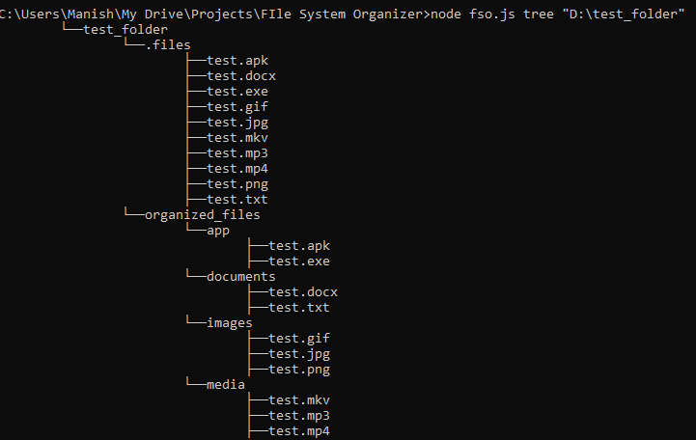

**Organize command**

Organize command will take a directory as an input then move each and every file in that folder in 5 categories(as of now)-

1. app

['apk’, 'exe']

2. documents

['txt' , 'doc' , 'docx']

3. images

['zip' , '7z' , 'rar' , 'iso']

4. media

['gif' , 'jpg' ,'jpeg', 'png' ]

5. Archives

['zip' , '7z' , 'rar' , 'iso']

These 5 categories are 5 folders which will be made(if not already present) inside a folder “organized files” inside the working directory.

All the files from the input directly will be moved from there to the “organized files” folder if their extension name will match from any of the extension from their respected folder in “organized files” folder.

Tree view before Organize Command

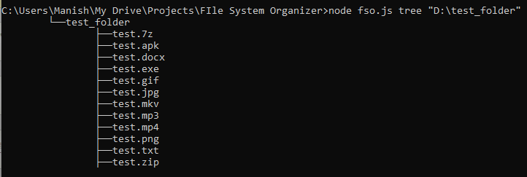

Tree view after Organize Command

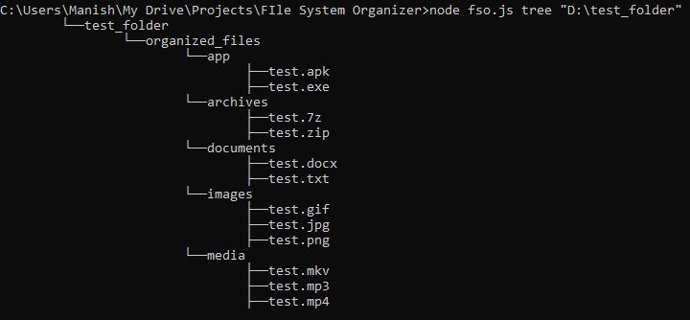

**Help Command**

Help command is a default command which can run even if a wrong input is given. This command shows all the possible commands which ae available to use in this script.

