AI / HCI Interactions and Synergies
Manish Basnet
2026 Summer - Artificial Intelligence for Human-Computer Interaction (MSAI-631-M90)
Dr. Dennis
May 2026

Introduction
Computers are no longer limited to laptops, desktops, or other devices that people traditionally recognize as computers. They are now embedded in daily activities such as making contactless payments, navigating with Google Maps, watching content on a Smart TV, and using AI chat tools for problem-solving. Human-Computer Interaction (HCI) is useful for understanding these experiences because it focuses on how interactive computing systems are designed, evaluated, and used by people. In this sense, the value of a computer system is not only determined by what it can process, but also by how efficiently, clearly, and confidently people can interact with it (Churchill et al., 2013).
Modern HCI is often multimodal. Instead of relying only on a keyboard or mouse, everyday interfaces now combine touch, speech, visual displays, sound, vibration, location data, image input, and sensor-based feedback. This is visible in smartphones that use touchscreens, GPS, notifications, and contactless payment systems; Smart TVs that combine remote controls, voice search, visual menus, and audio output; and AI chat systems that accept typed prompts, screenshots, files, and sometimes voice input. Multimodal interaction matters because different tasks require different forms of communication, and a well-designed system allows users to choose the most natural or efficient mode for the situation (Azofeifa et al., 2022).
AI has added another layer to HCI because computers are no longer only responding to fixed commands; they are increasingly interpreting user intent, generating suggestions, and helping users make decisions. Large language models and chat-based AI tools such as Gemini, Claude, and ChatGPT represent this shift because users can explain a problem in natural language, provide context through screenshots or files, and receive a response that supports troubleshooting, writing, analysis, or decision-making. However, AI/HCI also requires careful human judgment because AI-generated responses can be incomplete, uncertain, or incorrect. Therefore, effective human-AI interaction depends not only on the AI system’s capability, but also on how well the interface helps users understand, question, and verify its output (Yang et al., 2024).

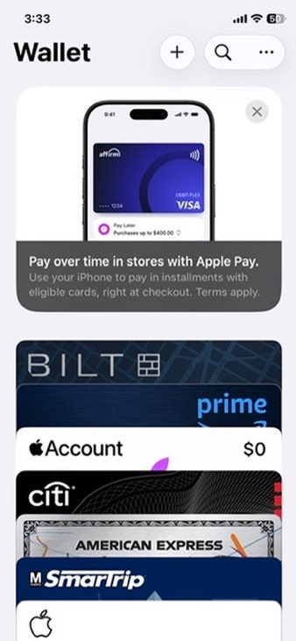
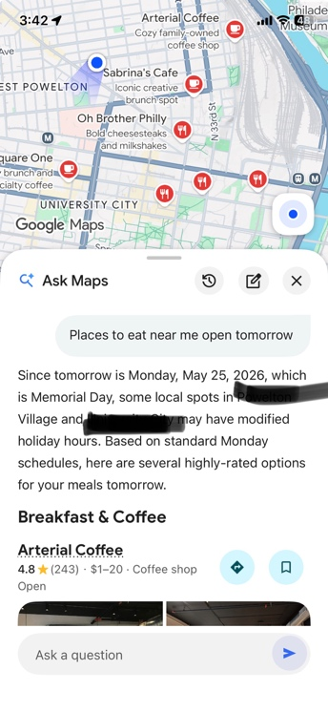

Case 1: The Smartphone

The smartphone is a strong example of multimodal HCI because a single task often involves multiple interaction modes. In the iPhone Wallet app, contactless payment combines touch or gesture activation, Face ID/passcode verification, near-field communication, visual confirmation, and often sound or vibration feedback. Google Maps adds another layer by combining typed or spoken queries, GPS location, map visuals, business data, and AI-assisted context. When asking Google Maps for “places to eat near me open tomorrow,” the system interprets location, time, and holiday-related business hours to warn that some places may have modified schedules.
The Weather app combines location data, visual icons, hourly forecasts, alerts, and temperature information to help users decide what to wear, when to travel, or whether to carry an umbrella. The Clock app is similarly important because alarms use audio, vibration, labels, repeat settings, and snooze controls to manage daily schedules. Its world clock feature also makes time-zone differences easier to understand when communicating across countries. These examples show that smartphone HCI is not only about complex apps; it also appears in small, repeated interactions that shape how people organize daily life.

Case 2: LLMs and AI Agents
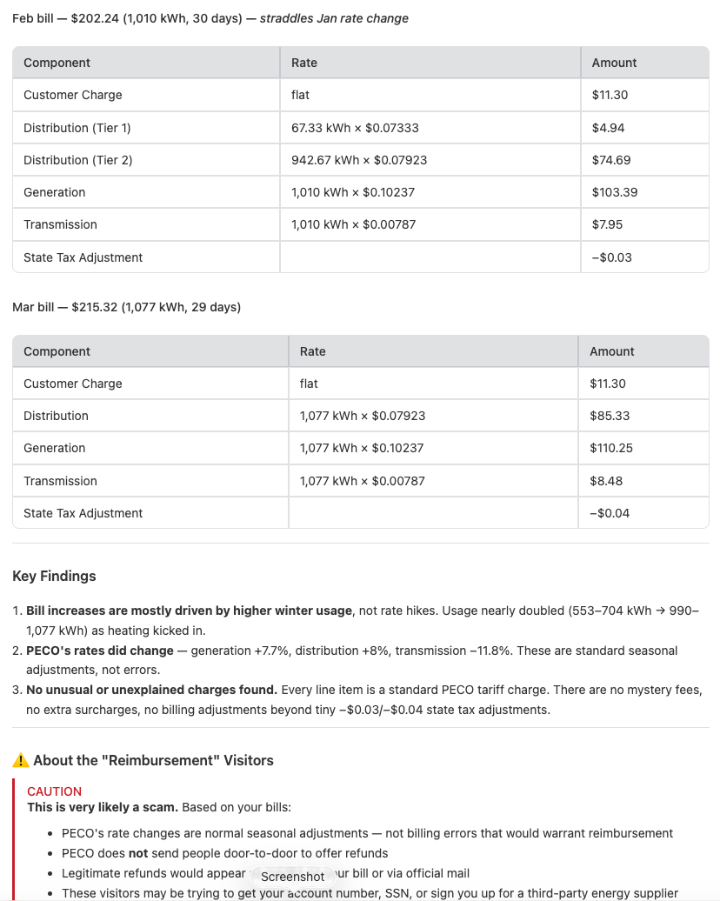


Large language models and AI agents show how HCI is shifting from fixed commands to context-based assistance. In Google’s AI Mode, asking for a battery replacement for a specific laptop model turns a technical search task into a conversational interaction: the user provides the model number, and the system interprets the request, searches relevant information, and summarizes likely replacement options.
The Antigravity example goes further. I had a salesman at my house claiming that my current electricity provider had increased its per-unit costs, encouraging me to switch to their company for savings. I asked Claude on Antigravity to validate whether this claim was true based on my past months’ bills. It came back with a dashboard showing that, while the bill had increased due to higher electricity consumption, it was not due to the rate changes. The interaction becomes a form of human-AI collaboration: the user defines the problem, the AI organizes the analysis, and the user evaluates whether the solicitor’s claim is supported by the data. These examples show both the usefulness and the responsibility of AI/HCI, because AI can reduce effort in technical troubleshooting and data analysis, but its output still needs to be checked against evidence before being trusted.
Case 3: Smart TV


The Smart TV is another everyday example of multimodal HCI because it combines physical remote control, voice input, visual menus, streaming apps, and audio output. In this case, voice search is useful because typing a long movie title, such as The Perks of Being a Wallflower, with a TV remote is slow and inconvenient, especially when an individual app like Peacock does not provide its own voice search feature on the TV operating system. This shows how interface design can reduce friction in ordinary entertainment tasks. It also shows how smart TVs function as embedded computing systems. They are not general-purpose computers like laptops, but they still process user input, search across apps, display results, and support AI-assisted recommendations within a home entertainment environment.

References
Azofeifa, J. D., Noguez, J., Ruiz, S., Molina-Espinosa, J. M., Magana, A. J., & Benes, B. (2022). Systematic Review of Multimodal Human–Computer Interaction. Informatics, 9(1), 13. https://doi.org/10.3390/informatics9010013
Churchill, E. F., Bowser, A., & Preece, J. (2013). Teaching and learning human-computer interaction. Interactions, 20(2), 44–53. https://doi.org/10.1145/2427076.2427086
Yang, D., Wu, S. T., & Hearst, M. A. Human-AI Interaction in the Age of LLMs. 5, 34–38.
Credit to ChatGPT for providing the search queries to find the relevant sources.

