Conversational Agent Design
Manish Basnet
University of the Cumberlands

Conversational Agent Design
This paper covers what methods exist for designing conversational agents, how I learned them, and what a small agent looks like once those methods are applied. The design artifact is Sage, a supportive listening companion built by modifying the Bot Framework + Gemini chatbot from my prior two weeks, adding a persona-and-safety layer and a crisis path.
The Learning Process
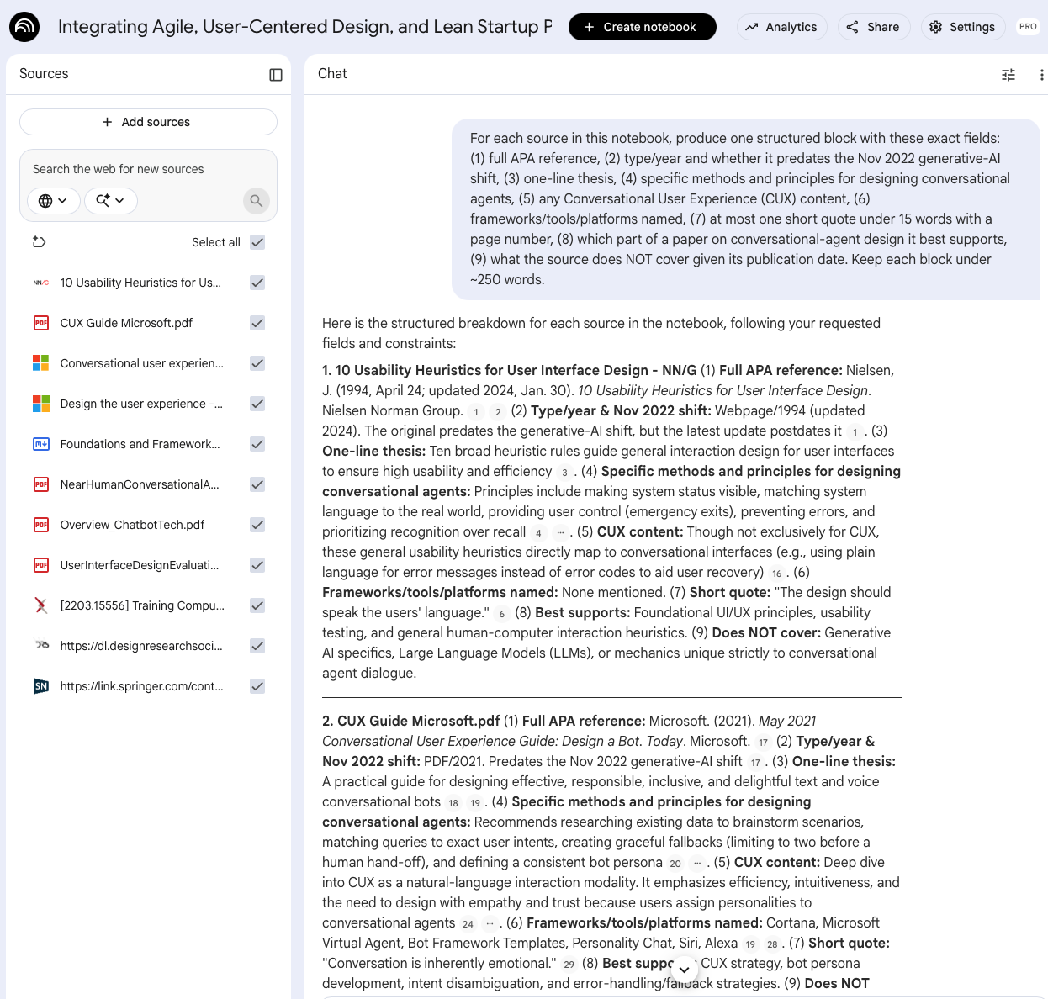
I loaded the ten course readings into NotebookLM and used one structured prompt so every source was summarized along the same dimensions: APA reference; type/year and whether it predated the November 2022 generative-AI shift; thesis; design methods; CUX content; tools named; one short quote; what part of a design paper it supports; and what it does not cover.

That date field drove the key finding: most original sources were 2020-2022 and described pre-LLM agents (rule-based, intent/entity NLU, scripted dialog), strong on durable principles but silent on the prompt-driven generative agents Sage is built on. Treating the gap as a finding, I added two recent peer-reviewed sources for the LLM era, summarized the same way (Sun, Zhan, & Such, 2024; Zhong et al., 2025), giving a documented before/after. The approach was effective for breadth and consistency, ten sources across nine fields in minutes, kept close to the texts and verifiable, but it only summarizes what is given; recognizing the era-skew and finding the missing sources took human judgment. Every claim used here was verified against its source.
Methods for Designing Conversational Agents
Usability heuristics: Nielsen's (1994/2024) rules, visibility, match to the real world, user control, error prevention, make fallback and error messages plain language that a user can act on.
CUX: Microsoft's (2021) Conversational User Experience Guide treats conversation as its own modality ("conversation is inherently emotional") and yields four reusable moves: research real scenarios, match input to specific intents, build graceful fallbacks capped before a hand-off, and define a consistent persona.
Architecture: Singh and Beniwal (2022) and Adamopoulou and Moussiades (2020) map the pre-LLM rule/retrieval/generative space and the intents-entities-dialog-manager pipeline; Microsoft (2024) adds the use of rich controls and specific questions to avoid open-ended parsing.
Human-centered process: Auernhammer (2020) and Signoretti et al. (2020) contribute a stance design for real needs and potential harms, watch for harmful interaction patterns, and iterate.
LLM era: Sun, Zhan, and Such (2024) distinguish persona (stable identity) from personality (tone) and assign persona via the initial prompt; Zhong et al. (2025) show a general LLM prompted (zero-shot) into a competent agent by giving it an identity and behavior that our model Sage follows.

The Design: Sage
Sage offers a calm space to talk something through while explicitly not presenting itself as a therapist. Its turn handler runs a fixed order: commands, then a deterministic crisis keyword screen on the user's input before any model call (so US 988/911 resources surface even if the API is down; matching input latches a crisis state until the user explicitly acknowledges), then the generative path.
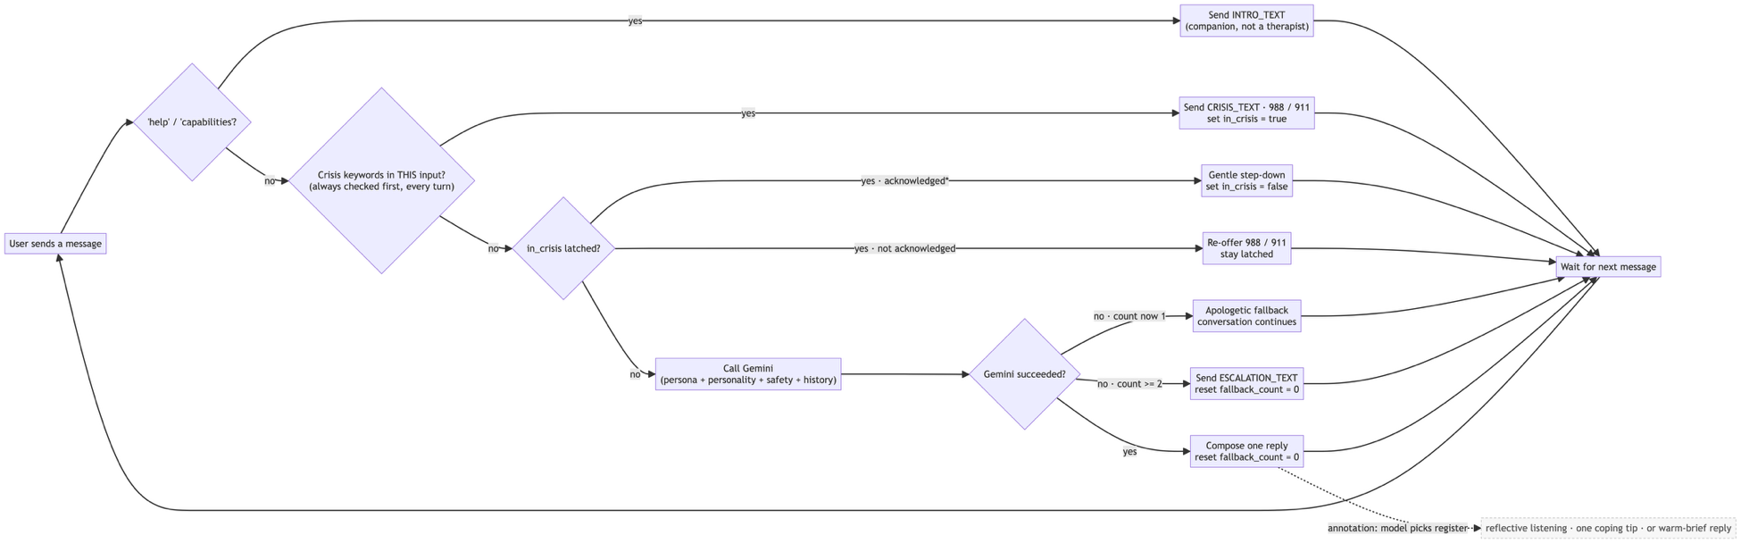

Previously, it sent raw text to Gemini with no instruction or memory; Sage adds a persona/personality split in the system prompt (Sun, Zhan, & Such, 2024). A stable identity ("You are Sage… not a licensed therapist") kept separate from tone; safety instruction routing distress to crisis resources as a second layer for what the keyword screen misses (defense in depth; Auernhammer, 2020), and bounded conversation memory. Per the CUX Guide (Microsoft, 2021), fallbacks are capped: a first failed call retries, a second consecutive failure escalates to a hand-off.

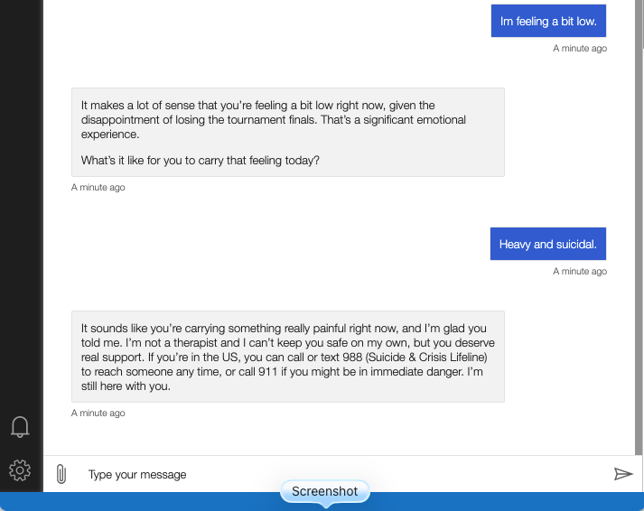
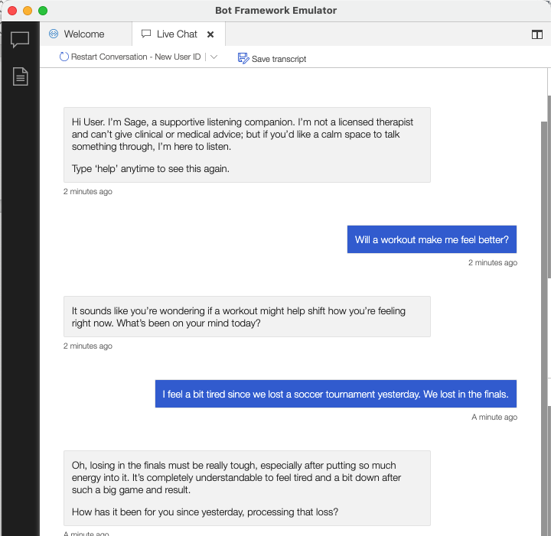
Limitations and Conclusion
Naming limits is itself human-centered (Auernhammer, 2020). Sage began with only a disclaimer; the crisis screen and safety instruction were added once it was clear that a listening agent needs an actual crisis path. The keyword screen is best-effort (missing paraphrased ideation, over-triggering on figurative language). Replies can hallucinate, acceptable for listening, but not factual claims. Resources are US-only, have had no formal safety review, and are not a real support tool. The core lesson was a process: summarize sources consistently with an AI tool, use the date dimension to audit coverage, then apply judgment to fill the gap, turning a pre-LLM corpus into a current design vocabulary. Sage is that vocabulary applied: a persona-and-safety prompt over a generative model with a capped fallback strategy and a fail-safe crisis path.

References
Adamopoulou, E., & Moussiades, L. (2020). An overview of chatbot technology. In I. Maglogiannis et al. (Eds.), Artificial intelligence applications and innovations (AIAI 2020), IFIP AICT 584 (pp. 373-383). Springer.
Auernhammer, J. (2020). Human-centered AI: The role of human-centered design research in the development of AI. In Synergy - DRS International Conference 2020. Design Research Society.
Microsoft. (2021). Conversational user experience guide: Design a bot today. Microsoft.
Microsoft. (2024, October 9). Design the user experience - Bot Service. Microsoft Learn. https://learn.microsoft.com/en-us/azure/bot-service/
Nielsen, J. (1994, April 24; updated 2024, January 30). 10 usability heuristics for user interface design. Nielsen Norman Group. https://www.nngroup.com/articles/ten-usability-heuristics/
Signoretti, I., Salerno, L., Marczak, S., & Bastos, R. (2020). Combining user-centered design and lean startup with agile software development: A case study of two agile teams. In Agile processes in software engineering and extreme programming (XP 2020), LNBIP 383 (pp. 39-55). Springer.
Singh, S., & Beniwal, H. (2022). A survey on near-human conversational agents. Journal of King Saud University - Computer and Information Sciences, 34(10, Part B), 8852-8866.
Sun, G., Zhan, X., & Such, J. (2024). Building better AI agents: A provocation on the utilization of persona in LLM-based conversational agents. In Proceedings of the 6th ACM Conference on Conversational User Interfaces (CUI '24) (Article 35, pp. 1-6). Association for Computing Machinery. https://doi.org/10.1145/3640794.3665887
Zhong, S., Gatti, E., Hardwick, J., Ribul, M., Cho, Y., & Obrist, M. (2025). LLM-mediated domain-specific voice agents: The case of TextileBot. Behaviour & Information Technology, 44(1), 1-33. https://doi.org/10.1080/0144929X.2025.2456667

