How to access google drive into Ubuntu 18.04

Prerequist:
-should have google drive account
-should have login in online account in ubuntu gnome , if you enter window sign button + A and will search online account ,there you should have add microsoft account

sudo apt-get install gnome-control-center

or
this may be you already have in your system ,if not no worries -

sudo apt install gnome-online-accounts

this will take you online ,give some permission and you will be ok to go-

gnome-control-center online-accounts

gnome-online-accounts
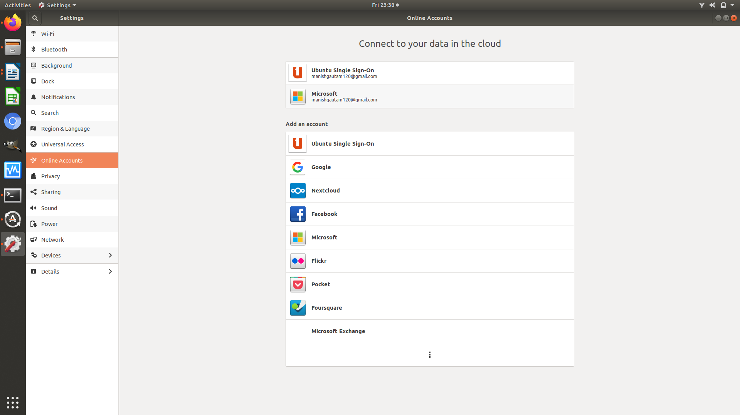

by using ppa you will be going to download repository from internet make sure internet is well connected-

sudo add-apt-repository ppa:alessandro-strada/ppa

sudo update is used for system to update missing packages-

sudo apt-get update

installing google drive into our system-

sudo apt-get install google-drive-ocamlfuse

this will allow us to use google drive ,some permission you have to allow between the process, make sure you are in right path -
google-drive-ocamlfuse

creating one folder to have all our file into one place to make secure-

mkdir ~/gdrive
you can find folder in home directory

this is usefull command to to view all google drive file into folder -

google-drive-ocamlfuse ~/gdrive

If you unmount file from the system, whenever you feel there are no file you want to access right now you can unmount the file and again by mounting file would be display,above command is use for mounting purpose and for veiwing purpose-

sudo umount ~/gdrive

above two command is use whenever you want to see and not to see
google-drive-ocamlfuse ~/gdrive

sudo umount ~/gdrive

All the best !!!
written by -Darkness
manishgautam120@gmail.com

