https://medium.com/@RobertKhou/how-to-migrate-from-bitbucket-to-github-75c87a892767

How to migrate from Bitbucket to GitHub
We have been happily using Bitbucket over the last years. But as more and more tools offer better out-of-the-box integration with Gitub, we increasingly move our repositories over to Github.
Here are the steps to move a Git repository:

Step 1: Create Github repository
First, create a new private repository on Github.com. It’s important to keep the repository empty, e.g. don’t check option Initialize this repository with a README when creating t
he repository.

Step 2: Move existing content
Next, we need to fill the Github repository with the content from our Bitbucket repository:
- Check out the existing repository from Bitbucket
$ git clone https://USER@bitbucket.org/USER/PROJECT.git
2. Add the new Github repository as upstream remote of the repository checked out from Bitbucket
$ cd PROJECT
$ git remote add upstream https://github.com:USER/PROJECT.git
3. Push all branches
$ git push upstream master
$ git push --tags upstream

Step 3: Clean up old repository
Delete the bitbucket repository.
- Git
- Github
- Bitbucket
- Migration
- Software Development

How to move private repositories from Github to Bitbucket

https://befused.com/git/github-bitbucket-move

How to move private repositories from Github to Bitbucket
Github is a great service and remains the epicentre of open source code. But for a single developer paying for private repositories, its payment plans don't make a lot of sense. This is because they charge by the number of repositories you have. I tend to have quite a few small private repos for various projects, so the cost creeps up pretty quick. I have absolutely no objection paying Github for private repos, but the pricing structure does need to be sensible.
Bitbucket's pricing structure makes a lot more sense. They charge by the number of users, rather than repositories. As a bonus, it is free for up to 5 users. And you get unlimited repositories, a price increase is only triggered by an increase in the number of users. This makes a lot more sense than charging my repositories because it better reflects the size of the organisation. A large organisation with more users will pay more, a smaller organisation with less users will pay less and a single developer will pay nothing without being constrained by the number of repositories. Makes sense right?
Like I said before, I don't mind paying. The fact that bitbucket give it to me for free is a bonus.

Moving repos from Github to Bitbucket
Now down to the meat of this post - how to actually move your private repositories from Github to Bitbucket!

Import from Github to Bitbucket
- In Bitbucket on the top menu, click Repositories and then Import Repository 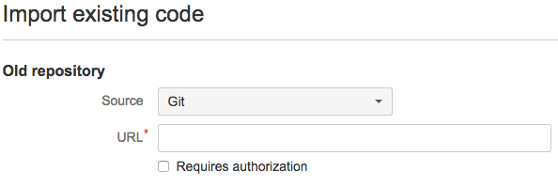
- Select Git
- Select 'Require Authentication'. Add the username and password from your github account. Note: You will get an authentication denied error anyway, which you can ignore.
- Copy the URL from your Github account. This should be https://github.com/USERNAME/REPONAME.git. This can be found in the right hand column under HTTPS 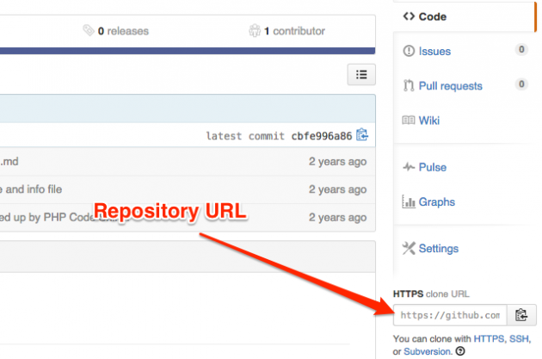
- Add the URL you copied in step 4 to URL field in Bitbucket
- The fields under New repository will be automatically filled in, including the Name. If you want to change the name and add a description, you can do so here. 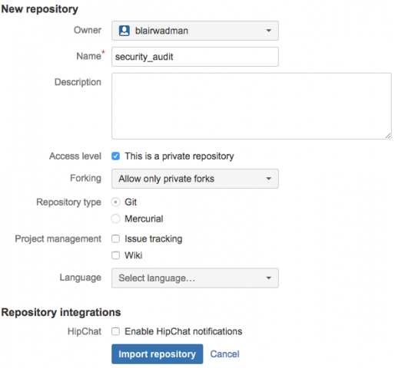
- Click import repository.

Change the origin URL
- Go to the repository on your local machine on the command line
- Type: git remote -v. This should show that the repo origin is still on github. E.g.
origin https://USERNAME@github.com/USERNAME/REPONAME.git (fetch)
origin https://USERNAME@github.com/USERNAME/REPONAME.git (push)
- Edit the git config file for the repository: sudo nano .git/config
- Change url (under remote "origin") and change github.com to bitbucket.com. You may need to change the username if your username is different on bitbucket. You should also change it to the git URL. i.e. git@bitbucket.org:USERNAME/REPONAME.git

Delete Github repository
Once you are happy that everything is working correctly with Bitbucket, it is time to delete the repository from Github.
- Go to the repo
- Go to settings 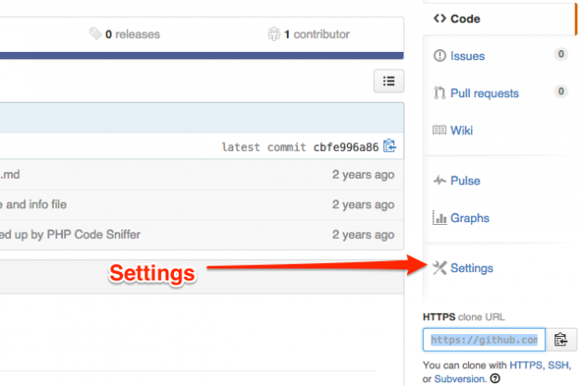
- Under the Danger zone tab, click delete this repo

Downgrade your plan
Now that you have your repository safely on Bitbucket, and you have it deleted from Github, it is time to save some money and downgrade your Github plan to the free one.
- Go to settings for your account. Go to billing tab. Click on change plan tab. Downgrade to free account.

Repeat
Repeat for all of your private repos.
That is all there is to it! If you have never used Bitbucket before, it is a good idea to do this for one repository first and ensure you are happy with Bitbucket before you switch everything over.

