How to Install Skype on Ubuntu 18.04

Skype is one of the most popular communication applications in the world that allows you to make free online audio and video calls, and affordable international calling to mobiles and landlines worldwide.

Prerequisites
The user you are logged in as must have sudo privileges to be able to install packages.Installing Skype on Ubuntu
Complete the following steps to install Skype on Ubuntu.

1. Download Skype
Open your terminal either by using the Ctrl+Alt+T keyboard shortcut or by clicking on the terminal icon.
Download the latest Skype .deb package using the following wget command:
wget https://go.skype.com/skypeforlinux-64.deb
Copy

2. Install Skype
Once the download is complete, install Skype by running the following command as a user with sudo privileges:
sudo apt install ./skypeforlinux-64.deb
Copy
You will be prompted to enter your password. The output will look something like this:
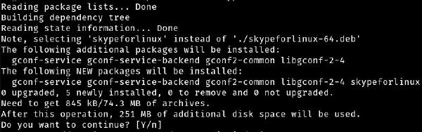

3. Start Skype
Now that you have Skype installed on your Ubuntu desktop, you can start it either from the command line by typing skypeforlinux or by clicking on the Skype icon (Activities -> Skype):
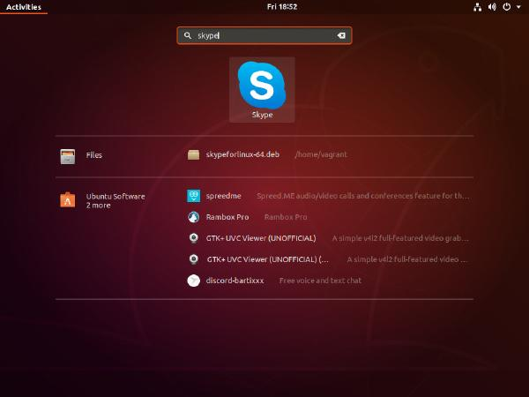
When you start Skype for the first time, a window like the following will appear:

From here you can sign in to Skype with your Microsoft Account and start chatting and talking with your friends and family.

Updating Skype
During the installation process, the official Skype repository will be added to your system. Use the cat command to verify the file contents:
cat /etc/apt/sources.list.d/skype-stable.list
Copy
deb [arch=amd64] https://repo.skype.com/deb stable main
Copy
This ensures that your Skype installation will be updated automatically when a new version is released through your desktop standard Software Update tool.

Conclusion

