

Copyright © Seán Kennedy

Working with Selected
Classes from the Java API
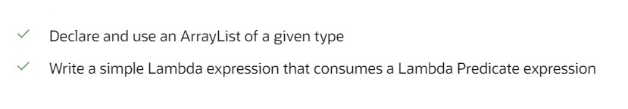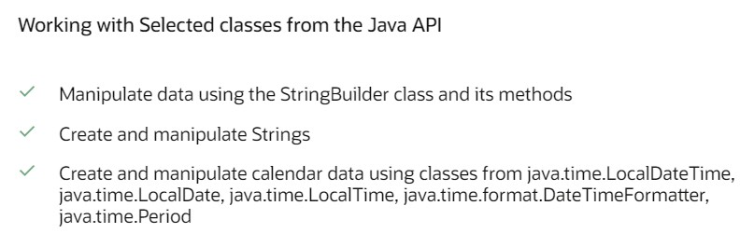Working with Selected Classes from the Java API

Java 8 OCA (1Z0-808)

2

Copyright © Seán Kennedy
Interfaces

• In general, when you create an interface, you are defining a contract for what a class can do; without saying anything about how the class will do it.

• A class “signs” the contract with the keyword implements.

• When implementing an interface, you are agreeing to
adhere (obey) to the contract defined in the interface.

• If a concrete (non-abstract) class is implementing an interface, the compiler will ensure that the class has implementation code for each abstract method in the interface.
3

Copyright © Seán Kennedy
Interfaces

• Whereas a class can extend from only one other class, a class can implement many interfaces.
➢class Dog extends Animal implements Moveable, Loveable
➢ a Dog “is-a” : Animal, Moveable and Loveable

➢As of Java 8, it is now possible to inherit concrete methods from interfaces. Interfaces can now contain two types of concrete methods: static and default.
➢ Implementation classes are NOT required to implement an interface’s static or default methods. The default interface methods are inheritable but the static interface methods are not.

4

Copyright © Seán Kennedy
Interfaces

• Interfaces themselves are implicitly abstract
• public abstract interface I{} ⬄ public interface I
• top-level interfaces can have public or package-private access

• All interface methods are implicitly public

5

Copyright © Seán Kennedy
Interfaces

• All interface methods are implicitly abstract (unless declared as default or static, the new features introduced in Java 8).

• All variables declared in an interface must be public, static and final i.e. interfaces can only declare constants (not instance variables).

• As with abstract classes you cannot new an interface type but they can be used as references:
• Printable p = new Printer(); // Printable is an
interface
6

Copyright © Seán Kennedy
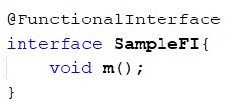Functional Interfaces

• A functional interface is an interface that has only one abstract method. This is known as the SAM (Single Abstract Method) rule.
• default methods do not count
• static methods do not count
• methods inherited from Object do not count*

7

Copyright © Seán Kennedy
Lambdas

• A lambda expression is just a block of code that
helps in making your code more concise.

• A lambda expression only works with functional
interfaces.

• A lambda expression is an instance of a class that
implements a functional interface.

8

Copyright © Seán Kennedy
Lambdas

• Lambdas look a lot like methods and in some quarters are called “anonymous methods”. However, it is an instance with everything but the method stripped away.

• A lot can be inferred (by the compiler) from the interface definition (which remember, has only one abstract method). The lambda expression is the instance that implements the interface that has been boiled down to the bare essentials.

9

Copyright © Seán Kennedy
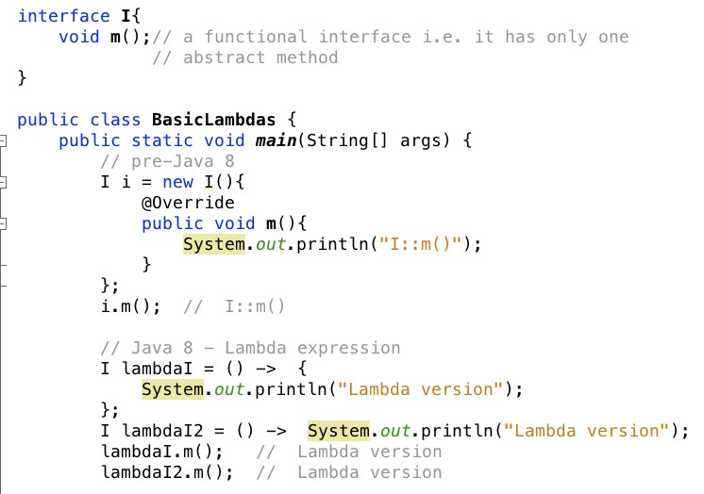

Method code.

10

Copyright © Seán Kennedy

