

Copyright © Seán Kennedy

Working with Streams
and Lambda Expressions

Method References
Method References

• Lambda expressions help in making your code more
concise (fewer keystrokes).

• Method references, can, in certain situations, help in
making your lambda expressions even more concise.

• If all your lambda expression does is call one method,
then that is an opportunity to use a method reference.

• If a lambda parameter is simply passed to another method, then the redundancy of specifying the variable twice can be removed.

2

Copyright © Seán Kennedy
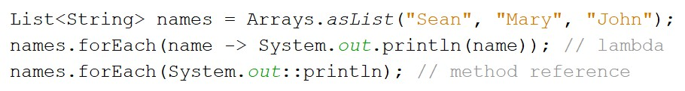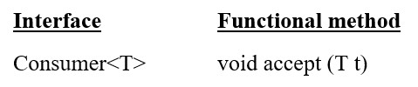Method References

3

Copyright © Seán Kennedy
Method References

• There are four different styles/types:
1. Bound – instance known at compile-time
2. Unbound – instance provided at runtime
3. Static
4. Constructor

• With method references, context is key!
• the functional interface type being created is hugely important
in determining context.

• The compiler turns your method references into lambdas
in the background.

4

Copyright © Seán Kennedy

