

Copyright © Seán Kennedy

Streams

Introduction and Stream Pipelines
What is a Stream?

• Like lambdas and functional interfaces, streams were another new addition in Java 8.

• A stream is a sequence of data that can be processed with
operations.

• Streams are not another way of organising data, like an array or a Collection. Streams do not hold data; streams are all about processing data efficiently.

2

Copyright © Seán Kennedy
What is a Stream?

• While streams make code more concise, their big advantage is that streams, by using a pipeline, can, in certain situations, greatly improve the efficiency of data processing.

• The real power of streams comes from the multiple
intermediate operations you can perform on the stream.

3

Copyright © Seán Kennedy
The Pipeline

• A stream pipeline consists of the operations that run on a
stream to produce a result.

• There are 3 parts to a stream pipeline:

a) Source – where the stream comes from e.g. array, collection or file.
b) Intermediate operations – transforms the stream into another one. There can as few or as many as required.
c) Terminal operation – required to start the whole process and produces the result. Streams can only be used once i.e. streams are no longer usable after a terminal operation completes (re-generate the stream if necessary).

4

Copyright © Seán Kennedy
The Pipeline

• filter() is an intermediate operation and as such can filter the stream and pass on the filtered stream to the next operation (another intermediate operation or a terminal operation).

• count() and forEach() are both terminal operations that
end the stream.

• The pipeline operations are the way in which we specify how and in what order we want the data in the source manipulated. Remember, streams don’t hold any data.

5

Copyright © Seán Kennedy
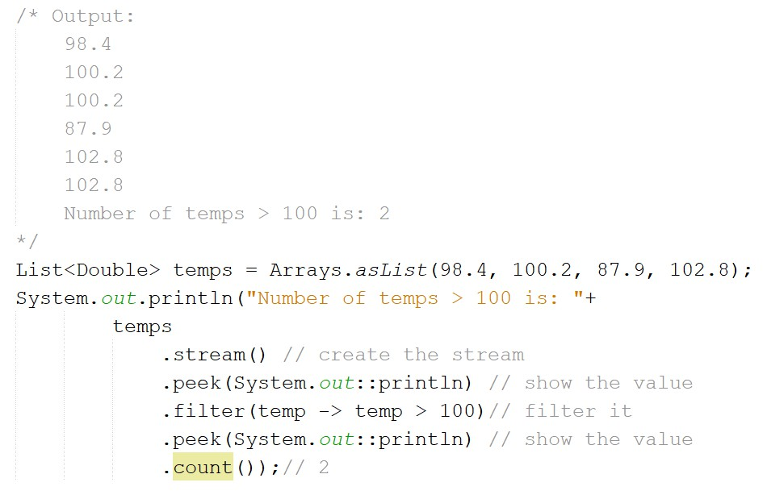The Pipeline

6

Copyright © Seán Kennedy

Copyright © Seán Kennedy

Streams

Streams are Lazy
Streams are Lazy

• The principle of “lazy” evaluation is that you get what you need only when you need it. For example, if you were displaying 10,000 records to a user, the principle of lazy evaluation would be to retrieve 50 and while the user is viewing these, retrieve another 50 in the background.

• “Eager” evaluation would be to retrieve all 10,000
records in one go.

• With regard to streams, this means that nothing happens until the terminal operation occurs.

8

Copyright © Seán Kennedy
Streams are Lazy

• The pipeline specifies what operations we want
performed (on the source) and in which order.

• This enables the JDK to reduce operations whenever possible.

• For example, why run an operation on a piece of data if the operation is not required:
➢we have found the data element we were looking for

➢we may have a limit set on the number of elements we want to operate on

9

Copyright © Seán Kennedy
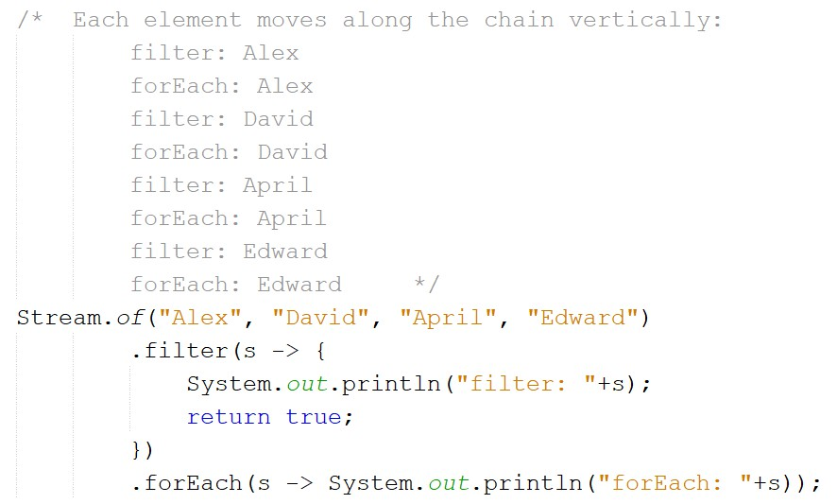

Streams are Lazy

10

Copyright © Seán Kennedy
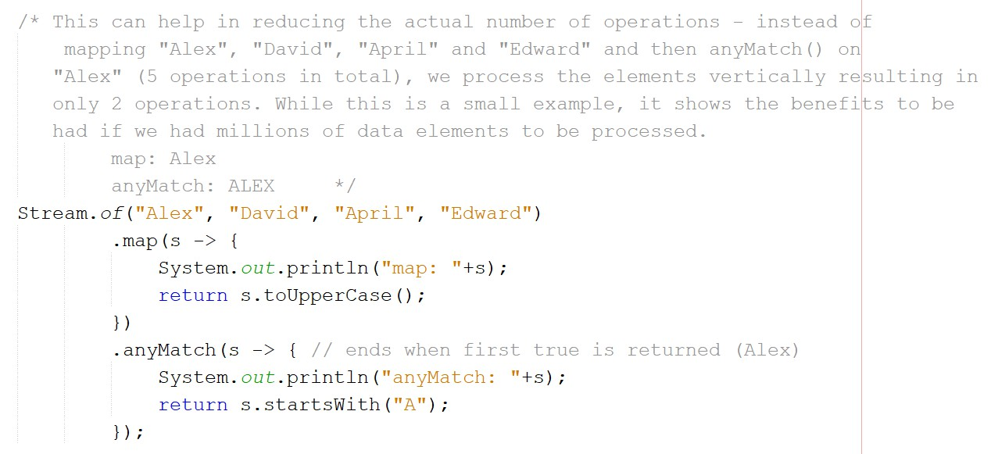

Streams are Lazy

11

Copyright © Seán Kennedy
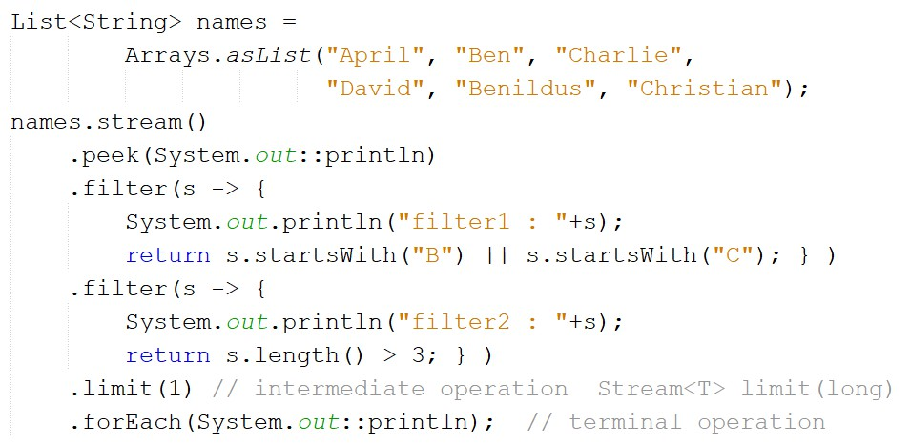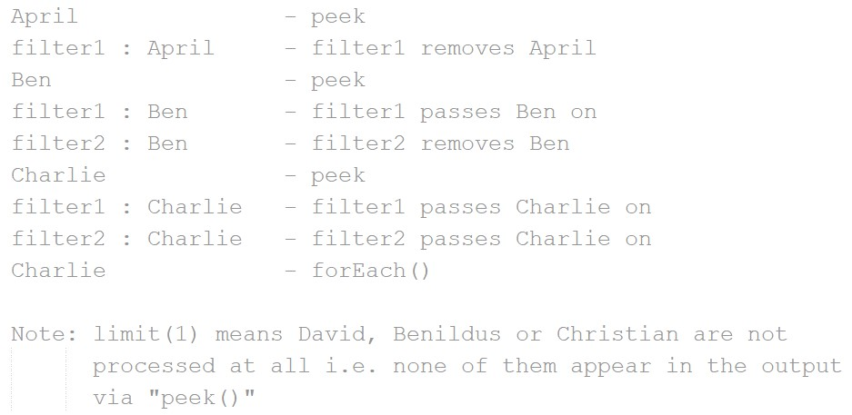Streams are Lazy

12

Copyright © Seán Kennedy

