

Copyright © Seán Kennedy

Streams

Terminal Operations
Terminal Operations

• Terminal operations can be performed without any
intermediate operations but not the other way around.

• Reductions are a special type of terminal operation where all of the contents of the stream are combined into a single primitive or Object (Collection).

• We will have a look at the most common ones over the coming slides. Note that the comments in the code are very important.

2

Copyright © Seán Kennedy
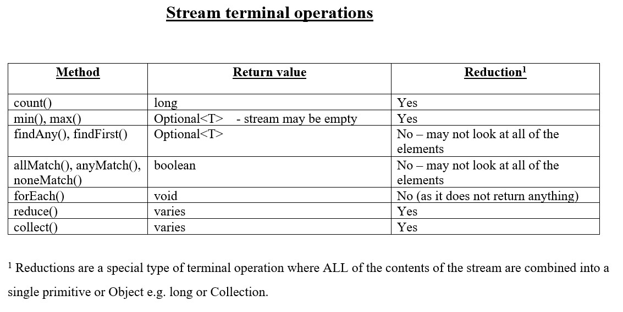

3

Copyright © Seán Kennedy
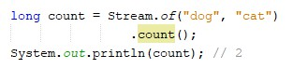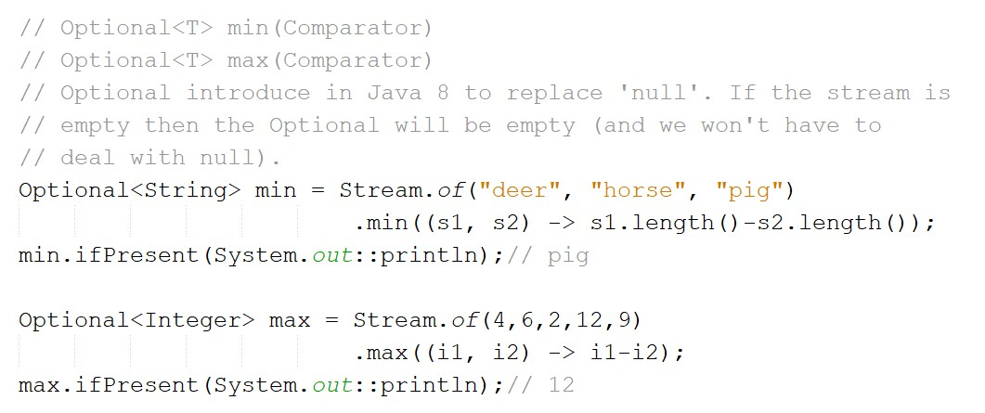Terminal Operations
count(), min(), max()

4

Copyright © Seán Kennedy
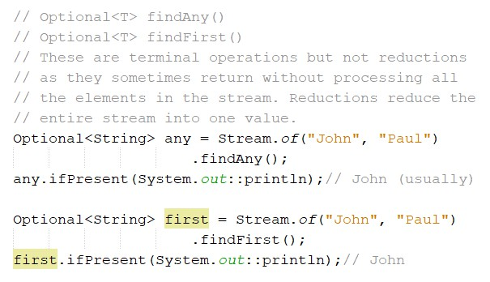Terminal Operations
findAny(), findFirst()

5

Copyright © Seán Kennedy
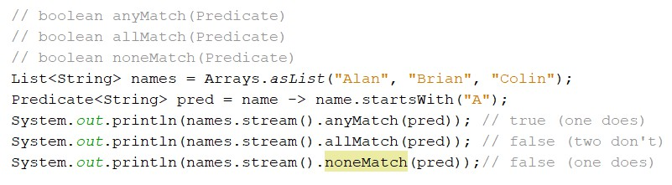Terminal Operations
anyMatch(), allMatch(), noneMatch()

6

Copyright © Seán Kennedy
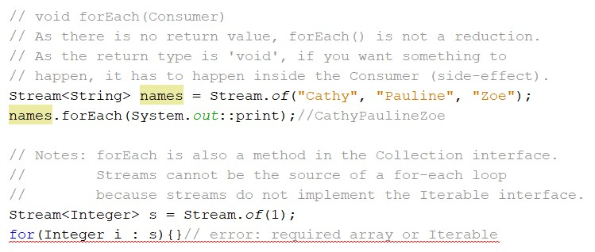Terminal Operations
forEach()

7

Copyright © Seán Kennedy
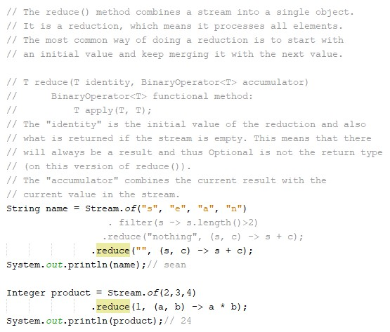

Terminal Operations
reduce()

8

Copyright © Seán Kennedy
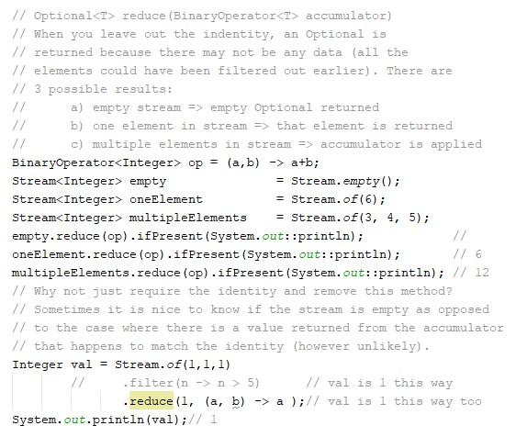

Terminal Operations
reduce()

9

Copyright © Seán Kennedy
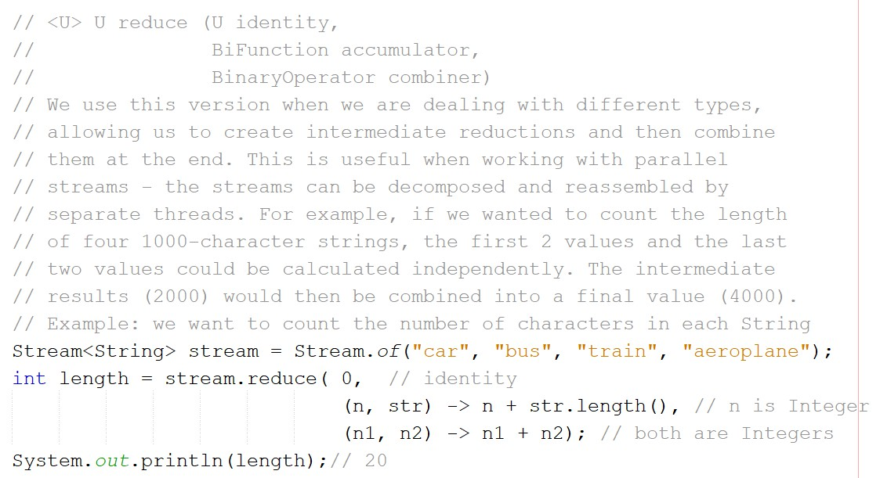Terminal Operations
reduce()

10

Copyright © Seán Kennedy
Terminal Operations
collect()

• This is a special type of reduction called a mutable reduction because we use the same mutable object while accumulating. This makes it more efficient than regular reductions.

• Common mutable objects are StringBuilder and
ArrayList.

11

Copyright © Seán Kennedy
Terminal Operations
collect()

• It is a really useful method as it lets us get data out of
streams and into other forms e.g. Map’s, List’s and Set’s.

• There are two versions. We will look at one version now but later on, we will look at the more important one (the one that works with pre-defined collectors).

12

Copyright © Seán Kennedy
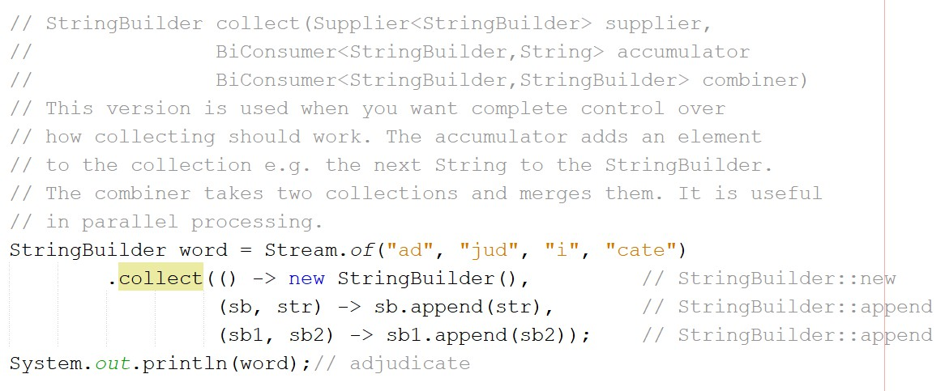Terminal Operations
collect()

13

Copyright © Seán Kennedy

