

Copyright © Seán Kennedy

Streams

Terminal Operations collect() using API Collectors
Terminal Operations
collect() – using API-defined Collectors

• Now we will look at the other version collect() – the one that accepts pre-defined collectors from the API.

• We access these collectors via static methods on the
Collectors interface.

• It is important to pass the Collector to the collect() method
➢a Collector does not do anything on it’s own. It exists to
help collect elements.

2

Copyright © Seán Kennedy
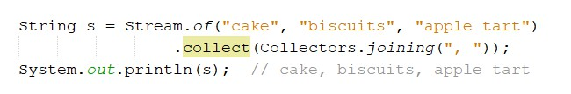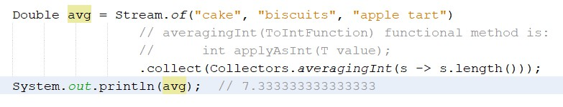Terminal Operations
collect(Collector)

3

Copyright © Seán Kennedy
Terminal Operations
Collectors.toMap()

• Collecting into Maps:
➢two Functions required: the first function tells the collector how to create the key; the second function tells the collector how to create the value.

1 of 3
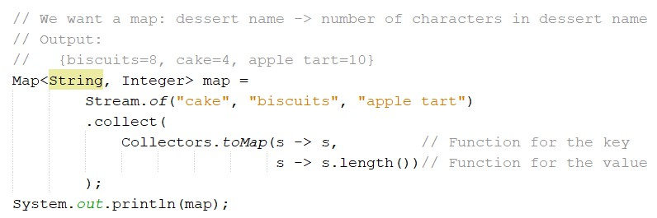

4

Copyright © Seán Kennedy
Terminal Operations
Collectors.toMap() – opposite of previous example

2 of 3
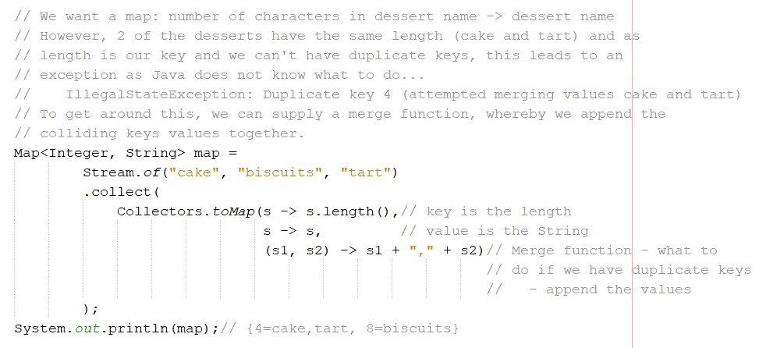

5

Copyright © Seán Kennedy
Terminal Operations
Collectors.toMap()

3 of 3
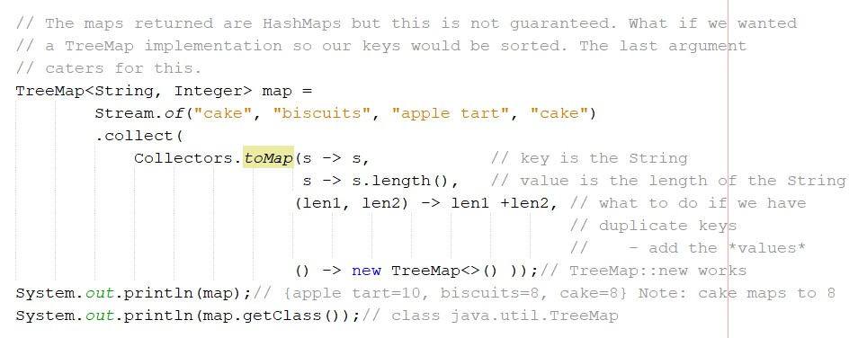

6

Copyright © Seán Kennedy
Terminal Operations
Collectors.groupingBy()

• groupingBy() tells collect() to group all of the elements into
a Map.

• groupingBy() takes a Function which determines the keys in
the Map.

• Each value is a List of all entries that match that key. The
List is a default, which can be changed.

1 of 3

7

Copyright © Seán Kennedy
Terminal Operations
Collectors.groupingBy()

1 of 3
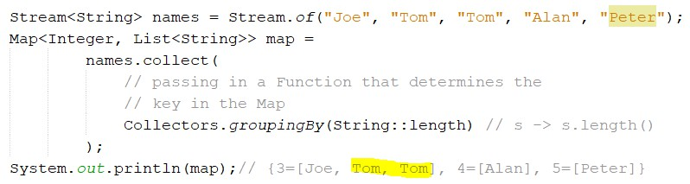

8

Copyright © Seán Kennedy
Terminal Operations
Collectors.groupingBy()

• What if we wanted a Set instead of a List as the value in the
map (to remove the duplication of “Tom”) ?

• groupingBy() is overloaded to allow us to pass down a “downstream collector”. This is a collector that does something special with the values.

2 of 3
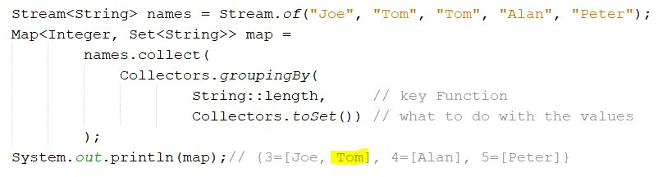

9

Copyright © Seán Kennedy
Terminal Operations
Collectors.groupingBy()

• There are no guarantees on the type of Map returned.

• What if we wanted to ensure we got back a TreeMap but leave the values as a List? We can achieve this by using the (optional) map type Supplier while passing down the toList() collector.

3 of 3
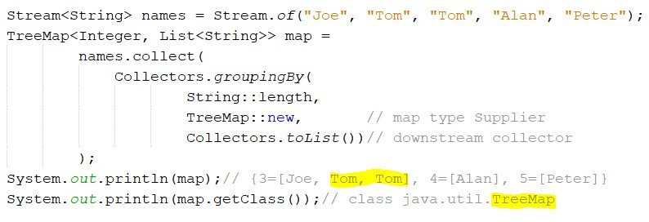

10

Copyright © Seán Kennedy
Terminal Operations
Collectors.partitioningBy()

• Partitioning is a special case of grouping where there are
only two possible groups – true and false.

• The keys will be the booleans true and false.

1 of 4
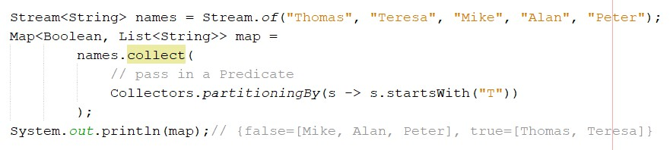

11

Copyright © Seán Kennedy
Terminal Operations
Collectors.partitioningBy()

2 of 4
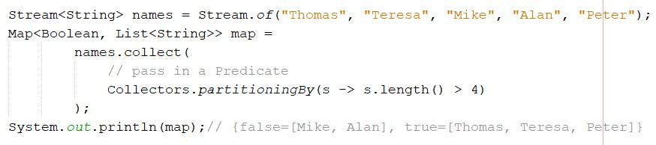

12

Copyright © Seán Kennedy
Terminal Operations
Collectors.partitioningBy()

3 of 4
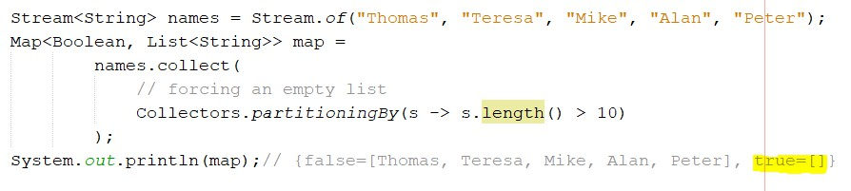

13

Copyright © Seán Kennedy
Terminal Operations
Collectors.partitioningBy()

• As with groupingBy(), we can change the values type from
List to Set.

4 of 4
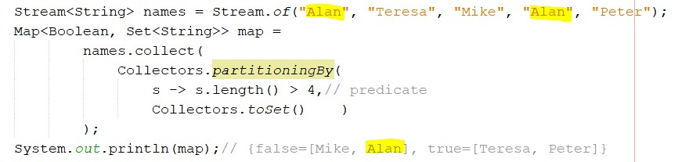

14

Copyright © Seán Kennedy

