

Copyright © Seán Kennedy

Streams

Intermediate Operations
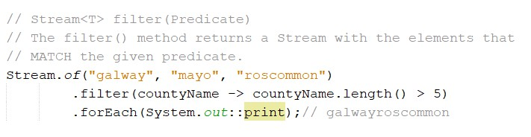Intermediate Operations
filter()

• Unlike a terminal operation, an intermediate operation produces a stream as a result.

2

Copyright © Seán Kennedy
Intermediate Operations
distinct()

• distinct() returns a stream with duplicate values removed.
• equals() is used i.e. case sensitive.

• distinct() is a stateful intermediate operation.
• it behaves like a filter – if it has not seen the object previously, it passes it on and remembers it; if it has seen it already, it filters it out.

3

Copyright © Seán Kennedy
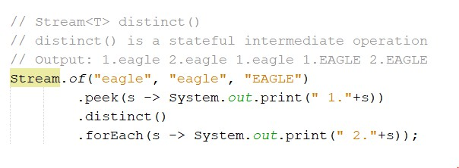Intermediate Operations
distinct()

4

Copyright © Seán Kennedy
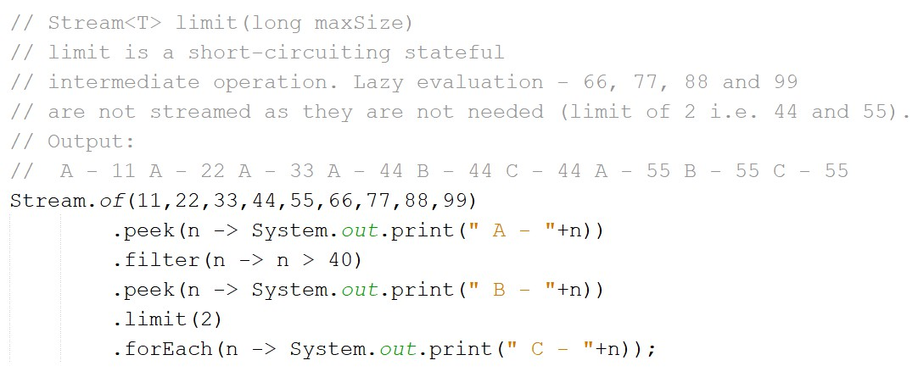Intermediate Operations
limit()

• limit() is a short-circuiting stateful intermediate operation.

5

Copyright © Seán Kennedy
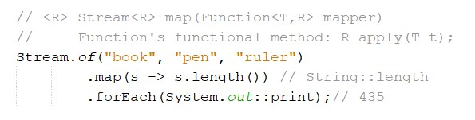Intermediate Operations
map()

• map() creates a one-to-one mapping between elements in the stream and elements in the next stage of the stream.

• map() is for transforming data.

6

Copyright © Seán Kennedy
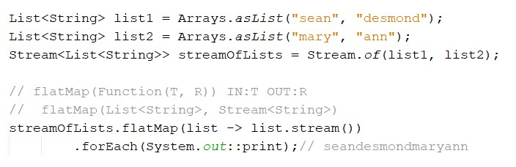Intermediate Operations
flatMap()

• flatMap() takes each element in the stream
e.g. Stream<List<String>> and makes any elements it contains
top-level elements in a single stream e.g. Stream<String>.

7

Copyright © Seán Kennedy
Intermediate Operations
sorted()

• sorted() returns a stream with the elements sorted.

• Just like sorting arrays, Java uses natural ordering unless we
provide a comparator.

• sorted() is a stateful intermediate operation; it needs to see all of the data before it can sort it.

8

Copyright © Seán Kennedy
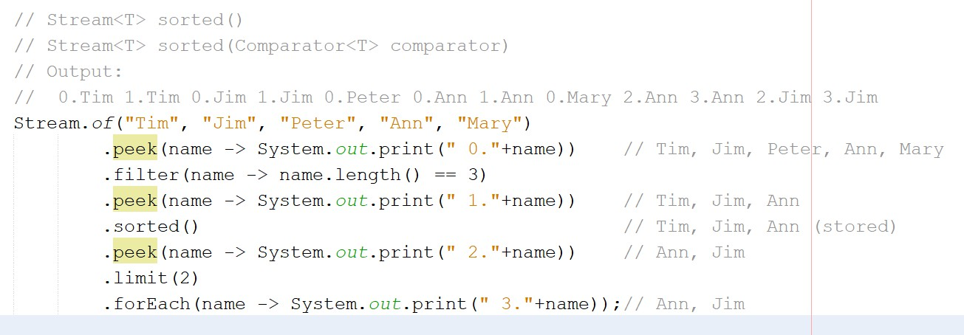Intermediate Operations
sorted()

10

Copyright © Seán Kennedy
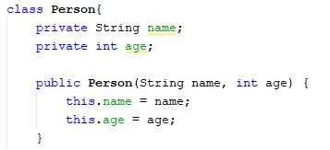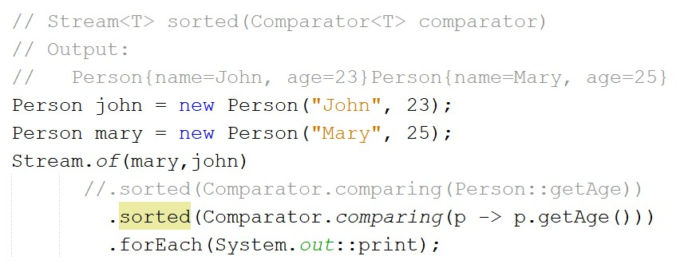Intermediate Operations
sorted(Comparator)

11

Copyright © Seán Kennedy

