

Copyright © Seán Kennedy

Streams

Primitive Streams
Primitive Streams

• As opposed to Stream<T> e.g. Stream<Integer>, Stream<Double> and Stream<Long>; Java actually provides other stream classes that you can use to work with
primitives:

➢IntStream – for primitive types int, short, byte and char

➢DoubleStream – for primitive types double and float

➢LongStream – for primitive type long

➢IntStream Stream<Integer>

➢DoubleStream Stream<Double>

➢LongStream Stream<Long>
2

Copyright © Seán Kennedy
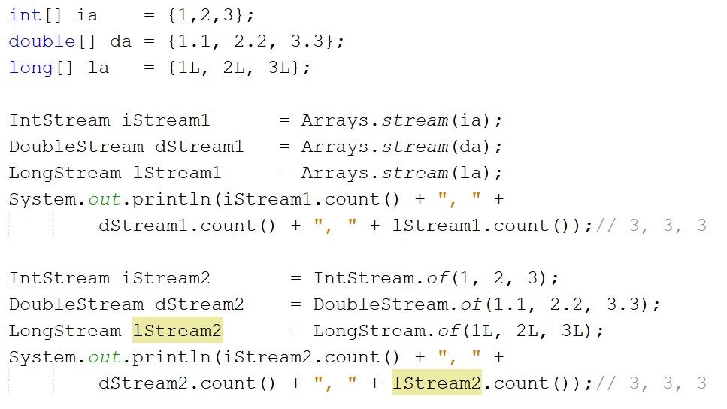Creating Primitive Streams

3

Copyright © Seán Kennedy
Primitive Streams

• The primitive streams, in addition to containing many of the Stream methods, also contain specialised methods for working with numeric data.

• The primitive streams know how to perform certain common operations automatically e.g. min(), max(), sum() and average().

4

Copyright © Seán Kennedy
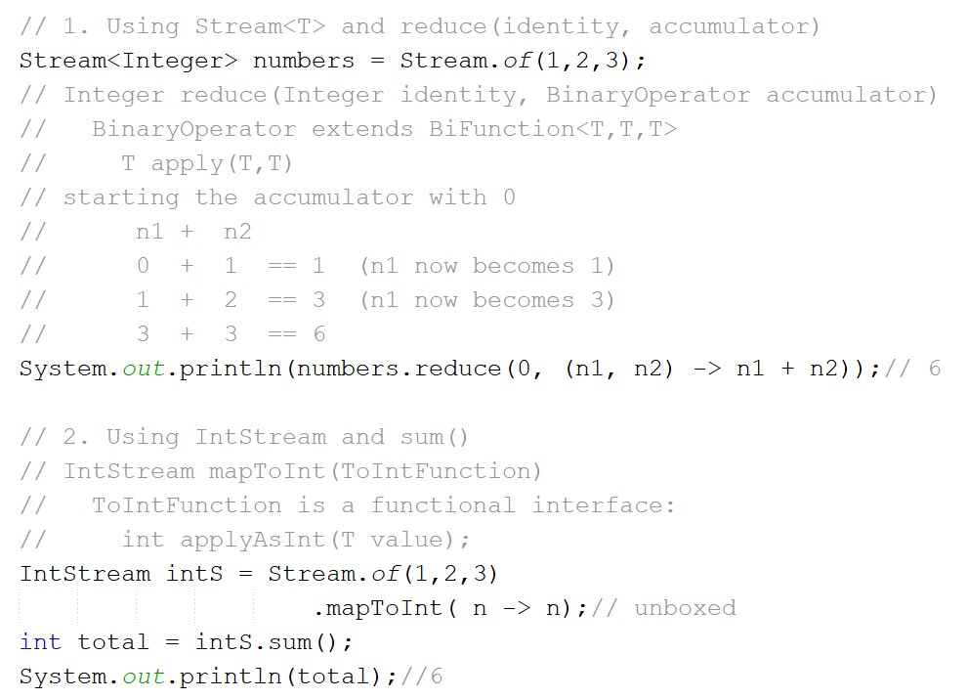Primitive Streams

5

Copyright © Seán Kennedy
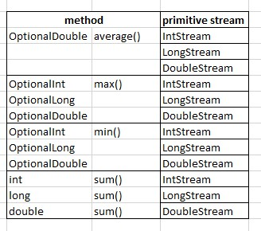Common Primitive Stream Methods

6

Copyright © Seán Kennedy
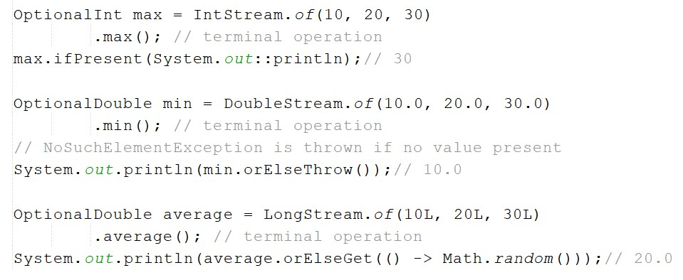Common Primitive Stream Methods

7

Copyright © Seán Kennedy
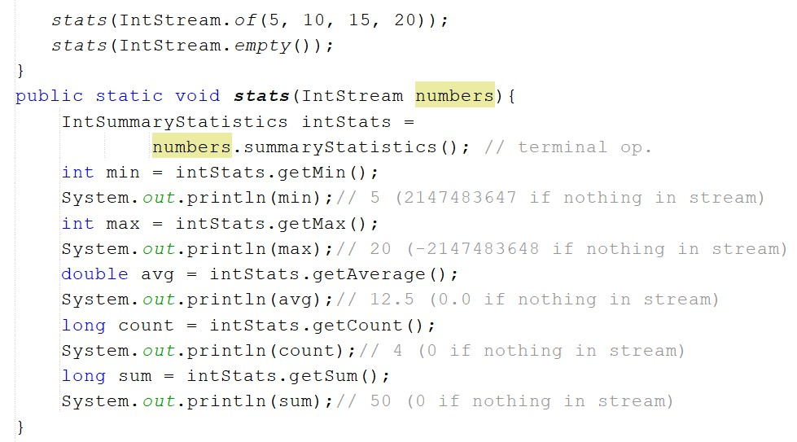Summarising Statistics

8

Copyright © Seán Kennedy
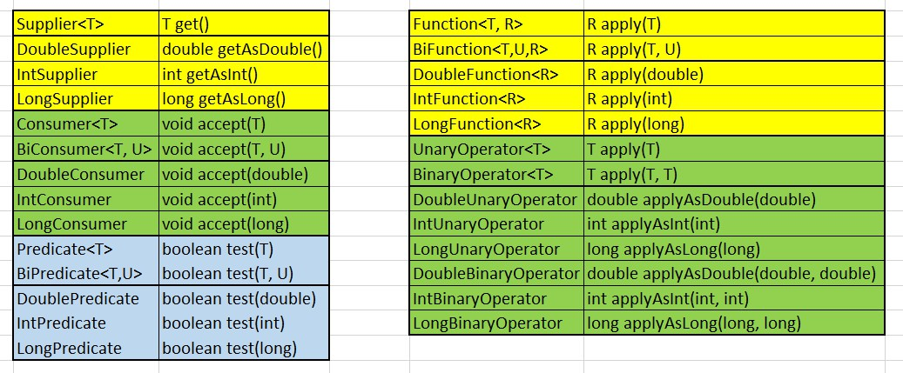Functional Interfaces

11

Copyright © Seán Kennedy
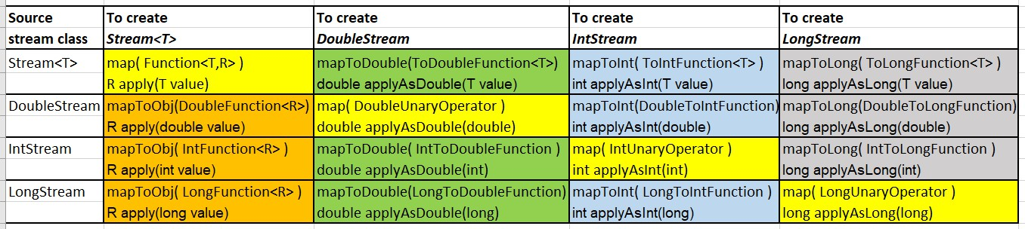Mapping Streams

12

• Another way to create a primitive stream is by mapping from
another stream type.

Copyright © Seán Kennedy

