

Copyright © Seán Kennedy

Streams

Optionals
Optionals

• Think of an Optional as a box that may or may not be empty.

• Before Java 8, programmers would return null instead of Optional. Returning an Optional is now a clear way for the API to state that there might not be a value in there (and that the programmer must deal with that).

• In addition to Optional<T>, there are Optional’s for the primitive types:
• OptionalDouble, OptionalInt and OptionalLong

2

Copyright © Seán Kennedy
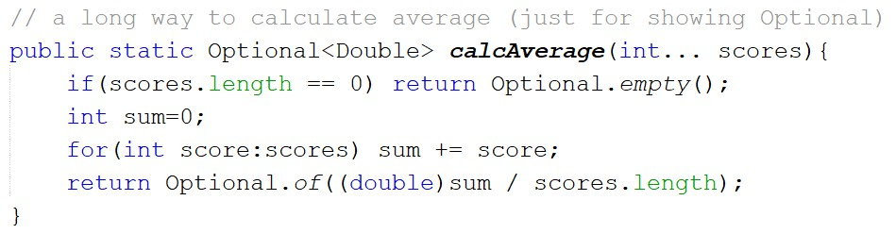Optional Examples

3

Copyright © Seán Kennedy
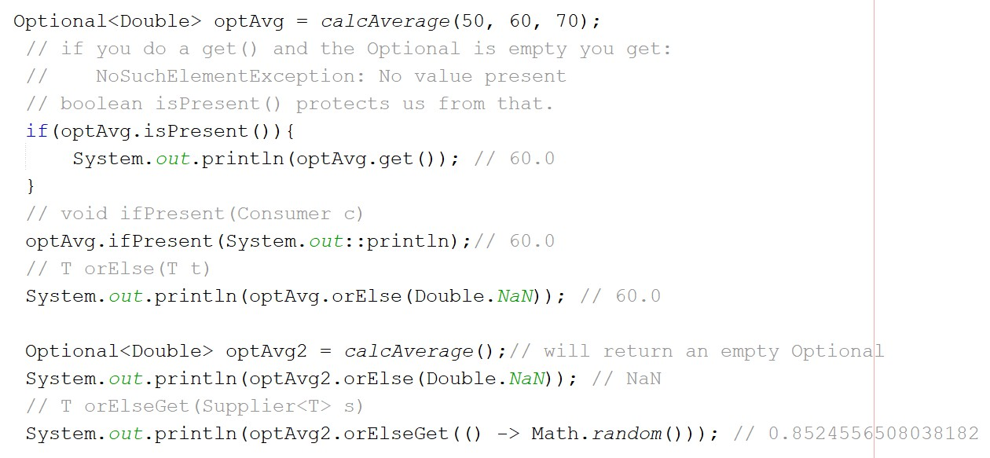Optional Examples

4

Copyright © Seán Kennedy
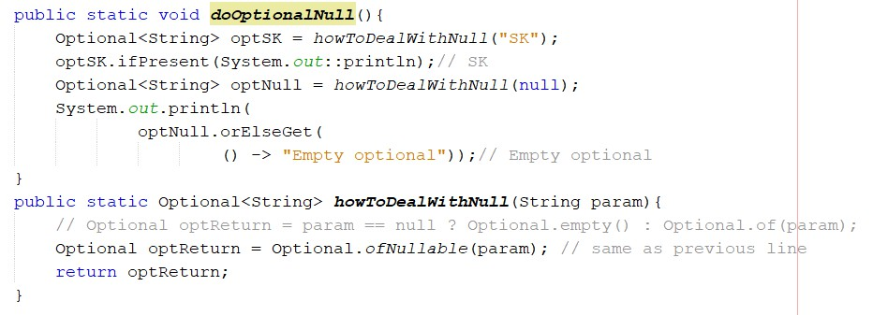Optional Examples

5

Copyright © Seán Kennedy
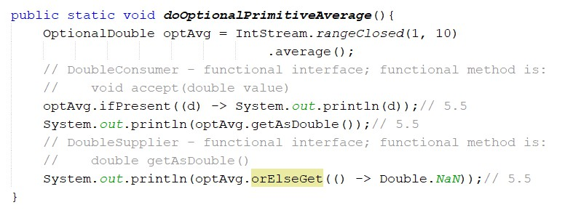Optional Examples

6

Copyright © Seán Kennedy

