

Copyright © Seán Kennedy

Streams

Parallel Streams
Parallel Streams

• All of the streams thus far have been sequential streams i.e. the streams have processed the data one element at a time.

• Parallel streams can process elements in a stream concurrently i.e. at the same time.

• Java achieves this by splitting the stream up into sub- streams and then the pipeline operations are performed on the sub-streams concurrently (each sub-stream has its own thread).

2

Copyright © Seán Kennedy
Parallel Streams

• To make a stream parallel, we can use the parallel() or
parallelStream() methods.

• parallel() is available in Stream<T>.

• parallelStream() is defined in the Collection<E> interface

3

Copyright © Seán Kennedy
Parallel Streams

Collection<E>

Stream<T>

4

Copyright © Seán Kennedy
Parallel Streams

• Firstly, let’s look at a sequential stream that sums up a
stream of numbers.

Sequential stream
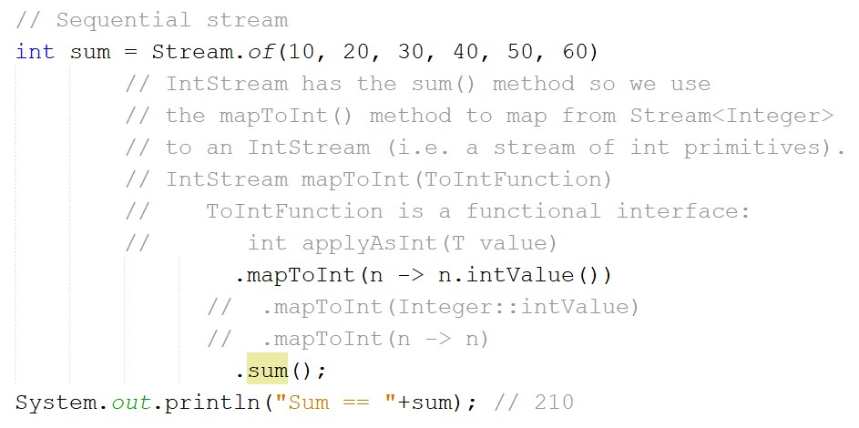

5

Copyright © Seán Kennedy
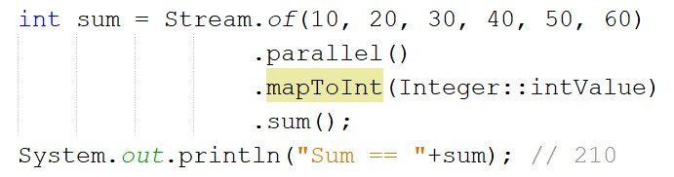Parallel Streams

Parallel stream

6

Copyright © Seán Kennedy
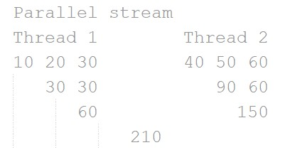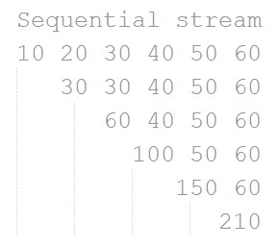Parallel Streams

• What is happening in the background?

7

Copyright © Seán Kennedy
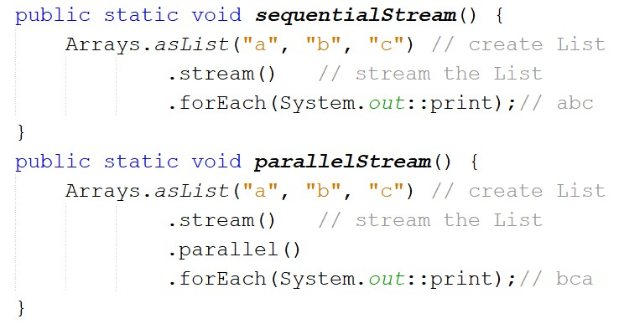Parallel Streams

• Be careful if order is important, as the order of thread completion will determine the final result (not the order in the original collection).

8

Copyright © Seán Kennedy

