**I have created 3 Projects.**

1. **Spring Boot Back End: Eureka server**
2. **Spring Boot Back End : StockApplication.**
3. **React UI Application : stock-react-springboot.**
4. **To run : Eureka server:**
5. Go to Project directory ..\.. \SpringBootEurekaNamingServer
6. Run maven command
7. $ mvn spring-boot:run
8. APP URL: <http://localhost:8761/>

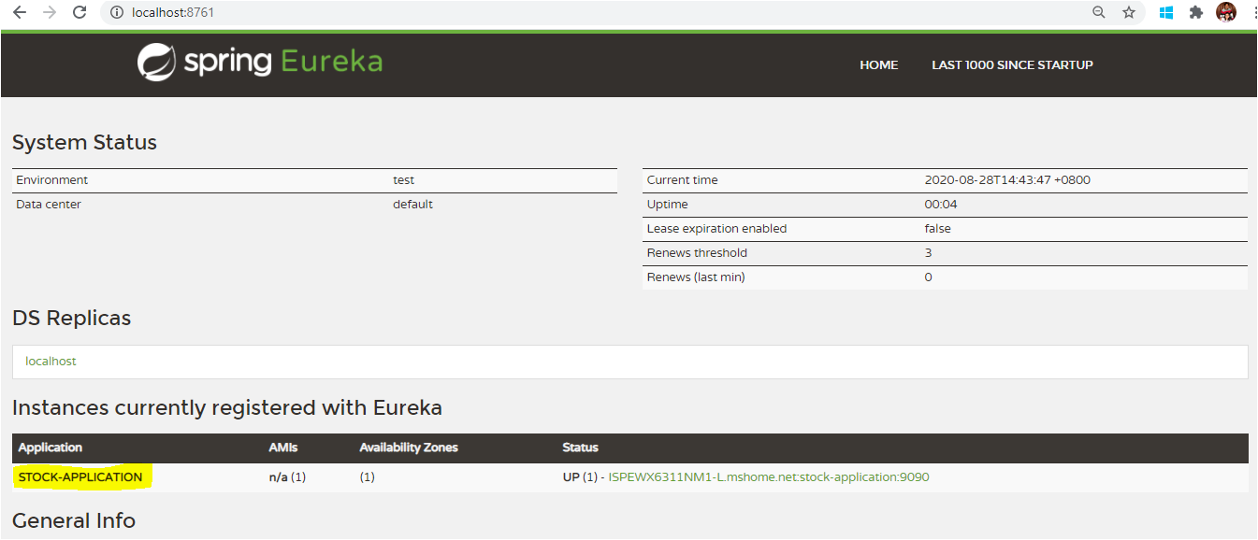

1. **To run StockApplication:**
2. Go to Project directory ..\.. \StockApplication
3. Run maven command

$ mvn spring-boot:run -Dmaven.test.skip=true

1. Application will run on port :9090

URL **real-time** stock pricing bases on evettime:

<http://localhost:9090/api/v1/stockspricing>

JSON Response:

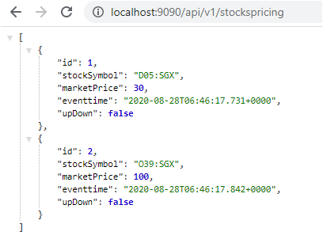

URL real-time stock:

<http://localhost:9090/api/v1/stocks>

Response :

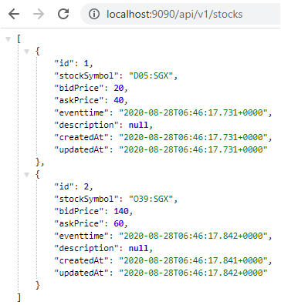

URL to find stock based on ID:

<http://localhost:9090/api/v1/stocks/1>

Response

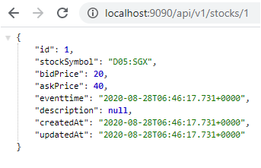

**Actuator API for Health check**

<http://localhost:9090/actuator/health>

Response

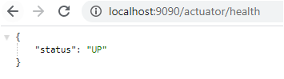

**JUNIT TEST CASES RUN RESULT**

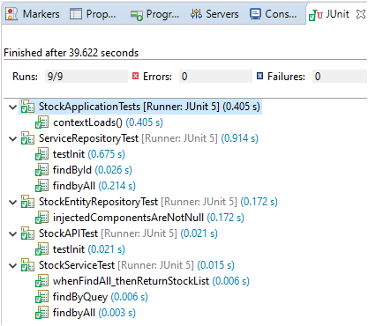

1. **React UI Application RUN.**

$ ..\..\stock-react-springboot\stock-react-ui> npm start

URL For React UI : <http://localhost:3000/stockspricing>

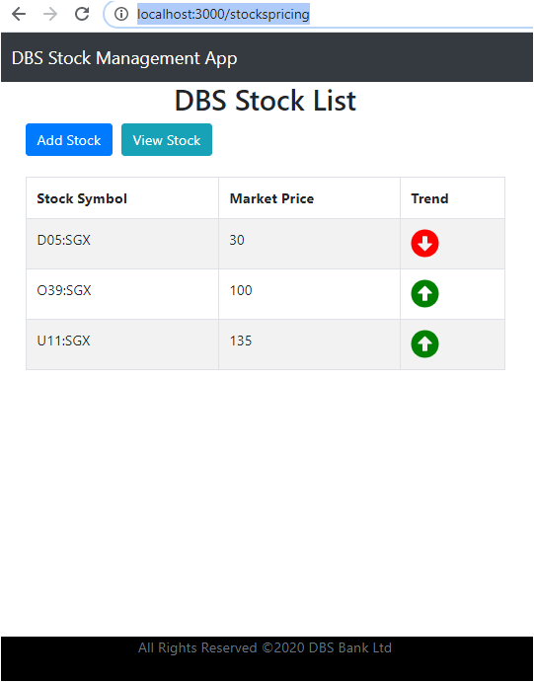

It is not the part of requirement but I feel if I can provide. I have extended API to View Backend real time data for admin users in user iterface.

URL : <http://localhost:3000/stocks>

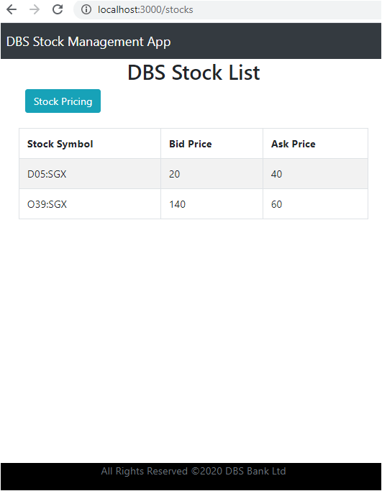

URL to add stock by backed Team it there is some missing Stock;

<http://localhost:3000/add-stock/_add>

