**C360 INDEX REFRESH**

Operations Guide

Author: Rahul Kumar

**Version: 1.0**

Date: 19th--Oct-2016

Status: Draft

# **Overview:**

The Client 360 indexer job scripts, code and configuration files have been installed in the Public Cloud Production Kubernetes cluster.

Namespace c360-intg.

The persistent volume is mounted under **/c360/shared/data**. This is the root directory of all script, code and configurations files. This persistent volume is available to all workloads (jobs or deployments) running in the production cluster namespace c360-intg.

During the weekend, three indexer Job will execute in parallel.

Two hours prior to indexer jobs, prune indices job will be executed which will delete/clear all the unwanted indices which are not mapped to any alias.

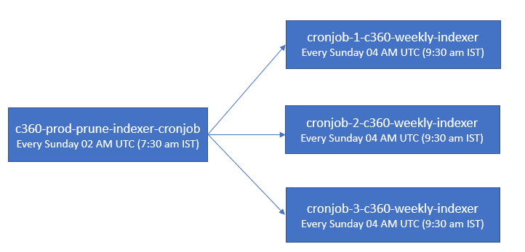

# **INDEX REFRESH OVER WEEKEND:**

***The following indexes are refreshed over the weekend. The job to refresh them is triggered at 4 am UTC(9:30 am IST) every Sunday:***





**ACCESS & PRE-REQUISTIES:** Please cross-check if you already have these accesses or not.

* Public cloud Kubernetes cluster: <https://cloud.ibm.com/resources>

Pre-Prod/Test : c360-staging-cluster

Production : c360-prod-cluster

For c360-intg namespace.

* Access to CEDP Platform & bluegroup coedl_client360_api.

If not able to access, please follow the document titled as “CEDP New User Access Process (Client360) v1”.



* Access to below Slack Channel:

Pre-Prod/Test:



Production:



* Access of build server dpydalbld0301.sl.bluecloud.ibm.com
* Kubernetes installed on your local machine.

**DAILY MONITORING TASK FOR OPS:**

All notification of the index refresh can be checked on Slack channel: #client360_cloud_prod_indexer:

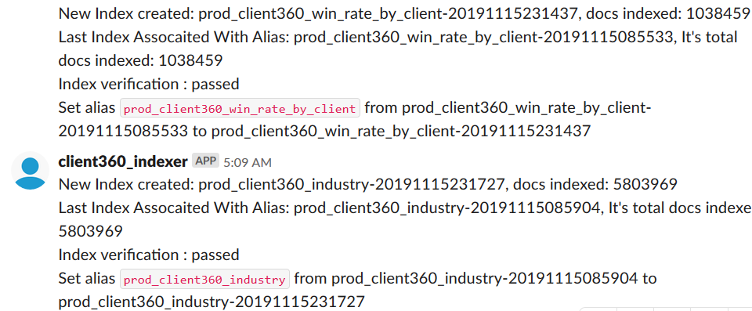

As per the schedule we need to monitor if all the indexes are completed fine or not and then need to maintain one excel sheet.

**CRON JOBS:**

1. c360-prod-prune-indexer-cronjob
2. cronjob-1-c360-weekly-indexer
3. cronjob-2-c360-weekly-indexer
4. cronjob-3-c360-weekly-indexer

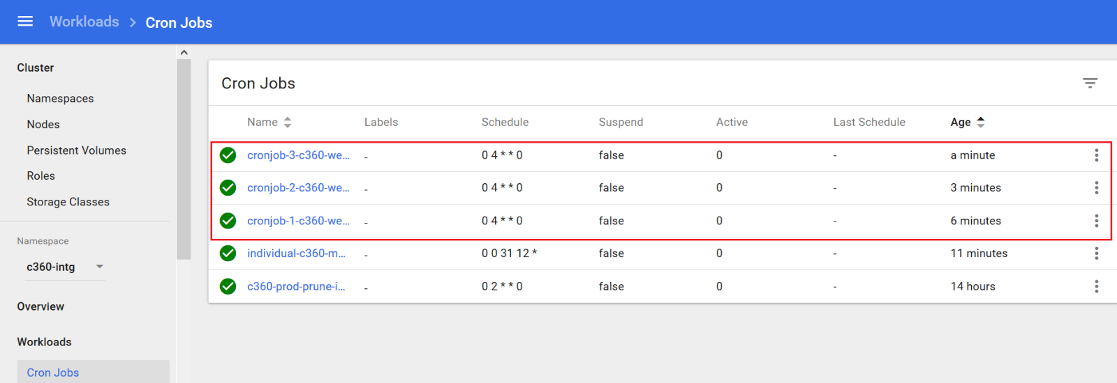

**Prune Indices:**

Schedule Time: Every Sunday 02 AM UTC (7:30 am IST)

It will delete all the indices which are not mapped to any alias. It will be executed before the actual job to clean the unwanted indices.

**Cron Job 1:**

Schedule Time: Every Sunday 04 AM UTC (9:30 am IST)

It will execute the first batch of indices:

|  |  |
| --- | --- |
| JOB SET 1 | API |
| c360_seller_indexer | #seller indexer |
| c360_sales_connect_team_members | #sales connect |
| c360_opportunity_summary | #sales connect |
| c360_sales_connect_contacts | #sales connect |
| c360_sales_connect_user_profile_indexer | #sales connect |
| c360_sales_connect_accounts | #sales connect |
| c360_recent_opportunities_sales_connect_acc | #sales connect |
| c360_cost_base | #cost |
| c360_cost_annual | #cost |

**Cron Job 2:**

Schedule Time: Every Sunday 04 AM UTC (9:30 am IST)

It will execute the second batch of indices:

|  |  |
| --- | --- |
| JOB SET 2 | API |
| c360_ibase_comp_summary | #ibase summary |
| c360_ibase_comp_aggs | #ibase comp |
| c360_ibase_comp | #ibase comp |
| c360_rev_annual | #revenue aiw |
| c360_rev_base | #revenue aiw |
| c360_wallet_indexer | #wallet |

**Cron Job 3:**

Schedule Time: Every Sunday 04 AM UTC (9:30 am IST)

It will execute the third batch of indices:

|  |  |
| --- | --- |
| JOB SET 3 | API |
| c360_dnb | #duns |
| c360_dnb_agg | #duns |
| c360_company_names | #company aiw |
| c360_company | #company aiw |
| c360_dc | #company aiw |
| c360_gc | #company aiw |
| c360_gbl_buy_grp | #company aiw |
| c360_buy_grp | #company aiw |
| c360_contract_summary | #contract aiw |
| c360_nps | #Surveys Support |
| c360_nss | #Surveys Support |
| c360_nps_relexp | #nps Relationship Experience |
| c360_nps_salexp | #nps Sales Experience |
| c360_ldw | #LDW AIW indexer |
| c360_win_rate | #winrate indexer |
| c360_win_rate_by_client | #winrate indexer |
| c360_ind_opty | #industry |
| c360_ind_rev | #industry |

**Manual Trigger:**

**Prune Indices:**

**Job Name: c360-prod-prune-indexer-cronjob**

* Click on action



* Click on Trigger, it will trigger the Job

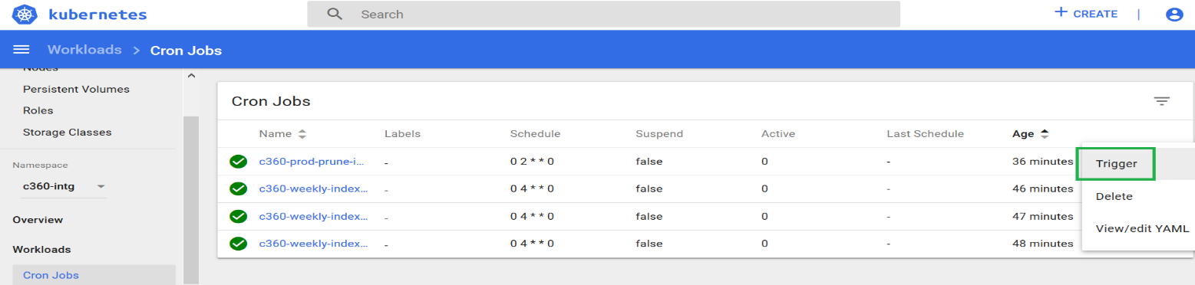

* To check the status and logs, search latest c360-prod-prune-indexer-cronjob-manual and click on pod

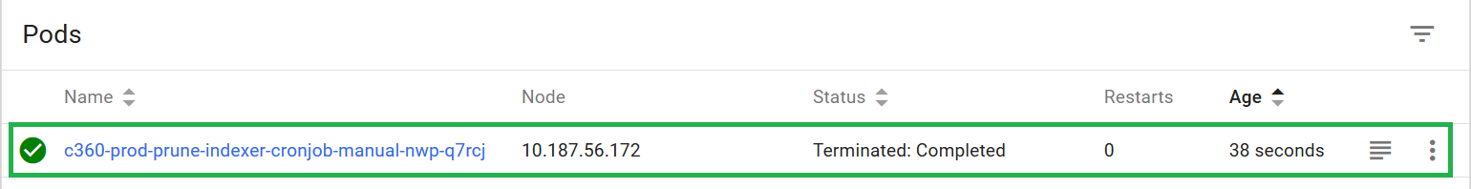

* click on logs

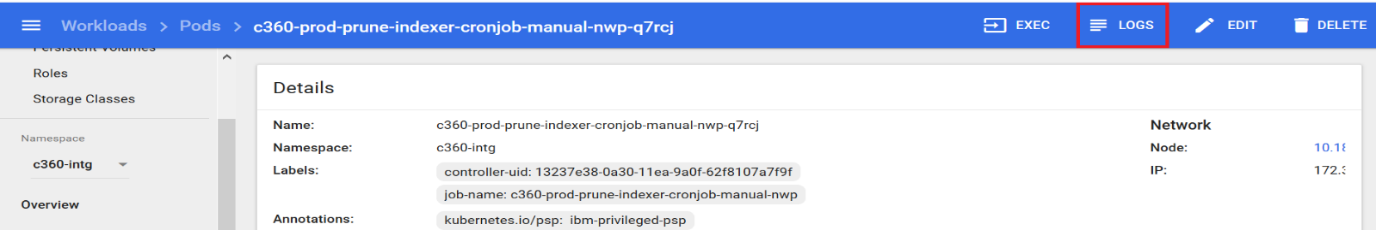

* Logs will be display as below

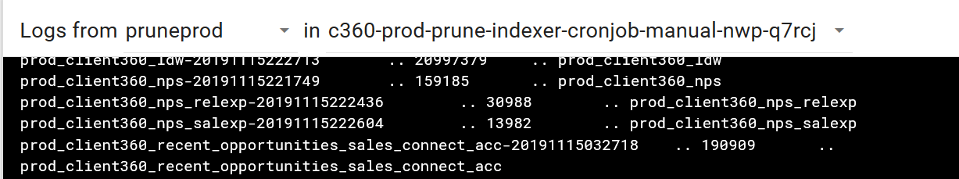

**Indexer Jobs:**

**Job Name: cronjob-1-c360-weekly-indexer**

* Click on Trigger, it will trigger the Job

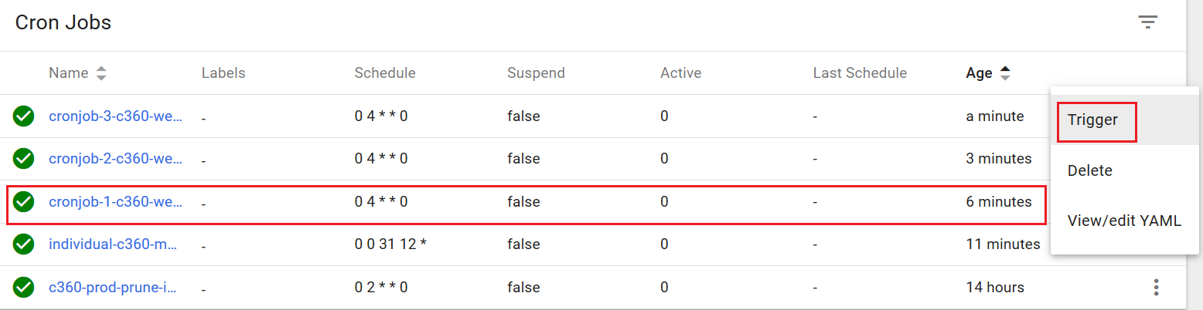

* To check the status, Click on Pods and search latest cronjob-1-c360-weekly-indexer-manual and click on pod

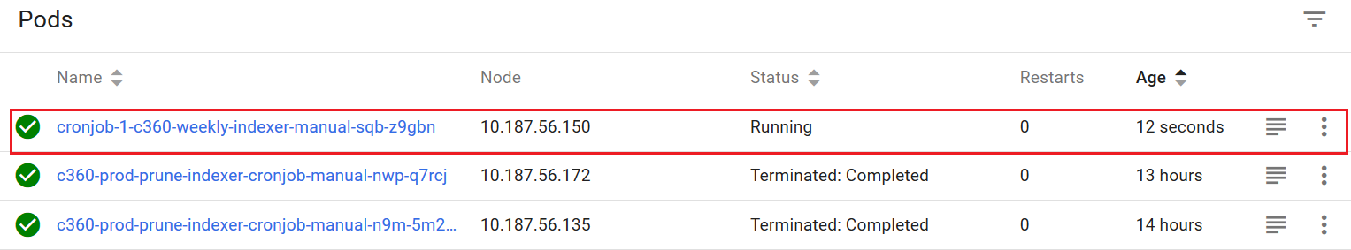

* To check the application logs, connect to public cloud Kubernetes cluster by using “connect via cli” and examine the logs file on shared file system.

Pre-Prod/Staging: “c360-prod-cluster”

Production: “c360-prod-cluster”

**Examining log files on the shared file system**

You can open a bash shell into any running pod by executing the following command in power shell:

kubectl exec -i -t <podname> bash --namespace c360-intg

Pre-Prod/Staging: c360-util-1-84879b6dc5-zs9g5

Production: c360-util-1-65887956bd-dlmsr

Eg: kubectl exec -i -t c360-util-1-65887956bd-dlmsr bash --namespace c360-intg

To get the <podname> execute “kubectl get pods --namespace c360-intg”

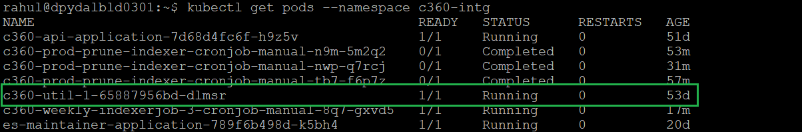

Note: if a pod has STATUS = Completed you cannot open a bash shell into it.

There is one pod (c360-util-1-65887956bd-dlmsr) that is always running and never completes. This pod can always be used for starting a bash shell.

The shared file system /c360/shared/data is available to all pods when they are running. All indexer jobs write their logs to /c360/shared/data/logs/prod

You can check the logs at the below location based on the test/prod server.

* + - /c360/shared/data/logs/test
    - /c360/shared/data/logs/prod

Then,  
tail -f <logfile>  
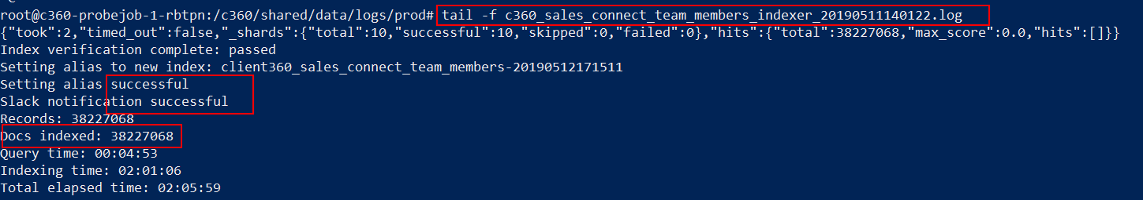  
  
NOTE: To delete a job  
kubectl delete job <JOBNAME> --namespace c360-intg

**Job Name: cronjob-2-c360-weekly-indexer (Same as cronjob-1-c360-weekly-indexer)**

**Job Name: cronjob-3-c360-weekly-indexer (Same as cronjob-1-c360-weekly-indexer)**

**Delete Job:**

**Through Kubernetes GUI:**

* Click on actions

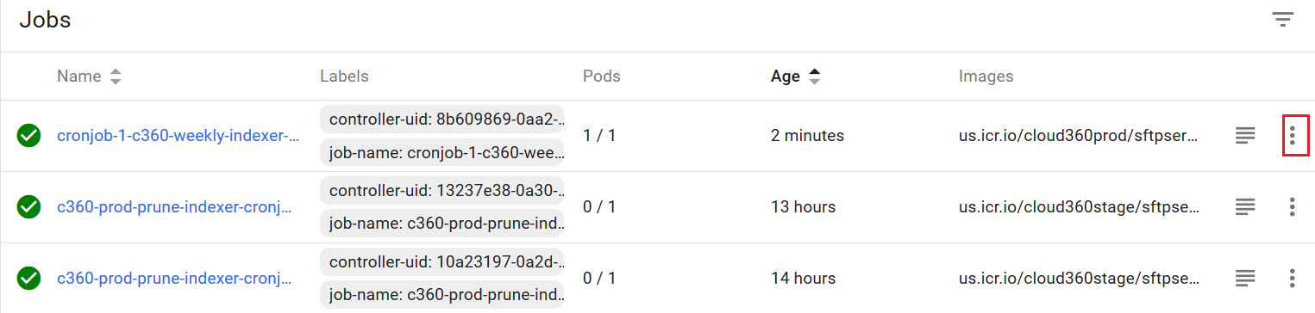

* Click on delete, refresh the page and wait for few seconds. Job and all associated pods will get deleted.

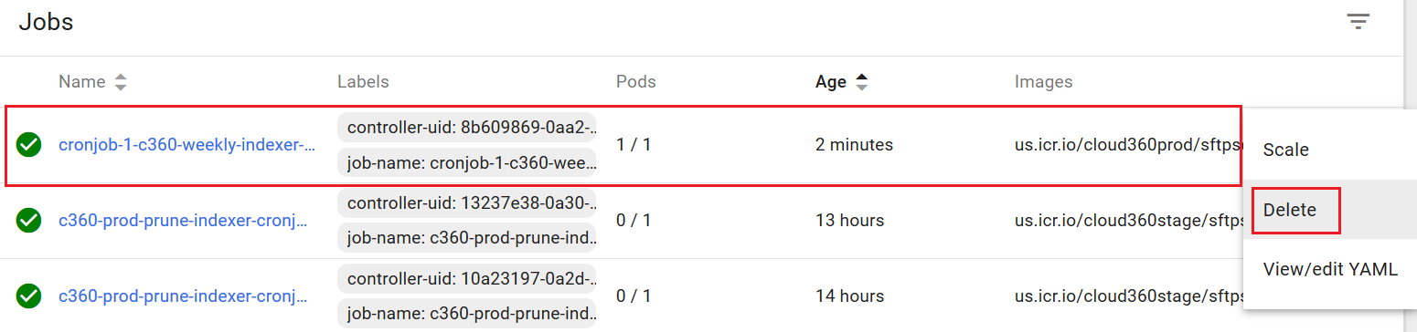

**Through cmd/powershell(If Kubernetes installed on your local machine):**

kubectl delete job <JOBNAME> --namespace c360-intg

**Delete Pod:**

**Through Kubernetes GUI:**

* Click on actions and then on delete. Refresh the page and wait for few seconds. Pod will get deleted.

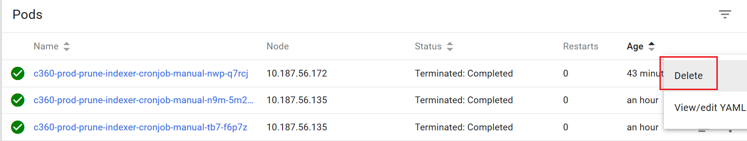

**Through cmd/powershell(If Kubernetes installed on your local machine):**

kubectl delete pod <JOBNAME> --namespace c360-intg

**Execute Individual Index:**

**Through Kubernetes GUI:**

* From Cron jobs select “individual-c360-manual-indexerjob” , Click on actions and then view/edit YAML file.

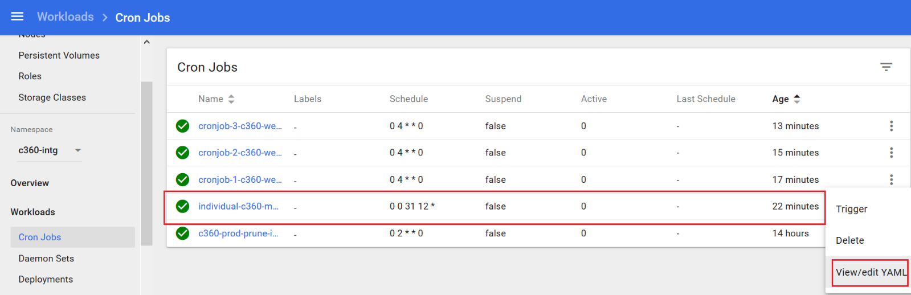

* Update fully qualified properties file name in YAML file that will be used by the indexer to tell it what index to build and click on update.

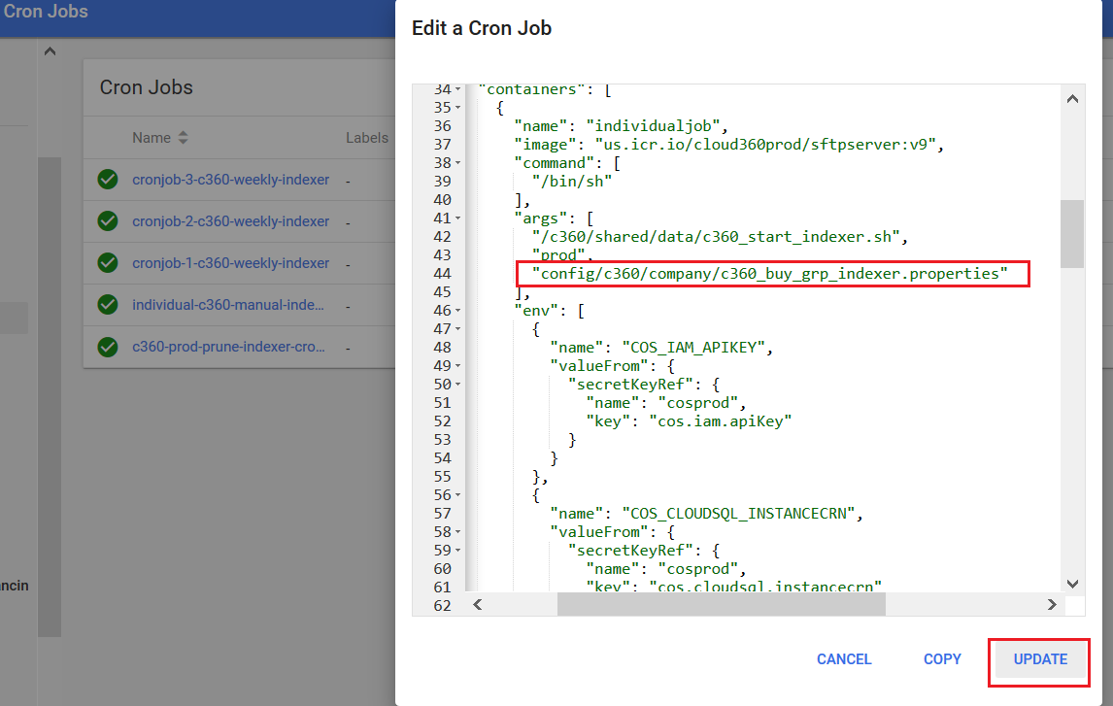

* YAML file will get saved and refresh, Click on Trigger to start the job.

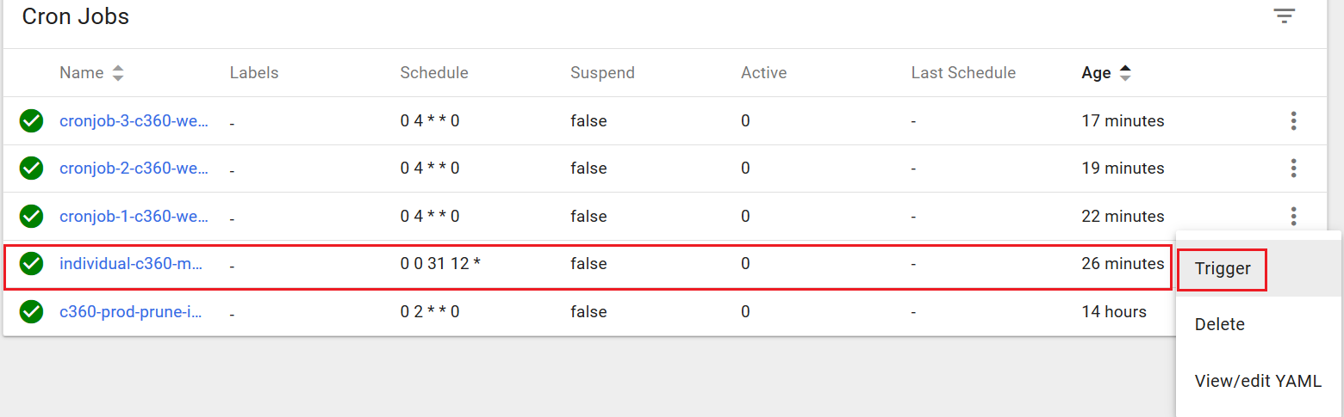

* To check the status, Click on Pods and search latest individual-c360-manual-indexerjob-manual and click on pod

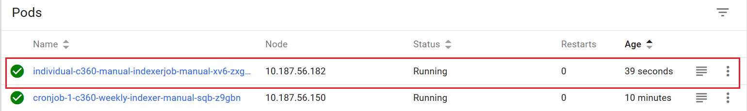

**Through Build Machine:**

* **login to build server:** **dpydalbld0301.sl.bluecloud.ibm.com**
* login to below public cloud kubernetes cluster by using “connect via cli”
* Pre-Prod/Staging: “c360-prod-cluster”
* Production : “c360-prod-cluster”



* On the build machine navigate to the /build/kube-jobs-cloud-prod/src directory.
* cd /build/kube-jobs-cloud-prod/src
* Copy the generic job indexer to the src directory from the src-master directory.
* cp ../src-master/c360_run_an_indexer_job.json .
* Using vi edit the file c360_run_an_indexer_job.json that you copied into the src directory and modify the line shown below with the fully qualified properties file name that will be used by the indexer to tell it what index to build. For convenience a file called listofpropertiesfiles.txt can be found in the src-master directory.

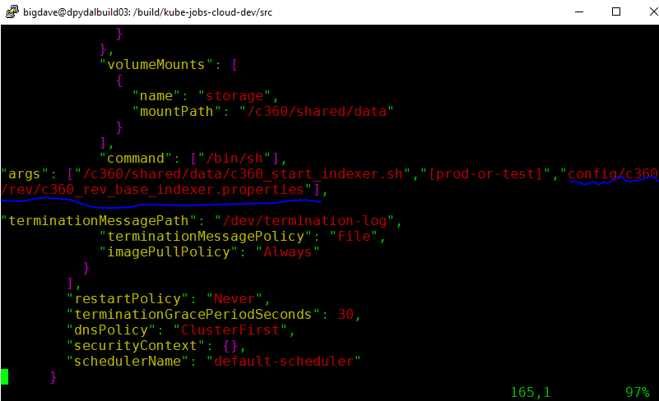

* Save and close the file.
* Change the file permissions of the file src/c360_run_an_indexer_job.json to 666. This will insure that other users will not have access permissions when they access the file to run jobs.
* chmod 666 c360_run_an_indexer_job.json
* Navigate to /build/kube-jobs-cloud-prod
* cd /build/kube-jobs-cloud-prod
* Execute the script to submit the job to Kubernetes.
* ./rundevjobs.sh
* This script will submit the job to Kubernetes for execution.

**Logs Clean Up**

The following instructions will prevent the failure encountered caused by log files filling up the file system.

* Please add this to your run book for execution every Friday at 4:00PM ET:

This process can be done either from the build machine or your local workstation if you have kubectl installed.

* Login to below public cloud kubernetes cluster by using “connect via cli” on build machine or your local workstation if you have kubectl installed
* Pre-Prod/Staging: “c360-prod-cluster”
* Production : “c360-prod-cluster”
* kubectl exec -i -t <podname> bash --namespace c360-intg
* To get the <podname> execute kubectl get pods –namespace c360-intg
* Pre-Prod/Staging: c360-util-1-84879b6dc5-zs9g5

Production: c360-util-1-65887956bd-dlmsr

* Eg: kubectl exec -i -t c360-util-1-65887956bd-dlmsr bash --namespace c360-intg
* cd /c360/shared/data/logs/prod and rm *.log
* cd /c360/shared/data/logs/indexer and rm server*

**Index maintenance utility/Set the alias manually**

Open Index maintenance utility by clicking on below url:

* Production:

<https://esadmin.c360-prod-cluster.us-south.containers.appdomain.cloud/esadmin>

* Stage/Test/Dev:

https://esadmin.c360-dev-cluster.us-south.containers.appdomain.cloud/esadmin

It will be looked like below:

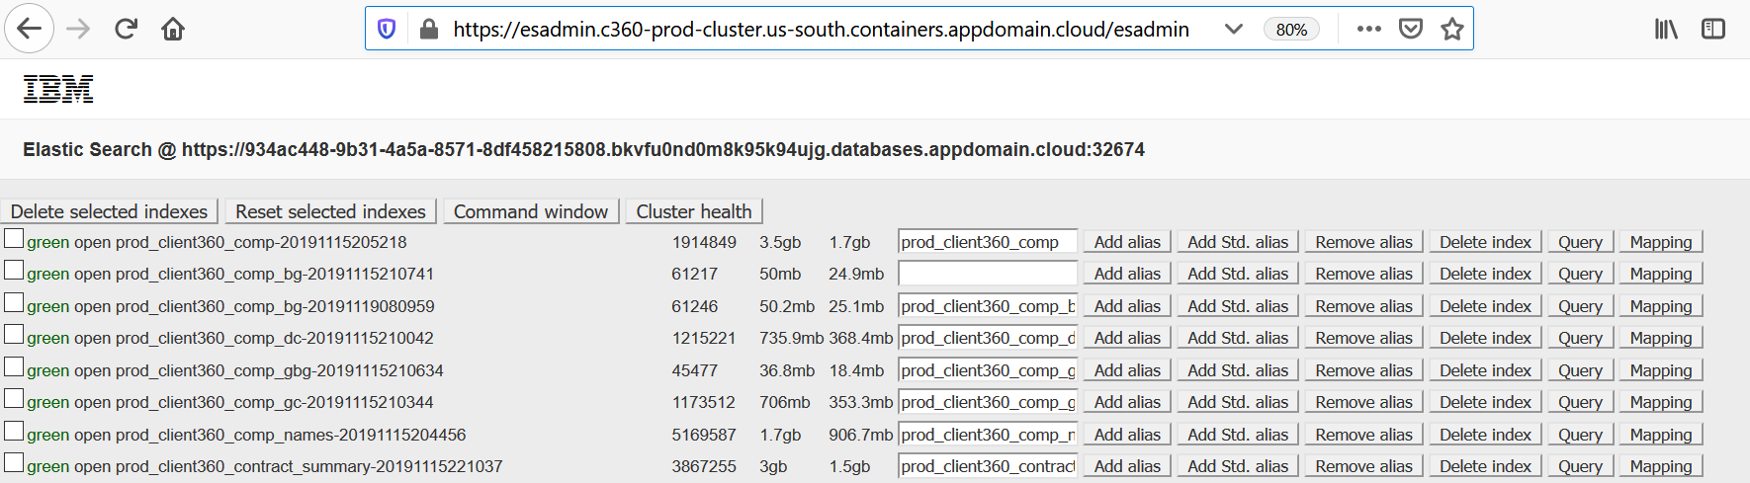

Ops team can perform below tasks from this utility:

* **Add Alias**
* **Remove alias**
* **Delete Index**
* **Query the Index**
* **Check the mapping of the index**

**Add Alias**

To add the alias, just provide the valid alias name starting with prod_client360 (E.g.: prod_client360_comp_bg) for production in the below text box and click on Add alias button.

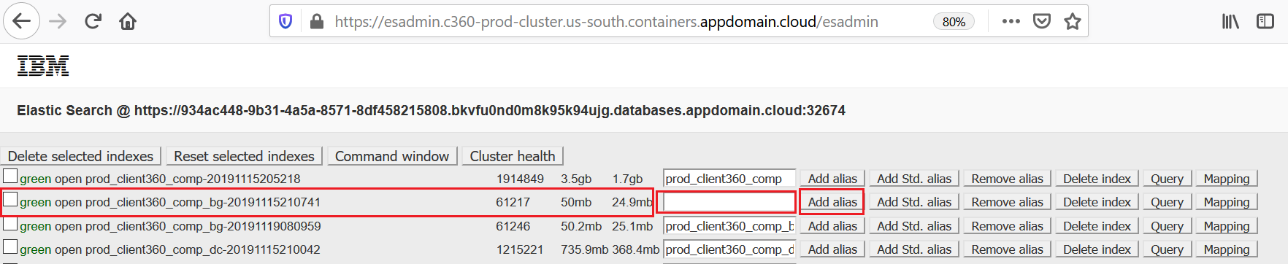

Alias will get added

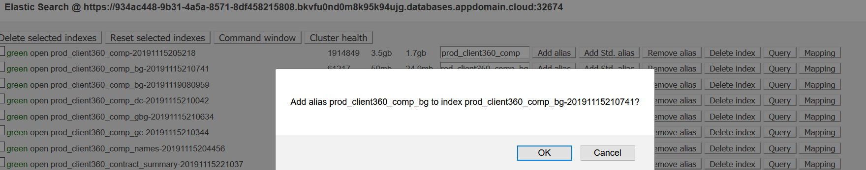

**Through Postman**

You can do it by simple sending a post request using any rest client like postman. Use below details for that

Method: Post

Production Url:

https://934ac448-9b31-4a5a-8571-8df458215808.bkvfu0nd0m8k95k94ujg.databases.appdomain.cloud:32674[/_aliases](https://elastic-test-01.data.zc2.ibm.com:9200/_aliases)

Test (Stage or PreProd)/Dev Url:

https://7e0f6432-dd07-4437-b532-bbe32d6c6bb6.8117147f814b4b2ea643610826cd2046.databases.appdomain.cloud:31765[/_aliases](https://elastic-test-01.data.zc2.ibm.com:9200/_aliases)

Authentication: Basic

User-Id and Password: Contact David Partow /Team Avengers

Body:

{

"actions" : [

{ "add" : { "index" : “<index_name>", "alias" : “<alias_name>" } }

]

}

**Alias Naming Convention**

* Production:

[prod_client360_<indexname>](https://esadmin.c360-prod-cluster.us-south.containers.appdomain.cloud/esadmin) (Eg: prod_client360_comp_bg)

* Stage/Test:

[stage_client360_<indexname>](https://esadmin.c360-prod-cluster.us-south.containers.appdomain.cloud/esadmin) (Eg: stage_client360_comp_bg)

* Dev:

[dev_client360_<indexname>](https://esadmin.c360-prod-cluster.us-south.containers.appdomain.cloud/esadmin) (Eg: dev_client360_comp_bg)

**Remove Alias**

To remove the alias, just select the index and click on “Remove alias” button

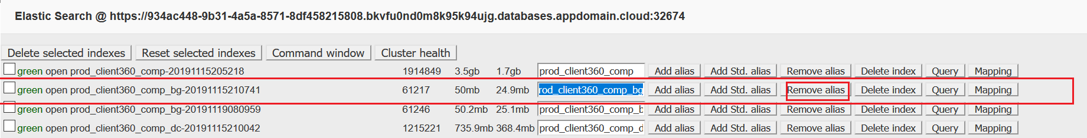

**Delete Index**

To delete specific single index , click on delete index button of index like below:

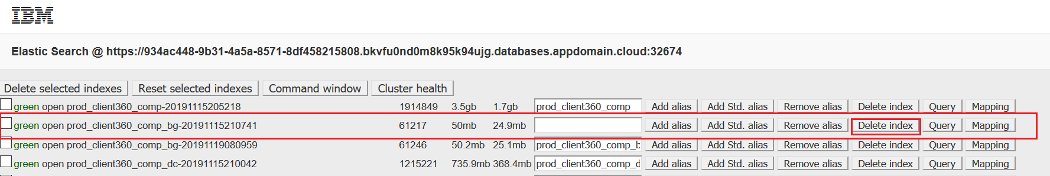

To delete multiple indexes, select the indices by clicking on check-box and then click on “Delete Selected Indexes”

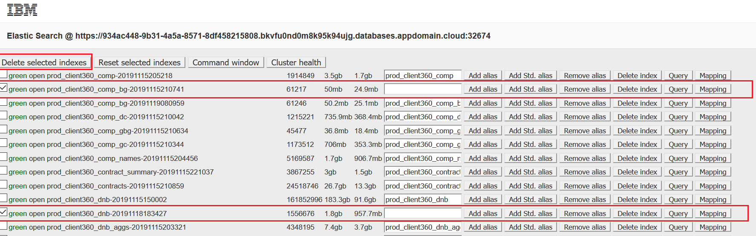

**Error / Failure of Indexes**

Common Failure causes:

1. **Failure due to Query Time Out on Cloud SQL Service**

Try to fix by individual index refresh rerun until two times. If still failing, then please raise CDASS Jira ticket for Avengers Team.

2. **Query Failed due to internal error on Cloud SQL Service**

Try to fix by individual index refresh rerun until two times. If still failing, then please raise CDASS Jira ticket for Avengers Team.

**3. Indexer Failed due to out of memory issue**

Try to fix by individual index refresh rerun until two times. If still failing, then please raise CDASS Jira ticket for Avengers Team.

**4. Failure on verification phase**

* Check the difference between docs indexed on latest and last successful runs to see if the failure is because of positive or negative change. The difference of the two values should not exceed plus or minus 10 percent. If it is so, then it will pass else it will get fail.

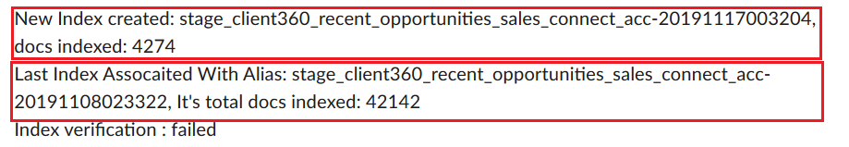

* Positive change means we have more data in tables when compared with last run and vice-versa for negative change. Take a confirmation from Steve Gardner/Helen Dark for the difference in number of documents getting indexed.
* If delta is more than 10% get confirmation from Steve Gardner/Helen Dark on whether to re-run or only need to set the alias manually. For setting up alias manually (if needed) raise CDASS Jira and assign to Ops Team. Ops Team need to set the alias manually to point to the recently refreshed index.
* If delta is less than 10%, get confirmation from Steve Gardner/Helen Dark on whether to re-run or only need to set the alias manually. For setting up alias manually (if needed) raise CDASS Jira and assign to Ops Team. Ops Team need to set the alias manually to point to the recently refreshed index.

**Frequently asked questions:**

**1) What shall I do if there is no slack notification for an index refresh from the list of active indexes mentioned in the document?**

Check the logs to identify if the index refresh was triggered. If yes, try checking for the reason of failure in mid-way.

**2) Where can I confirm if the alias is pointing to correct index?**

The best to do that is to check the alias on Index maintenance utility.

Open Index maintenance utility by clicking on below url:

* Production:

<https://esadmin.c360-prod-cluster.us-south.containers.appdomain.cloud/esadmin>

* Stage/Test/Dev:

https://esadmin.c360-dev-cluster.us-south.containers.appdomain.cloud/esadmin

**3. MAINTAINING THE EXCEL SHEET:**For every Monday (after weekend refreshes are done) , we need to update and send the below excel sheet to Helen Dark via mail keeping C360 Ops members and Team Avengers in CC.



-------------------------------------------------------End of Document-------------------------------------------------------