DS604: Introduction to Data Management

**Project SAFAR**

**ER Diagram**

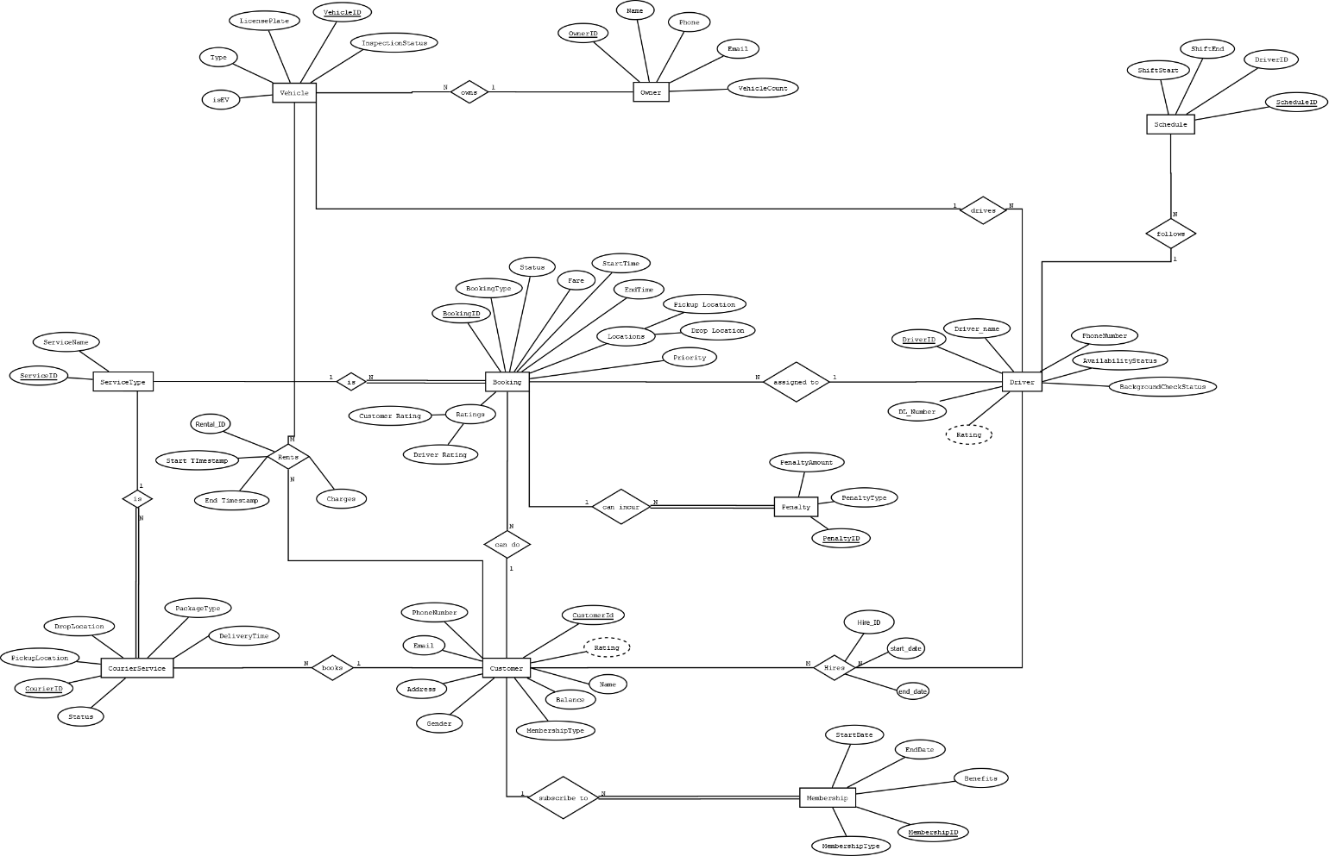

**Relational Schema**

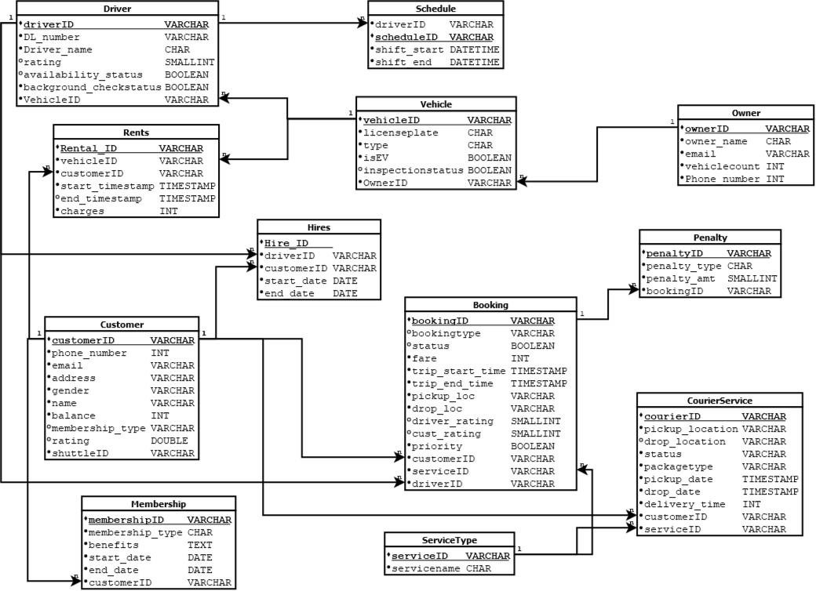

**Normalization Proof’s**

For a table to be in BCNF, the following must hold:

## It must be in 3NF (Third Normal Form), 2NF (Second Normal Form) and 1NF (First Normal Form).

1. For every non-trivial functional dependency, **X → Y**, X must be a **superkey** (meaning that X alone should uniquely determine Y).

## BCNF Check for Each Table:

1. **Driver Table:**
   * Primary Key: driverID
   * Functional Dependencies: driverID → DL_number, driver_name, rating, availability_status, background_checkstatus, vehicleID
   * This table seems to be in BCNF since there are no partial or transitive dependencies, and the primary key (driverID) uniquely determines all attributes.

## Schedule Table:

* + Primary Key: scheduleID
  + Functional Dependencies: scheduleID → driverID, shift_start, shift_end
  + This is in BCNF, as scheduleID uniquely determines all attributes.

## Vehicle Table:

* + Primary Key: vehicleID
  + Functional Dependencies: vehicleID → licenseplate, type, isEV, inspectionstatus, ownerID
  + This is in BCNF, as vehicleID is a superkey and there are no partial or transitive dependencies.

## Owner Table:

* + Primary Key: ownerID
  + Functional Dependencies: ownerID → owner_name, email, vehiclecount, Phone number
  + This is in BCNF since ownerID uniquely determines all other attributes.

## Rents Table:

* + Primary Key: Rental_ID
  + Functional Dependencies: Rental_ID → vehicleID, customerID, start_timestamp, end_timestamp, charges
  + This table is in BCNF because Rental_ID is the primary key and uniquely determines all other attributes.

## Hires Table:

* + Primary Key: Hire_ID
  + Functional Dependencies: Hire_ID → driverID, customerID, start_date, end_date
  + This table is in BCNF since Hire_ID uniquely determines all other attributes.

## Customer Table:

* + Primary Key: customerID
  + Functional Dependencies: customerID → phone_number, email, address, gender, name, balance, membership_type, rating, shuttleID
  + This table is in BCNF because customerID is the primary key and uniquely determines all other attributes.

## Membership Table:

* + Primary Key: membershipID
  + Functional Dependencies: membershipID → membership_type, benefits, start_date, end_date, customerID
  + This is in BCNF since membershipID uniquely determines all attributes.

## Booking Table:

* + Primary Key: bookingID
  + Functional Dependencies: bookingID → bookingtype, status, fare, trip_start_time, trip_end_time, pickup_loc, drop_loc, driver_rating, cust_rating, priority, customerID, serviceID, driverID
  + This is in BCNF because bookingID uniquely determines all attributes.

## Penalty Table:

* + Primary Key: penaltyID
  + Functional Dependencies: penaltyID → penalty_type, penalty_amt, bookingID
  + This is in BCNF because penaltyID uniquely determines all other attributes.

## CourierService Table:

* + Primary Key: courierID
  + Functional Dependencies: courierID → pickup_location, drop_location, status, packagetype, pickup_date, drop_date, delivery_time, customerID, serviceID
  + This is in BCNF because courierID uniquely determines all other attributes.

## ServiceType Table:

* + Primary Key: serviceID
  + Functional Dependencies: serviceID → servicename
  + This is in BCNF since serviceID uniquely determines all other attributes.

# Conclusion:

## All the tables in the schema seem to be in BCNF. Each table has a primary key (or superkey) that uniquely determines all other attributes, and there are no partial or transitive dependencies.

**DDL SCRIPT**

**Driver’s Table**

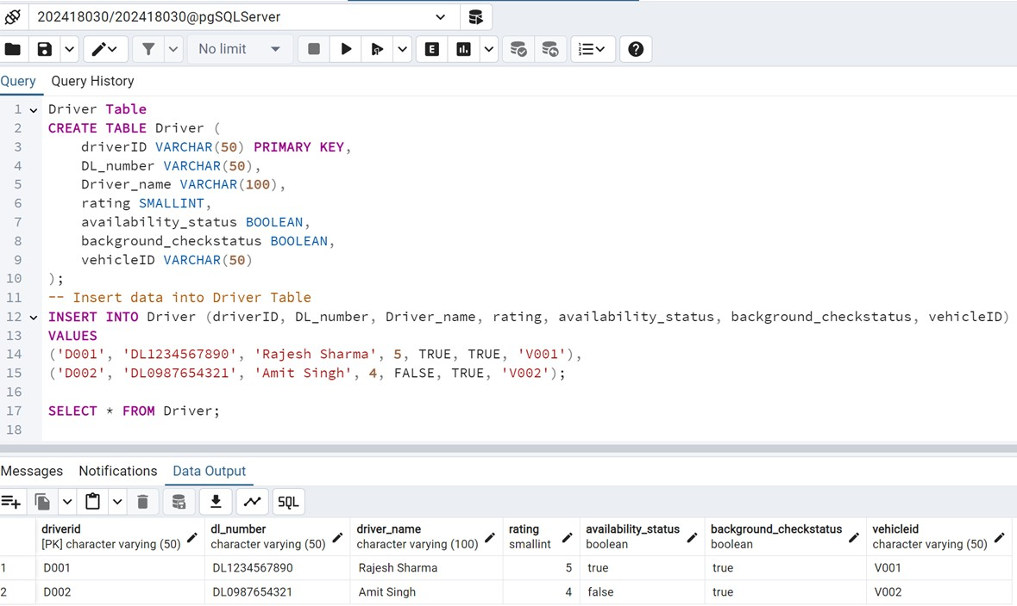

**Vehicle’s Table**

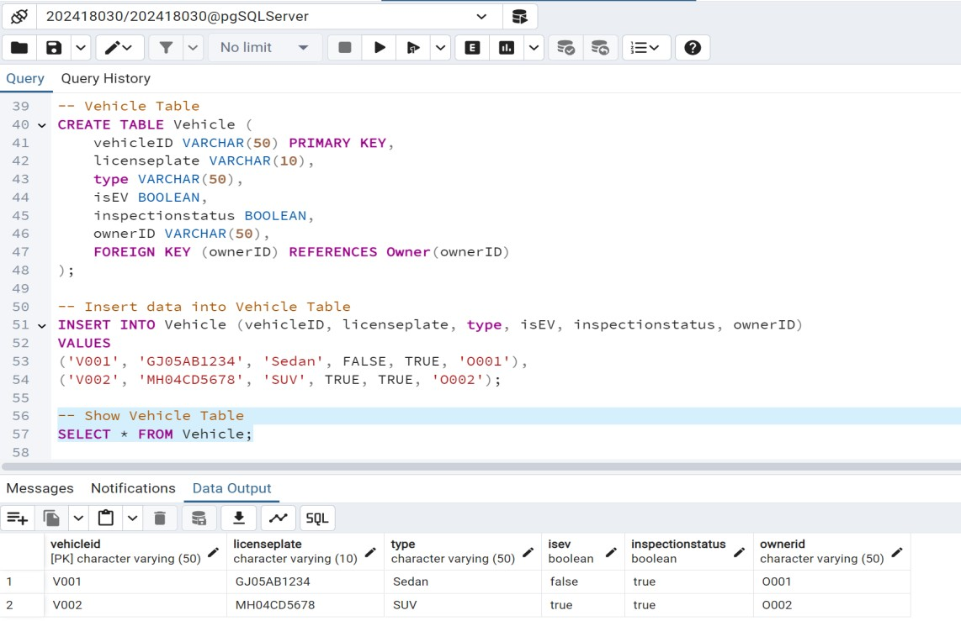

**Schedule’s Table**

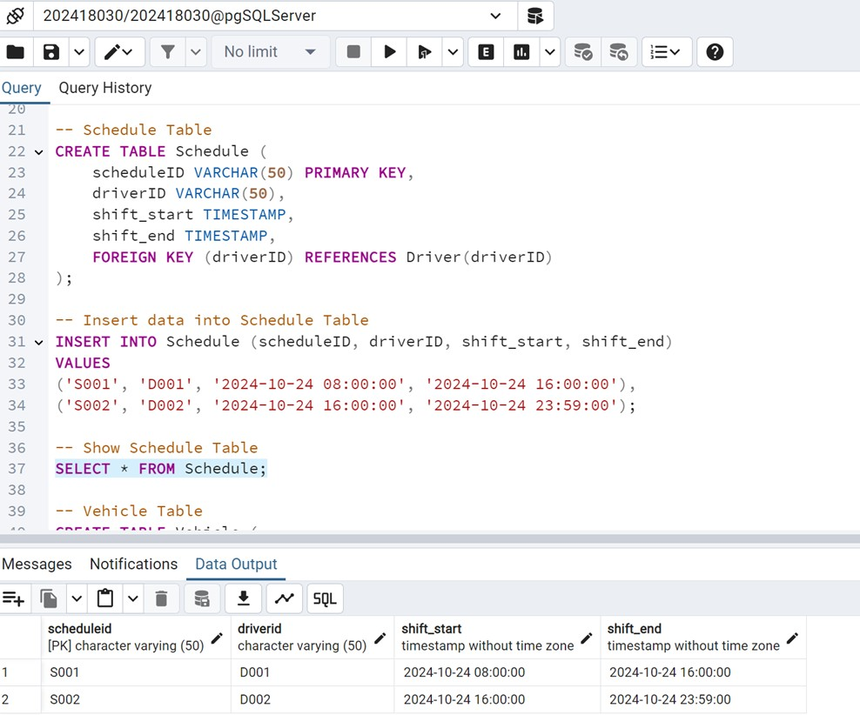

**Owner’s Table**

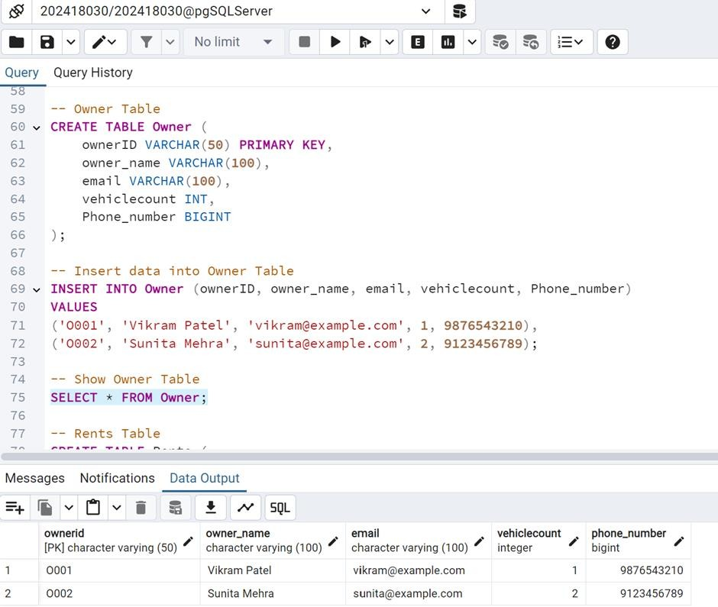

**Rent’s Table**

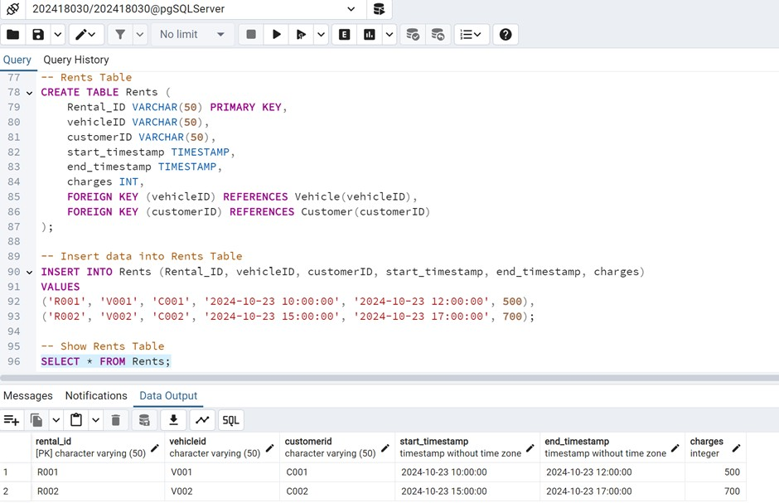

**Hire’s Table**

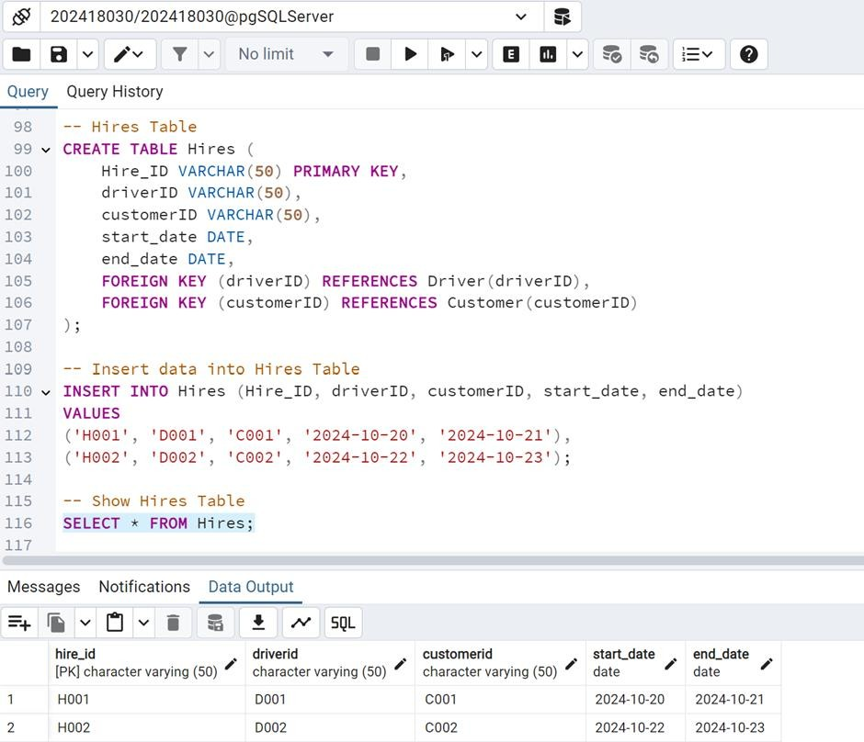

**Customer’s Table**

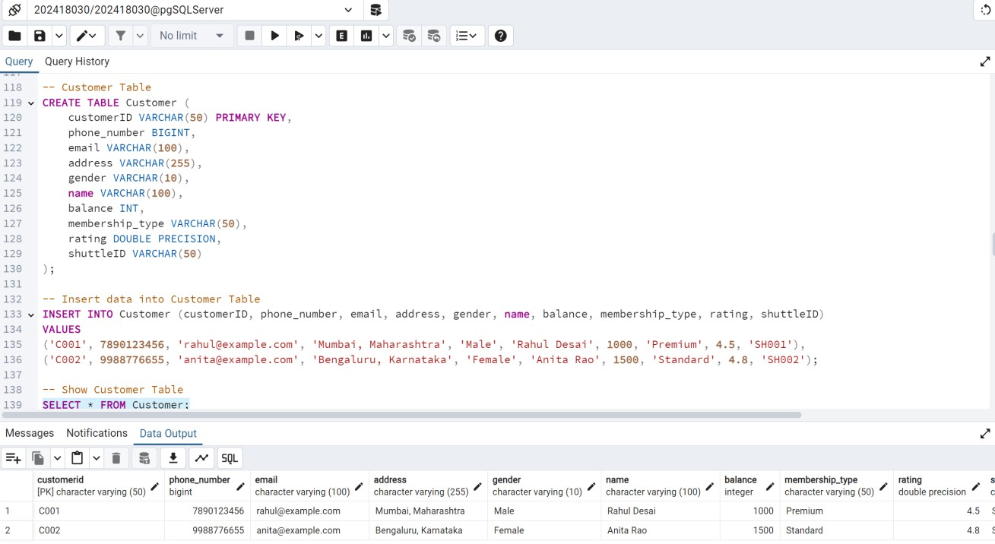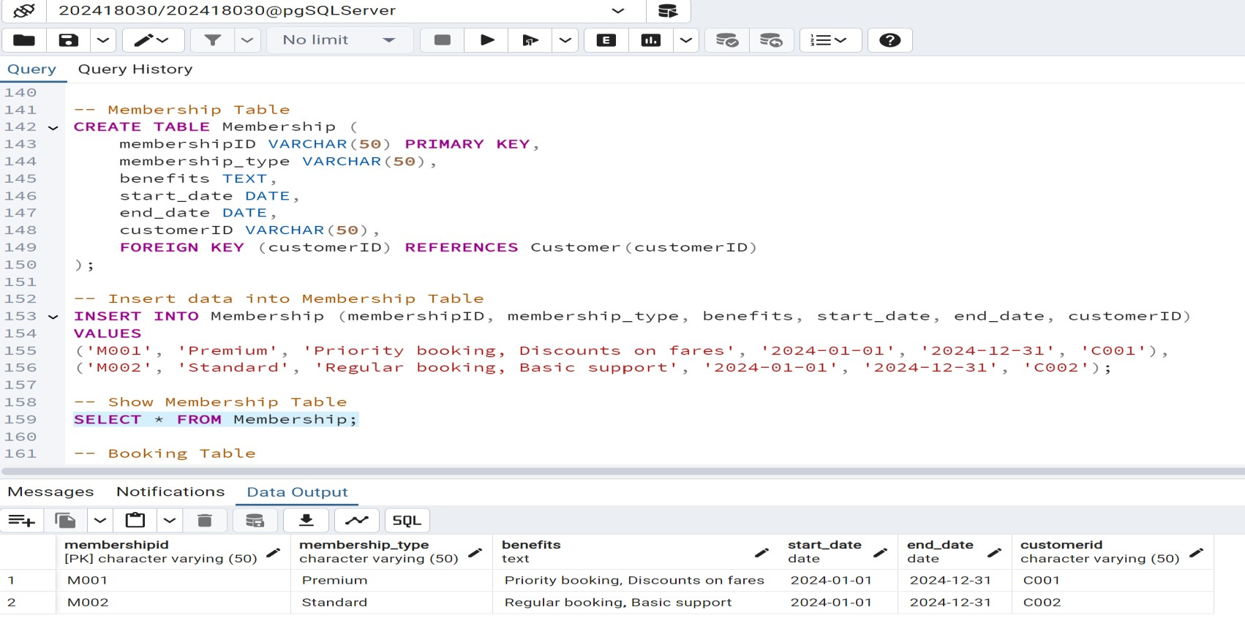

**Membership’s Table**

**Booking’s Table**

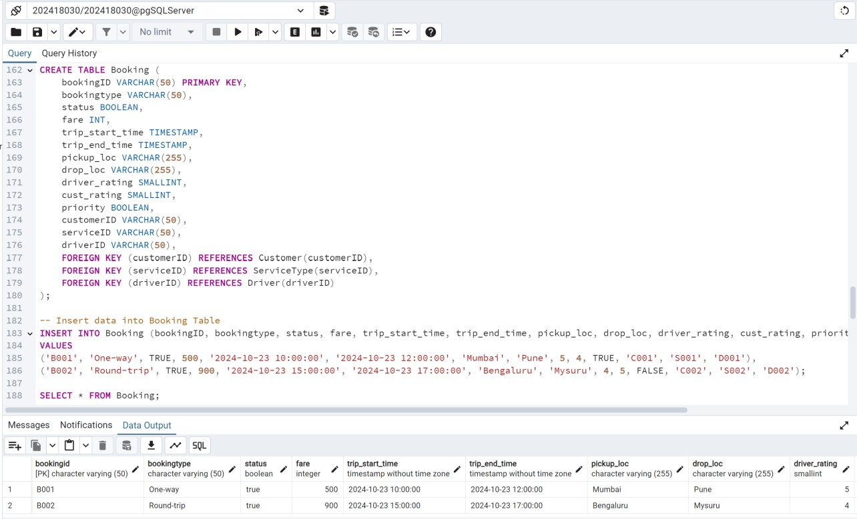

**Penalty’s Table**

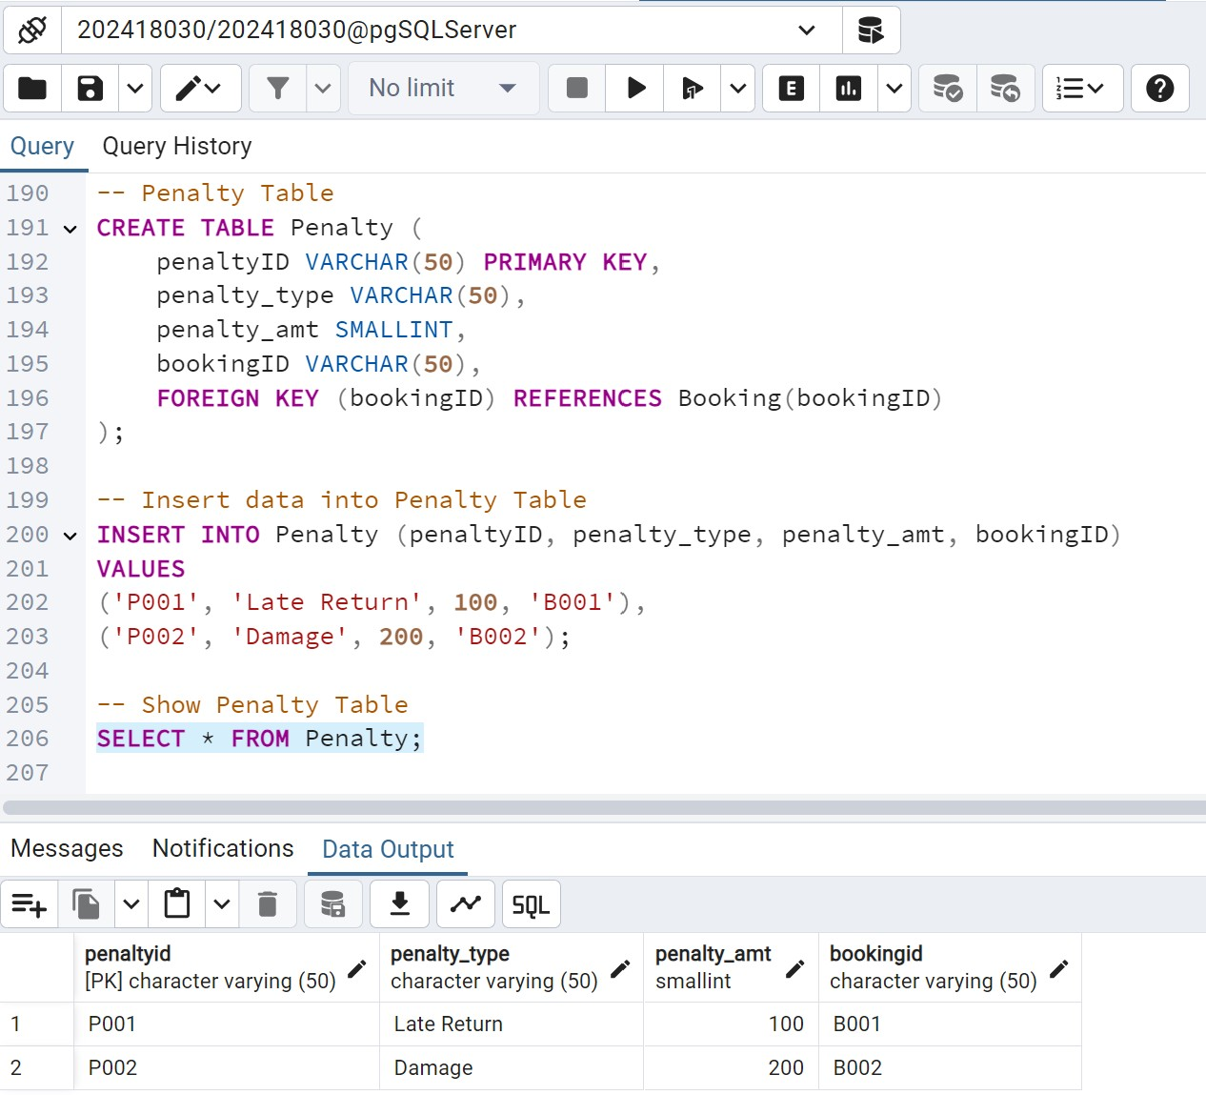

**Courier Service’s Table**

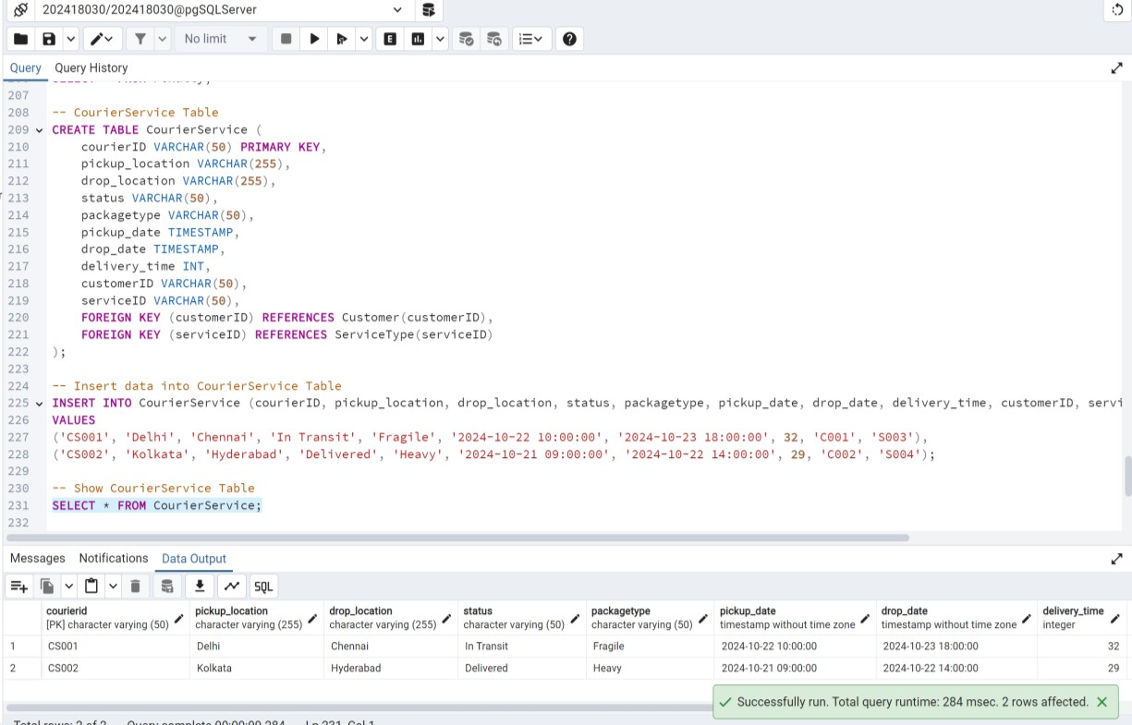

**Service’s Table**

