**1.) Write a program in vb.net to create a simple calculator. Draw below design and implement.**

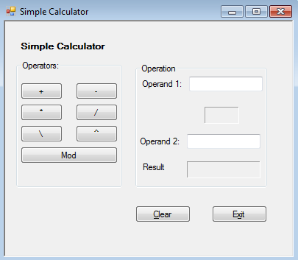

PublicClassForm1

PrivateSub Button1_Click(sender AsSystem.Object, e AsSystem.EventArgs) Handles Button1.Click

Dim A AsDouble

Dim B AsDouble

Dim result AsDouble

A = Double.Parse(TextBox1.Text)

B = Double.Parse(TextBox2.Text)

result = A + B

lbl.Text = "+"

TextBox3.Text = result.ToString("N")

EndSub

PrivateSub Button2_Click(sender AsSystem.Object, e AsSystem.EventArgs) Handles Button2.Click

Dim A AsDouble

Dim B AsDouble

Dim result AsDouble

A = Double.Parse(TextBox1.Text)

B = Double.Parse(TextBox2.Text)

result = A - B

lbl.Text = "-"

TextBox3.Text = result.ToString("N")

EndSub

PrivateSub Button3_Click(sender AsSystem.Object, e AsSystem.EventArgs) Handles Button3.Click

Dim A AsDouble

Dim B AsDouble

Dim result AsDouble

A = Double.Parse(TextBox1.Text)

B = Double.Parse(TextBox2.Text)

result = A * B

lbl.Text = "*"

TextBox3.Text = result.ToString("N")

EndSub

PrivateSub Button4_Click(sender AsSystem.Object, e AsSystem.EventArgs) Handles Button4.Click

Dim A AsDouble

Dim B AsDouble

Dim result AsDouble

A = Double.Parse(TextBox1.Text)

B = Double.Parse(TextBox2.Text)

result = A / B

lbl.Text = "/"

TextBox3.Text = result.ToString("N")

EndSub

PrivateSub Button5_Click(sender AsSystem.Object, e AsSystem.EventArgs) Handles Button5.Click

Dim A AsDouble

Dim B AsDouble

Dim result AsDouble

A = Double.Parse(TextBox1.Text)

B = Double.Parse(TextBox2.Text)

result = A Mod B

lbl.Text = "mod"

TextBox3.Text = result.ToString("N")

EndSub

EndClass

**Output:**

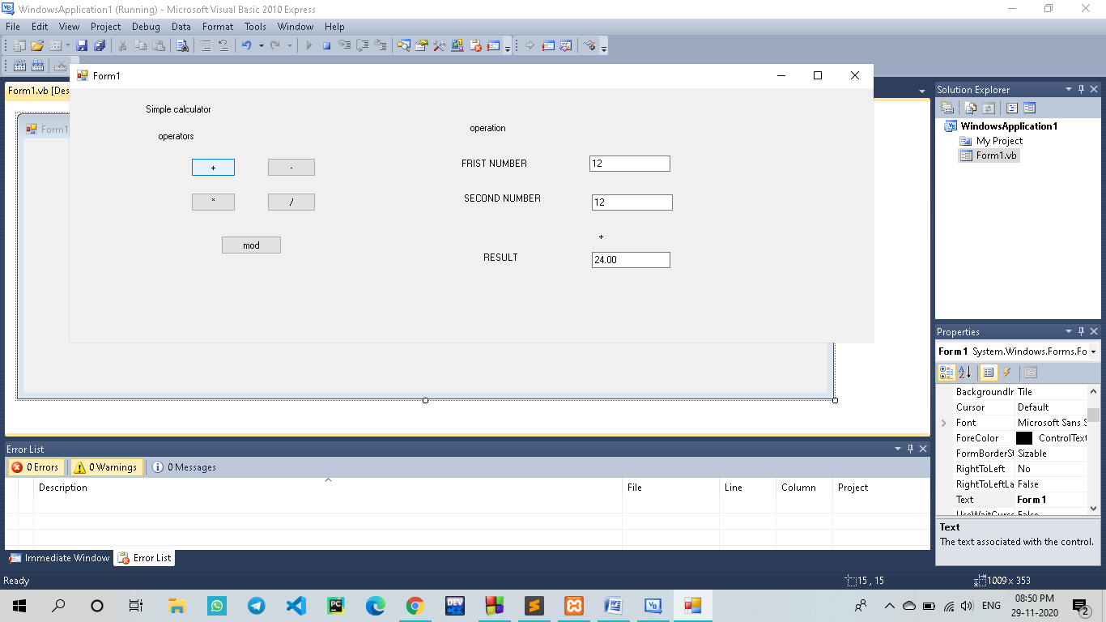

**2. Write a program in vb.net to How to Reverse Set of Numbers.**

ModuleModule1

SubMain()

Dim no, rev, temp AsInteger

Console.WriteLine("enter the no")

no = CInt(Console.ReadLine())

rev = 0

temp = no

While temp > 0

Dim t AsInteger

t = temp Mod 10

rev = rev * 10 + t

temp = temp / 10

EndWhile

Console.WriteLine("Reverse number=>" + rev.ToString())

Console.ReadKey()

EndSub

EndModule

**Output:**

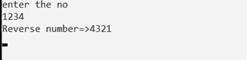

**3**.)**Write a Vb.net program to design the following form, select the question number from combo box that question will be displayed into textbox and the options for that question will be displayed on four radio buttons, select option and click on submit button result should be displayed in another textbox.**

PublicClassForm1

PrivateSub ComboBox1_SelectedIndexChanged(ByVal sender AsSystem.Object, ByVal e AsSystem.EventArgs) Handles ComboBox1.SelectedIndexChanged

IfComboBox1.SelectedItem() = "Question 1"Then

RichTextBox1.Text = "What is Capital Of India ?"

RadioButton1.Text = "Delhi"

RadioButton2.Text = "Pune"

RadioButton3.Text = "Mumbai"

RadioButton4.Text = "Chennai"

EndIf

IfComboBox1.SelectedItem() = "Question 2"Then

RichTextBox1.Text = "What is Capital Of Maharashtra ?"

RadioButton1.Text = "Pune"

RadioButton2.Text = "Nagpur"

RadioButton3.Text = "Mumbai"

RadioButton4.Text = "Nagar"

EndIf

IfComboBox1.SelectedItem() = "Question 3"Then

RichTextBox1.Text = "What is Capital Of Maharashtra ?"

RadioButton1.Text = "Pune"

RadioButton2.Text = "Nagpur"

RadioButton3.Text = "Mumbai"

RadioButton4.Text = "Nagar"

EndIf

EndSub

PrivateSub Button1_Click(ByVal sender AsSystem.Object, ByVal e AsSystem.EventArgs) Handles Button1.Click

Dim correct AsString

Dim wrong AsString

correct = "Answer is correct"

wrong = "Answer is wrong"

IfComboBox1.SelectedItem() = "Question 1"Then

If RadioButton1.Checked Then

TextBox1.Text = correct

ElseIf RadioButton2.Checked Then

TextBox1.Text = wrong

ElseIf RadioButton3.Checked Then

TextBox1.Text = wrong

ElseIf RadioButton4.Checked Then

TextBox1.Text = wrong

EndIf

EndIf

IfComboBox1.SelectedItem() = "Question 2"Then

If RadioButton1.Checked Then

TextBox1.Text = wrong

ElseIf RadioButton2.Checked Then

TextBox1.Text = wrong

ElseIf RadioButton3.Checked Then

TextBox1.Text = correct

ElseIf RadioButton4.Checked Then

TextBox1.Text = wrong

EndIf

EndIf

IfComboBox1.SelectedItem() = "Question 3"Then

If RadioButton1.Checked Then

TextBox1.Text = wrong

ElseIf RadioButton2.Checked Then

TextBox1.Text = wrong

ElseIf RadioButton3.Checked Then

TextBox1.Text = correct

ElseIf RadioButton4.Checked Then

TextBox1.Text = wrong

EndIf

EndIf

EndSub

EndClass

**Output:**

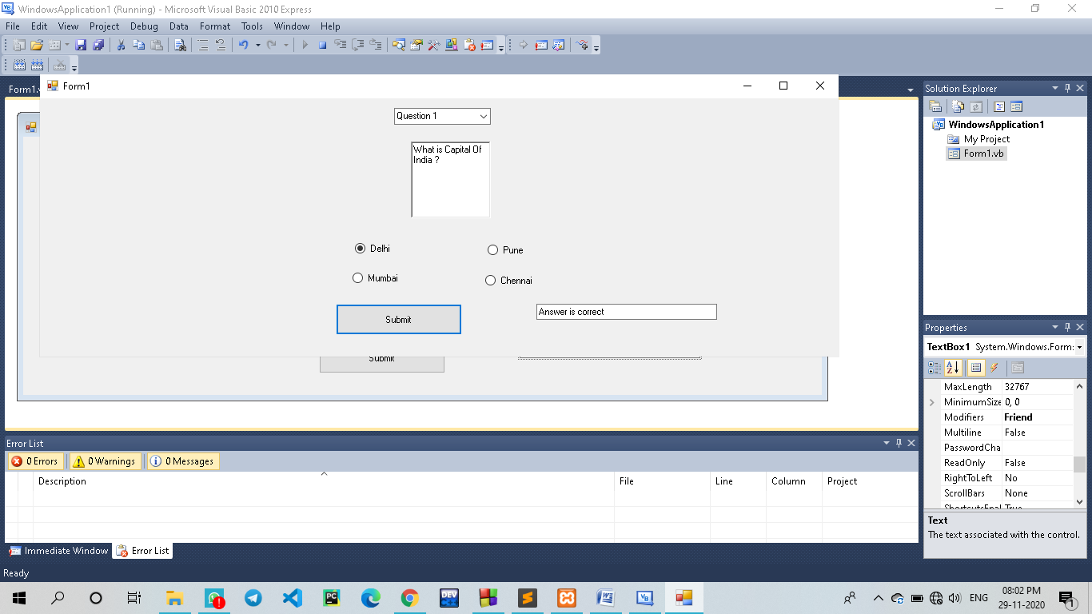

### 4.) Write a Vb.net program to accept number from user into the TextBox. Calculate the square root of that number also convert the entered number into binary number and display result into the Message Box.

### PublicClassForm1

### PrivateSub Button1_Click(sender AsSystem.Object, e AsSystem.EventArgs) Handles Button1.Click

Dim n AsInteger

DimsqrAsDouble

DimrmAsInteger

Dim str1 AsString

n = CInt(TextBox1.Text)

sqr = n * n

While n

rm = n Mod 2

str1 = str1 &rm

n = n \ 2

EndWhile

MessageBox.Show("Square Root :"&sqr&" Binary Number : "& str1)

StrReverse(str1)

EndSub

EndClass

**Output:**

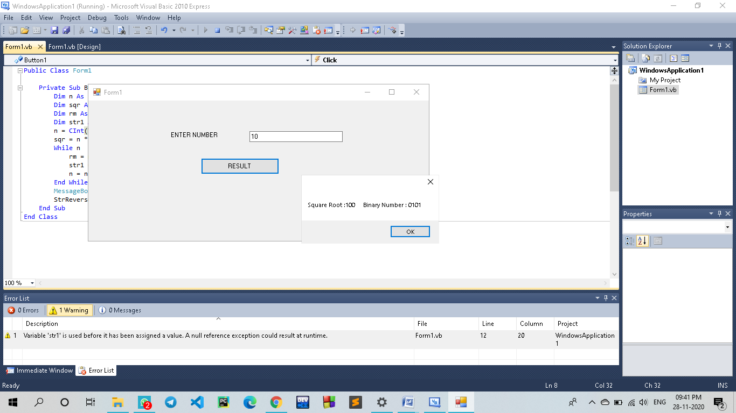

**5.)Write VB program to find octal, hexadecimal, binary of given decimal number.**

PublicClassForm1

Dim n AsInteger

DimbsAsString

PrivateSub Button2_Click(sender AsSystem.Object, e AsSystem.EventArgs) Handles Button2.Click

TextBox1.Text = " "

TextBox2.Text = " "

TextBox3.Text = " "

TextBox4.Text = " "

EndSub

PrivateSub Button1_Click(sender AsSystem.Object, e AsSystem.EventArgs) Handles Button1.Click

n = Val(TextBox1.Text)

bs = " "

While n > 0

bs = n Mod 2 &bs

n = n / 2

EndWhile

TextBox2.Text = bs

n = Val(TextBox1.Text)

TextBox3.Text = Oct(n)

TextBox4.Text = Hex(n)

EndSub

EndClass

**Output:-**

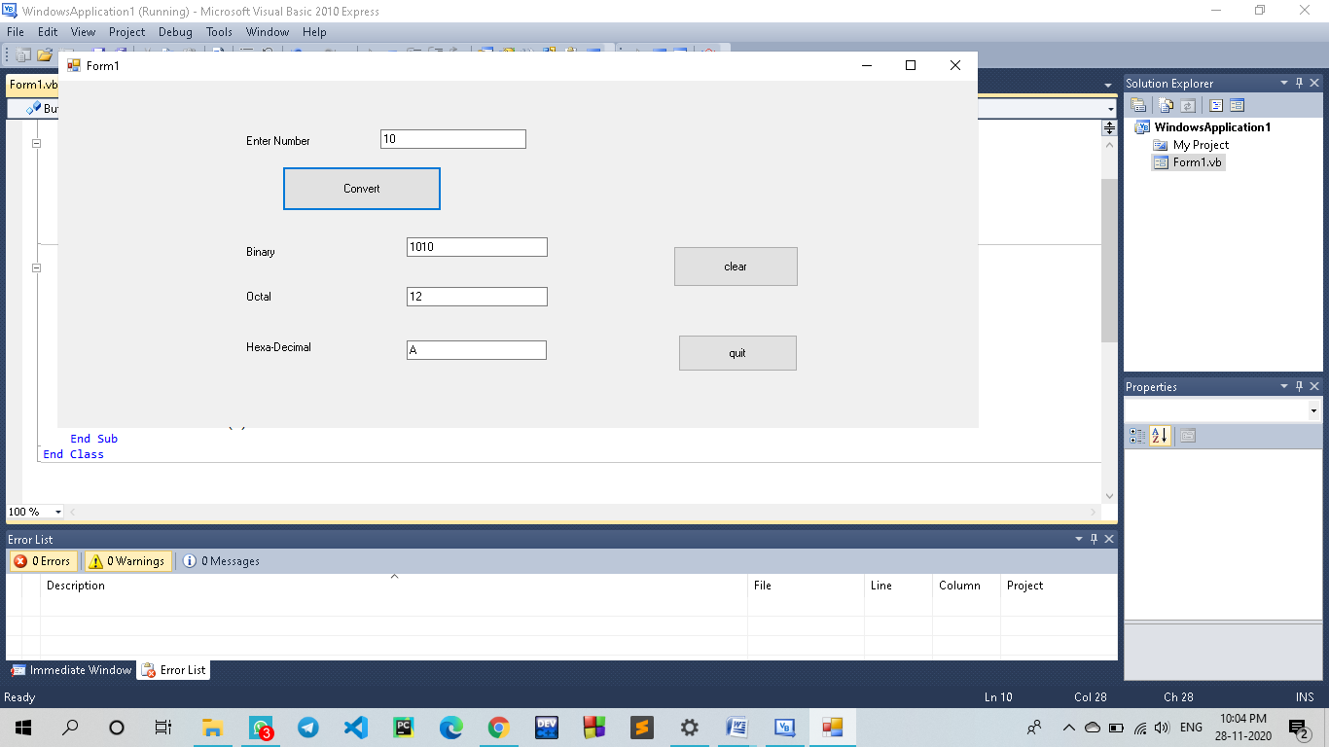

**6.)Write a program to find the sum, subtraction and Multiplication of two numbers using the function*.***

PublicClassForm1

Dim a AsInteger

Dim b AsInteger

PrivateSub Form1_Load(sender AsSystem.Object, e AsSystem.EventArgs) HandlesMyBase.Load

EndSub

PrivateSub Button1_Click(sender AsSystem.Object, e AsSystem.EventArgs) Handles Button1.Click

a = TextBox1.Text

b = TextBox2.Text

TextBox3.Text = a + b

EndSub

PrivateSub Button2_Click(sender AsSystem.Object, e AsSystem.EventArgs) Handles Button2.Click

a = TextBox1.Text

b = TextBox2.Text

TextBox3.Text = a - b

EndSub

PrivateSub Button3_Click(sender AsSystem.Object, e AsSystem.EventArgs) Handles Button3.Click

a = TextBox1.Text

b = TextBox2.Text

TextBox3.Text = a / b

EndSub

PrivateSub Button4_Click(sender AsSystem.Object, e AsSystem.EventArgs) Handles Button4.Click

a = TextBox1.Text

b = TextBox2.Text

TextBox3.Text = a * b

EndSub

EndClass

**Output:**

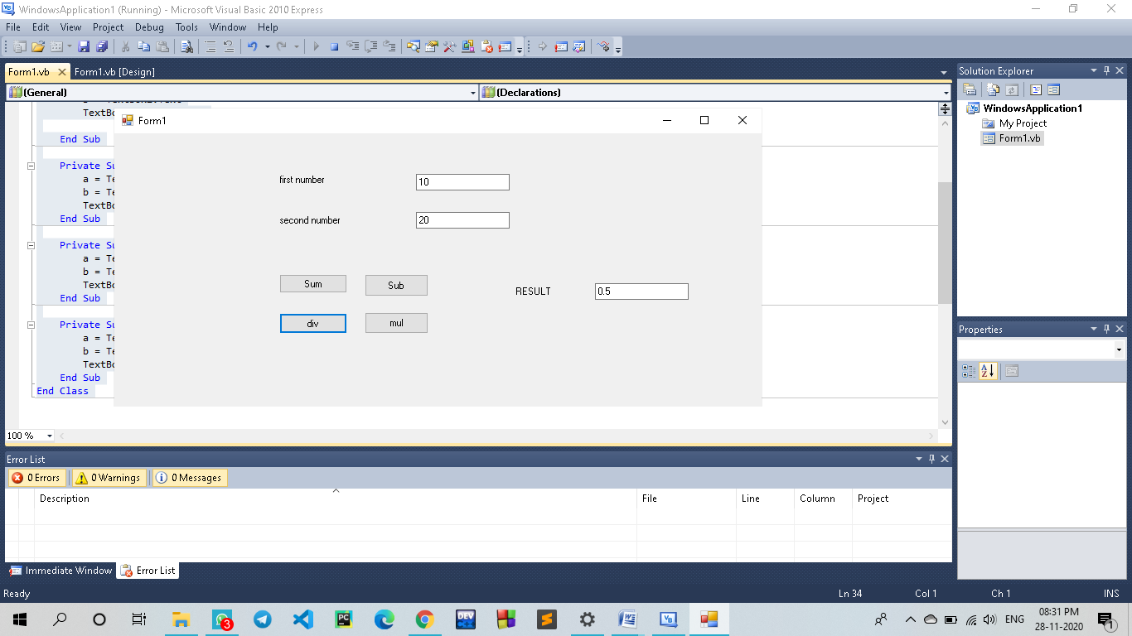

**7.)Write a program to reverse a number and check whether the given number is palindrome or not.**

ModuleModule1

SubMain()

Dim r, n, temp, sum AsInteger

n = 454 ' enter number

sum = 0

temp = n

While n > 0

r = n Mod 10

'getting remainder

sum = (sum * 10) + r

n = n / 10

EndWhile

If temp = sum Then

Console.WriteLine("palindrome number")

Else

Console.WriteLine("not palindrome")

EndIf

Console.ReadLine()

EndSub

EndModule

**Output:**

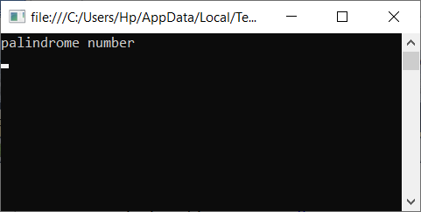

**8.)Create a program to find the Area and Parameter of a rectangle using the class and object in VB.NET.**

PublicModuleExercise

FriendClassRectangle

Public Length AsDouble

Public Height AsDouble

FunctionPerimeter() AsDouble

Return (Length + Height) * 2

EndFunction

Function Area#()

Return Length * Height

EndFunction

EndClass

PublicFunctionMain() AsInteger

Dim Recto AsRectangle

Recto = NewRectangle

Recto.Length = 42.58 :Recto.Height = 28.08

MsgBox("=-= Rectangle Characteristics =-="&vbCrLf& _

"Length: "&vbTab&vbTab&Recto.Length&vbCrLf& _

"Height: "&vbTab&vbTab&Recto.Height&vbCrLf& _

"Perimeter: "&vbTab&Recto.Perimeter() &vbCrLf& _

"Area: "&vbTab&vbTab&Recto.Area())

Return 0

EndFunction

EndModule

**Output:**

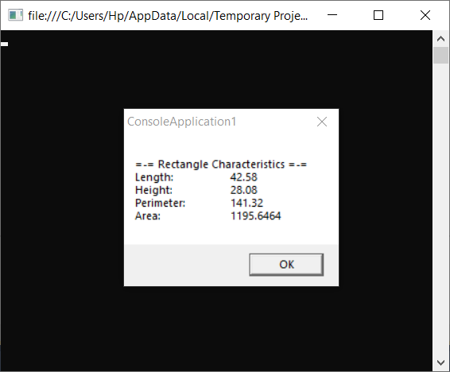

**9.)Create a program to define the default constructor and parameterized constructor in a VB.NET programming language.**

**Default constructor:-**

Module Module1

Class User

Public name, location AsString

PublicSubNew()

name = "PRIYANKA RAUTRAY"

location = "khapa"

EndSub

EndClass

SubMain()

Dim user As User = NewUser()

Console.WriteLine(user.name)

Console.WriteLine(user.location)

Console.WriteLine("Press Enter Key to Exit..")

Console.ReadLine()

EndSub

EndModule

**Parameterized constructor:-**

Module Module1

Class User

Public name, location AsString

PublicSubNew(ByVal a AsString, ByVal b AsString)

name = a

location = b

EndSub

EndClass

SubMain()

Dim user As User = NewUser("priyankarautray", "khapa")

Console.WriteLine(user.name)

Console.WriteLine(user.location)

Console.WriteLine("Press Enter Key to Exit..")

Console.ReadLine()

EndSub

**Output:**

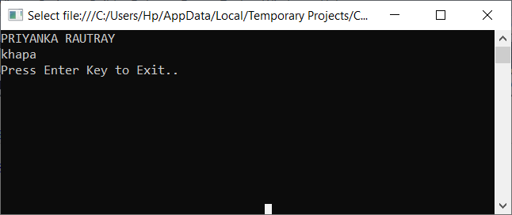

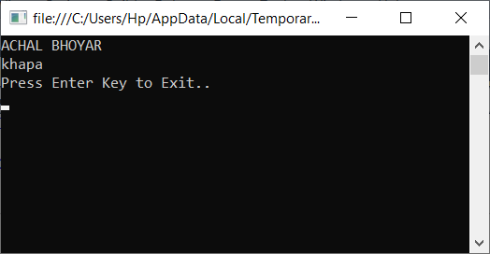

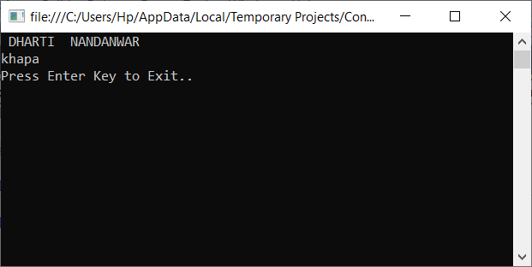

**10.)Create a program to understand the concept of Inheritance in VB.NET.**

Public Class User

Public Name As String

Private Location As String

Public Sub New()

Console.WriteLine("Base Class Constructor")

End Sub

Public Sub GetUserInfo(ByValloc As String)

Location = loc

Console.WriteLine("Name: {0}", Name)

Console.WriteLine("Location: {0}", Location)

End Sub

End Class

Public Class Details

Inherits User

Public Age As Integer

Public Sub New()

Console.WriteLine("Child Class Constructor")

End Sub

Public Sub GetAge()

Console.WriteLine("Age: {0}", Age)

End Sub

End Class

Class Program

Public Shared Sub Main(ByValargs As String())

Dim d As Details = New Details()

d.Name = "SagarSatpute"

d.Age = 20

d.GetUserInfo("pipla (da.b)")

d.GetAge()

Console.WriteLine(vbLf&"Press Any Key to Exit..")

Console.ReadLine()

End Sub

End Class

**Output:**

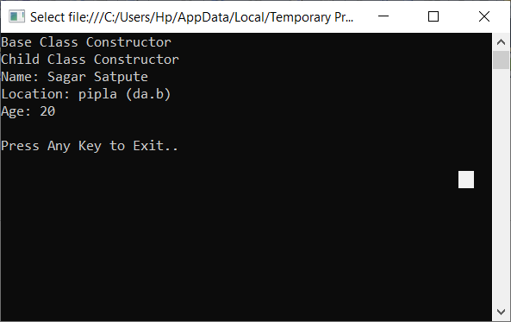

**11.)Create and implement an instance using a class in VB.NET**

Modulemybox

ClassBox

Public length AsDouble

Public breadth AsDouble

Public height AsDouble

EndClass

SubMain()

Dim Box1 AsBox = NewBox()

Dim Box2 AsBox = NewBox()

Dim volume AsDouble = 0.0

Box1.height = 5.0

Box1.length = 6.0

Box1.breadth = 7.0

Box2.height = 10.0

Box2.length = 12.0

Box2.breadth = 13.0

volume = Box1.height * Box1.length * Box1.breadth

Console.WriteLine("Volume of Box1 : {0}", volume)

volume = Box2.height * Box2.length * Box2.breadth

Console.WriteLine("Volume of Box2 : {0}", volume)

Console.ReadKey()

EndSub

EndModule

**Output:**

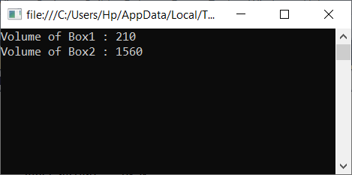

**12.) Create a program to handle an exception using the Try, Catch, and Finally keywords for dividing a number by zero in VB.NET programming.**

Module Module1

SubdivisionFunction(ByVal n1 AsInteger, ByVal n2 AsInteger)

Dim answer AsInteger

Try

answer = n1 \ n2

Catch ex AsDivideByZeroException

Console.WriteLine("Exception: {0}", ex)

Finally

Console.WriteLine("Answer is: {0}", answer)

EndTry

EndSub

SubMain()

divisionFunction(4, 0)

Console.ReadKey()

EndSub

EndModule

**Output:-**

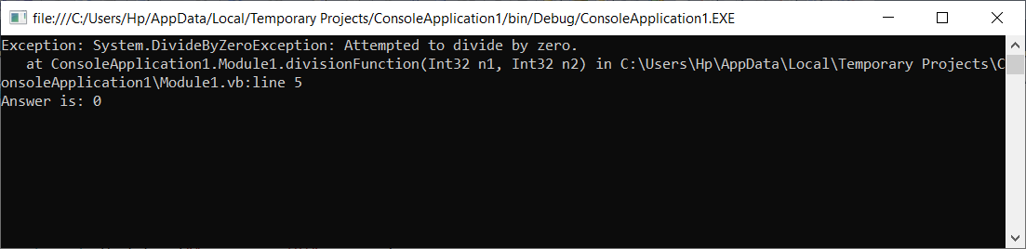

**13.)Create a program to display the multiple windows in the**[**VB.NET**](https://www.javatpoint.com/vb-net)**Windows Forms.**

PublicClassForm1

PrivateSubFirstpage(sender AsSystem.Object, e AsSystem.EventArgs) HandlesMyBase.Load

EndSub

PrivateSub Button1_Click(sender AsSystem.Object, e AsSystem.EventArgs) Handles Button1.Click

DimSecondFormAsNewfrmSecond

SecondForm.Show()

EndSub

EndClass

**Output:**

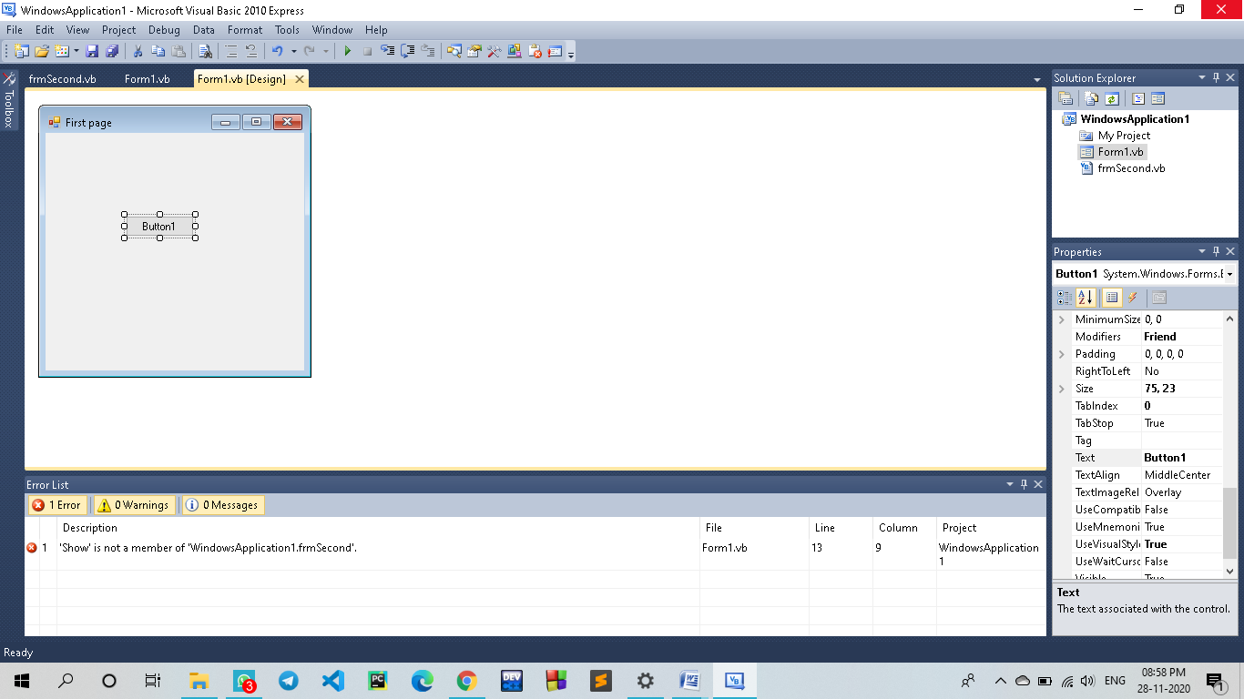

**14.) Create a simple program to understand the use of Timer Control in the VB.NET Windows Forms.**

**Code:**

PublicClassTimerProgram

PrivateSubTimerProgram_Load(sender AsObject, e AsEventArgs) HandlesMyBase.Load

Me.Text = "BCA"'Set the title for a Windows Form

Label1.Text = "WELCOME TO Visual Basic "

TextBox1.Text = 1

Timer1.Enabled = True

Button1.Text = "Start"

Button1.BackColor = Color.Blue

Button1.ForeColor = Color.White

Button2.Text = "Stop"

Button2.BackColor = Color.Red

Button2.ForeColor = Color.White

Timer1.Start()

Timer1.Interval = 600 'set the time interval

EndSub

PrivateSub Timer1_Tick(sender AsObject, e AsEventArgs) Handles Timer1.Tick

If Label1.ForeColor = Color.RedThen

Label1.ForeColor = Color.Blue

ElseIf Label1.ForeColor = Color.BlueThen

Label1.ForeColor = Color.Red

EndIf

TextBox1.Text = TextBox1.Text + 1 'Incremenet the TextBox1 by 1

EndSub

PrivateSub Button2_Click(sender AsObject, e AsEventArgs) Handles Button2.Click

Timer1.Stop() ' Stop the timer

EndSub

PrivateSub Button1_Click(sender AsObject, e AsEventArgs) Handles Button1.Click

Timer1.Start() 'Start the timer

EndSub

EndClass

**Output:**

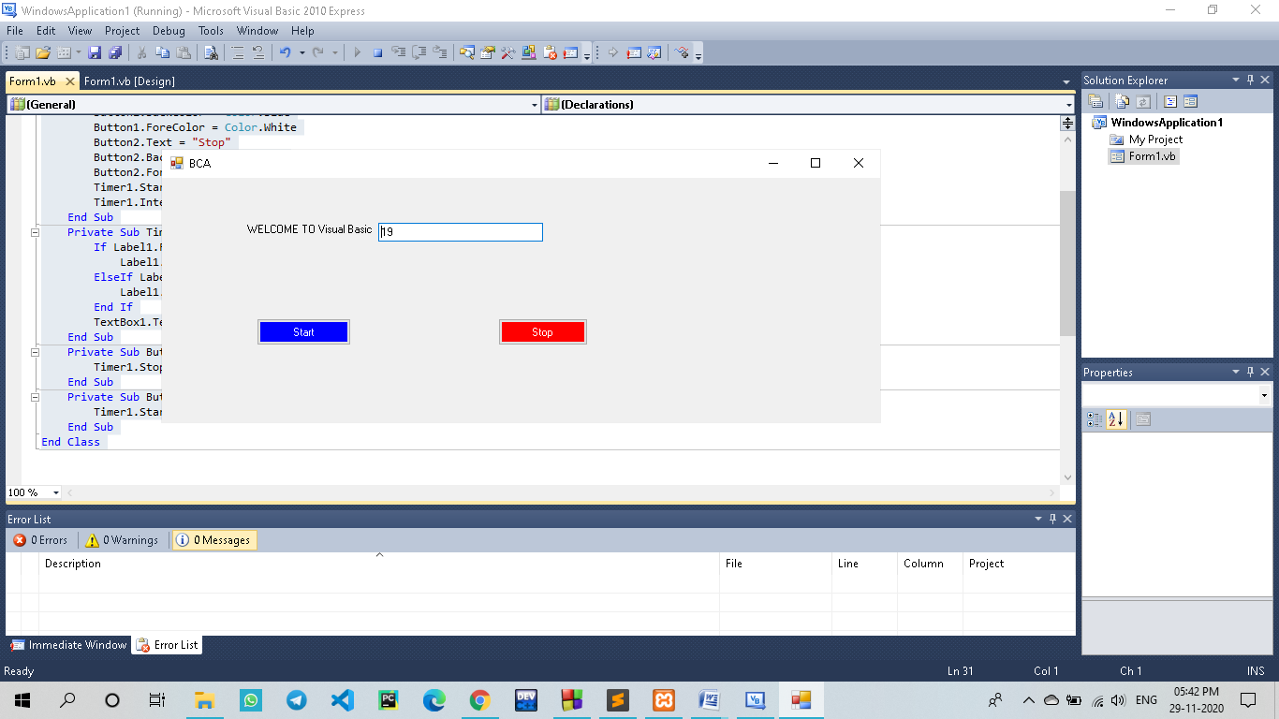

**15.) Write VB program that moves image left or right using click event.**

PublicClassForm1

PrivateSub Button1_Click(ByVal sender AsSystem.Object, ByVal e AsSystem.EventArgs) Handles Button1.Click

If PictureBox1.Left <= 0 Then

PictureBox1.Left = 0

Else

PictureBox1.Left = PictureBox1.Left - 10

EndIf

EndSub

PrivateSub Button2_Click(ByVal sender AsSystem.Object, ByVal e AsSystem.EventArgs) Handles Button2.Click

If PictureBox1.Left >= 5000 Then

PictureBox1.Left = 5000

Else

PictureBox1.Left = PictureBox1.Left + 10

EndIf

EndSub

EndClass

**Output:**

