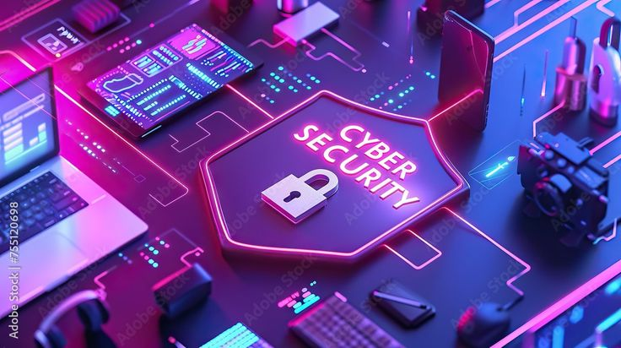
ABOUT TASK 5

During my research on UPI fraud, I was surprised to learn that people can be easily tricked into losing money by using simple methods like fake calls and QR codes. Many people do not know that they do not need to put in their UPI PIN to receive money, which is one of the common ways fraudsters trick people.

This task has helped me realize the importance of being cautious while using digital payment platforms. One thing I have learned from this task is that I will never agree to any unknown payment requests and will never disclose my details to anyone.

This task has helped me learn about real-life cyber threats and the importance of being digitally aware in real life.

