PropertyPointers
Homepage Section-Change
With Screenshot References, Red-Marked Removal Items & Developer-Ready Replacement Copy
Prepared for: PropertyPointers
Objective: Reposition the homepage from a generic listing portal to India’s complete real estate ecosystem for Properties, Developers, Realty Advisors, Vendors, Tools, Insights and Reports.

Uploaded Screenshots Included in This Report
Section | Screenshot File | Primary Audit Focus
Header Section | Header section .png | Navigation, ecosystem menu depth, business CTAs
Hero Banner Section | hero banner section.png | Positioning, search, trust claims and stats
Explore By Category Section | expoler by cat section .png | Category SEO and buyer-intent expansion
Featured Properties Section | featured properties section .png | Property card quality, crawlability and conversion
List Property CTA Section | above blog section.png | Lead capture expansion beyond property owners
Blog / Insights Section | blog section .png | Content authority and SEO funnel improvement
Service Areas Section | we serve section.png | City SEO, image accuracy and local discovery
Why PropertyPointers Section | why property pointers section .png | Risky claims and ecosystem replacement copy
Testimonials Section | testimonal section .png | Credibility, proof and safer review language
Footer Section | footer section .png | Ecosystem footer links, trust alignment and newsletter

Legend
RED = Remove / change / legally risky | GREEN = Recommended replacement copy | BLUE = Design / SEO / developer notes

Final recommended positioning:
Beyond Listings. India’s Complete Real Estate Ecosystem.
Discover properties, compare developers, connect with realty advisors, explore trusted real estate vendors, and make smarter property decisions with insights and tools.
The homepage should become the central landing page for five business engines:
- Buyer and tenant property discovery
- Developer / builder project visibility and paid packages
- Realty advisor onboarding and profile monetisation
- Vendor marketplace onboarding and category sponsorships
- SEO traffic through city pages, locality pages, blogs, calculators

Immediate Red-Mark Removal List
REMOVE / CHANGE | REPLACEMENT / REASON
India’s #1 Trusted Real Estate Platform | Remove unless legally and data-backed. Use: India’s Complete Real Estate Ecosystem.
Find Your Dream Property Today | Too generic. Use: Beyond Listings. India’s Complete Real Estate Ecosystem.
100% Verified Listings | Risky if every listing is not independently verified. Use: Quality-Checked Listings Where Marked.
Zero Brokerage / No Middlemen | Conflicts with broker/advisor/partner model. Use: Direct & Advisor-Assisted Property Discovery.
All listed projects are RERA compliant | Risky unless verified for every project. Use: RERA Details Where Available.
Rated 4.8/5 by over 1 million customers | Remove unless actual verified proof exists. Use: Built for trust, transparency and better decisions.
Reach millions of potential buyers | Avoid unless verified traffic supports this. Use: Reach active property seekers and real estate professionals.
Testimonials with unverified names/claims | Rename to Early User Feedback or add verified source, user type, city and date.

1. Header / Navigation Section
Priority: Very High | Timeline: 48 hours
Uploaded screenshot reference: Header Section
Point | Details
CURRENT SCREENSHOT OBSERVATION | Header currently shows logo, All India, Buy, Rent, Developers, Partners, Vendors, Insights, About, Careers, Post Property FREE, Login and Register. The structure is clean, but it still behaves like a normal property portal menu instead of an ecosystem menu.
REMOVE / CHANGE IMMEDIATELY | Remove or change “Partners” as the main public label because it is vague. Do not keep About and Careers as high-priority space if the business goal is onboarding developers/advisors/vendors. Do not rely on only “Post Property FREE” as the main CTA because it targets only property owners.
RECOMMENDED REPLACEMENT | Rename “Partners” to “Realty Advisors”. Add a second CTA: “Join Partner Program”. Add mega menu groups: Developers, Realty Advisors, Vendors, Insights and Tools. Keep About/Careers under Company or move them after main business CTAs.
WHY THIS CHANGE IS NEEDED | The first impression must show that PropertyPointers is an ecosystem: Properties + Developers + Advisors + Vendors. Header menu is the most important conversion map for users and partners.
IMAGE / DESIGN FORMAT | Use a sticky header with subtle shadow. Add icons in mega menu: building for Developers, person + location pin for Realty Advisors, tools/grid for Vendors, chart/report for Insights, calculator for Tools. Use gold highlight only for CTAs.
DEVELOPER / SEO NOTES | Track header CTA clicks separately: post_property_click, join_partner_click, list_project_click, join_advisor_click, list_service_click. Use SEO-friendly href URLs, not only JavaScript dropdown actions.

2. Hero Banner + Search + Stats Section
Priority: Very High | Timeline: 48 hours
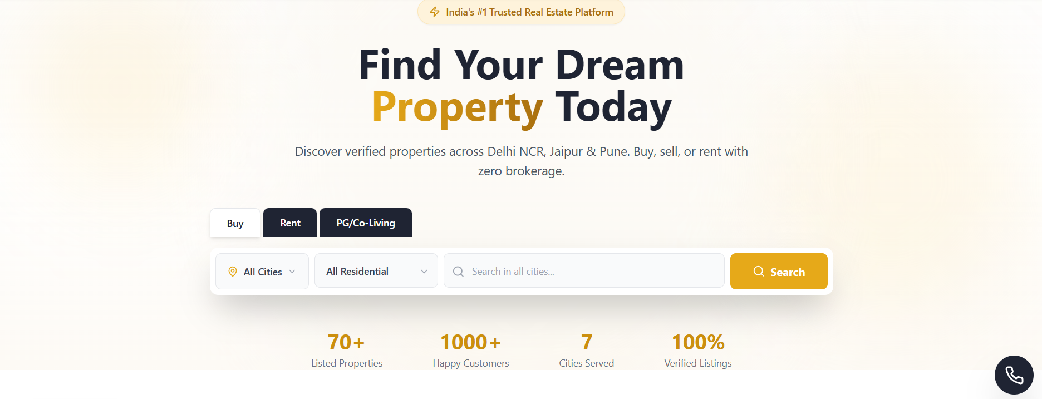

Point | Details
CURRENT SCREENSHOT OBSERVATION | Hero currently says “India’s #1 Trusted Real Estate Platform”, “Find Your Dream Property Today”, and “Discover verified properties across Delhi NCR, Jaipur & Pune. Buy, sell, or rent with zero brokerage.” Search is focused on Buy, Rent, PG/Co-Living. Stats show 70+ listed properties, 1000+ happy customers, 7 cities served, 100% verified listings.
REMOVE / CHANGE IMMEDIATELY | Remove: “India’s #1 Trusted Real Estate Platform”, “Find Your Dream Property Today”, “verified properties” if not fully verified, “zero brokerage”, “1000+ happy customers” unless proven, and “100% Verified Listings”.
RECOMMENDED REPLACEMENT | Use heading: “Beyond Listings. India’s Complete Real Estate Ecosystem.” Subline: “Discover properties, compare developers, connect with realty advisors, explore trusted real estate vendors, and make smarter property decisions with insights and tools.” CTAs: Explore Properties | List Your Project | Join as Realty Advisor | List Your Service. Search tabs: Buy | Rent | Commercial | Developers | Advisors | Vendors.
WHY THIS CHANGE IS NEEDED | Hero has only 3 seconds to establish market positioning. The current copy does not explain your biggest advantage: developers, advisors, vendors, tools and insights in one platform.
IMAGE / DESIGN FORMAT | Keep the current clean white/gold look or upgrade to a premium white-to-soft-gold gradient with a right-side ecosystem visual: property card + developer card + advisor profile + vendor category + analytics overlay. Use a glass search module with rounded corners and popular search chips.
DEVELOPER / SEO NOTES | Stats should be database-driven. If counts are dynamic, show actual values. Search tabs should lead to separate indexable result pages such as /properties?type=sale, /developers, /realty-advisors, /vendors.

3. Explore By Category Section
Priority: Medium to High
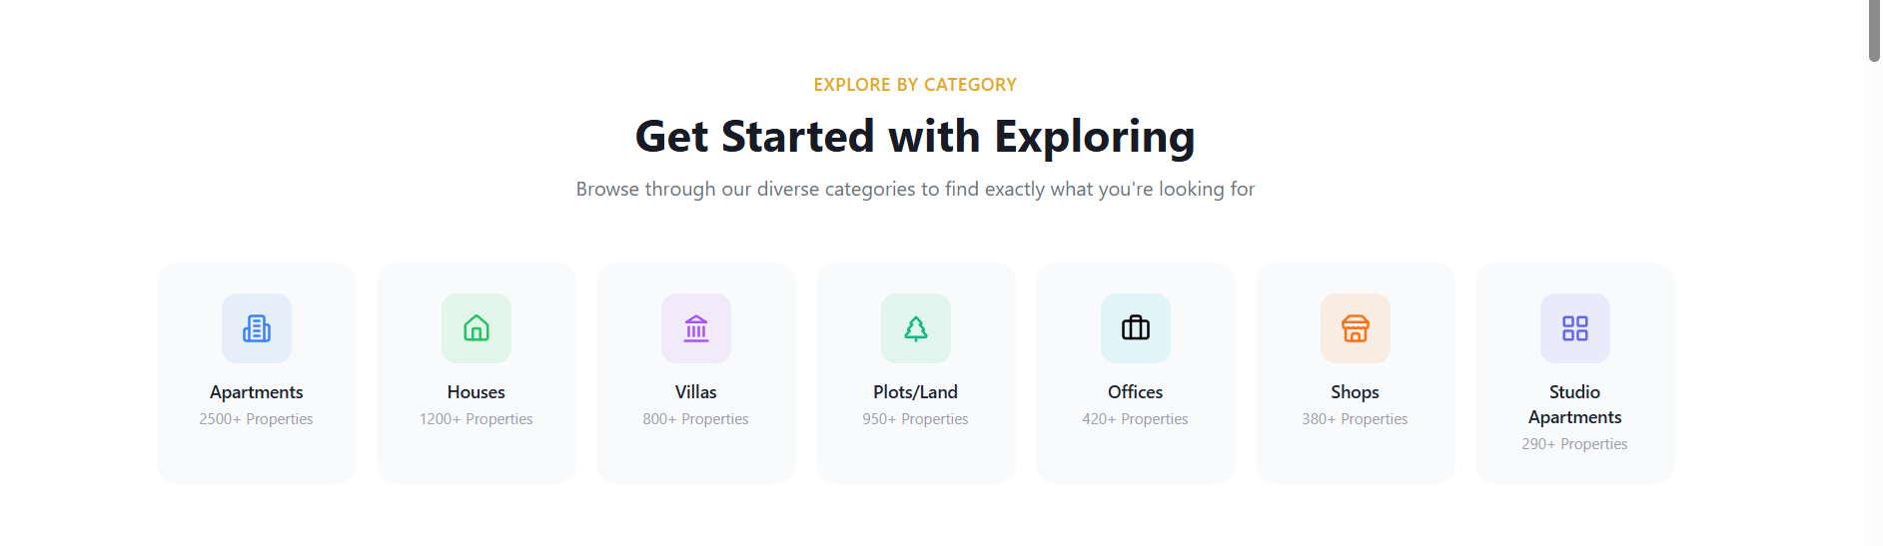

Point | Details
CURRENT SCREENSHOT OBSERVATION | Current section says “Get Started with Exploring” and shows Apartments, Houses, Villas, Plots/Land, Offices, Shops and Studio Apartments with property counts. The layout is clean but basic.
REMOVE / CHANGE IMMEDIATELY | Change generic heading “Get Started with Exploring”. Do not show inflated category counts unless they match actual inventory. Do not keep only basic residential categories.
RECOMMENDED REPLACEMENT | Heading: “Explore Real Estate Opportunities”. Categories: Apartments, Independent Houses, Villas, Plots & Land, Commercial Offices, Retail Shops, Studio Apartments, New Launch Projects, Ready-to-Move Properties, Investment Properties, Luxury Properties, Commercial Investment.
WHY THIS CHANGE IS NEEDED | Category cards should map to real buyer intent and SEO pages. Commercial, investment, new launch and ready-to-move categories can generate higher-value leads than generic browsing.
IMAGE / DESIGN FORMAT | Convert icon-only cards into image-led or hybrid cards. Keep icon top + property count, but add a short one-line value: “For end users”, “For rental income”, “For commercial investment”.
DEVELOPER / SEO NOTES | Each category must link to an SEO-friendly URL, e.g., /flats-for-sale, /commercial-property, /shops-for-sale, /new-launch-projects, /ready-to-move-properties. Add alt text and schema breadcrumbs.

4. Featured Properties Section
Priority: High
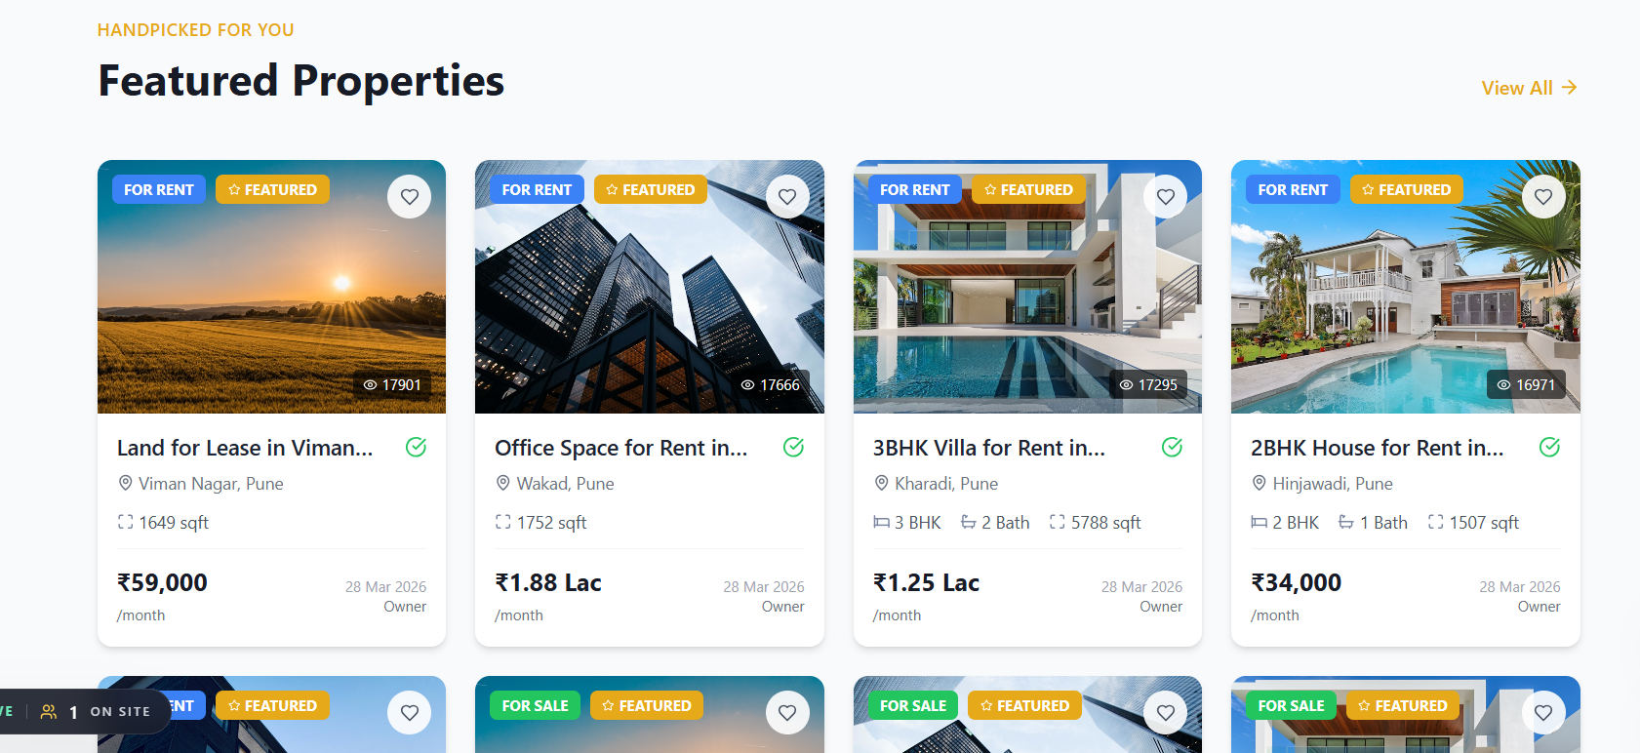

Point | Details
CURRENT SCREENSHOT OBSERVATION | Featured property cards show rent/sale badges, images, views, truncated titles, locality, size, price and owner. Most visible properties are from Pune and the image quality is inconsistent.
REMOVE / CHANGE IMMEDIATELY | Remove fake-looking view counts if not tracked accurately. Avoid repeated/random stock images. Avoid truncated property titles as the only visible title. Do not rely only on image cards if text is not crawlable.
RECOMMENDED REPLACEMENT | Each card should show: full property name, city/locality, property type, price, size, possession, posted by, RERA details where available, quality-checked badge where marked, CTA: View Details | WhatsApp/Enquire. Add tabs: Residential | Commercial | New Launch | Investment.
WHY THIS CHANGE IS NEEDED | Featured properties should support conversion and SEO. If property information is incomplete or not credible, users will not enquire and Google will not understand the listing inventory.
IMAGE / DESIGN FORMAT | Use consistent 16:9 property images. Add badges sparingly: For Sale/For Rent, Featured, RERA Details Available, Developer Listed, Owner Listed. Replace green tick icon with a clear tooltip: “Quality-checked where marked”.
DEVELOPER / SEO NOTES | Server-render property card text. Add structured data where appropriate. Link every card to a unique detail page. Track card view, wishlist, view details, WhatsApp and enquiry events.

5. List Property CTA / Lead Capture Section
Priority: Very High


Point | Details
CURRENT SCREENSHOT OBSERVATION | Current CTA says “Ready to List Your Property?” and asks property owners to list for free and reach millions of potential buyers and tenants.
REMOVE / CHANGE IMMEDIATELY | Remove “reach millions” unless supported by actual traffic. Do not make the only CTA about property owners. This ignores developers, advisors, vendors and buyer requirements.
RECOMMENDED REPLACEMENT | Replace with “What Are You Looking For?” Four cards: I want to buy/rent property | I am a developer/builder | I am a realty advisor | I am a vendor/service provider. Add CTA buttons: Share Requirement | List Project | Join Advisor Network | List Service.
WHY THIS CHANGE IS NEEDED | PropertyPointers revenue will come from multiple user types. This section should become the main conversion hub for the ecosystem, not only a property posting box.
IMAGE / DESIGN FORMAT | Use four equal cards with different icons and light background. Add a dark/gold “Early Partner Program” strip below for developers, advisors and vendors.
DEVELOPER / SEO NOTES | Use separate forms and CRM routing by user type. Buyer fields: budget, location, property type, timeline. Developer fields: company, project, city, RERA details. Advisor fields: specialisation, city. Vendor fields: category, portfolio, city coverage.

6. Blog / Latest Insights Section
Priority: High
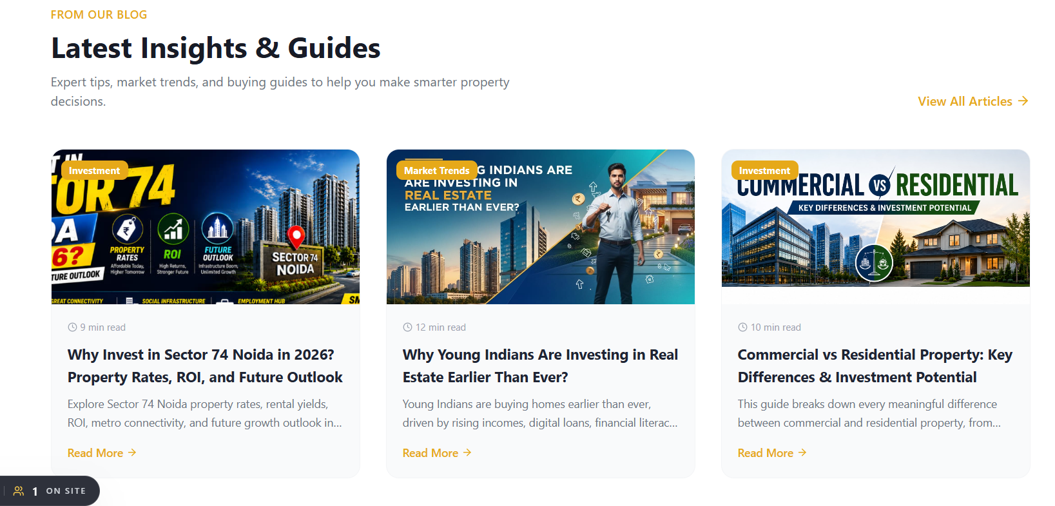

Point | Details
CURRENT SCREENSHOT OBSERVATION | Current blog section shows 3 visible cards: Sector 74 Noida investment, Young Indians investing in real estate, and Commercial vs Residential property. Cards have thumbnails, reading time, title, excerpt and read more.
REMOVE / CHANGE IMMEDIATELY | Do not use overly crowded thumbnail designs with too much text. Do not limit blogs to only general buyer content. Do not hide developer/advisor/vendor education content.
RECOMMENDED REPLACEMENT | Heading: “Latest Real Estate Insights”. Add tabs: Market Trends | Locality Guides | RERA & Legal | Developer Growth | Advisor Growth | Vendor Opportunities. Show 6 cards on desktop, not only 3.
WHY THIS CHANGE IS NEEDED | Content must support both traffic and business onboarding. Blogs should bring buyers from Google and also educate developers, advisors and vendors to join the ecosystem.
IMAGE / DESIGN FORMAT | Use cleaner editorial thumbnails with less text, city tag, category badge, reading time, updated date and author. Add “View All Articles” plus “Download Market Report” CTA.
DEVELOPER / SEO NOTES | Interlink blogs to city pages, locality pages, property pages, developer pages, advisor landing page, vendor landing page and calculators. Add Article schema and FAQ sections in relevant posts.

7. Service Areas / City Section
Priority: High
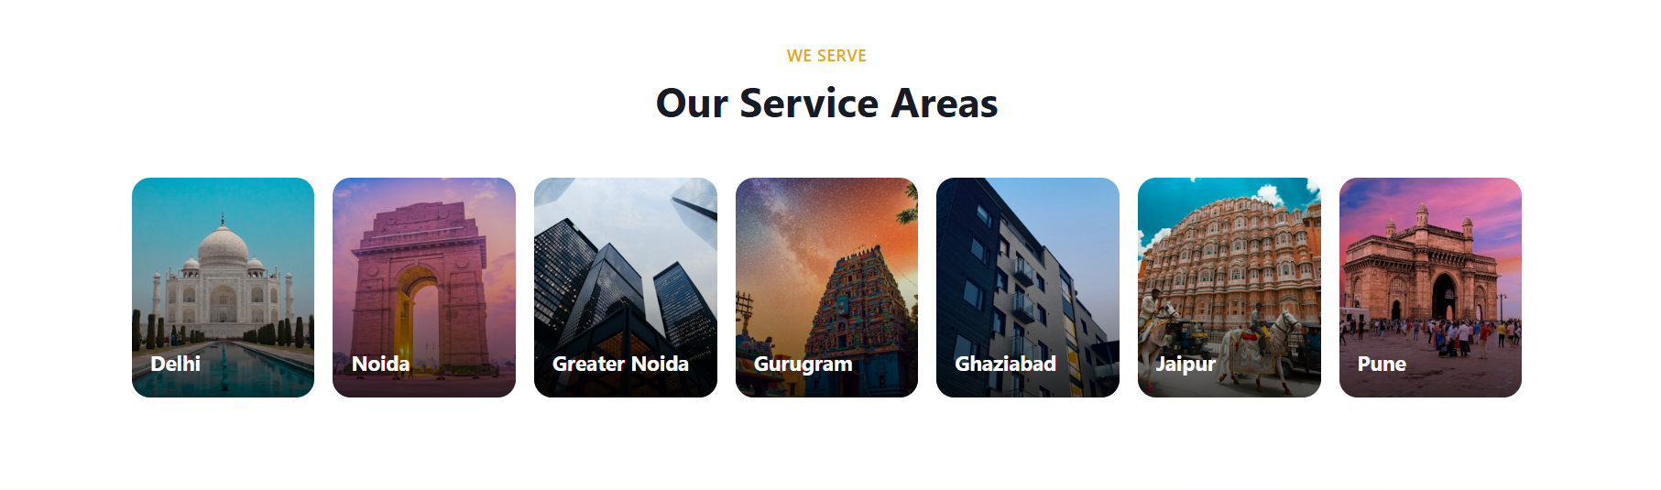

Point | Details
CURRENT SCREENSHOT OBSERVATION | Current “Our Service Areas” section shows city cards for Delhi, Noida, Greater Noida, Gurugram, Ghaziabad, Jaipur and Pune with large images.
REMOVE / CHANGE IMMEDIATELY | Do not use inaccurate or generic city images. Example: Noida should not be represented by India Gate. Gurugram should use corporate skyline, not unrelated religious/heritage imagery. Do not keep cards without SEO details.
RECOMMENDED REPLACEMENT | Rename heading to “Explore Properties by City”. Each card should show city name, property count, top localities, top property types, starting budget and CTA: Explore City.
WHY THIS CHANGE IS NEEDED | City pages are a major SEO engine. Users search “property in Noida”, “flats in Gurgaon”, “commercial property in Delhi NCR”. Service area cards should push users into city landing pages.
IMAGE / DESIGN FORMAT | Use city-relevant skyline/map images: Noida expressway/sector skyline, Gurugram corporate towers, Greater Noida township/expressway, Delhi cityscape, Jaipur city/modern-historic blend, Pune IT skyline.
DEVELOPER / SEO NOTES | Link cards to dedicated city pages with crawlable content: /properties-in-noida, /properties-in-gurugram, etc. Add city schema, FAQs and internal links to popular localities.

8. Why PropertyPointers Section
Priority: Very High
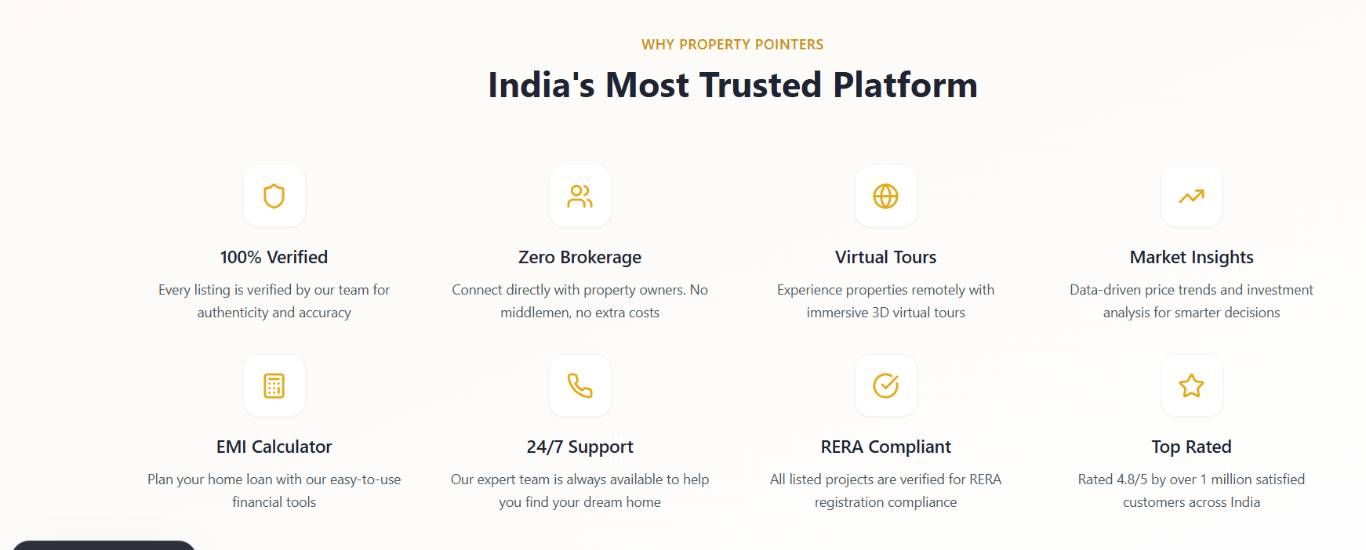

Point | Details
CURRENT SCREENSHOT OBSERVATION | Current section says “India’s Most Trusted Platform” and includes 100% Verified, Zero Brokerage, Virtual Tours, Market Insights, EMI Calculator, 24/7 Support, RERA Compliant and Top Rated.
REMOVE / CHANGE IMMEDIATELY | Remove or soften: “India’s Most Trusted Platform”, “100% Verified”, “Zero Brokerage”, “RERA Compliant”, “Top Rated”, “Rated 4.8/5 by over 1 million satisfied customers”, and “24/7 Support” if support is not truly 24/7.
RECOMMENDED REPLACEMENT | Use heading: “Why PropertyPointers”. Cards: Beyond Listings, Transparent Discovery, Developer Profiles, Realty Advisor Network, Vendor Marketplace, Smart Tools, Market Insights, Assisted Journey.
WHY THIS CHANGE IS NEEDED | The current section is high-risk because several claims may be difficult to prove and conflict with the platform’s broader advisor/vendor model. This section should explain differentiation, not make blanket claims.
IMAGE / DESIGN FORMAT | Use 8 clean icon cards. Keep gold icon styling but add more meaningful visuals: network, developer building, advisor profile, vendor tools, calculator, report, checklist, assisted journey.
DEVELOPER / SEO NOTES | Each card should link to supporting pages: /trust-and-safety, /developers, /realty-advisors, /vendors, /calculator, /blog, /market-reports.

9. Testimonials / Reviews Section
Priority: High
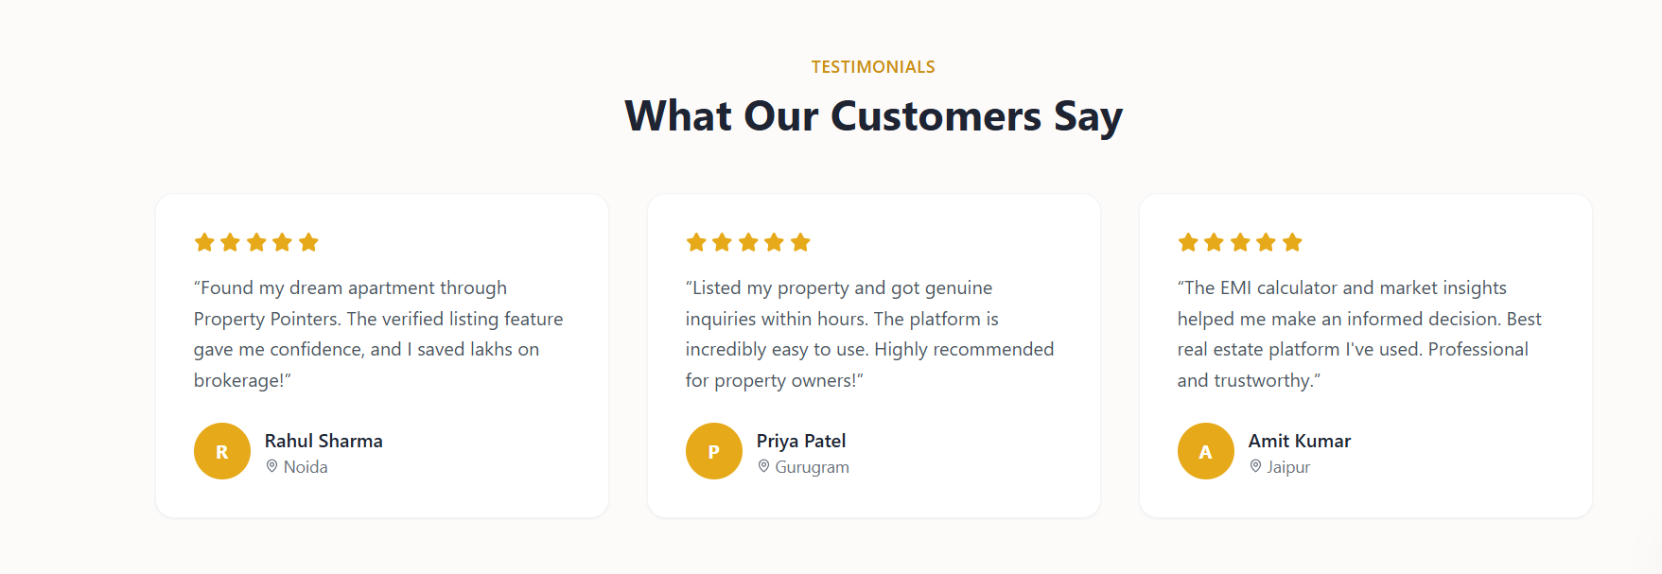

Point | Details
CURRENT SCREENSHOT OBSERVATION | Current section says “What Our Customers Say” and shows three testimonial cards with star ratings and names: Rahul Sharma, Priya Patel and Amit Kumar.
REMOVE / CHANGE IMMEDIATELY | Remove or rename if reviews are not verified. Avoid claims like “saved lakhs on brokerage”, “genuine inquiries within hours”, or “best real estate platform” unless these are actual verified testimonials with consent.
RECOMMENDED REPLACEMENT | Rename section to “Early User Feedback” until verified reviews are collected. Add user type, city, date and verification status. Example: “Buyer Feedback · Noida · March 2026”. Add disclaimer line: “Feedback reflects individual experiences and may vary.”
WHY THIS CHANGE IS NEEDED | Credible social proof helps conversion; fake or unverified reviews reduce trust. Developers and serious partners will check whether the claims look genuine.
IMAGE / DESIGN FORMAT | Use cleaner testimonial cards with user initials or real photos only if consent is available. Add category tags: Buyer, Owner, Advisor, Vendor, Developer.
DEVELOPER / SEO NOTES | Build a review collection flow. Only show “Verified” tag when the review is linked to a real enquiry/listing/partner account. Avoid Review schema unless reviews are genuine and policy-compliant.

10. Footer Section
Priority: High
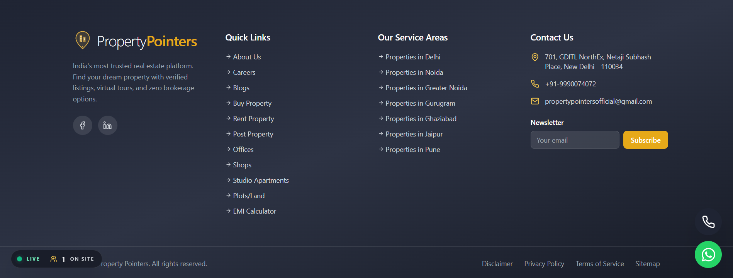

Point | Details
CURRENT SCREENSHOT OBSERVATION | Footer currently says “India’s most trusted real estate platform. Find your dream property with verified listings, virtual tours, and zero brokerage options.” Quick links include basic pages and categories. Service areas are listed. Newsletter asks only for email.
REMOVE / CHANGE IMMEDIATELY | Remove: “India’s most trusted real estate platform”, “dream property”, “verified listings” as blanket claim, and “zero brokerage options” if the platform includes advisors/brokers. Remove weak newsletter form that captures only email.
RECOMMENDED REPLACEMENT | Footer copy: “PropertyPointers is a real estate ecosystem platform helping users discover properties, compare developers, connect with realty advisors, explore real estate vendors and make informed property decisions with tools and insights.” Add columns: Property Search, Ecosystem, Resources, Company.
WHY THIS CHANGE IS NEEDED | Footer should reinforce ecosystem positioning and help SEO through internal links. It should also route partners to onboarding pages.
IMAGE / DESIGN FORMAT | Use dark navy footer, gold accents, clear columns, social icons, CTA strip above footer. Newsletter should capture Name, Email, City Interest and User Type.
DEVELOPER / SEO NOTES | Add footer links to /developers/list-your-project, /realty-advisors/join, /vendors/list-your-service, /partners/early-partner-program, /trust-and-safety, /market-reports, /pricing, /sitemap.xml.

11. New Sections Missing from Current Homepage
The uploaded screenshots show that several high-value sections are missing or not yet strong enough. These sections are essential if PropertyPointers wants to become a large real estate ecosystem.
Missing Section | Recommended Heading | Content Needed | Placement
Trust Strip | Built for Transparent Property Decisions | Quality-checked listings, RERA details where available, advisor-assisted discovery and buyer due diligence guidance. | Immediately after hero/search
Popular Localities | Popular Localities to Explore | Sector 74 Noida, Sector 150 Noida, Noida Extension, Sector 62, Greater Noida West, Yamuna Expressway, Dwarka Expressway, Sohna Road. | After city/service area section
Developers Section | For Developers & Builders | Developer profile, project microsite, RERA details, lead generation and market visibility. | Before or after featured properties
Realty Advisors Section | Join as a Realty Advisor | Professional profile, locality expertise, active listings, reviews and enquiry system. | After developer section
Vendor Marketplace Section | Real Estate Vendor Marketplace | Interiors, architects, contractors, property lawyers, marketing agencies, photographers and other vendors. | After advisor section
Property Tools Section | Smart Tools for Better Property Decisions | EMI, stamp duty, registry charges, rental yield, ROI, construction cost, rent vs buy and RERA guide. | Before blog/insights
Market Reports Section | PropertyPointers Market Reports | Noida report, Gurgaon commercial report, Delhi NCR rental yield, top developers, top advisors and vendor report. | After insights
How It Works | How PropertyPointers Works | Separate journeys for buyers, developers, advisors and vendors. | Before lead capture
Early Partner Program | Join Early. Get Priority Visibility. | Early-stage onboarding for developers, advisors and vendors with limited category slots. | Before testimonials
FAQ Section | Frequently Asked Questions | Clarify verification, brokerage, developers, advisors, vendors, posting, contact and due diligence. | Before newsletter/footer

12. Final Recommended Homepage Order
- Header with ecosystem mega menu
- Hero: Beyond Listings. India’s Complete Real Estate Ecosystem.
- Multi-intent search: Buy, Rent, Commercial, Developers, Advisors, Vendors
- Trust strip: quality-checked, RERA details where available, advisor-assisted, buyer due diligence
- Stats section with safe, real metrics
- Explore Real Estate Opportunities
- Featured Property Opportunities
- Explore Properties by City
- Popular Localities to Explore
- For Developers & Builders
- Join as a Realty Advisor
- Real Estate Vendor Marketplace
- Smart Tools for Better Property Decisions
- Latest Real Estate Insights
- PropertyPointers Market Reports
- Why PropertyPointers
- How PropertyPointers Works
- What Are You Looking For? lead capture
- PropertyPointers Early Partner Program
- Early User Feedback
- Frequently Asked Questions
- Get Weekly Property Insights newsletter
- Footer with ecosystem links

13. Ready-to-Use Homepage Copy Blocks
Block | Final Copy
Hero Heading | Beyond Listings. India’s Complete Real Estate Ecosystem.
Hero Subline | Discover properties, compare developers, connect with realty advisors, explore trusted real estate vendors, and make smarter property decisions with insights and tools.
Trust Strip Heading | Built for Transparent Property Decisions
Developer Section | Build your project visibility beyond normal listing portals. PropertyPointers helps developers create a professional digital presence with developer profiles, project pages, RERA information, location highlights, buyer enquiry forms and market visibility.
Realty Advisor Section | Build your digital identity as a trusted real estate professional. Create your advisor profile, showcase local expertise, list properties, collect reviews and receive direct buyer enquiries.
Vendor Section | Get discovered by property buyers, developers, owners and advisors. List your service, showcase your portfolio and receive relevant business enquiries from the real estate ecosystem.
Early Partner Program | Join early. Get priority visibility before the platform becomes crowded. Limited city-wise and category-wise onboarding is open for developers, realty advisors and vendors.
Footer Copy | PropertyPointers is a real estate ecosystem platform helping users discover properties, compare developers, connect with realty advisors, explore real estate vendors and make informed property decisions with tools and insights.

14. Technical SEO & Developer Checklist
Checklist Item | Instruction
Server-render important content | Property cards, city pages, calculator content, blog cards and FAQs should not depend only on client-side rendering.
Unique meta data | Every page needs unique SEO title and description. Avoid one generic title across the site.
City/locality pages | Create crawlable pages for Noida, Delhi, Gurugram, Greater Noida, Ghaziabad, Jaipur, Pune and top localities.
Calculator hub | Calculator pages need H1, intro, formula, example, FAQs, related tools and CTA. Avoid “Loading calculators…” as crawler-visible output.
Schema markup | Add Organization, WebSite, BreadcrumbList, FAQPage, Article, LocalBusiness and appropriate listing/developer/advisor/vendor schema.
Image optimisation | Use WebP, compressed images, lazy loading, descriptive alt text and consistent image ratios.
Lead tracking | Track CTAs by user type: buyer, developer, advisor, vendor, report download, WhatsApp and phone click.
Internal linking | Blogs should link to city pages, locality pages, developer pages, advisor pages, vendor pages and tools.

15. Final Recommendation
PropertyPointers should not compete only as a property listing portal. The homepage must clearly prove the ecosystem model: property discovery, developer visibility, realty advisor network, vendor marketplace, tools, insights, market reports and multi-user lead capture.
Final website line: -
PropertyPointers — Beyond Listings. India’s Complete Real Estate Ecosystem.
If the above section-wise changes are implemented, the homepage will look more credible to buyers, developers, advisors and vendors, and will support SEO growth, social growth and paid onboarding revenue.

