 |  |  |  |  |  | 
 |  | ELECTRICAL SCOPE OF WORK
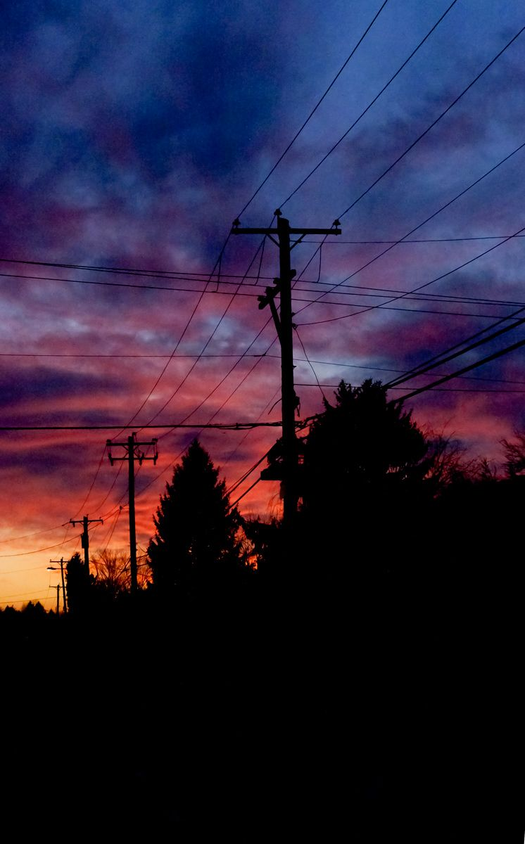
 |  | UPGRADE OF THE ELECTRICAL SYSTEM |  |  |  | 
 |  |  |  |  |  | ELECTRICAL SERVICES
 |  | CLIENT: Mr. John Doe |  |  |  | 205 Electrical Works Street
 |  |  |  |  |  | Greentown, 22312 NY
 |  | EFFECTIVE DATE: 01-07-2021
 |  | Project Description |  | Tasks Description
 |  | The electrical system of John Colins High School Campus needs to be upgraded due to the increase of building construction in the campus thereby there is a growth of power  consumption. Therefore, the school administration has decided for the upgrading of the transformer based on the total power loading of the entire campus as per master plan.  Lorem ipsum dolor sit amet, consectetuer adipiscing elit. Maecenas porttitor congue massa. Fusce posuere, magna sed pulvinar ultricies, purus lectus malesuada libero, sit amet commodo magna eros quis urna. Nunc viverra imperdiet enim. Fusce est. Vivamus a tellus. Pellentesque habitant morbi tristique senectus et netus et malesuada fames ac turpis egestas. Proin pharetra nonummy pede.  Lorem ipsum dolor sit amet, consectetuer adipiscing elit. Maecenas porttitor congue massa. Fusce posuere. |  | 1 Removal of Existing Transformers & Accessories
 |  |  |  | 1.1 Remove the existing transformers supplying the temporary energized buildings
 |  |  |  | 1.2 Handover all removed electrical equipment and materials to campus administrator
 |  |  |  | 2 Disconnection, Wire pulling and Reconnection at New MDP
 |  |  |  | 2.1 Disconnect the overhead conductor supplying Academic Building II
 |  |  |  | 2.2 Temporary reconnection of existing wires at New MDP dedicated for Academic Building II
 |  |  |  | 3 Transformer Pad Fence and High Tension Support
 |  |  |  | 4 Lines & Hardwares (supply and install lines and hardwares including electrical protection)
 |  |  |  | 5 Installation of New 10-200kVA Transformers and Accessories
 |  |  |  | 5.1 Deliver the transformers at the project site without any additional cost of the project
 |  |  |  | 5.2 Install Three (3) 200 kVA transformers and accessories
 |  |  |  | 5.3 Conduct tests for the wires and transformers with the presence of School Representative
 |  |  |  | Deliverables |  | Technical support & Warranty
 |  | Prerequisites |  | • Three 200kVA transformers installed |  | ELECTRICAL SERVICES provides 1 day response time to technical support calls on 24/7 basis. Warranty period is 24 months (on all installed electrical equipment and work provided).  Lorem ipsum dolor sit amet, consectetuer adipiscing elit. Maecenas porttitor congue massa.
 |  |  |  | • Electrical consultant tests of transformers
 |  | • Permits  • Prerequisite 2 description here  • Lorem ipsum dolor sit amet |  | • Reports and measurements
 |  |  |  | • Lorem ipsum dolor sit amet consectetuer
 |  |  |  | • Maecenas porttitor congue massa
 |  |  |  |  |  | © TemplateLab.com

