STATEMENT OF WORK: GOOGLE APPS DEPLOYMENT SERVICES

This Statement of Work (“SOW”) entered into between the parties set out in the table below and effective from the Effective Date, and relates to the services to be provided under it.

Institution: | Name.:
 | Principal address:
 | Project Manager:
 | Telephone:
 | Email:
Contractor: | Contractor:
 | Principal place of business:
 | Project Manager:
 | Telephone:
 | Email:
Effective Date:
Charges ($USD): | Services
 | Project Management / Consulting | ▢ | per university
 |  | ▢ | per day
 | Basic Provisioning and | ▢ | per university
 | Deployment | ▢ | per day
 | Change Management | ▢ | per university
 |  | ▢ | per day
 | Data Migration | ▢ | per university
 |  | ▢ | per day
 | SSO Configuration | ▢ | per university
 |  | ▢ | per day
 | Additional Deployment Support | ▢ | per university
 |  | ▢ | per day

AGREED TERMS

- SERVICES

Contractor will include in the Deployment Plan:

1

CONFIDENTIAL

- the “Minimum Deployment Services” set out in the Schedule;

- the number of consultants that will deliver each stage of the deployment; and

- how long each stage of the deployment will last (in days).

Schedule: Minimum Deployment Services

- Project Management/Consulting

  - Gather requirements, provide project planning and consultation, and coordinate the execution

- Basic provisioning / deployment

  - Activate the university’s chosen domain name(s)

  - Activate Google Apps for Education for the university’s domain(s)

  - Activate ‘dual delivery’ for incoming student and staff email

  - Provision Google Apps accounts for all the university students and staff

  - Implement custom branding for Google Apps for Education

  - Provision organizational units and sub domains

  - Define and create groups for faculty, staff and students

  - Configure email security service settings (e.g. SPF records, DKIM, DMARC)

  - Configure appropriate domain and service settings

- Initial Change Management and Custom Communications:

  - Communication plan to define plan and approach from project communications

  - Create selfhelp / helpdesk and FAQs website in custom language

  - Send email Universitywide to notify faculty, staff and students about the new Apps services

  - Assist in Go Live day and preparation

  - Provide guidance and templates for communicating change via newsletter, poster, banner, etc.

- Data migration

  - Facilitate and complete data migration from any legacy mail systems (e.g. Microsoft Exchange, Lotus, Postfix)

- Single Sign On and password sync

  - Implement single signon (or other authentication) for all Google Apps accounts authentication

HighLevel Project Plan

The overall timeline for this SOW is represented below. The proposed start date for this project is [DATE] and the proposed date for the Global GoLive is September [DATE]

2

CONFIDENTIAL
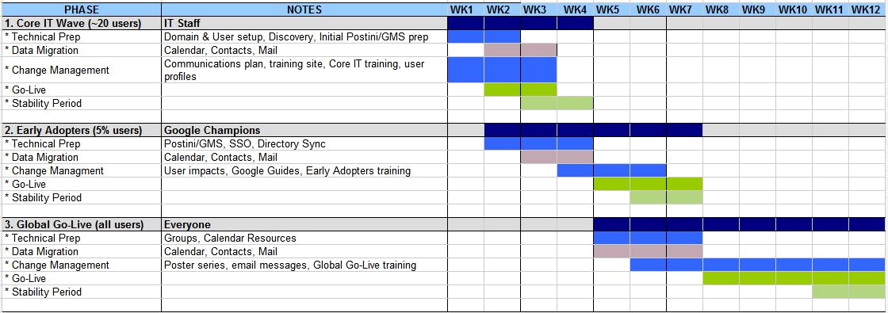

Signed by the parties on the dates shown below.

Education Institution Partner

Signature: Signature:

Print Name: Print Name:

Position: Position:

Date: Date:

3

CONFIDENTIAL

