NYSED DATA DASHBOARD SOLUTIONS RFP Attachment 6.8 Statement of Work Template

THIS IS STATEMENT OF WORK dated [Date] (the “SOW”) to the Contract dated [Date] (the “Agreement”) between NEW YORK STATE EDUCATION DEPARTMENT (“NYSED”), whose principal place of business is [address], and Vendor, whose principal place of business is at[address]. This SOW describes the scope of the NYSED’s implementation of the (Vendor Name) (Solution Name). The purpose of the SOW is to provide an overall structure and schedule for delivery of the system as it relates to implementation, training, maintenance and all other services required to provide the solution.

1. Project Title:

Education Data Portal (“EDP”) Data Dashboard Solutions

2. Responsible Project Owner:

NYSED Project Owner:

Vendor Project Owner:

3. Product Requirements:

All functionality as outlined in the RFP Attachment 6.2 – Detailed Requirements, as completed by the vendor, will be expected to be part of the solution provided.

4. Project Timeline and Deliverables Overview:

Major project milestones and deliverables are indicated in the table below. Please provide estimated dates based on the assumed contract signing date provided:

Party | Milestone |  |  | Date | Deliverable
Vendor | 1. | Contract |  | October 2012
 | Signing (Year 1)
Vendor | 2. | Revised work |  |  | Project Plan
 | plan approved |  |  |  | Staffing Plan
 | (Year 1)
Vendor | 3. | Specification for |  |  | Updated Detailed Requirements
 | launch |  |  |  | Design Specification
 | functionality
 | signed off (Year 1)
Vendor | 4. | LEA | selection |  | Validated Pre-Production System
 | demo |  | available |  | Test plans
 | (Year 1) |  |  |  | Test Case Descriptions

1
 |  |  |  |  | User Acceptance Test Scripts
 |  |  |  |  | Code Base Audit
 |  |  |  |  | Statewide Product Demonstration
 |  |  |  |  | Regional Product Demonstration
Vendor | 5. UAT signed off |  |  |  | Usability Tests
 | and |  | product |  | Usability Test Results and Implementation Plan
 | launched (Year 1) |  |  |  | Planning Sessions
 |  |  |  |  | Product Training
 |  |  |  |  | End-user Training Manual
 |  |  |  |  | System Training Manual
 |  |  |  |  | End-user System Documentation
 |  |  |  |  | Technical System Documentation
 |  |  |  |  | Hosting Services
 |  |  |  |  | Site and System Security Plan
 |  |  |  |  | Backup and Disaster Recovery Plan
Vendor | 6. Post |  | Launch |  | On-site Support
 | (Year | 2 | and |  | Warranties Maintenance and Support Services
 | beyond) |  |  |  | Technical Support
 |  |  |  |  | Documentation Updates
 |  |  |  |  | Year 2 LEA Dashboard Selections

In the event of any inconsistency between the above and deliverables and delivery dates set out elsewhere in this SOW, then such other deliverables and delivery dates will govern.

5. Payment Schedule

All deliverable invoicing will be consistent with the Deliverable Acceptance policy found in Section 4.13.2 of the RFP. Invoicing for the Implementation Cost component (A) will be by milestone as follows:

Milestone |  |  |  |  | Payment Amount
1. | Revised work |  |  | plan | 10%
approved
2. | Specification |  | for launch |  | 20%
functionality signed off
3. | LEA | selection |  | demo | 20%
available
4. | UAT | signed | off | and | 35%
product launched
5. 90 days after launch |  |  |  |  | 15%

2

Invoicing for Annual Cost component (B) will begin after launch and be annual as follows:

Payment | Date | Payment Amount
1st payment | Nov 1 | 25% of Annual Fee
2nd payment | Feb 1 | 25% of Annual Fee
3rd payment | May 1 | 25% of Annual Fee
4th payment | August 1 | 25% of Annual Fee

The Annual Cost will cover the period from August 1 through July 30, prorated as necessary, and be calculated as follows:

Annual Cost = Adjusted Unit Price multiplied by the sum of the Active Student Enrollment on the most recent available BEDS day for all locations that have selected the proposed solution.

Daily prorating will occur when:

- the SLA explicitly provides (e.g., service outage, etc.);
- service is not provided for the whole year (e.g., late launch or contract termination); OR
- locations switch providers, with NYSED approval, at times other than the annual selection period.

The initial contracts will be based on an equal 33 1/3 % split across LEA’s will be adjusted following each round of LEA demo and selection.

6. Detailed Tasks

For the task requirements listed below (1-27) please decompose each major task into anticipated sub-tasks or work elements.

Project Initiation, Planning and Management

ID | Requirement | Sub-Tasks/Work Elements

3
ID | Requirement | Sub-Tasks/Work Elements

- The Vendor shall refine and deliver its proposed project plans consistent with agreements made during contract negotiation. The plan should address:

Work Breakdown Structure (WBS) Project Schedule

Quality Management Risk Management Change Management Acceptance Management

Issue Management and Escalation Communication

Implementation/Transition (including migration plans) Training
- The Vendor shall amend as needed its proposed staffing plan (Attachment 6.6) that identifies individual resources assigned to each of the project activities.

Detailed Requirements Definition

ID | Requirement | Sub-Tasks/Work Elements

3. The Vendor shall update the detailed requirements.

Design Specification

ID | Requirement | Sub-Tasks/Work Elements


- The Vendor shall translate the detailed requirements into a design specification including technical architecture specification, user Interface (e.g., “wire frames”) and functional specifications, and data interface specifications.

System Construction

ID | Requirement | Sub-Tasks/Work Elements

4
ID |  | Requirement |  | Sub-Tasks/Work Elements
 | 5. | The Vendor shall deliver a validated system in the Pre-
 |  | Production environment. This shall include:
 |  | ingestion of NYSED/LEA data from the SLI
 |  | interface with the SLI API
 |  | Integration to the SLI and NYSED | Identity
 |  | Management System (including State and NYC
 |  | federation), RBAC System, and application
 |  | licensing system

Integration and Testing

ID | Requirement | Sub-Tasks/Work Elements
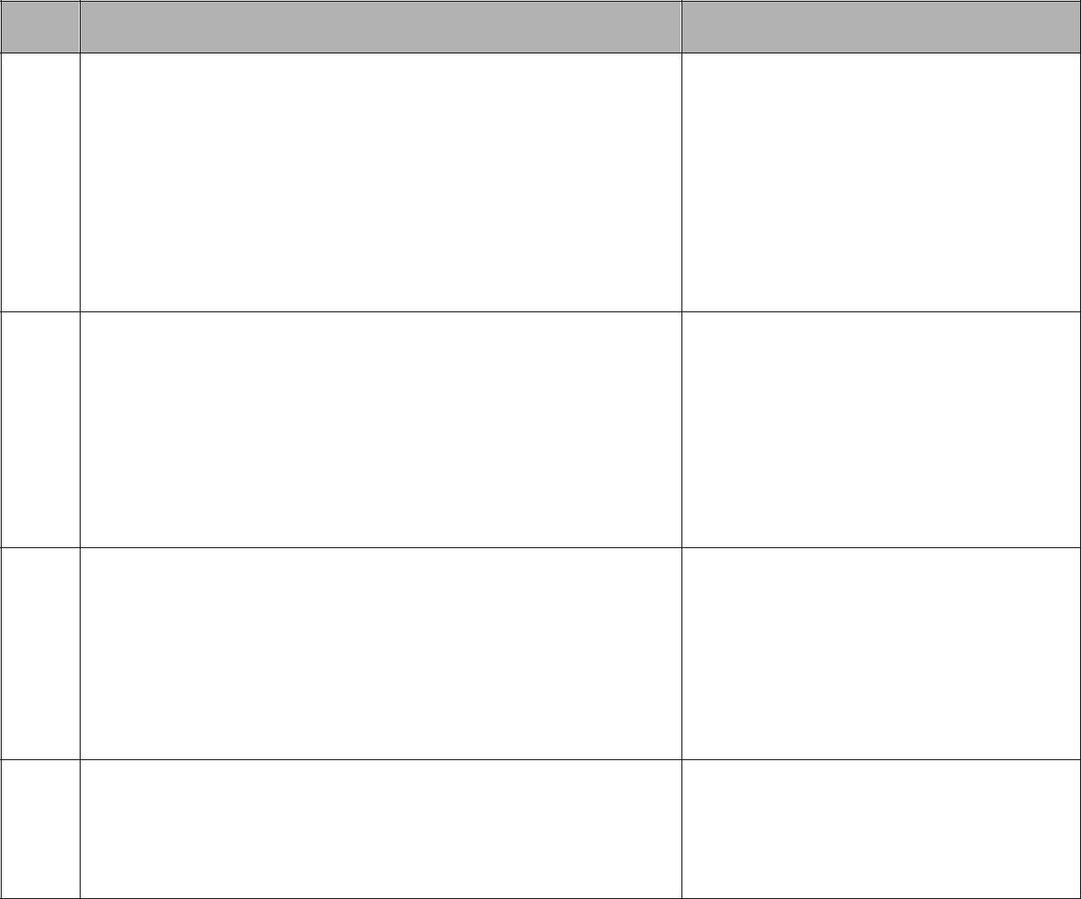

- The Vendor shall document test plans defining:

the overall strategy for validating the functionality of the system
the approach to ensure test coverage of each requirement
the individual test cases that will be performed to execute the testing strategy

the environments in which the tests will be conducted

- The test plans shall include:

testing objectives

scope of testing (both what is in and what is out of scope) responsibilities (who will be performing the test)

testing approach testing sequence defect reporting and criteria

- The test case descriptions shall be traced to requirements and include:

test data needed to execute the tests

preconditions required prior to the start of test criteria for suspending and resuming testing expected test results

- The Vendor shall design and create User Acceptance Test (UAT) scripts for NYSED approval or modification. Upon NYSED request, additional specific UAT scripts will be created.

5
ID | Requirement | Sub-Tasks/Work Elements
10 | The Vendor will subcontract with an industry-recognized
 | security firm (agreeable to NYSED) for a security audit of
 | the code base consistent with the requirements of the New
 | York State Office of Cyber Security applicable to State
 | agency information technology projects, with any material
 | findings and recommendations corrected at no additional
 | cost. The Vendor's security measures are subject to
 | review and approval by NYSED, both through an informal
 | audit of policies and procedures and/or through inspection
 | of security methods used within the researchers’
 | infrastructure, storage, and other physical security.

Usability Analysis

ID | Requirement | Sub-Tasks/Work Elements
11. | The Vendor shall develop and deploy usability tests.
12. | The Vendor shall conduct an analysis of the usability test
 | results and provide an implementation plan for incorporating
 | the results into the system.

Documentation

ID | Requirement | Sub-Tasks/Work Elements
13. | The Vendor shall develop end-user system documentation
 | using a NYSED-owned wiki tool. End-user roles will include
 | educators, parents and students.
14. | The Vendor shall develop technical system documentation
 | using a NYSED-owned wiki tool.
15. | The Vendor shall deliver updates to the end-user and
 | technical system documentation described above for the
 | Demo release, the full production release and any
 | subsequent releases offered by the Vendor.

Application Warranty Services

6
ID | Requirement | Sub-Tasks/Work Elements
16. | The Vendor shall provide staff support on-site for 60 days.
17. | The vendor shall comply with the terms described in
 | Attachment 6.4 Maintenance and Support Services.

Application Maintenance and Technical Support Services

ID | Requirement | Sub-Tasks/Work Elements
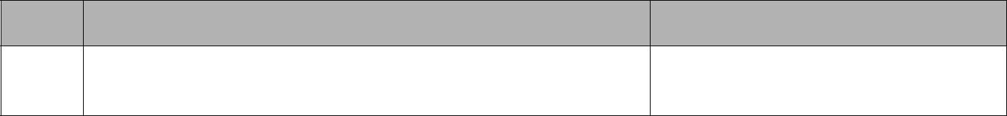

- The vendor shall comply with the terms described in Attachment 6.4 Maintenance and Support Services.

Training and Documentation

ID | Requirement |  | Sub-Tasks/Work Elements
19. | The Vendor shall attend planning sessions with NYSED and the
 | Content Management and System Services vendor to plan for
 | the development of (a) end-user documentation, (b) help desk
 | materials and strategy, and (c) training/professional
 | development materials and strategy. Sessions will be held as
 | follows:
 |  | • Initial session – to be held in Albany, duration up to five (5)
 |  | days
 |  | • Follow-on sessions – three additional one (1) day sessions
 |  | in Albany, approximately every six months through end of
 |  | Year 2 (12 days total)
 | • | NYSED will provide meeting space

7
ID | Requirement |  | Sub-Tasks/Work Elements
20. | The Vendor shall provide product training to the Content
 | Management and System Services vendor for (a) data
 | dashboard functionality, (b) end-user documentation, and (c)
 | help desk materials and strategy and training/professional
 | develop materials and strategy (the Data Dashboard vendors
 | will provide electronic copies of all materials to the Content
 | Management and System Services vendor):
 |  | • Initial session – to be held in Albany, duration up to five
 |  | (5) days
 |  | • Follow-on sessions – three additional one (1) day
 |  | sessions to be held in Albany, approximately every six
 |  | months through end of Year 2 (4 days total)
 |  | • Training sessions will accommodate up to 30 people per
 |  | session
 | • | NYSED will provide training facilities (room, PCs,
 |  | Internet connectivity, projector, etc.)
21. | The Vendor shall develop and deploy using a NYSED-owned
 | wiki tool an end-user training manual.
22. | The Vendor shall develop and deploy using a NYSED owned
 | wiki tool technical system training manual.

Hosting

ID | Requirement | Sub-Tasks/Work Elements
23. | The vendor shall comply with the terms described in Attachment
 | 6.3 Hosting Services.
24. | The vendor shall provide a site and system security plan.
25. | The vendor shall provide a backup and disaster recovery plan.

Product Demonstrations

ID |  | Requirement |  | Sub-Tasks/Work Elements


- The Vendor shall provide a Statewide product demonstration (via webinar).

- The Vendor shall provide at least twelve (12) regional live product demonstrations.

8

9

7. Assumptions

Please state any applicable assumptions.

10

