Objective 2.2 — EDA and Feature-Selection Audit

Dataset and predictors
Objective 2.2 analyses 208 team-match records derived from 104 World Cup fixtures, with two related observations per match. All eight predictors and the non-negative goals-scored target are complete. The team-level goals, match identities and dates agree with the original master workbook. Four features explicitly reuse Objective 2.1 concepts: FIFA ranking, Elo rating, previous-five average goals scored and previous-five win rate. Knockout stage, host nation and prior World Cup appearances are additional pre-match descriptors. However, cumulative World Cup goals conceded overlaps conceptually with Objective 2.1’s previous-five goals conceded; therefore compliance with the maximum-four-shared-concepts rule requires clarification before submission.

Exploratory findings
Teams scored an average of 1.48 goals per observation; 55 rows record zero goals and 71 record one. In the training data, FIFA ranking and Elo are strongly negatively correlated (r = −0.90), with VIFs of 5.70 and 6.17 respectively. This indicates potential coefficient instability, not necessarily an inaccurate model. Cumulative World Cup statistics were reconstructed using only earlier fixtures; the 1,040 previous-five evidence rows passed internal chronology and arithmetic checks. External ranking and match-source authenticity were not independently established by these checks.

Distribution shift and performance
The chronological split comprises 164 training rows (82 matches) and 44 test rows (22 matches). Only 20 training observations were from knockout games, compared with all 44 test observations. In addition, 32 test rows exceed the training range for prior World Cup matches, indicating extrapolation risk. The saved model’s test MAE is 0.982 goals, RMSE 1.266 goals and R² 0.084, indicating limited explained test variation. These observations do not identify a causal reason for the model’s performance.

Audit recommendation
Figure D summarises the stage and experience shifts. The existing model should not be silently modified; the overlapping conceded-goals concept should first be resolved against the assessment rubric. Generative AI assisted with source-file inspection, calculations, code preparation and writing; all figures and numerical statements were checked against supplied outputs. No new model was trained.
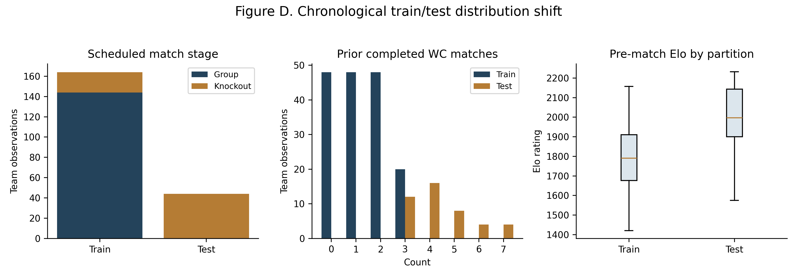
Figure D. Chronological training/test feature distributions (saved partitions; descriptive diagnostic).

