FIFA WORLD CUP 2026 | LINEAR REGRESSION
GROUP RESEARCH REPORT — OBJECTIVES 2.1 AND 2.2
Members: Enosh Basnet (S400562) · Manish Chaudhary (S400984) · Himanshu Pravat (S400927) · Suraj Devkota (S397467)

1 Research objectives and study design
We model two related football outcomes using the 104 matches of the 2026 FIFA World Cup (11 June to 19 July). Objective 2.1 predicts the goal difference of a match, Y = goals by Team A minus goals by Team B, with one row per match (104 rows). Objective 2.2 predicts how many goals a single team scores, using 208 team–match rows, two for every fixture. Penalty shootout goals are left out of both targets. Each task uses exactly eight explanatory variables, all of which should be known before kickoff.

Feature design and rationale
The two sets of eight variables mix team quality, recent form, tournament context and match history. In Objective 2.1 every variable is a difference, Team A minus Team B, so the orientation stays consistent. Objective 2.2 uses each team’s own values instead. Four feature families are reused across the two objectives and are marked with *.
Code | Objective 2.1 — match-level differences | Objective 2.2 — team-level information
X1 | FIFA ranking (A − B) | FIFA ranking position *
X2 | Elo rating (A − B) | Elo rating before kickoff *
X3 | Mean goals scored, previous 5 (A − B) | Mean goals scored, previous 5 *
X4 | Mean goals conceded, previous 5 (A − B) | Win rate, previous 5 *
X5 | Win rate, previous 5 (A − B) | Knockout-stage indicator
X6 | Clean-sheet rate, previous 5 (A − B) | Host-nation indicator
X7 | Days since previous match (A − B) | Prior 2026 WC matches completed
X8 | Mean prior-opponent FIFA rank (A − B) | Goals conceded in earlier 2026 WC games

So four inputs are shared outright. The two conceded-goals measures are related but not identical: one is a difference in the previous-five international average, the other a running total of goals conceded at the 2026 World Cup. We point this out openly rather than assume it satisfies a “shared variable” rule that is somewhat ambiguous.

Data preparation and avoiding leakage
We found no problems with match IDs, scores, completeness or chronology in the source workbook: all 104 match targets were verified and no modelling values were missing. We also checked the 208-row conversion against the recorded teams and the 1,040 historical previous-five observations. Rankings, Elo ratings and form measures were meant to reflect only what was known before each fixture. The tournament-to-date appearances and goals conceded come strictly from earlier completed fixtures, so neither the current match nor any same-day result leaks in. These checks show the data is internally consistent; they don’t independently confirm every historical source.
Both models are ordinary least-squares (OLS) regressions with an intercept. We split the data by time: the 82 earlier fixtures are used for training and the 22 later ones for testing. For Objective 2.2 the two team rows from each match stay together, giving 164 training and 44 test rows. Test outcomes were never used to fit or choose a model. Ridge and Lasso were compared using expanding-window cross-validation (CV) on the training data only, and then evaluated once on the held-out set. Because team histories are updated before each knockout kickoff, these are rolling pre-match forecasts rather than predictions all made before the tournament began.

2 Objective 2.1 — Predicting match goal difference

Descriptive and exploratory results
Over the 104 matches, Team A scored more goals in 50, fewer in 30 and the same number in 24. Goal difference ranged from −4 to +6, with a mean of +0.481. In the full-sample EDA, the strongest simple correlations with the target were the Elo difference (Pearson r = +0.627) and the FIFA ranking difference (r = −0.621). The sign is reversed for ranking because a lower rank number means a stronger team. The two were themselves strongly correlated (r = −0.898), as were recent goals scored and win rate (r = +0.735). These are descriptive patterns only; they don’t show causation or tell us what each variable adds on its own.
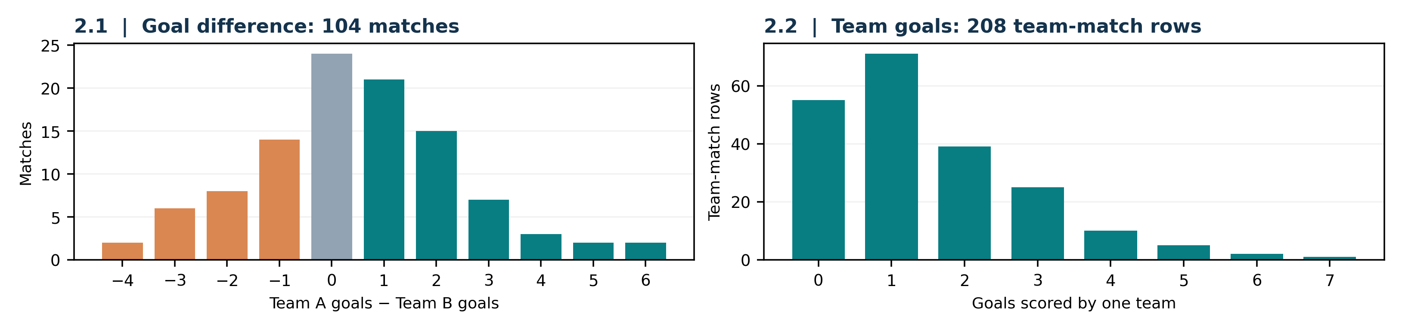
Figure 1. Distributions of the recorded outcomes. The 208 team records in 2.2 are the same 104 fixtures counted twice, not extra matches.

Multicollinearity, outliers and coefficient interpretation
On the full sample, the variance inflation factors (VIFs) for FIFA rank (5.625), Elo (6.275) and win rate (6.134) are above the usual threshold of 5. That overlap can make individual OLS coefficients unstable. The 1.5×IQR rule flagged 18 feature-level observations across 14 matches, and Match 13 stands out with a rest-days difference of −70. As a diagnostic check only, we dropped it temporarily: the X7 mean moved from −0.490 to +0.184 days and the X7–target correlation from +0.042 to +0.098. The official model still keeps all 104 matches, Match 13 included.
On the 82 training matches, the fitted intercept is +0.359 goals. Some of the coefficients are −0.01645 goals per rank position for FIFA rank, +0.001713 goals per point for Elo, +0.2101 for previous-five goals scored and +0.6051 for the clean-sheet-rate difference. Each one describes an association while holding the other seven predictors fixed. The signs and sizes can be read in their own units, but they don’t establish causation, and raw magnitudes in different units shouldn’t be used to rank which variable matters most. The rank and Elo estimates need extra caution because those two variables are collinear.

Baseline predictive performance
Set | n | MAE (goals) | RMSE (goals) | R²
Train | 82 | 1.207 | 1.545 | 0.449
Test | 22 | 1.249 | 1.540 | 0.115
Test: mean baseline | 22 | 1.466 | 1.768 | −0.166

A test MAE of 1.249 means the predictions were off by about 1.25 goals on average. On test RMSE, OLS beats the training-mean baseline (1.540 against 1.768), but an R² of 0.115 shows it explains only a small share of the variation in these later knockout matches. The mean test residual is −0.748 goals (actual minus predicted), so the model overpredicted on this particular 22-match test set. That doesn’t necessarily mean it is biased at every stage of the tournament.

What this means for model development
The EDA supports keeping all eight variables as a plain baseline while we compare regularised alternatives. High VIFs and one odd rest interval aren’t enough on their own to justify dropping features or observations. With eight predictors and only 82 training matches, the coefficients may be unstable or tied to this tournament’s conditions. The held-out test set stays untouched during tuning.

3 Objective 2.2 — Predicting goals scored by one team

Feature justification and focused EDA
Each of the 208 rows holds one team’s goals in one match plus eight descriptors known before kickoff. FIFA rank and Elo stand in for team strength, while previous-five goals scored and win rate capture attacking form and recent results. The knockout and host indicators add context, and earlier 2026 WC appearances and goals conceded describe a team’s tournament experience and defensive history. These last two are cumulative, so they aren’t interchangeable with the previous-five international averages in Objective 2.1. Host status means the team is a co-host country, not necessarily that the match was played at home.
The target is a nonnegative count (mean 1.481 goals, standard deviation 1.393). In all, 55 team rows recorded no goals, 71 scored one and 39 scored two, so 126 of 208 rows (60.6%) scored at most one. We checked predictor availability at the team–fixture level, and the 1,040 past-five records and cumulative WC histories reconcile internally. Even so, the team-level FIFA and Elo pair is still strongly correlated (train r ≈ −0.899; VIFs 5.70 and 6.17), which limits how far the coefficients can be interpreted.

Temporal distribution shift: a major limitation
Only 20 of the 164 training team rows are knockout observations, while all 44 held-out rows are. On top of that, 32 of the 44 held-out rows have more prior WC fixtures than the training maximum of three, and some teams reach seven. With so few knockout examples to learn the stage coefficient from, and an experience count the model has never seen, we can’t be confident that performance on the later rounds carries over to other stages. The two team rows from one match also share the same game conditions, so they shouldn’t be treated as independent.
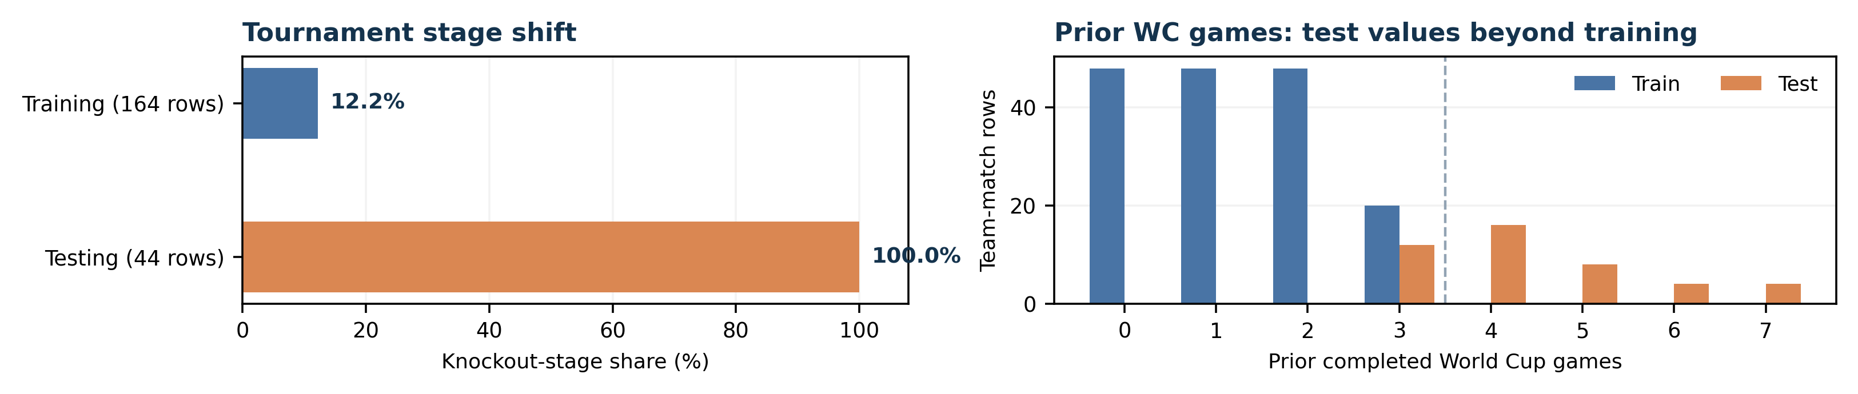
Figure 2. The shift over time in match stage and prior tournament experience, taken from the saved team-row partitions.

Regression output and evaluation
OLS on the 164 training rows gives an intercept of −1.111 goals. Among the conditional coefficients, FIFA rank is −0.01576, Elo +0.001858, host status +0.7435 and knockout status −0.4213. The previous-five win-rate coefficient is −0.6286 once the other variables are accounted for. That direction looks backwards, but it doesn’t prove that winning lowers scoring; it may come from correlated predictors and the way teams progress through the tournament. Note also that raw linear predictions are continuous and can go negative, even though goals scored cannot.
Set | Team rows | MAE (goals) | RMSE (goals) | R²
Train | 164 | 0.964 | 1.268 | 0.188
Test | 44 | 0.982 | 1.266 | 0.084
Test: mean baseline | 44 | 1.065 | 1.324 | -0.002

The test MAE of 0.982 means predictions missed by almost one goal per team–match on average. OLS has a slightly lower test RMSE than the training-mean baseline (1.266 against 1.324), with R² = 0.084. That small gain, together with a test set made up only of knockout games, raises doubts about how well the model generalises. A low R² doesn’t by itself mean the data or code is wrong.

4 Comparative experiments, interpretation and recommendations

Systematic comparison: OLS, Ridge and Lasso
Expanding-window CV on the training data alone is used to pick the regularisation penalties, so no held-out outcomes are involved. For 2.1, Ridge (α = 10) cuts the aggregate CV RMSE from 1.899 for OLS to 1.693, a 10.9% reduction. For 2.2, Lasso (α = 0.1) cuts it from 1.387 to 1.306 (5.9%). These are real improvements within training-based validation, but the regularised models don’t consistently beat OLS on the later knockout-stage test matches.
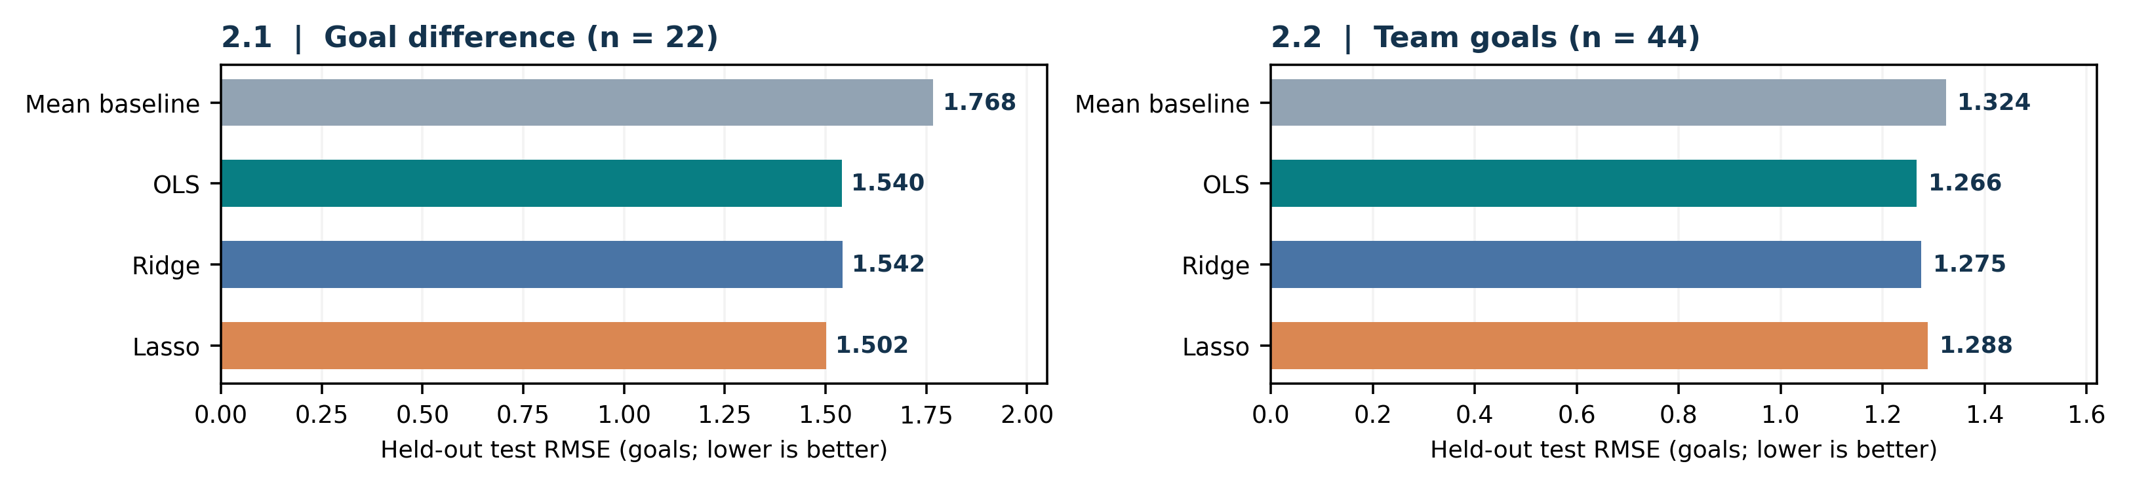
Figure 3. Held-out RMSE for the OLS, Ridge and Lasso models chosen on the training data, plus the training-mean benchmark. Lower is better.
Measure | 2.1 Goal difference | 2.2 Team goals
OLS test RMSE / test R² | 1.540 / 0.115 | 1.266 / 0.084
Ridge test RMSE (α) | 1.542 (10) | 1.275 (100)
Lasso test RMSE (α) | 1.502 (0.1) | 1.288 (0.1)
Lowest test RMSE observed | Lasso (descriptive only) | OLS (descriptive only)

Scientific interpretation and uncertainty
The gaps between the algorithms are small next to typical errors of about one to one and a half goals. We shouldn’t look back and pick whichever model happened to score best on the test set; tuning should rely on training-only CV, not the final test data. Match-resampled bootstrap intervals for the RMSE improvement over the training-mean baseline include zero in both tasks (2.1: −0.025 to +0.445; 2.2: −0.042 to +0.148 goals), so the apparent gains remain uncertain. Residual, leverage and Cook’s-distance checks pointed to some influential observations, which we did not remove automatically. Some of the early expanding-window folds were also small, including one with just 16 matches for eight predictors in 2.1.

Recommendations and final conclusions
For 2.1, we would keep OLS as an easy-to-understand benchmark and treat CV-selected Ridge as a possibly more stable alternative, pending further testing. For 2.2, OLS stays as the benchmark, and the next step would be to try time-aware regularisation or count-based models through new experiments that use training data only. Better pre-match form and context features, more historical data and tests across several forward tournament windows would all add confidence. We would avoid dropping features without a reason, rebuilding the models around test results, or reading the coefficients causally.
Both objectives follow the intended dataset structures and rest on reproducible, leakage-conscious modelling, systematic EDA and a comparison of algorithms. Still, the low held-out R² values (0.115 and 0.084), the shifts in tournament stage, the overlapping predictors and the small samples all limit how far these models can be trusted for real forecasting. The main takeaway is that gains during training-based validation don’t guarantee better predictions on future matches.
Provenance, collaboration and AI use: The datasets were compiled from archived fixtures, rankings and Elo sources. Team members cross-checked the Python validation, modelling and evaluation outputs. Generative AI helped with research, code and drafting, and the numerical results were reviewed independently. Our internal consistency checks do not fully authenticate every historical source.

