FIFA WORLD CUP 2026 · MULTIPLE LINEAR REGRESSION ·

2. Data Description and Preparation

2.1 Dataset and explanatory variables
The analysis uses 104 FIFA World Cup 2026 matches from the Master_104_Matches worksheet of the final project workbook. The sample includes 72 group-stage and 32 knockout-stage fixtures. Each row represents one match and retains its match ID, date, stage and original Team A/Team B ordering. The outcome variable (Y), goal_difference, is the number of goals scored by Team A minus those scored by Team B. It measures the recorded scoring margin; it is not the same as a classification of victory after a penalty shootout.
Eight explanatory variables describe relative pre-match team strength, recent attacking and defensive form, recovery time and previous-opponent strength (Table 1). They were designed using information from matches or rankings available before the fixture under study. For consistency, differences are calculated in the original Team A minus Team B direction. A negative value is not inherently erroneous: a lower FIFA ranking number or fewer goals conceded can favour Team A, while a positive Elo difference generally favours Team A.
Table 1. Explanatory variables used in Objective 2.1.
Code | Worksheet column | Definition
X1 | fifa_rank_diff | FIFA ranking of A − FIFA ranking of B
X2 | elo_rating_diff | Elo rating of A − Elo rating of B
X3 | last5_avg_goals_scored_diff | Last-five average goals scored: A − B
X4 | last5_avg_goals_conceded_diff | Last-five average goals conceded: A − B
X5 | last5_win_rate_diff | Last-five win rate: A − B
X6 | last5_clean_sheet_rate_diff | Last-five clean-sheet rate: A − B
X7 | rest_days_diff | Calendar-day rest interval: A − B
X8 | last5_opponent_strength_diff | Average rank of previous five opponents: A − B

2.2 Data integrity and preparation
Validation confirmed 104 unique match IDs (1–104), complete and finite numeric modelling columns, and no duplicate rows. Every goal difference equals Team A goals minus Team B goals; all dates fall within 11 June–19 July 2026. X5 and X6 stay within −1 to +1. No row was removed, replaced, scaled or imputed. Recorded scores and result notes are retained for auditing, never as explanatory variables.

3. Exploratory Data Analysis

3.1 Target distribution and descriptive statistics
Figure 1 shows the frequency of each recorded goal-difference value. The observed range is −4 to +6 goals, the median is 0 and the mean is +0.481 (sample standard deviation 2.024). Of the 104 matches, 50 have positive goal difference, 30 have negative goal difference and 24 have zero. Thus Team A scored more in 50 matches, Team B scored more in 30, and the recorded goals were level in 24. A zero value may include a knockout match subsequently decided by penalties; shootout goals are not part of this target.
Table 2 summarises the nine modelling columns using their original units. FIFA ranking differences (X1) range from −77 to +76 positions, whereas Elo differences (X2) range from −512 to +579 points. The numerical spreads cannot be compared as if their units were interchangeable. Win-rate and clean-sheet differences have medians of zero; rest-days difference (X7) also has a median of zero. The last-five opponent-strength difference (X8) extends from −45.20 to +57.20 ranking positions.
Table 2. Selected descriptive statistics (N = 104 for every column; no missing modelling values).
Variable | Mean | Median | SD | Minimum | Maximum
X1 | -7.21 | -6.50 | 33.64 | -77.00 | +76.00
X2 | +59.95 | +76.50 | 246.46 | -512.00 | +579.00
X3 | +0.13 | +0.20 | 1.02 | -2.20 | +2.80
X4 | -0.07 | -0.20 | 0.96 | -2.80 | +2.60
X5 | +0.06 | +0.00 | 0.35 | -1.00 | +0.80
X6 | +0.00 | +0.00 | 0.37 | -1.00 | +0.80
X7 | -0.49 | +0.00 | 7.01 | -70.00 | +6.00
X8 | -0.54 | +0.20 | 22.24 | -45.20 | +57.20
Y | +0.48 | +0.00 | 2.02 | -4.00 | +6.00

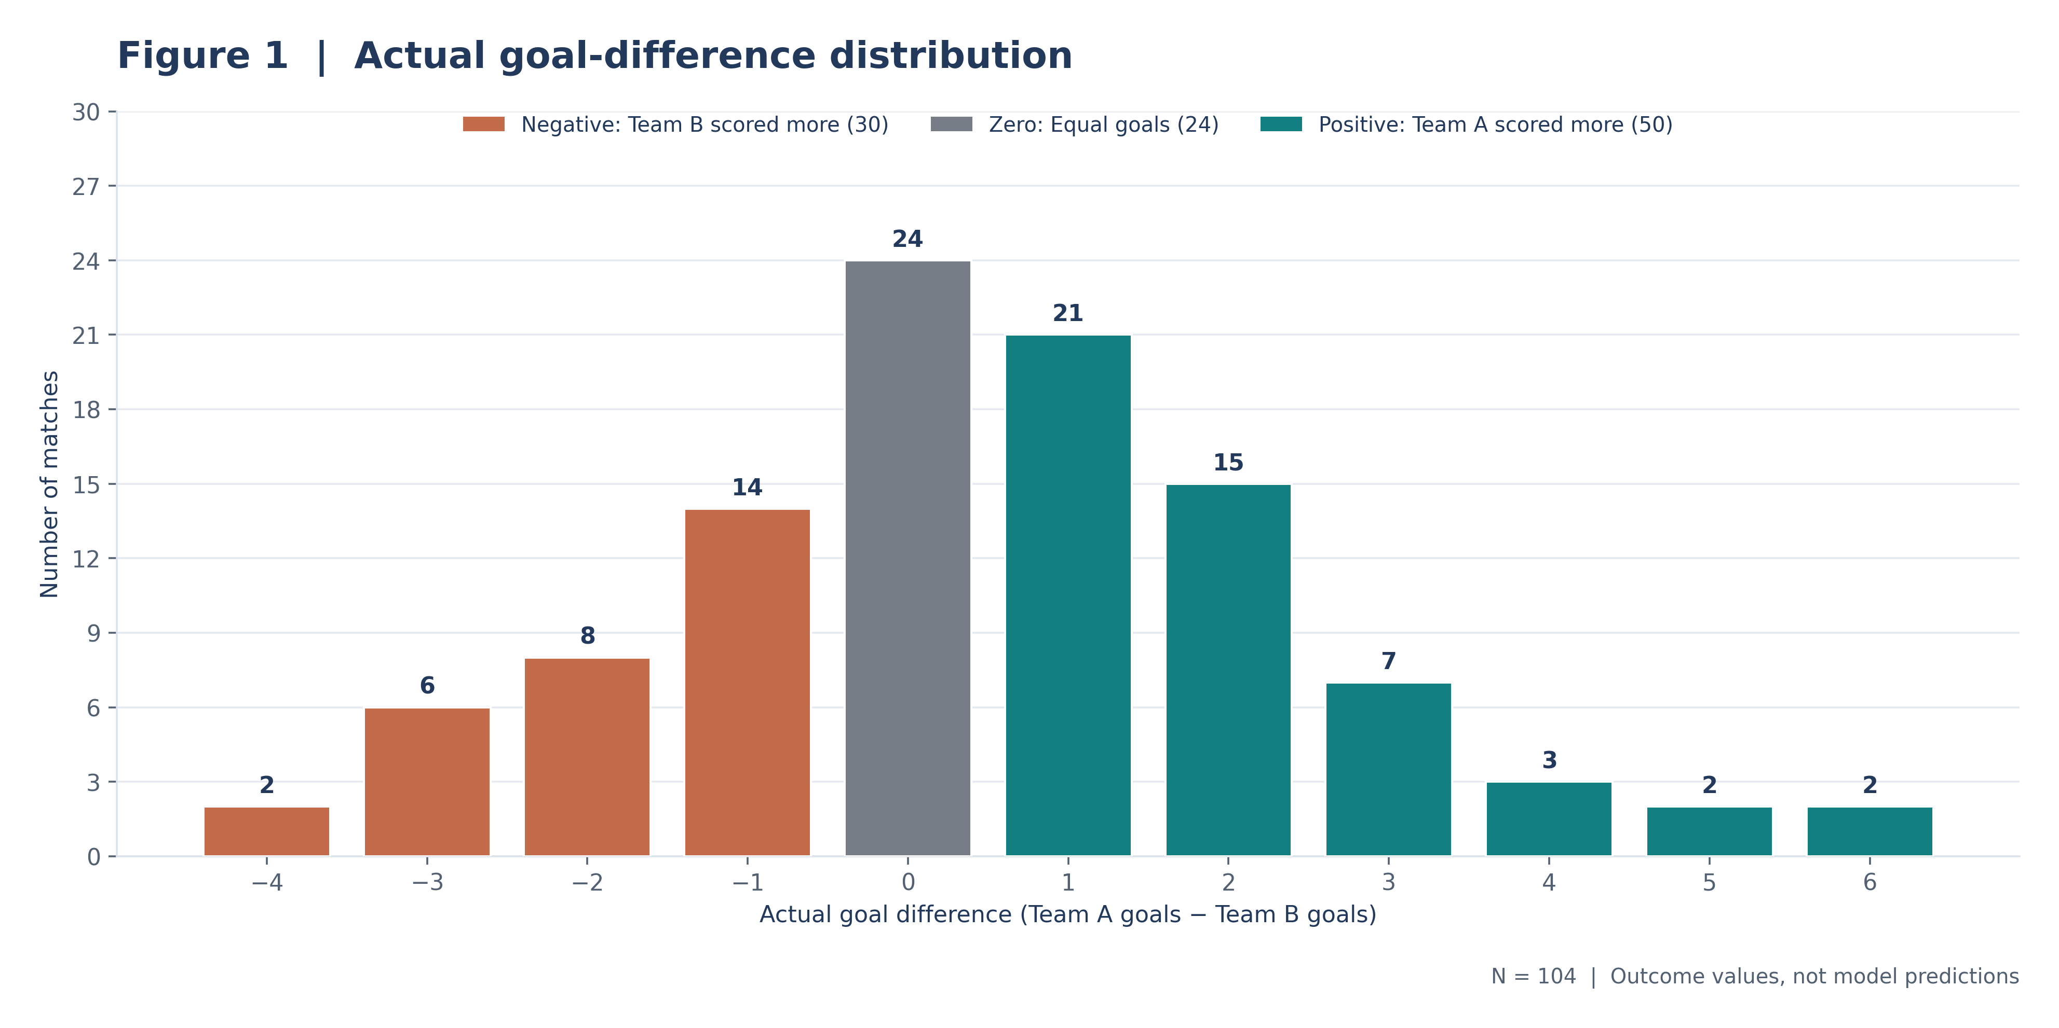
Figure 1. Distribution of observed Team A minus Team B goal difference (N = 104); negative, zero and positive margins are differentiated.

3.2 Feature distributions and unusual observations
The distributions differ in spread, concentration and number of repeated values. X5 and X6 are discrete because they summarise results over only five earlier fixtures; X7 has 62 exact zeros. The eight boxplots from Task 2 identified 18 feature-level observations beyond the conventional 1.5 × interquartile-range (IQR) fences, involving 14 different matches. These are review flags, not 18 proven data errors. Notable examples are Match 18 (X8 = +57.20) and Match 70 (X5 = −1.00; X6 = −1.00). Both rate differences are mathematically valid, including their boundary values.
Match 13 has the most striking X7 value, −70 days. As shown in Figure 4, this extends the full-range horizontal scale and conceals much of the central distribution. The second panel temporarily hides Match 13 solely to make the other 103 observations visible; no row was removed from the official dataset. Further interpretation of its effect is provided in Section 5.
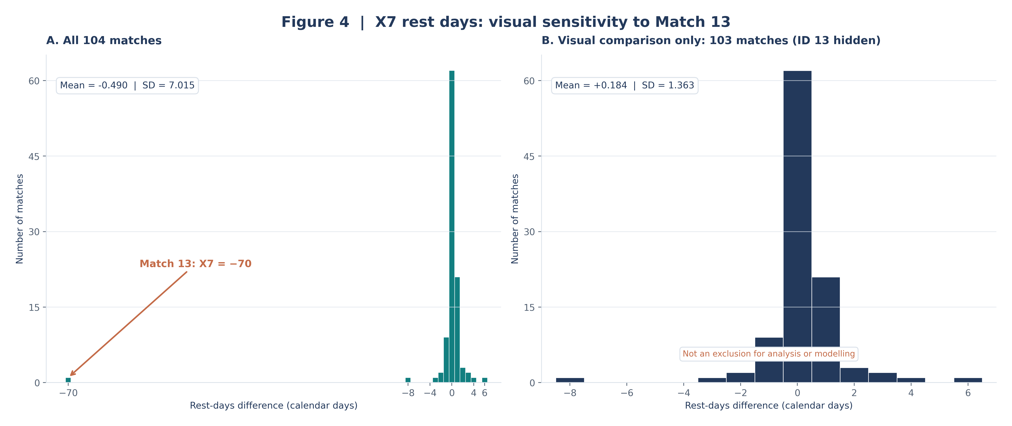
Figure 4. X7 rest-day differences for (A) all 104 matches and (B) 103 matches in a visual-only sensitivity comparison; Match 13 (−70) remains in the dataset.

3.3 Exploratory predictor–outcome patterns
The eight scatter plots in Figure 5 show the goal-difference margin against each original explanatory variable. Both positive and negative margins occur across feature ranges, and observations fall on horizontal bands because goals are discrete counts. Some variables show more visible directional structure than others, but overlapping points and the unusual X7 observation complicate visual assessment. These plots provide descriptive context only; they do not demonstrate causal effects, statistical significance or the contribution of a predictor when other variables are controlled.
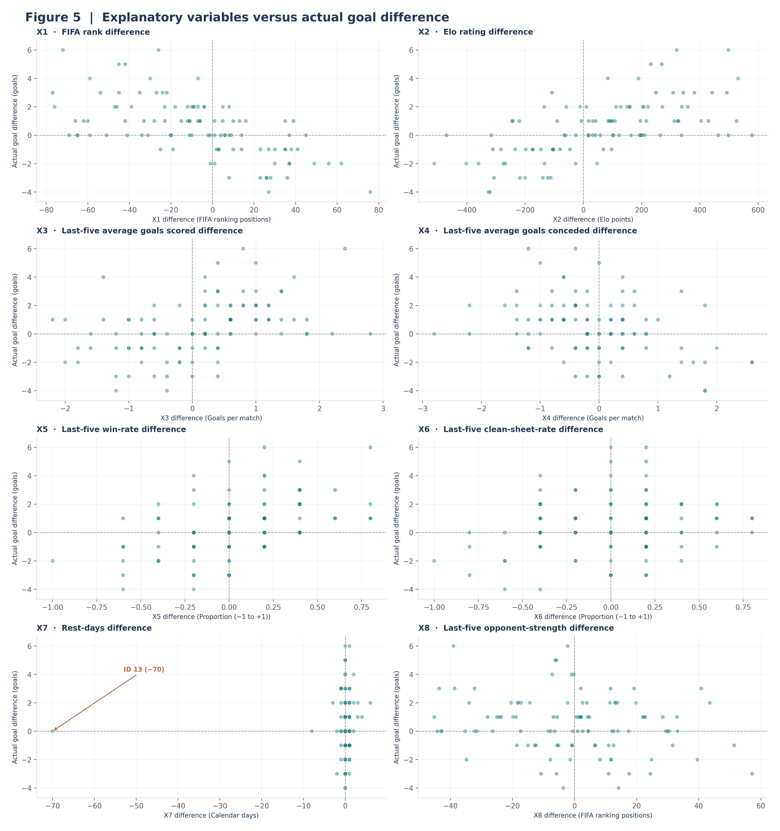
Figure 5. Scatter plots of all eight original pre-match differences against actual goal difference (104 observations per panel); no fitted lines or predictions.

4. Correlation and Multicollinearity Analysis

4.1 Pearson and Spearman associations
Pearson correlation measures the direction and strength of a linear association, while Spearman correlation compares ranked observations to describe a monotonic association. Both lie between −1 and +1. As shown in Table 3, the strongest absolute Pearson associations with goal difference are for Elo difference (X2, +0.627) and FIFA ranking difference (X1, −0.621). Win-rate difference (X5, +0.486) and average goals scored difference (X3, +0.436) show moderate positive associations. Rest-days difference (X7, +0.042) has a weak Pearson association with the recorded outcome in the full sample.
Table 3. Bivariate associations between each explanatory variable and goal difference (N = 104).
Feature | Pearson r | Spearman ρ
X1 | -0.621 | -0.630
X2 | +0.627 | +0.642
X3 | +0.436 | +0.498
X4 | -0.357 | -0.339
X5 | +0.486 | +0.499
X6 | +0.193 | +0.164
X7 | +0.042 | +0.069
X8 | -0.209 | -0.176

Pearson and Spearman agree on the direction of association for all eight variables; the largest difference between these methods is for X3 (Pearson +0.436; Spearman +0.498). Ties are common for discrete variables such as X5, X6 and X7 and should be considered when interpreting rank correlations. Figure 6 also shows predictor-to-predictor relationships: X1–X2 is −0.898, X3–X5 is +0.735, and X4–X6 is −0.732. Negative correlations are legitimate given the feature definitions. A pairwise association does not establish causation or an explanatory variable’s independent contribution in a multivariable model.
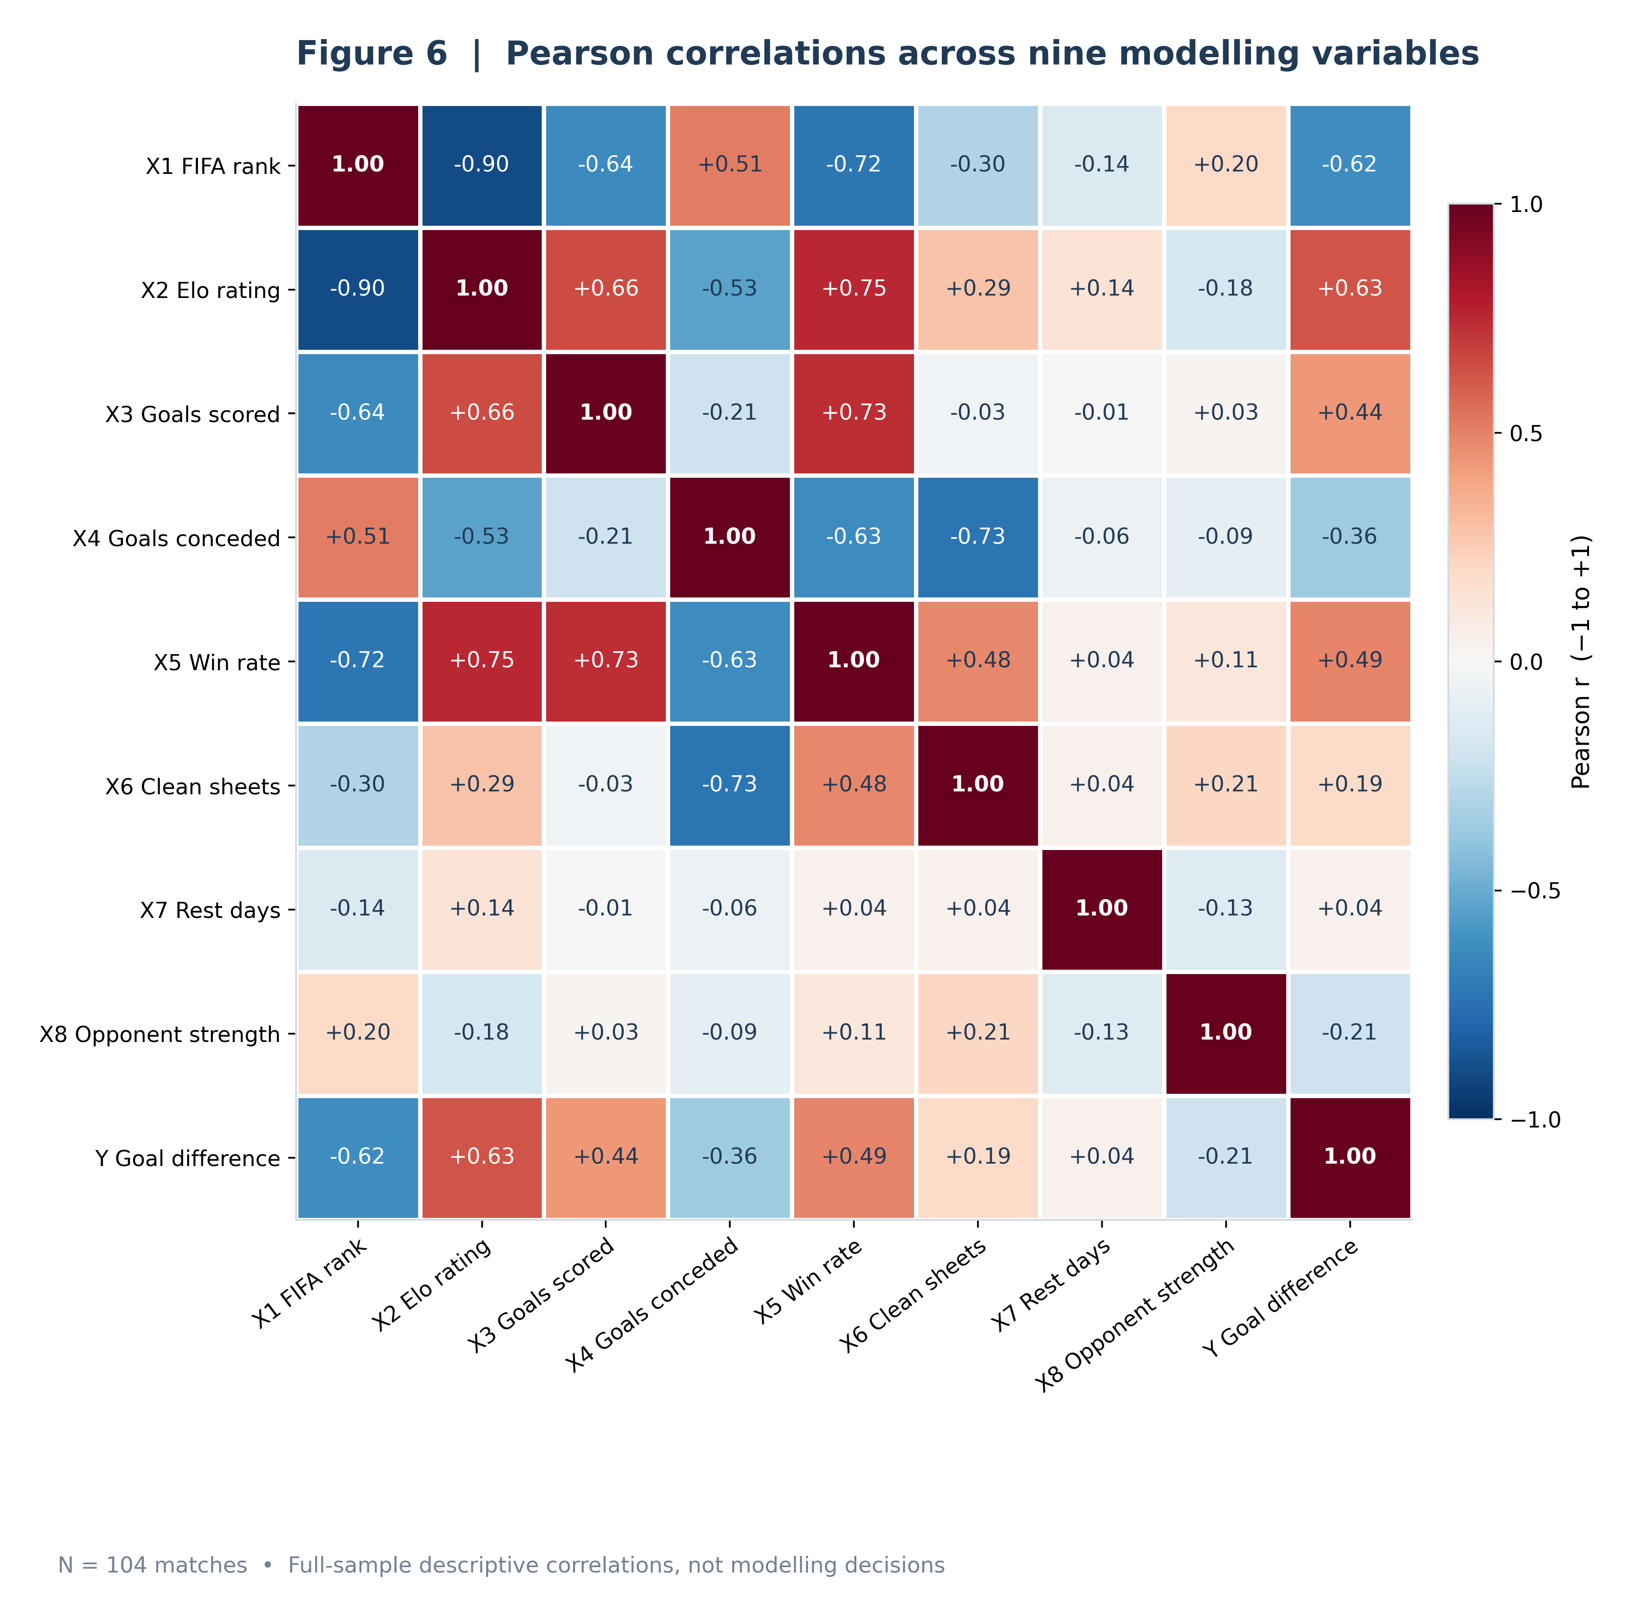
Figure 6. Pearson correlation matrix for X1–X8 and observed goal difference (N = 104); coefficients are annotated to two decimal places.

4.2 Variance inflation factor investigation
Variance inflation factor (VIF) measures how strongly one predictor can be explained by a linear combination of the other predictors. It is calculated from auxiliary regressions including an intercept; it is not a measure of predictive accuracy. X1, X2 and X5 exceed the conventional screening threshold of 5 (Table 4), while no predictor exceeds 10. In particular, X2 has the highest VIF (6.275), followed by X5 (6.134) and X1 (5.625). These findings warrant investigation because overlap among predictors can make individual coefficient estimates unstable or difficult to interpret, even if a later model can make predictions. The VIF thresholds are diagnostic guidance, not automatic reasons to discard variables.

Table 4. Predictor variance inflation factors (auxiliary regressions include an intercept).
Feature | VIF | Screening
X1 | 5.625 | Investigate (>5)
X2 | 6.275 | Investigate (>5)
X3 | 4.264 | Below 5
X4 | 3.031 | Below 5
X5 | 6.134 | Investigate (>5)
X6 | 3.117 | Below 5
X7 | 1.049 | Below 5
X8 | 1.306 | Below 5

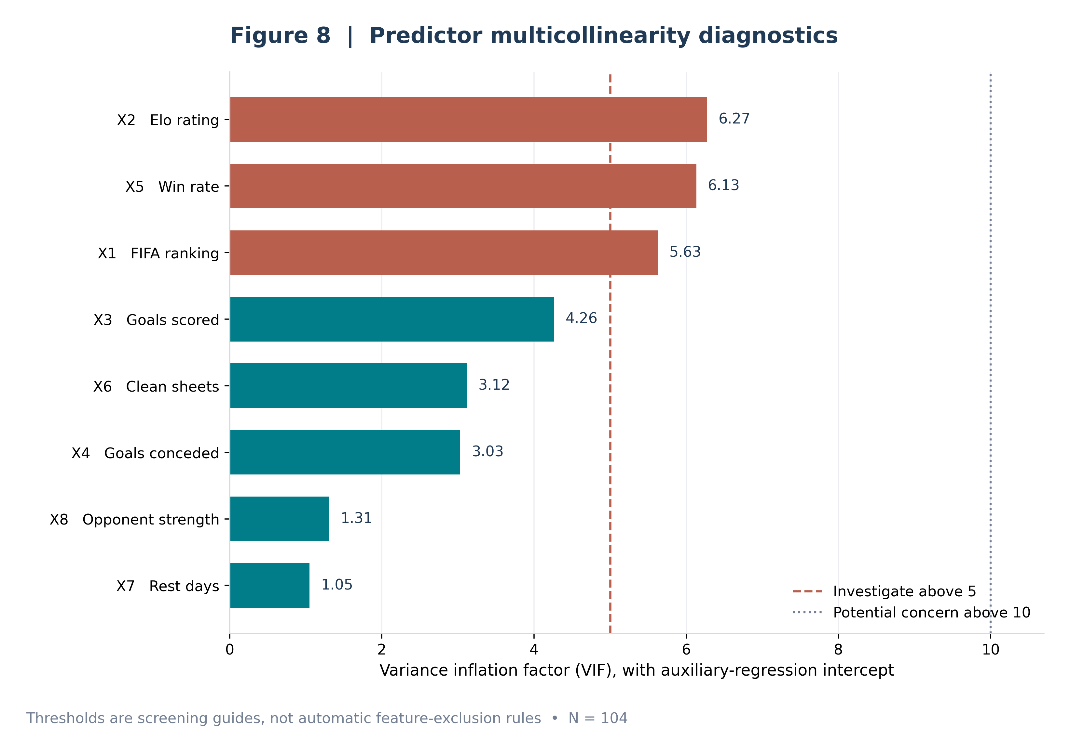
Figure 8. Variance inflation factors for X1–X8; reference lines at 5 and 10 indicate screening thresholds, not mandatory removal criteria.

5. Outlier Sensitivity and Methodological Limitations

5.1 Match 13: X7 sensitivity
Match 13 is unusual but not mathematically impossible. With all 104 matches, X7 has a mean of −0.490 days and sample standard deviation of 7.015 days. In the 103-match diagnostic comparison, the mean is +0.184 and standard deviation 1.363. Its Pearson correlation with goal difference changes from +0.042 to +0.098, while Spearman changes only from +0.069 to +0.064. The Pearson relationship of X7 with X1 also changes from −0.143 to +0.039. Such shifts illustrate why an extreme value can affect magnitude-based correlations more than rank-based summaries. They do not demonstrate that the record is false or should be removed. All 104 matches remain in the official dataset and any later modelling must document influence checks and their rationale.

5.2 Evidence boundaries and next-stage safeguards
Workbook checks verify completeness, numerical consistency and reproducible calculations, but do not authenticate every underlying football fixture, historical ranking or pre-match source. Earlier research used external archives and AI assistance, so remaining source qualifications must travel with the model handover. Correlation is unadjusted association and VIF describes predictor dependence; neither establishes causation, statistical significance or predictive accuracy. Member 1 conducted no significance tests or regression evaluation.
The full-sample diagnostics are descriptive and must not guide feature selection, tuning or outlier treatment using held-out test outcomes. After a train/test strategy is established, any data-driven preprocessing and influence decisions must rely on training data only; test matches should be reserved for final evaluation. Member 2 can then specify the regression design, splitting strategy, assumption checks and evaluation plan without treating this exploratory report as model-selection evidence.

AI-Assistance Disclosure
Generative AI assisted with earlier historical research, Python programming, validation, figure preparation and report drafting. The numerical findings and original figures were checked against the final workbook and Task 1–3 outputs. Programmatic checks establish internal consistency, not independent football-source verification. The submitting team remains responsible for reviewing sources and explaining the methods.
Source: project master workbook and previously validated Task 1–3 outputs; no new external research.

