PWD: pwd prints the full pathname of the current working directory.

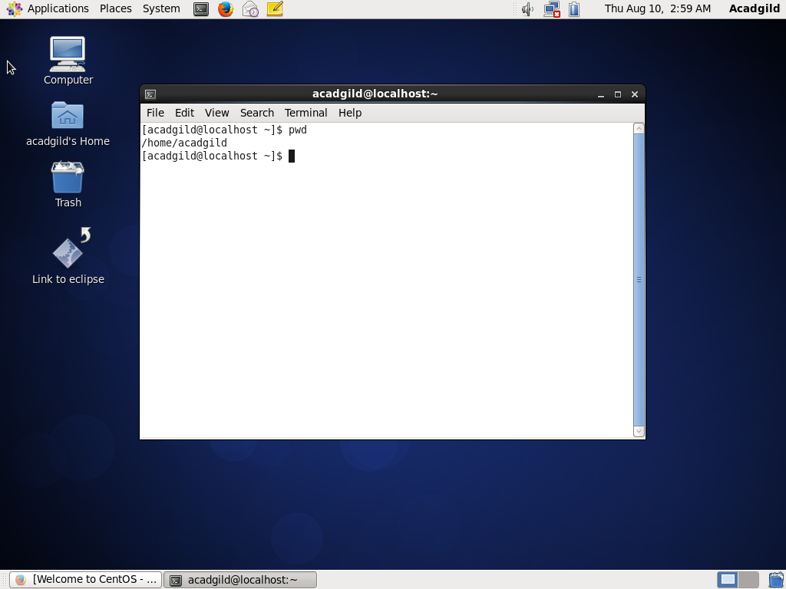

VI:

VI test.txt: When you run this command it opens up the file. If the file does not exist then it will create it for you then open it up.

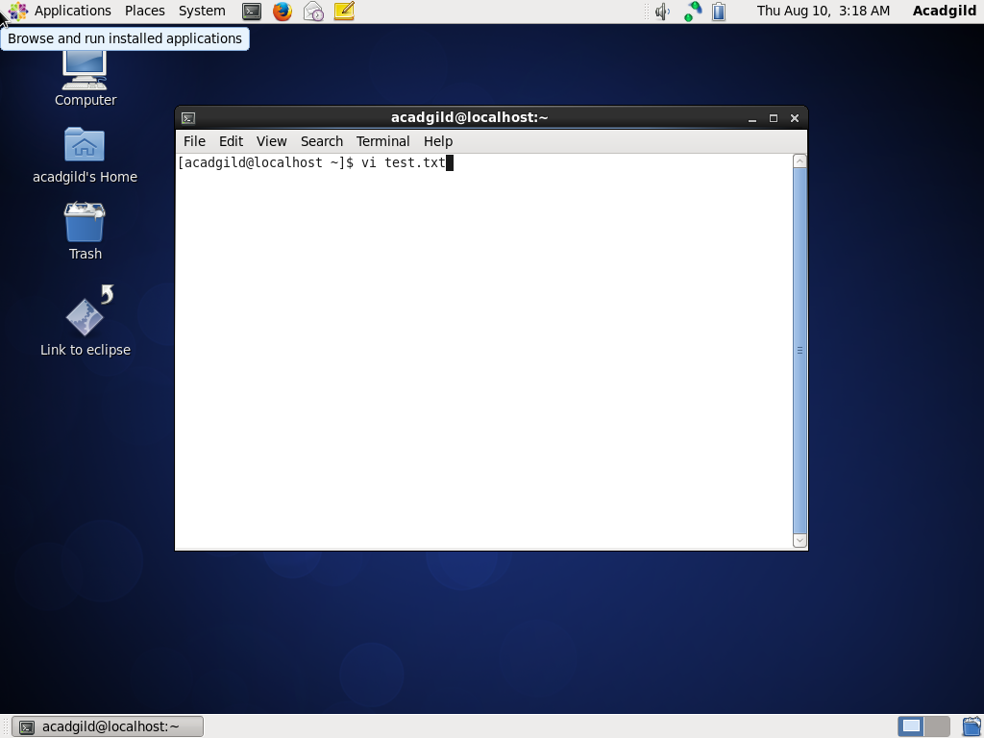

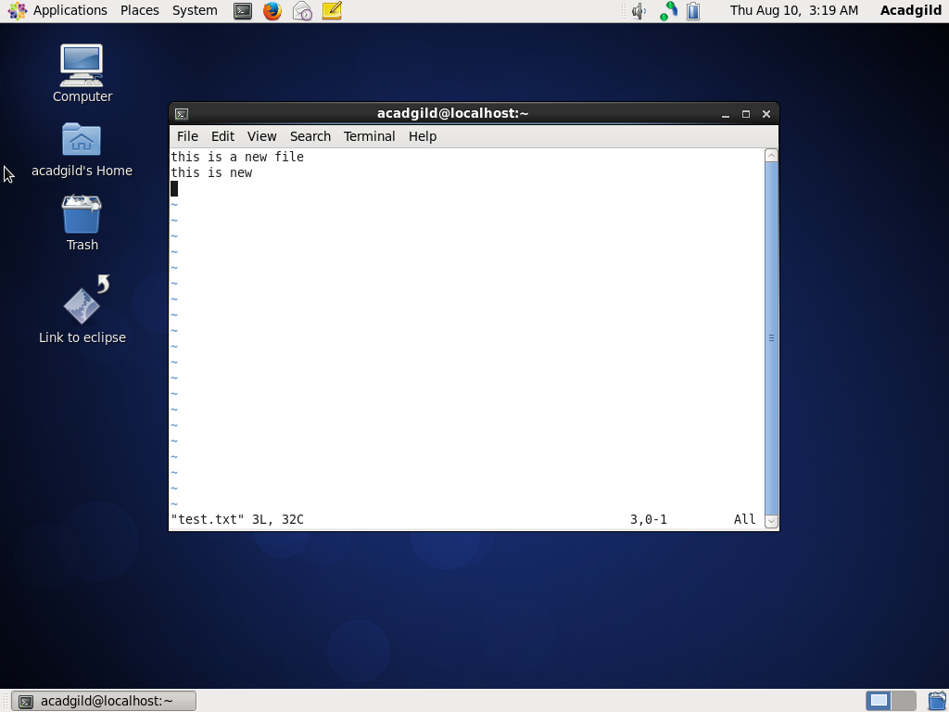

Press esc.

* **ZZ** (capitals) - Save and exit
* **:q!** - discard all changes, since the last save, and exit
* **:w** - save file but don't exit
* **:wq** - again, save and exit

Touch : The touch command updates the access and modification times of each FILE to the current system time.

Mkdir: If the specified DIRECTORY does not already exist, mkdir creates it.

Rm: The rm command removes (deletes) files or directories.

Ls: Lists the contents of a directory.

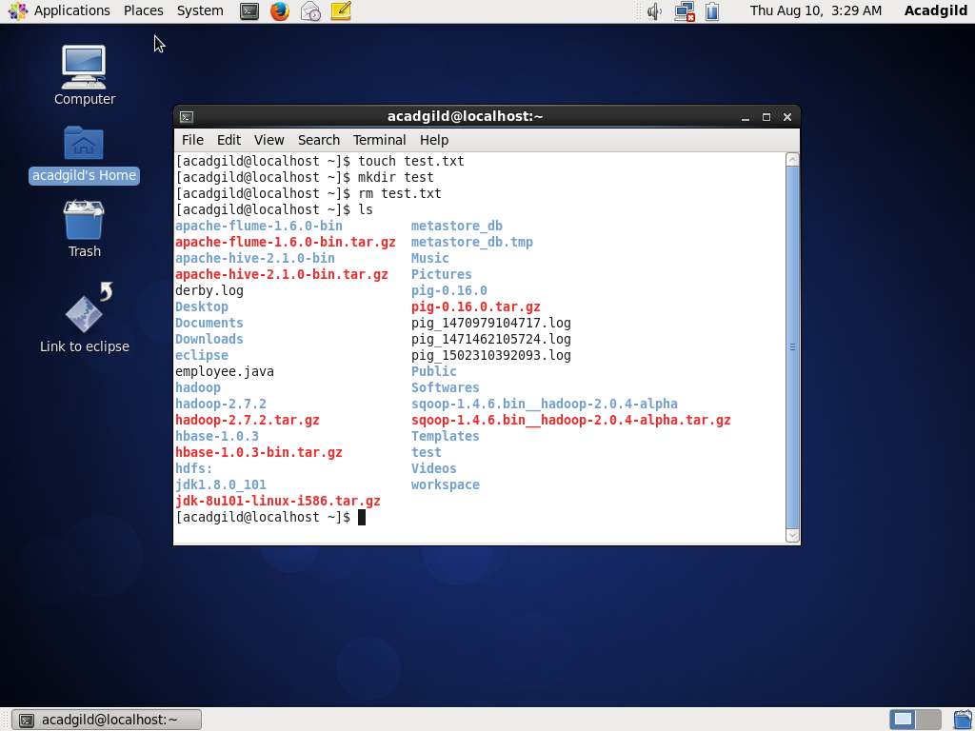

Echo: It’s a command line which displays line of text

Cat: It reads data from files, and outputs their contents. It displays the contents of a file at the command line.

Who: prints information about all users who are currently logged in.

Cd: changes the shell's current working directory.

Date: print out, or change the value of, the system's time and date information.

Cal: display a calendar from the command line.

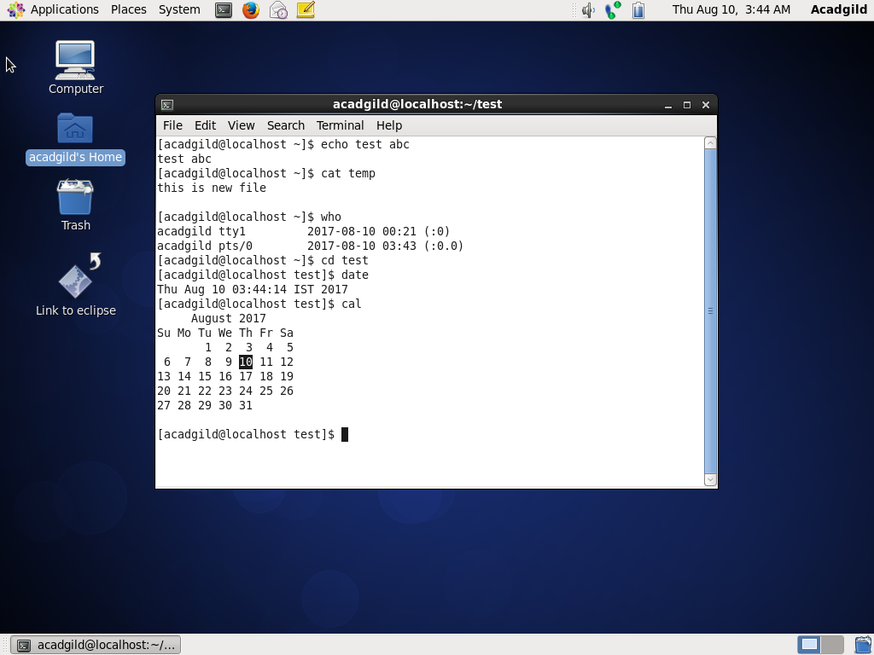

Mv: used to move or rename files.

Cp: used to make copies of files and directories.

Which: Locate the executable file associated with a given command.

