INDIRA GANDHI NATIONAL OPEN UNIVERSITY

BCSP-064

Mikuni India Vendor Portal

by

Riya Kumari
+91-8750419059

Under Guidance
of
Mr. Manish Kumar

Submitted to the School of Computer and Information Sciences, IGNOU
in partial fulfilment of the requirements
for the award of the degree
Batchelor of Computer Applications (BCA)
2021


Indira Gandhi National Open University
Maidan Garhi
New Delhi – 110068.

T A B L E O F C O N T E N T S
S.No. | Particulars | Page No.
 | Title of Project------------------------------------------------ | 1
 | Certificate of Approval -------------------------------------- | 3
 | Certificate of Originality ------------------------------------- | 4
 | Bio-Data of Guide-------------------------------------------- | 5
 | Acknowledgement ------------------------------------------- | 9
 | Introduction ------------------------------------------------- | 11
 | Objective of the Project------------------------------------- | 13
 | Tools & Platform--------------------------------------------- | 16
 | Process Decomposition-------------------------------------- | 18
 | Project Category--------------------------------------------- | 23
 | Hardware Requirement Specification----------------------- | 27
 | Software Requirement Specification------------------------ | 29
 | Software Development Life Cycle--------------------------- | 31
 | Feasibility Study--------------------------------------------- | 35
 | A Complete Structure of Program--------------------------- | 38
 | Date Flow Diagram------------------------------------------ | 40
 | E-R Diagram------------------------------------------------- | 42
 | Project Module----------------------------------------------- | 45
 | Input details (Data Base)------------------------------------ | 48
 | Coding------------------------------------------------------- | 49
 | Form Layout------------------------------------------------- | 230
 | Scope of Future application--------------------------------- | 238
 | Methodology------------------------------------------------- | 241
 | Tools and Techniques--------------------------------------- | 244
 | System Testing Planning------------------------------------ | 248
 | Bibliography ------------------------------------------------- | 254

PROFORMA OF BCA PROJECT PROPOSAL (BCSP-064)
(Project’s Title and Guide Details)

COMPANY OF COMPUTER AND INFORMATION SCIENCES
IGNOU, MAIDAN GARHI, NEW DELHI – 110 068

II. PROFORMA FOR THE APPROVAL OF BCA PROJECT PROPOSAL (BCSP-064)

(Note: All entries of the proforma of approval should be filled up with appropriate and complete information.
Incomplete proforma of approval in any respect will be summarily rejected.)

Enrolment No.: ………………………

Project Proposal No :…………………..
(for office use only)
Study Centre: ……………….……….

Regional Centre:……… RCCode:……..
E-mail: ………….………..…………...
Telephone No.: ………………………
1. Name and Address of the Employee ………………..………………………..…………………………………….
…………………………………………………………………………
………………………………………………………………………
2. Title of the Project .………..………………………………..………………………………

3. Name and Address of the Guide …………………..…………………………………………………….

……………….………………………………………………………..

…………………………………………………………………………..

Ph.D* M.Tech.* B.E*/B.Tech.* MCA M.Sc.*
4. Educational Qualification of the Guide

(Attach bio-data also)
(*in Computer Science / IT only)
5. Working / Teaching experience of the Guide** ……………………………………………………………………
……………………………………………………………………………………………………….……………………………
(**Note: At any given point of time, a guide should not provide guidance for more than 5 MCA Employees of IGNOU)

6. Software used in the Project …………….………………………………………………………………..

7. If already pursued MCA from IGNOU,
mention the title of the project (MCSP - 060) and the s/w used………………………………………

Signature of the Employee Signature of the Guide

Date: ………………… Date: …………………….

For Office Use Only
……………………………………
Signature, Designation, Stamp of the Project Proposal Evaluator

Approved Not approved Date: …………………….

CERTIFICIATE OF ORIGINALITY

This is to certify that the project report entitled _______________________________

submitted to Indira Gandhi National Open University in partial fulfilment of the

requirement for the award of the degree of BATCHELOR OF COMPUTER

APPLICATIONS (BCA) , is an authentic and original work carried out by

Mr. / Ms.______________________________________________

with enrolment no. _______________________under my guidance.

The matter embodied in this project is genuine work done by the student and

has not been submitted whether to this University or to any other University /

Institute for the fulfilment of the requirements of any course of study.

………………………. ...……………………….
Signature of the Student: Signature of the Guide

Date: ……………….. Date: …………………

Name and Address Name, Designation
of the student and Address of the Guide:
……………………….. ………………………..
……………………….. ………………………..
……………………….. ………………………..
……………………….. ………………………..

Enrolment No…………

BIODATA OF GUIDE

Manish Kumar
Resume
H.NO-15, Gali No 09 Govind Puri,
New Delhi-110020
Mobile: - 9873826567
E-mail: manishkrm6@gmail.com

Objectives:
To obtain a challenging position in software field, which will allow for constant, social and technical growth and a chance to use and enhance my knowledge and experience.

Professional Qualifications:
- MCA from GGSIPU secured 79.87% in June 2015
- BCA from IGNOU secured 61% in June 2011
Skill Set:
- (MERN Developer) MongoDB, Express Js, React Js, Node Js, React-Native, Flutter & Dart, PHP, CodeIgniter, Laravel, Mysql, Java, C, C++
Currently Learning:
- Socket.io, Web RTC, WebSockets, Advance MERN Projects & AI.
Overall Summary:
- 3 Years 7 Months experience as a Senior Software Developer & Software Solution Architect in commercial software development Indovision Services Pvt Ltd and 6 Months in Animon Live Pvt Ltd as a Software Developer, 1 Year in Alivenet Solution Private Ltd.
- Hands on experience of Object Oriented Analysis, Design, Testing, and Implementation.
- Hands on experience in Data-Structures & Algorithm.
Professional Details:
From July 2017 to till date: As a Senior Software Developer for the Indovision Services Pvt Ltd, New Delhi.

Project #1: EY-Auditor SAP
Team Size: 4
Environment: Node Js, Express Js, PHP, Codeigniter, Mysql, developed in Windows 10.
Description: This is an in-house project for their transcription department in J2EE and MySql as backend. The main objective of the software is to process all the activities done by Transcription’s person and Quality checker online. It downloads all the voice files from the ftp server to the local server automatically as per schedule and calculates length (duration) of voice files automatically. It creates job as per voice file and assign it to the TC and QC automatically according to the user’s quality grade and capability. It also sets the priority for a job. It creates log files to store all the activities of every user and provides a set of useful reports to the MIS department. This software is based on J2EE architecture with the tools Core Java, JDBC, Java Mail, Servlet, JSP, Beans with Linux (Red Hat 8.0) as operating system and My Sql as backend database.

Job Responsibility: I had assigned to Developing, Testing and Implementation modules for Transcription Software i - e (Master Control Panel, Urgent Client Reports, Voice Reports, Daily Reports)

Project #2: Payroll System 1.0.1
Team Size: 2
Environment: J2EE, MySql 5.0, Apache Tomcat, Linux, and Win NT.
Description: This is an in-house project for their Accounts Department in J2EE and MySql as backend. The main objective of the software is to generate their pay slip of individual month of individual employee by using their login Id and password. After 22nd of ever month pay slip is automatically generated. Payroll System automatically calculated Addition Details (OT, Allowances Bonus, Incentives, and more.), Deduction Details (ESI, Advance Salary, Provident Found, and more) and Leave Details mean extra Leave calculation if any. Also generate report for report for Tax deduction purpose and payment statement for Banks.

Job Responsibility: I was completely responsible for Developing, Testing and Implementation

Project #3: NTSC Finance Admin (National Small Ind. Corporation Ltd.)
Team Size: 2
Environment: PHP, MySql, Apache Tomcat, Linux, and Win NT, AJAX.
Description: This project maintains all information of information of Student who are joining for IT or Non IT Course or Training for Engineer. Drawing and for more department. Maintain Department, Course, Batch and collection of fee and their mode of payment. The admin person and branch head can easily track total actual and accrual collection for each and every months.

Job Responsibility: I was completely responsible for Developing, Testing and Implementation

From May 2006 to Oct 2006: As an S/w Developer for the SUPER SOFT, New Delhi.
Project #1: SST Inventory System.
Environment: VB 6.0, MS SQL 5.0, Windows 2000.
Team Size: 3
Description: Here, I had assigned to develop a desktop Application named by SST Enterprises in VB.6.0 and MS SQL 5.0.My responsibilities were to create necessary databases, E-R Diagram, Flow Diagram and finally coding. The aim of this Application is to provide all information to Clint (Shops) and Vendor (Companies)

Job Responsibility: I was completely responsible for Developing, Testing and Implementation

Project #2: Satayanaraya Finance System
Environment: VB 6.0, MS SQL 5.0, Windows 2000.
Team Size: 3
Job Responsibility: Front end as VB 6.0 with MySql as backend.
Abstract : This software is made for the finance companies (Satayanaryan) and for the dealers who sale their product on the finance basis. It maintains all the record of customers with required information, Daily Book of shop / showroom. It also generates reports & queries Module to view the required information.

Job Responsibility: I was completely responsible for Developing, Testing and Implementation

Technical Expertise:

LANGUAGES : C/C++, PHP, JAVA/ J2EE,(Core Java, Servlets, JSP
JDBC, JAVA MAIL, Bean. Visual Basic 6.0
DBMS/RDBMS : MS Access, My Sql 5.0, Sql
Operating System : All version of Windows and UNIX
Packages : MS-OFFICE 2000, Dream Weaver
WEB : HTML 4.0, Tomcat, WAMP Server, Apache, AJAX.
Scripting Languages : Java Script, VBScript

Academics Qualifications:
Degree | Discipline | Board/University | Percentage
B.Sc. | Che (H), Physics, Math | LNMU, Bihar | 56.00 %
Intermediate  1994-96 | Mathematics, Physics, Chemistry | B.I.E.C Board, Patna | 43.50 %
High school  1994 | Science, SST, Hindi, English | B.S.S.E Board, Patna | 68.88 %

PERSONAL DETAILS:

Father’s Name | Sri. Jagish Thakur
Date of Birth | 30th September 1978
Nationality | Indian
Sex | Male
Marital Status | Married

PLACE: - New Delhi

DATE: -____________
KEDAR NATH THAKUR

ACKNOWLEGEMENT

In the Current Age of information technology the application of IT in the business is the New Technique of business automation. As a BCA student form IGNOU, its well-planed course curriculum languages and packages designed to undergo helped me to learn lot and being an IT professional to support in the part of developing environment. But in the field of software development the real skill to be a good professional is to have the through knowledge on the basis of project. So Idec iced to mark this project for a “Delhi Metro Maintainance System”.

I thankfully acknowledged the encouragement and guidance provided by Mr Kedar Nath Thakur without whose help this report could not have achieved its present form.

The planning, coding and production of this project have been an arduous task has been made easy by the sound advice of my guide and teachers. I am very indebted to my project guide whose expert guidance was instrument al in shaping the form and contents of this project. I drew a lot from the experience knowledge of my guide who was always there to encourage the thought processing in me. I extent my heart felt gratefulness to him for his support. I am very thankful to the lab assistant for the corporation in making this project, their help & the for the innumerable hours they spared out of their busy schedule and the valuable suggestions that they generously gave throughout the study and this project is deeply appreciated. Naturally, I alone must carry the responsibility for any error or omission that may have crept into the project. The good people mentioned above did the very best they could do with me.
It is my duty to record a sincere thanks & a deep sense of gratitude towards all the respected teachers without whose guidance, kind interest & constant encouragements completion of this project wouldn’t have been possible.
I would also like to offer my special thanks and formal appreciation to the persons who had been my sole inspirations throughout the training.

MANISH KUMAR

INTRODUCTION

The Current Scenario of Advanced Society Follows up the Application of Information Technology as the key to achieve the target with less effort and high performance. A system that runs without the implementation of it is treated to be an old era. The technology is ready to provide all the aspects of advanced communication and infotainment to the new generation. Where people should make the effort to achieve it.
Some important features for this project to support for users requirement are:

- Controlling entire project through a descent menu.
- Maintaining details regarding Problem Log details
- Maintaining details regarding Troubleshoot details
- Maintaining details regarding of Types of Problem details.
- Maintaining details regarding Logs of Troubleshoot details

A Delhi Metro Maintainance System will be providing a more user-friendly mechanism to the entire user associated with the process. The Delhi Metro Maintainance System comprises fallowing actions to automate all the process.

OBJECTIVES OF THE PROJECT

In the era of 21st century, no one can neglect the use IT industry in the world. In has become very typical to manage at the aspect of an organization manually. Every industry has an intension to display the IT Application to automate the whole process of the organization in a systematic and efficient way.

Delhi Metro Maintainance System also has very important role in human life like owner commercial industries. So the organization has a responsibility to provide a battler their Employee and it is only possible if they have complete information, which should be accessed easily by using this automated software Problem Log, Troubleshoot, and Type of problem.

The purpose of this software is to provide an efficient way to represent the relationship between User and Trobleshooter and become time saving approach to Delhi Metro Maintainance System.
In each and every Company their functionality same as but slightly varies the constraints because their rule and regulation of the Company. This project related to a particular Company and their objective is given below.

- Logging of new problem.
- Addition of new Trobleshooter
- Addition of new Problem Type
- Keeping of records of problem logs and Troubleshooted
- Various Type of reports.
Company works/activity process incurs time delay and excessive cost resulting from the manual work/activity procedure. As a solution to these problems the Company decided to automate the work/activity documentation and tracking process.

TOOL AND PLATFORM

Front – end
As front – end or user interface J2EE (Java, Servlet, Jsp) programming language will be used. It is completely an OOPS (Object Oriented Programming System) base programming language and product of Sun Mircosystem Ltd.

Web Server
Apache Tomcat 5.0 is a web server userd in this project and it is a product given by Apache Software Foundation.

Back – end
MySql 5.0 will be used as back-end or database. MySql 5.0 has the feature of RDBMS (Relational Database Management System), which support the operation such as creation, manipulation, and deletion of database object. This also supports user friendliness. These were reason for using MySql 5.0 back-end.

Window XP
Window XP will be the Operating System that will be used for the deployment of the Delhi Metro Maintainance System.
From the outset, Windows XP was designed to be a robust, reliable operating system that could be easily maintained and that could be extended to take advantage of new technologies as they were developed. The system includes a highly functional executive that executes in kernel mode, and provides native system services. The executive provides the sole; secure entry point into the system there are no back door entry points that could compromise security or damage the system in any way. In addition, the design includes a layer of protected system services that function in user mode between the application layer and the operating system. This modular approach allows additional crucial services to be added with no change to the executive layer.

PROCESS DECOMPOSITION
1. Purpose of document
To specify the techniques and methodology that will be used to study the current system and the people who have participated in the study. Also to specify the software engineering model that will be used and the works tasks that will be used as a part of the software engineering process that will be followed
2. Study Methodology
To obtain information about the current system and determine the requirement of the new system, study of the current system has been carried out. Extensive discussions and interaction with various members of the Employee, Departments of Delhi Metro Maintainance System at various levels has allowed conceptualization of the details of the current system to understand the requirements of the Delhi Metro Maintainance System, the required flow, structure and operations have been studied in detail. This has helped in a better understanding of the requirement as well as in deriving the common aspects of the system.
3. Software Engineering Mode
Model Used: WATERFALL MODEL
Rationale behind model used:
The waterfall model suggests a systematic, Sequential approach to software development that begins at the current system level and progresses through analysis, design, coding, testing and support. It also allows for some overlapping and iterations, making it flexible. It also makes the development process more visible.
This software engineering model is most appropriate for the nature of the Delhi Metro Maintainance System to be developed. The flow from one stage of development to another confirms to the fact that due to the system being user centric and data intensive, designing of the system would be in vain till the user requirements are completely understood. This is made possible by interviewing the users and developing prototypes for the areas that are not completely understood. Only once the requirements have been completely understood can the designing process begin this is to prevent major changes to the system after designing. The flow of the waterfall method is not only useful for the system development process but also for the user since documents are produced are regular intervals for review of the work done and its progress by the management at Delhi Metro Maintainance System
4. Process Decomposition
The software development process for the project can be decomposed into the following set of framework activities:
1. Employee/User Communication
- Meet with New Employee
- Identify needs benefits and project constraints
- Study current system and the feasibility of the new system
- Generate feasibility report
2. Project Plan
- Establish problem statement
- Review problem statement
- Review problem statement as required
- Establish the work task set.
3. Risk analysis
- Identify risks, their probability of occurrence and their impact on the system to be developed
- Determine major risks and methods to avoid, monitor and manage the risks
- Document the risks and the plan to mitigate, monitor and manage these risks
4. Requirement Analysis
- Scope and define the system inputs, control, outputs, and the desired input/output interface.
- Decompose the system into classes/entities, identify their attributes and define their behaviors.
- Define entity relationships that relate the entities.
- Analyze any scope for reusability
- Develop the software specification
- Review the software specification
- Revise the software specification
5. System Engineering and Design
- Study the system specification
- Decompose the system into sub systems
- Determine the architectural design of the system
- Design the database
- Carry out normalization
- Describe each sub system in a manner that can be implemented by decomposing it further into modules. Modules can further be decomposed into units.
- Design each operation of each sub-system at a procedural level by choosing and designing the appropriate algorithms.
- Design the user interface
- Document the design model
- Review the design model.
- Revise the design model as required
6. System Coding
- Develop the database tables
- Implement each macro operation to be performed on an entity in separate Form.
- Establish the interfaces between backend and the front end
7. System Construction
- Integrate the Form files developed during coding into modules.
- Establish communication between each module of each sub system
- Contact each sub system by integration of its component modules.
- Integrate the sub systems to give the system.
- Implement any system level functionality.
8. System testing
- Cross check the functional system operations with the system specification
- Using beta testing techniques to validate the system operation.

PROJECT CATEGORY

RDBMS (Relational Data Base Management System)

- OOPs (Object Oriented Programming language)

The project is Graphical User Interface (GUI) Web Technology based software with J2EE (Java, Servlet, Jsp) as front-end and NetBeans 5.5 used as IDE and MySql 5.0 as backend tool. NetBeans IDE 5.5 this taken as the front end tool because the best user friendly GUI’s can be made with ease of coding

Object Oriented
A major factor in the invention of Object-Oriented approach is to remove some of the flaws encountered with the procedural approach. In OOP, data is treated as a critical element and does not allow it to flow freely. It bounds data closely to the functions that operate on it and protects it from accidental modification from outside functions. OOP allows decomposition of a problem into a number of entities called objects and then builds data and functions around these objects. A major advantage of OOP is code reusability. Some important features of Object Oriented programming are as follows:
- Emphasis on data rather than procedure
- Programs are divided into Objects
- Data is hidden and cannot be accessed by external functions
- Objects can communicate with each other through functions
- New data and functions can be easily added whenever necessary
- Follows bottom-up approach
Concepts of OOP

- Objects
- Classes
- Data Abstraction and Encapsulation
- Inheritance
- Polymorphism
Objects
Objects are the basic run-time entities in an object-oriented system. Programming problem is analyzed in terms of objects and nature of communication between them. When a program is executed, objects interact with each other by sending messages. Different objects can also interact with each other without knowing the details of their data or code.
Classes
A class is a collection of objects of similar type. Once a class is defined, any number of objects can be created which belong to that class.
Data Abstraction and Encapsulation
Abstraction refers to the act of representing essential features without including the background details or explanations. Classes use the concept of abstraction and are defined as a list of abstract attributes. Storing data and functions in a single unit (class) is encapsulation. Data cannot be accessible to the outside world and only those functions, which are stored in the class, can access it.
Inheritance
Inheritance is the process by which objects can acquire the properties of objects of other class. In OOP, inheritance provides reusability, like, adding additional features to an existing class without modifying it. This is achieved by deriving a new class from the existing one. The new class will have combined features of both the classes.
Polymorphism
Polymorphism means the ability to take more than one form. An operation may exhibit different behaviors in different instances. The behavior depends on the data types used in the operation. Polymorphism is extensively used in implementing Inheritance.
Advantages of OOP
Object-Oriented Programming has the following advantages over conventional approaches:
- OOP provides a clear modular structure for programs which makes it good for defining abstract data types where implementation details are hidden and the unit has a clearly defined interface.
- OOP makes it easy to maintain and modify existing code as new objects can be created with small differences to existing ones.
- OOP provides a good framework for code libraries where supplied software components can be easily adapted and modified by the programmer. This is particularly useful for developing graphical user interfaces.

HARDWARE REQUARMENT SPECIFICATION

Processor : P3 – 2.0 GHZ

Motherboard : Chipset/Intel – Original

RAM : 128MB SD RAM

Hard Disk Drive : 20 GB Seagate

Floppy Drive : Samsung 1.44 FDD

CD Rom Drive : 48X, 52X Read Write

Monitor : Samsung Multimedia Keyboard

Multimedia Kits : ATX

Printer : HP Printer

Modem : 64 kbps Modem (Intex) External

SOFTWARE REQUIREMENT OF SPECIFICATION

- Microsoft window XP
- NetBeans IDE 5.5
- MySql 5.0
- Microsoft office 2003 (Microsoft Word)
- Technology J2EE (Java, Servlet, Jsp)
- Apache 5.5 Web Server

Software Development Life Cycle (SDLC)

Development Process
At Stylus we follow a process oriented development methodology designed to minimize project risks and development time. We focus on business solutions that fulfill business goals, instead of merely providing technical solutions. All our applications are built on the basis of this philosophy.
The approach that we adopt is the spiral iterative methodology, where the project goes through one or more iterations of all project stages. The above presentation gives a brief overview of the process.
We have defined processes for requirements capture, analysis, design, development, testing and deployment. We generate UML diagrams representing the Use Case Model, Analysis Model, Design Model, Implementation Model and Test Model.

Requirement Definition
In this stage, Company requirements are gathered. This is done on the basis of information provided by the Company in the form of documents, existing systems & process specs, on-site analysis interviews with end-users, market research and competitor analysis. This stage has the following steps:
- Requirements Analysis with Business Application Goal and High Level Requirement gathering
- Creation of Visual Scope Document and Feature List
- Providing technical recommendations and High Level Requirement Specification
Analysis
In this stage, a detailed analysis is carried out from the information in the vision & scope document and feature list. This stage has the following steps:
- Analysis and creation of Software Requirement Specification
- Creation of Use Case Specification & Diagram and generating the Use Case Model
- Design business rules and flow diagrams
- Establishment of Requirement Tractability Matrix
- Validation of the Scope and estimates against the contract and revisions made if necessary

Design
In this stage, the application design is developed on the basis of the software requirement specification; use case specification, business rules & diagrams and the scope agreed upon in the Requirement Definition stage. This stage has the following steps:
- Designing Architectural Diagrams
- Creation of High Level Design and Low Level Design class diagrams
- Establishment of Entity Relationship Diagram, Data Flow Diagram and Deployment Diagram
- User Interface - The prototype is developed and validated against the requirements and presented to the Company for approval
- The use cases elaborated in the analysis model are represented using collaboration diagrams
- Design model elaborations are made from the analysis model. Validation of the scope, estimates against the contract and revisions are made if necessary
- The Implementation Model is generated from design
- The Test Model is generated from use cases

Development
In this stage, the actual code based on the design is created and tested against design requirements and test cases. This stage has the following steps:
- The development of code base proceeds as per implementation and design models
- The application source code is tested according to the test cases and test plan
- Documentation of processes
- Creation of Use Case Test results

Integration and Testing
In this stage, the developed application is tested through test cases, test plans and user acceptance criteria in the deployed environment.
- Integration and quality testing is carried out resulting in test reports
- Support acceptance tests carried out
- Support feedback and debugging
- Company acceptance

Deployment and Acceptance
In this stage, the developed application is deployed on the live server.
- Integrated Application and Deployment plan
- Implementation on Company Premises or Hosting Server
- Implementation Signoff by Company
- Creation of Archived Software Artic rafts
- Transition of application to the maintenance team
The steps above are iterated through until the final deliverable is completed.
We will submit a detailed project schedule in accordance with the above deliverables. The project schedule will clearly indicate the responsibility of the Company and the developer and indicate the dates by which each person will submit their deliverables.
Stylus has been following the above spiral iterative methodology while developing applications in the past.

FEASIBILITY STUDY
1. Statement of needs

1.1 The current system
The current system of Company is a manual work/activity system. It is complex system and involves a complex procedure for information storage and documentation of a particular Company work/activity. The Employee/User contacts the IT Person with his Troubleshoot requirement.

1.2 Drawbacks of the current system
Drawbacks of the current system which functions as specified above can be enumerated as follows:
- There are delays in reports generated due to the inherent nature of manual system.
- The manual system has scope for loss of and error in information.
- The risk of loss of data on paper is high.
- The current organization of the system is complex and needs to be broken down into simpler processes for its better operation
As is apparent from the basic study, the manual sales procedure is complex, time Consuming and expensive one. The suggestions to automate this system are an appropriate solution.

2. Functional requirements

A brief study of the functional requirements reveals the need for the following Functionalities of the automated Company Management System:
Authenticate a user when he/she opens the application.
- Register New Log
- Serarch Existing Log
- Add New Troubleshooter
- Edit exits troubleshooter
- Delete exits troubleshoote
- View exits troubleshoote
- Generate different type of Report
  - By Pending Log
  - Between tow dates
  - By department
- Assumptions
The main assumptions that are being made for developing the Delhi Metro Maintainance System System are:
- The manual Helpdesk Support system is already in place
- Constraints
Various constraints put but the User and Troubleshooter and the nature of the existing system need to be taken into consideration during system development. The identified constraints include:
- Problem Log constraints:
i. This software should be a user-friendly interface.
ii. The software should have a protection mechanism to prevent unauthorized access.
iii. The system developed should be flexible to accommodate additional functionalities.

- Time constraint:
The software should be delivered within a specified time period.
- Preferences:
iv. The system developed should be portable in terms of database.
v. The system should not be limited in terms of number of admission details that can be specified by the user where the application is concerned though the same will be limited by the specific hardware and technology will used.
vi. User manual should be made available as a part of the developed system.

- Simplifications
To simplify the system, the number of Log that can be stored by the system being developed is bounded to a reasonable number as determined by the size of data types of the technology being used.

- Scalability Issues and Future Extensions

- The automated system for Helpdesk should be extendable to allow addition of more types of reports and new field in the Log Form as and when required.
- The data stored in the databases to be used by the automated system will initially be accessible only by the system and will respond to queries only by it. However, in future, this data can be made available for queries by other (marketing deptt, HRD etc.) departments.

A COMPLETE STRUCTURE OF PROGRAM

Welcome Page
User Details
Reports
Change Password
Student
Add User
By Pending Job
Trace Problem
By between Date
By Department
User Login
Add User
Add User
Add User
Register Problem

DATA FLOW DIAGRAM

Data flow diagram of advanced Delhi Metro Maintainance System is given below.

Context Flow Diagram
IT/SOFT DEP
IT ADMIN
PROBLEM

DFD Level 1
2
1
2
3
USER MASTER
PROBLEM DETAIL
ADMIN

2
LOGIN
PROBLEM
1
2
L0GIN
PROBLEM ASSIGN
3
4
PROBLEM SOLVER
USE MASTER
2
LOGIN
5
REPOTS
ADMIN
user
PROBLEM ASSIGN
TROUBLESHOOT DETAIL
5

E-R DIAGRAM
(WITH ATTRIBUTES)

USER NAME
USER MASTER
SOFT/IT DEPT
SOLVER/ IT ADMIN
TROUBLESHOOT DETAIL
IT ADMIN
LOGIN
REPORT
HANDLES
ASSIGN
REQUEST
Manage Records
USER PASS
DEPT
USER_ID
TO_id
Name
DOB
DOJ
COMMENT
TS_ID
Date
COM_ID
DEP
USER ID
USER NAME
USER_ID
USER NAME.
PASS
DEPT
COMP_ID
USER_ID
ASIGN_DATE
COM_ID
dATE
T_id
TO_id

PROJECT MODULE
Module and Their Description
Module: 1:-Problem Modular
Description: -This module deals with Problem Assign Details information. It includes following details.
- ID:-It helps to uniquely define the user.
- User name:-Name of the user.
- IP address:-IP address of the system which has problem.
- System’s IP address:-IP address of the system from where user enter his/her system’s problem.
- Department:-Department in which infected system is exist.
- Designation:-Designation of the user who enter the problem.
- Description:- Description of problem.
Module 2: Login Module
Description: -This module deals with login process by User/Solver/It Admin and this is handle with user name and password.
Module 3: Error Assign Module
Description:- This module has the following information:-
- Define the Error on the behalf of Error List.
- Define the type of Error i.e. whether Error is occur from IT department or software.
- Define the Trouble shooter for Assigned Error.
MODULE 4: Report Module
Description:- It contains following information:-
- There is a report page that contains details and explanation of current assigned Error i.e. available for user.
- On the other hand, there is a report page that contains the details and explanation of all the Error assigned at a particular period of time. Only IT Admin has right to view to this page.

INPUT DETAILS DATA BASE
      - The Users Table:-

Attribute Name | Type | Size | Description
User_Id | Number | 10 | Enter User ID
User_Name | Character | 20 | Name Of User
User_Password | Character | 15 | User’s Password
Department | Character | 20 | Department of User
Designation | Character | 20 | Designation of User

2. The Complaint Detail Table:--

Attribute Name | Type | Size | Description
Comp_Id | Number | 12 | Id of Complaint
IP_Address | Character | 20 | IP Address Of Computer
Name | Character | 15 | Name Of The Person Who is Complaining
Dept | Character | 15 | Department Of person who is Complaining
Designation | Character | 15 | Designation of person who is Complaining
Problem | Text | 100 | Problem is computer
Date | Date | NA | Date Of Complaint

3. The Problem Assign Table:-

Attribute Name | Type | Size | Description
Assign_Id | Number | 12
Comp_Id | Number | 12
Solver_Id | Number | 12
Department | Character | 15
Assign_Date | Date | NA

4. The Trouble Shoot Detail Table:-
Attribute Name | Type | Size | Description
Trobleshoot_Id | Number | 12
Complaint_Id | Number | 12
Comment | Text | 50
Troubleshoot_Date | Date | NA

In table no. 1 User id is primary key.
In table 2 complaint id is primary key.
In table 3 Assign Id is primary key and complaint id foreign key.
In table 4 complaint Id is foreign key and Troubleshoot Id primary key.

CODING

ErrorDetailBean.java
package helpdesk.bean;

import java.beans.*;
import java.io.Serializable;

/**
* @author kedar.t
*/
public class ErrorDetailBean extends Object implements Serializable
{

public ErrorDetailBean(){}

private String request_id;
private String request_date;
private String request_time;
private String requestDept;
private String status;
private String supportDept;
private String firstName;
private String lastName;
private String localIP;
private String requestDesc;
private String requestType;
private String assignedDate;
private String assignTo;
private String actionDetails;

public void setActionDetails(String actionDetails) { this.actionDetails = actionDetails;}
public void setRequestID(String request_id) { this.request_id = request_id;}
public void setRequestDate(String request_date) { this.request_date = request_date;}
public void setRequestTime(String request_time) { this.request_time = request_time;}
public void setRequestDept(String requestDept) { this.requestDept = requestDept;}
public void setStatus(String status) { this.status = status;}
public void setSupportDept(String supportDept) { this.supportDept = supportDept;}
public void setFirstName(String firstName) { this.firstName = firstName;}
public void setLastName(String lastName) { this.lastName = lastName;}
public void setLocalIP(String localIP) { this.localIP = localIP;}
public void setRequestDesc(String requestDesc) { this.requestDesc = requestDesc;}
public void setRequestType(String requestType) { this.requestType = requestType;}
public void setAssignedDate(String assignedDate) { this.assignedDate = assignedDate;}
public void setAssignTo(String assignTo) { this.assignTo = assignTo;}

public String getActionDetails() { return this.actionDetails;}
public String getRequestID() { return this.request_id;}
public String getRequestDate() { return this.request_date;}
public String getRequestTime() { return this.request_time;}
public String getRequestDept() { return this.requestDept;}
public String getStatus() { return this.status;}
public String getSupportDept() { return this.supportDept;}
public String getFirstName() { return this.firstName;}
public String getLastName() { return this.lastName;}
public String getLocalIP() { return this.localIP;}
public String getRequestDesc() { return this.requestDesc;}
public String getRequestType() { return this.requestType;}
public String getAssignedDate() { return this.assignedDate;}
public String getAssignTo() { return this.assignTo;}
}

SerAssignBean.java
/*
* SerAssignBean.java
*
* Created on August 11, 2008, 5:21 PM
*/

package helpdesk.bean;

import java.beans.*;
import java.io.Serializable;

/**
* @author kedar.t
*/
public class SerAssignBean extends Object implements Serializable
{
public SerAssignBean(){}

private String err_id;
private String err_date;
private String userDept;
private String status;
private String supportDept;
private String firstName;
private String lastName;
private String localIP;
private String errorDesc;
//develop by anuradha
private String uname;
private String umail;
private String userID;
private String userRole;
private int request_id;
private int priority_id;

public void setErrorID(String err_id) { this.err_id = err_id;}
public void setErrorDate(String err_date) { this.err_date = err_date;}
public void setUserDept(String userDept) { this.userDept = userDept;}
public void setStatus(String status) { this.status = status;}
public void setSupportDept(String supportDept) { this.supportDept = supportDept;}
public void setFirstName(String firstName) { this.firstName = firstName;}
public void setLastName(String lastName) { this.lastName = lastName;}
public void setLocalIP(String localIP) { this.localIP = localIP;}
public void setErrorDesc(String errorDesc) { this.errorDesc = errorDesc;}
public void setpriorityId(int priority_id) {this.priority_id = priority_id;}
//develop by anuradha
public void setUname(String uname) { this.uname = uname;}
public void setUmail(String umail) { this.umail = umail;}
public void setUserID(String userID) { this.userID = userID;}
public void setUrole(String userRole) { this.userRole = userRole;}
public void setrequestId(int request_id) {this.request_id = request_id;}

public String getErrorID() { return this.err_id;}
public String getErrorDate() { return this.err_date;}
public String getUserDept() { return this.userDept;}
public String getStatus() { return this.status;}
public String getSupportDept() { return this.supportDept;}
public String getFirstName() { return this.firstName;}
public String getLastName() { return this.lastName;}
public String getLocalIP() { return this.localIP;}
public String getErrorDesc() { return this.errorDesc;}
//develop by anuradha
public String getUname() { return this.uname;}
public String getUmail() { return this.umail;}
public String getUserID() { return this.userID;}
public String getUrole() { return this.userRole;}
public int getrequestId() {return this.request_id;}
public int getpriorityId() {return this.priority_id;}
}

UserBean.java
package helpdesk.bean;
import java.io.*;

public class UserBean implements Serializable {

public UserBean() {}

private int depid;
private String depname;
private String errtype;
private String typename;
private String errorDate;
private String errorID;
private String fName;
private String lName;
private String errorStatus;
private String errorDesc;
//develope by anuradha
private String adminID;
private String adminName; //error assigned to
private String localip;
private String passwd;
private int priority_id;
private String priority_name;
private int request_id;
private String request_cat;

public void setPasswd(String passwd) {this.passwd = passwd;}
public void setDepID(int depid) {this.depid = depid;}
public void setDepName(String depname) {this.depname = depname;}
public void setErrtype(String errtype) {this.errtype = errtype;}
public void setTypename(String typename) {this.typename = typename;}
public void setErrorID(String errorID){ this.errorID=errorID;}
public void setErrorDate(String errorDate){ this.errorDate=errorDate;}
public void setFname(String fName){ this.fName=fName;}
public void setLname(String lName){ this.lName=lName;}
public void setErrorStatus(String errorStatus){ this.errorStatus=errorStatus;}
public void setErrorDesc(String errorDesc) {this.errorDesc=errorDesc;}
//develope by anuradha
public void setadminID(String adminID) {this.adminID = adminID;}
public void setadminName(String adminName) {this.adminName = adminName;}
public void setlocalip(String localip) {this.localip = localip;}
public void setpriorityId(int priority_id) {this.priority_id = priority_id;}
public void setpriorityName(String priority_name) {this.priority_name = priority_name;}
public void setrequestId(int request_id) {this.request_id = request_id;}
public void setrequestCat(String request_cat) {this.request_cat = request_cat;}

public String getPasswd() {return this.passwd;}
public int getDepID() {return this.depid;}
public String getDepName() {return this.depname;}
public String getErrtype() {return this.errtype;}
public String getTypename() {return this.typename;}
public String getErrorID() {return this.errorID;}
public String getErrorDate() {return this.errorDate;}
public String getFname() { return this.fName;}
public String getLname() { return this.lName;}
public String getErrorStatus() {return this.errorStatus; }
public String getErrorDesc() {return this.errorDesc;}
public String getadminName() {return this.adminName;}
public String getlocalip() {return this.localip;}
public String getadminID() {return this.adminID;}
public int getpriorityId() {return this.priority_id;}
public String getpriorityName() {return this.priority_name;}
public int getrequestId() {return this.request_id;}
public String getrequestCat() {return this.request_cat;}
}

UserListBean.java
/*
* UserListBean.java
*
* Created on August 20, 2008, 3:29 PM
*/

package helpdesk.bean;

import java.io.Serializable;

/**
* @author kedar.t
*/
public class UserListBean implements Serializable
{
public UserListBean()
{
}

private String userID;
private String userName;

public void setUserID(String userID) {this.userID = userID;}
public void setUserName(String userName) {this.userName = userName;}

public String getUserID(){return this.userID;}
public String getUserName() {return this.userName;}
}
DSPool.java
package helpdesk.Connection;

import java.sql.Connection;
import java.sql.ResultSet;
import java.sql.Statement;
import java.sql.SQLException;
import javax.naming.Context;
import javax.naming.InitialContext;
import javax.sql.DataSource;
/**
* <p>Title: </p>
* <p>Description: </p>
* <p>Copyright: Copyright (c) 2008</p>
* <p>Company: SDPL</p>
* @author Vikas Dimri
* @version 1.0
*/

/**
* Class DSPool Returns a connection from a JNDI data source.
*
*/
public class DSPool
{
protected static Context ctx = null;
/**
* Method getConnection.
* @return Connection New connection from the pool
*/
public static Connection getConnection()
{
Connection con = null;
try
{
if (ctx == null)
ctx = new InitialContext();
con = ( (DataSource) ctx.lookup("java:comp/env/jdbc/HelpdeskDB")).getConnection();
//System.out.println("Opening Connection");
}
catch (Exception e)
{
e.printStackTrace();
}
return con;
}

/**
* Method retConnection.
* @return Connection to the pool
*/
public static void retConnection(Connection con)
{
try
{
if (con == null)
throw new Exception("No Connection Exist.");
if (! (con.isClosed()))
{
//System.out.println("Closing connection");
con.close();
}
}
catch (Exception e)
{
e.printStackTrace();
}
}

public static void closeRsandSt(ResultSet rs, Statement st)
{
try
{
if (rs != null)
rs.close();
if (st != null)
st.close();
}
catch (java.sql.SQLException se)
{
System.out.println("Error in Closing ResultSet and Statement : " +
se.getMessage());
}
finally
{
rs = null;
st = null;
}

}
}

HelpdeskServlet.java
package helpdesk.Controler;

import javax.servlet.*;
import javax.servlet.http.*;
import java.io.*;
import java.util.*;
import helpdesk.util.*;
import helpdesk.model.ServiceAssignment;
import helpdesk.model.User;
import helpdesk.bean.UserListBean;
import helpdesk.bean.ErrorDetailBean;

public class HelpdeskServlet extends HttpServlet {
private static final String CONTENT_TYPE = "text/html";
//Initialize global variables
public void init() throws ServletException {
}
//Process the HTTP Get request
public void doGet(HttpServletRequest request, HttpServletResponse response) throws ServletException, IOException
{
action(request,response);
}
//Process the HTTP Post request
public void doPost(HttpServletRequest request, HttpServletResponse response) throws ServletException, IOException
{
action(request, response);
}
public void action(HttpServletRequest request, HttpServletResponse response) throws ServletException, IOException
{
HttpSession session = request.getSession(true);
String requestID=request.getParameter("request_id");
String url="";
User usr= new User();
ServiceAssignment sas=new ServiceAssignment();
if(requestID.equalsIgnoreCase("login"))
{
String userid=request.getParameter("username");
String password=request.getParameter("password");
SecretPassword sp = new SecretPassword();
String paswd=sp.encrypt(password);
Login l=new Login();
boolean isLogin=l.isLogin(userid,paswd);
//System.out.println("isLogin:"+isLogin);
if(isLogin)
{
java.sql.Timestamp curDate=new java.sql.Timestamp(new java.util.Date().getTime());
String date=GeneralDate.changeDateFormat(curDate);
ServiceAssignment sa=new ServiceAssignment();
request.setAttribute("date",date);
session.setAttribute("userRole",l.userRole(userid));
session.setAttribute("user",userid);
List li=sa.serviceDetail(userid,l.userRole(userid));
request.setAttribute("service",li);
url="/main.jsp";
}
else
{
request.setAttribute("islogin","1");
url="/index.jsp";
}
}
if(requestID.equalsIgnoreCase("logout"))
{
session.invalidate();
session = request.getSession(false);
response.sendRedirect("/web/mainpage.jsp");
//url="/mainpage.jsp";
}
if(requestID.equalsIgnoreCase("assign"))
{
ServiceAssignment sa=new ServiceAssignment();
if(request.getParameter("assign").equalsIgnoreCase("yes"))
{
String errorID=request.getParameter("errorID");
String support_user_id="";
String admin_user_id=(String)session.getAttribute("user");
String dept_id="";
String error_status="";
if(request.getParameter("IT")!=null && request.getParameter("IT")!="")
{
dept_id="3";
support_user_id=request.getParameter("IT");
error_status="IS_PEN";
}
else if(request.getParameter("SW")!=null && request.getParameter("SW")!="")
{
dept_id="2";
support_user_id=request.getParameter("SW");
error_status="SS_PEN";
}
String priority =request.getParameter("Priority");
String requestCat=request.getParameter("req_cat");
String action=request.getParameter("action_details");
sa.assignRequest(sa.priorityID(priority),sa.requestCatID(requestCat),action,errorID,dept_id,support_user_id,admin_user_id,error_status);
java.sql.Timestamp curDate=new java.sql.Timestamp(new java.util.Date().getTime());
String date=GeneralDate.changeDateFormat(curDate);
request.setAttribute("date",date);
List li=sa.serviceDetail((String)session.getAttribute("user"),(String)session.getAttribute("userRole"));
request.setAttribute("service",li);
url="/main.jsp";
}
else if(request.getParameter("assign").equalsIgnoreCase("no"))
{
String errorID=request.getParameter("errid");
List userInfo=sa.assignInfo(errorID);
request.setAttribute("userInfo",userInfo);
url="/errorAssign.jsp";
}
}

if(requestID.equalsIgnoreCase("dateViseList"))
{
ServiceAssignment sa=new ServiceAssignment();
String date=request.getParameter("date");
request.setAttribute("date",date);
date=GeneralDate.getDateFormatBack(date); //dd/mm/yyyy to yyyy-mm-dd
List li=sa.serviceDetail((String)session.getAttribute("user"),(String)session.getAttribute("userRole"),date);
request.setAttribute("service",li);
url="/main.jsp";
}
if(requestID.equalsIgnoreCase("currentDateVise"))
{
ServiceAssignment sa=new ServiceAssignment();
java.sql.Timestamp curDate=new java.sql.Timestamp(new java.util.Date().getTime());
String date=GeneralDate.changeDateFormat(curDate);
request.setAttribute("date",date);
List li=sa.serviceDetail((String)session.getAttribute("user"),(String)session.getAttribute("userRole"));
request.setAttribute("service",li);
url="/main.jsp";
}
if(requestID.equalsIgnoreCase("errorDetail"))
{
ServiceAssignment sa=new ServiceAssignment();
String errorID=request.getParameter("errorid");
ErrorDetailBean edb=(ErrorDetailBean)sa.getErrorDetail(errorID);
request.setAttribute("errorDetail",edb);
url="/errorDetails.jsp";
}

if(requestID.equalsIgnoreCase("depHead"))
{

String strDep=request.getParameter("selDep");
String DepHead=Department.departmentHead(Integer.parseInt(strDep));
System.out.println("Department get from method"+DepHead);
List plist =usr.getPriority();
List rlist=usr.getRequestCateogory();
List dlist=usr.getDepName();
List reqList=usr.getRequestType();
request.setAttribute("rlist",rlist);
request.setAttribute("plist",plist);
request.setAttribute("dlist",dlist);
request.setAttribute("reqList",reqList);
request.setAttribute("DepHead",DepHead);
url="/userscreen.jsp?selDep="+strDep;
}

if(requestID.equalsIgnoreCase("markCom"))
{
String flag=request.getParameter("flag");
ServiceAssignment sa=new ServiceAssignment();
if(flag.equalsIgnoreCase("no"))
{
String errorID=request.getParameter("errid");
ErrorDetailBean edb=(ErrorDetailBean)sa.getErrorDetail(errorID);
request.setAttribute("errorDetail",edb);
url="/errorfeedback.jsp";
}
else if(flag.equalsIgnoreCase("yes"))
{
String errorID=request.getParameter("errID");
String actionTaken=request.getParameter("act");
String remark=request.getParameter("rem");
sa.markComplet(errorID,actionTaken,remark);
request.setAttribute("message","Mark Completed !!");
url="/message.jsp";
}
}
if(requestID.equalsIgnoreCase("addRequestType"))
{
String flag=request.getParameter("flag");
if(flag.equalsIgnoreCase("no"))
{
url="/addRequestType.jsp";
}
else if(flag.equalsIgnoreCase("yes"))
{
RequestType rt=new RequestType();
String reqType=request.getParameter("reqType");
int noOfUpdate=rt.addRequestType(reqType);
if(noOfUpdate>0)
request.setAttribute("message"," Request Type successfully added !!");
else
request.setAttribute("message"," Request Type successfully added !!");
url="/message.jsp";
}
}
if(requestID.equalsIgnoreCase("deleteRequestType"))
{
String flag=request.getParameter("flag");
if(flag.equalsIgnoreCase("no"))
{
url="/deleteRequestType.jsp";
}
else if(flag.equalsIgnoreCase("yes"))
{
RequestType rt=new RequestType();
String reqType=request.getParameter("reqType");
int noOfDelete=rt.deleteRequestType(reqType);
url="/deleteRequestType.jsp";
}
}
if(requestID.equalsIgnoreCase("addDepartment"))
{
String flag=request.getParameter("flag");
if(flag.equalsIgnoreCase("no"))
{
url="/addDepartment.jsp";
}
else if(flag.equalsIgnoreCase("yes"))
{
Department dept=new Department();
String deptName=request.getParameter("dept");
int noOfUpdate=dept.addDepartment(deptName);
if(noOfUpdate>0)
request.setAttribute("message"," Department is added successfully !!");
else
request.setAttribute("message","Error occur while adding Department !!");
url="/message.jsp";
}
}
if(requestID.equalsIgnoreCase("deleteDepartment"))
{
url="/deleteDepatrment.jsp";
String flag=request.getParameter("flag");
if(flag.equalsIgnoreCase("no"))
{
url="/deleteDepatrment.jsp";
}
else if(flag.equalsIgnoreCase("yes"))
{
Department dept=new Department();
String depID=request.getParameter("dep_id");
int dep=Integer.parseInt(depID);
int noOfUpdate=dept.deleteDepartment(dep);
url="/deleteDepatrment.jsp";
}
}
if(requestID.equalsIgnoreCase("regPrb"))
{
List plist =usr.getPriority();
List rlist=usr.getRequestCateogory();
List dlist=usr.getDepName();
List reqList=usr.getRequestType();
request.setAttribute("rlist",rlist);
request.setAttribute("plist",plist);
request.setAttribute("dlist",dlist);
request.setAttribute("reqList",reqList);
url="/userscreen.jsp";
}
if(requestID.equalsIgnoreCase("user"))
{
java.util.Date today = new java.util.Date();
String udate= new java.sql.Timestamp(today.getTime()).toString();
GeneralDate gdate=new GeneralDate();
String serviceNo=gdate.getServiceNo(udate);
String Firstname=request.getParameter("fname");
String Lastname=request.getParameter("lname");
String IPadd = request.getRemoteAddr();
String DepName=request.getParameter("dep_id");
String ReqType=request.getParameter("err_id");
String errorD=request.getParameter("err_desc");
int priority =Integer.parseInt(request.getParameter("pri_id"));
int reqCategory=Integer.parseInt(request.getParameter("req_id"));
String serviceID=Firstname.substring(0,3) + "/" + serviceNo ;
usr.errorRegister(IPadd,serviceID,udate,DepName,Firstname,Lastname,ReqType,errorD,priority,reqCategory);
request.setAttribute("service",serviceID);
url="/serviceNo.jsp";
}
if(requestID.equalsIgnoreCase("tracecomplaint"))
{
List dlist=usr.getDepName();
request.setAttribute("dlist",dlist);
url="/traceComplaint.jsp";
}
if(requestID.equalsIgnoreCase("complaintStatus"))
{
String serviceNo=request.getParameter("requestno");
List cList= usr.getComplaintStatus1(serviceNo);
request.setAttribute("cList",cList);
url="/ComplaintStatus.jsp";
}
if(requestID.equalsIgnoreCase("complaintStatus2"))
{
String Fname=request.getParameter("finame");
String Lname= request.getParameter("laname");
String depid=request.getParameter("dep_id");
List cList = usr.getComplaintStatus2(Fname,Lname,depid);
request.setAttribute("cList",cList);
url="/ComplaintStatus.jsp";
}
if(requestID.equalsIgnoreCase("forgetPass"))
{

UserInfo usinfo=new UserInfo();
List uList=usinfo.getadminUserList();
request.setAttribute("uList",uList);
url="/forgetPasswd.jsp";
}

if(requestID.equalsIgnoreCase("PassRecovery"))
{

String adminID =request.getParameter("ID");
System.out.println("adminID"+adminID);
UserInfo usinfo = new UserInfo();
usinfo.UpdatePasswd(adminID);
List passList=usinfo.getadminPasswdList(adminID);
request.setAttribute("passList",passList);
url="/passRecovery.jsp";
}

if(requestID.equalsIgnoreCase("adduser"))
{
url="/adduser.jsp";
}
if(requestID.equalsIgnoreCase("usercreated"))
{

java.util.Date today = new java.util.Date();
String udate= new java.sql.Timestamp(today.getTime()).toString();
String fname=request.getParameter("fname");
String lname=request.getParameter("lname");
String empid=request.getParameter("empid");
String username=fname + " " + lname;
String user_id=fname + empid ;
String passwod=request.getParameter("psswd");
SecretPassword sp = new SecretPassword();
String encryptpasswd= sp.encrypt(passwod);
String urole= request.getParameter("u_role");
String mailid=request.getParameter("mailid");
int result=sas.getNewUser(user_id.toLowerCase(),username,encryptpasswd,urole,mailid);
if(result>0)
request.setAttribute("message"," Support is added successfully !!");
else
request.setAttribute("message","Error occur while adding a new Support !!");
url="/message.jsp";
}
if(requestID.equalsIgnoreCase("edituser"))
{
List UserList=ServiceAssignment.getUsername();
request.setAttribute("user",UserList);
url="/edituser.jsp";
}

if(requestID.equalsIgnoreCase("edituser2"))
{
String Username=request.getParameter("uname");
List UDetails=ServiceAssignment.UserName(Username);
request.setAttribute("udetails",UDetails);
url="/modifyUserdetails.jsp";
}
if(requestID.equalsIgnoreCase("modifieduser"))
{

String olduid=request.getParameter("oldid");
String First_name =request.getParameter("fname");
String Last_name=request.getParameter("lname");
String User_name= First_name + " " + Last_name;
String Userid=First_name + "." + Last_name.substring(0,1);
sas.modifyUser(User_name, request.getParameter("UserRole"),request.getParameter("mailid"),Userid,olduid);
url="/usermodified.jsp";
}
if(requestID.equalsIgnoreCase("deleteuser"))
{
UserInfo usinfo=new UserInfo();
List uList=usinfo.getadminUserList();
request.setAttribute("uList",uList);
url="/deleteUser.jsp";
}
if(requestID.equalsIgnoreCase("deleteuserinfo"))
{

UserInfo usinfo=new UserInfo();
String adminname = request.getParameter("ID");
usinfo.deleteUser(adminname);
url="/Userdeleted.jsp";
}
if(requestID.equalsIgnoreCase("viewuser"))
{
UserInfo usinfo=new UserInfo();
List AdimList=usinfo.viewUser();
request.setAttribute("AdimList",AdimList);
url="/ViewDetails.jsp";
}
if(requestID.equalsIgnoreCase("department"))
{

User us=new User();
List depList= us.getDepName();
request.setAttribute("flag","yes");
request.setAttribute("depList",depList);
url="/report_dept.jsp";
}
if(requestID.equalsIgnoreCase("depart_rep"))
{
User us=new User();
request.setAttribute("flag","no");
List depList= us.getDepName();
request.setAttribute("depList",depList);
String depid=request.getParameter("depL");
List dReport=us.getDepReporting(depid);
request.setAttribute("dReport",dReport);
url="/report_dept.jsp";
}
if(requestID.equalsIgnoreCase("date"))
{
request.setAttribute("flag","yes");
url="/report_date.jsp";
}
if(requestID.equalsIgnoreCase("date_report"))
{
GeneralDate gnd= new GeneralDate();
String indate1= gnd.getDateFormatBack(request.getParameter("indate"));
String outdate1=gnd.getDateFormatBack(request.getParameter("outdate"));
User us= new User();
List dateRep=us.getDateReporting(indate1,outdate1);
request.setAttribute("flag","no");
request.setAttribute("dateReport",dateRep);
url="/report_date.jsp";
}
if(requestID.equalsIgnoreCase("pending"))
{
User us=new User();
List pReport= us.getpendingReport();
request.setAttribute("pReport",pReport);
url="/report_pending.jsp";
}
if(requestID.equalsIgnoreCase("changepass"))
{
Login l= new Login();
String userid=request.getParameter("username");
String password=request.getParameter("password");
SecretPassword sp = new SecretPassword();
String encryptpasswd= sp.encrypt(password);
int lintValid=l.validateUser(userid,encryptpasswd);
session.setAttribute("isfind",String.valueOf(lintValid));
session.setAttribute("finduser",userid);
url ="/changePassword.jsp";
}
if(requestID.equalsIgnoreCase("updatePass"))
{
Login l= new Login();
String strUser=request.getParameter("loginuser");
String strNewPass=request.getParameter("newpass");
SecretPassword sp = new SecretPassword();
String encryptpass=sp.encrypt(strNewPass);
int lintRes=l.updatePass(strUser,encryptpass);
if (lintRes==1)
lintRes=2;
else
lintRes=3;
session.setAttribute("isfind",String.valueOf(lintRes));
session.setAttribute("finduser",strUser);
url ="/changePassword.jsp";
}
if(!(requestID.equalsIgnoreCase("logout")))
{
ServletContext sc=getServletContext();
RequestDispatcher rd = sc.getRequestDispatcher(url);
rd.forward(request, response);
rd = null;
sc = null;
}

}

//Clean up resources
public void destroy() {
}
}

ServiceAssignment.java
/*
* ServiceAssignment.java
*
* Created on August 11, 2008, 4:10 PM
*
* To change this template, choose Tools | Template Manager
* and open the template in the editor.
*/

package helpdesk.model;

import java.sql.*;
import java.util.*;
import helpdesk.Connection.DSPool;
import helpdesk.bean.SerAssignBean;
import helpdesk.bean.ErrorDetailBean;
import helpdesk.util.*;
import javax.servlet.http.*;
/**
*
* @author kedar.t
*/
public class ServiceAssignment
{
/** Creates a new instance of ServiceAssignment */
public ServiceAssignment()
{
}
public List serviceDetail(String userID,String UserRole)
{
Connection con=null;
Statement st=null;
ResultSet rs=null;
String query="";
if(UserRole.equalsIgnoreCase("adm"))
query="SELECT error_id,error_date,first_name,last_name,dep_id,error_status FROM `error_register` where error_status not in ('COMP') order by error_date desc";
else
query="SELECT a.error_id,a.error_date,a.first_name,a.last_name,a.dep_id,a.error_status FROM error_register a,error_assign b where b.user_id='"+userID+"' and a.error_id=b.error_id and a.error_status not in ('COMP') order by a.error_date desc";
List service=new ArrayList();
try
{
con=DSPool.getConnection();
st=con.createStatement();
rs=st.executeQuery(query);
while(rs.next())
{
SerAssignBean sab=new SerAssignBean();
sab.setErrorID(rs.getString("error_id"));
sab.setErrorDate(rs.getString("error_date"));
sab.setFirstName(rs.getString("first_name"));
sab.setLastName(rs.getString("last_name"));
sab.setUserDept(Department.departmentName(rs.getInt("dep_id")));
sab.setStatus(rs.getString("error_status"));
service.add(sab);
sab=null;
}
}
catch(java.sql.SQLException se)
{
System.out.println("Err in serviceDetail method of ServiceAssignment class:"+se.getMessage());
}
finally
{
DSPool.closeRsandSt(null,st);
DSPool.retConnection(con);
}
return service;
}

public List serviceDetail(String userID,String UserRole,String date)
{
Connection con=null;
Statement st=null;
ResultSet rs=null;
String query="";
if(UserRole.equalsIgnoreCase("adm"))
query="SELECT error_id,error_date,first_name,last_name,dep_id,error_status FROM `error_register` where error_date>'"+date+" 00:00:00' and error_date<'"+date+" 23:59:59' and error_status not in ('COMP')";
else
query="SELECT a.error_id,a.error_date,a.first_name,a.last_name,a.dep_id,a.error_status FROM error_register a,error_assign b where b.user_id='"+userID+"' and a.error_id=b.error_id and a.error_status not in ('COMP') and a.error_date>'"+date+" 00:00:00' and a.error_date<'"+date+" 23:59:59' order by a.error_date desc";
List service=new ArrayList();
try
{
con=DSPool.getConnection();
st=con.createStatement();
rs=st.executeQuery(query);
while(rs.next())
{
SerAssignBean sab=new SerAssignBean();
sab.setErrorID(rs.getString("error_id"));
sab.setErrorDate(rs.getString("error_date"));
sab.setFirstName(rs.getString("first_name"));
sab.setLastName(rs.getString("last_name"));
sab.setUserDept(Department.departmentName(rs.getInt("dep_id")));
sab.setStatus(rs.getString("error_status"));
service.add(sab);
sab=null;
}
}
catch(java.sql.SQLException se)
{
System.out.println("Err in serviceDetail method of ServiceAssignment class:"+se.getMessage());
}
finally
{
DSPool.closeRsandSt(null,st);
DSPool.retConnection(con);
}
return service;
}
public List assignInfo(String errorID)
{
Connection con=null;
Statement st=null;
ResultSet rs=null;
String query="SELECT request_id,priority_id,error_id,error_date,dep_id,first_name,last_name,local_ip,error_desc FROM `error_register`where error_id='"+errorID+"'";
List errorInfo=new ArrayList();
try
{
con=DSPool.getConnection();
st=con.createStatement();
rs=st.executeQuery(query);
while(rs.next())
{
SerAssignBean sab=new SerAssignBean();
sab.setpriorityId(rs.getInt("priority_id"));
sab.setrequestId(rs.getInt("request_id"));
sab.setErrorID(rs.getString("error_id"));
sab.setErrorDate(rs.getString("error_date"));
sab.setFirstName(rs.getString("first_name"));
sab.setLastName(rs.getString("last_name"));
sab.setUserDept(Department.departmentName(rs.getInt("dep_id")));
sab.setLocalIP(rs.getString("local_ip"));
sab.setErrorDesc(rs.getString("error_desc"));
errorInfo.add(sab);
sab=null;
}
}
catch(java.sql.SQLException se)
{
System.out.println("Err in assignInfo method of ServiceAssignment class:"+se.getMessage());
}
finally
{
DSPool.closeRsandSt(null,st);
DSPool.retConnection(con);
}
return errorInfo;
}
public void assignRequest(int priority,int requestCat,String action, String errorID,String dept_id,String support_user_id,String admin_user_id,String error_status)
{
System.out.println("inside assignRequest");
Connection con=null;
Statement st=null;
ResultSet rs=null;
String qErrReg="update error_register set error_status='"+error_status+"',action_details='"+action+"' , request_id="+requestCat+" , priority_id="+priority+" where error_id='"+errorID+"'";
String qErrAss="update error_assign set user_id='"+support_user_id+"',assigned_on='"+new java.sql.Timestamp(new java.util.Date().getTime())+"',assigned_by='"+admin_user_id+"',dep_id='"+dept_id+"' where error_id='"+errorID+"'";
System.out.println("qErrReg:"+qErrReg);
System.out.println("qErrAss:"+qErrAss);
try
{
con=DSPool.getConnection();
st=con.createStatement();
st.addBatch(qErrReg);
st.addBatch(qErrAss);
int a[]=st.executeBatch();
System.out.println("a[]:"+a.length);
}catch(java.sql.SQLException se)
{
System.out.println("Err in assignRequest method of ServiceAssignment class:"+se.getMessage());
}
finally
{
DSPool.closeRsandSt(null,st);
DSPool.retConnection(con);
}
}
public ErrorDetailBean getErrorDetail(String errorID)
{
Connection con=null;
Statement st=null;
ResultSet rs=null;
String query="SELECT a.action_details, a.error_id,a.error_date,a.dep_id,a.first_name,a.last_name,a.local_ip,a.err_type_id,a.error_status,a.error_desc,b.user_id,b.assigned_on,b.assigned_by, b.dep_id FROM error_register a ,error_assign b where a.error_id=b.error_id and a.error_id='"+errorID+"'";
List errorInfo=new ArrayList();
ErrorDetailBean edb=null;
try
{
con=DSPool.getConnection();
st=con.createStatement();
rs=st.executeQuery(query);
System.out.println("ErrorDetailBean:"+query);
System.out.println("errorID:"+errorID);
while(rs.next())
{
edb=new ErrorDetailBean();
edb.setActionDetails(rs.getString("action_details"));
edb.setAssignTo(rs.getString("user_id"));
edb.setAssignedDate(rs.getString("assigned_on"));
edb.setFirstName(rs.getString("first_name"));
edb.setLastName(rs.getString("last_name"));
edb.setLocalIP(rs.getString("local_ip"));
String dateTime[]=GeneralDate.splitDateAndTime(rs.getString("error_date"));
edb.setRequestDate(dateTime[0]);
edb.setRequestTime(dateTime[1]);
edb.setRequestDept(Department.departmentName(rs.getInt("a.dep_id")));
edb.setRequestDesc(rs.getString("error_desc"));
edb.setRequestID(rs.getString("error_id"));

// edb.setRequestTime();

edb.setRequestType(rs.getString("err_type_id"));
edb.setStatus(rs.getString("error_status"));
String dep_id= rs.getString("b.dep_id");
edb.setSupportDept(Department.departmentName(Integer.parseInt(dep_id)));
//errorInfo.add(edb);
//edb=null;
}
}catch(java.sql.SQLException se)
{
System.out.println("Err in getErrorDetail method of ServiceAssignment class:"+se.getMessage());
}
finally
{
DSPool.closeRsandSt(null,st);
DSPool.retConnection(con);
}
return edb;
}
//develope by anuradha
public int getNewUser(String user_idd,String uname,String passwd,String urole,String mailid)
{
int result=0;
String active="act";
String query;
Connection con=null;
Statement st=null;
String depid;
String role_id;
try
{
if(urole.equalsIgnoreCase("Software Support"))
{
depid="SW";
role_id="ss";
}
else if(urole.equalsIgnoreCase("IT Support"))
{
role_id="is";
depid="IT";
}
else
{
role_id="adm";
depid="IT";
}
con=DSPool.getConnection();
query="insert into error_login(user_mail,user_id,user_pass,user_name,user_role,dep_id,user_status) values('"+mailid+"','"+user_idd+"','"+passwd+"','"+uname+"','"+role_id+"','"+depid+"','"+active+"')";
System.out.println(query);
st=con.createStatement();
result= st.executeUpdate(query);

st=null;
}
catch(Exception e)
{
System.out.println("exception occured in creating new User "+e.getMessage());
}
finally
{
DSPool.closeRsandSt(null,st);
DSPool.retConnection(con);
}
return result;
}
public static List getUsername()
{
List uName= new ArrayList();
String query;
Connection con=null;
Statement st=null;
ResultSet rs=null;
try
{
con=DSPool.getConnection();
query= "SELECT user_name FROM `error_login` where user_status='act' ";
st=con.createStatement();
rs=st.executeQuery(query);
while(rs.next())
{
SerAssignBean sab=new SerAssignBean();
sab.setUname(rs.getString("user_name"));
uName.add(sab);
sab=null;
}
}
catch(Exception e)
{
System.out.println("exception occured"+e.getMessage());
}
finally
{
DSPool.closeRsandSt(null,st);
DSPool.retConnection(con);
}
return uName;
}
public static List UserName(String username)
{
Connection con=null;
Statement st=null;
ResultSet rs=null;
List modifyList =new ArrayList();
String query2="";
String userid="";
String query ="SELECT user_id FROM `error_login` where user_name='"+username+"'";
System.out.println(query);
try
{
System.out.println("enter in try block");
con=DSPool.getConnection();
st=con.createStatement();
rs=st.executeQuery(query);
while(rs.next())
{
userid=rs.getString("user_id");
System.out.println("userid is"+userid);
}
System.out.println("out of while loop");
query2="select user_name,user_id,user_mail,user_role from error_login where user_id='"+userid+"'";
System.out.println(query2);
rs=st.executeQuery(query2);
while(rs.next())
{
SerAssignBean sab= new SerAssignBean();
sab.setUmail(rs.getString("user_mail"));
sab.setUname(rs.getString("user_name"));
sab.setUserID(rs.getString("user_id"));
sab.setUrole(rs.getString("user_role"));
modifyList.add(sab);
sab=null;
}
}
catch(Exception e)
{
System.out.println("Err occured:"+e.getMessage());
}
finally
{
DSPool.closeRsandSt(null,st);
DSPool.retConnection(con);
}
return modifyList;
}
public static int priorityID(String priority_name)
{
Connection con=null;
Statement st=null;
ResultSet rs=null;
int pid=0;
String query="SELECT priority_id FROM `priority` where priority_name='"+priority_name+"'";
try
{
con=DSPool.getConnection();
st=con.createStatement();
rs=st.executeQuery(query);
while(rs.next())
{
pid=rs.getInt("priority_id");
}
}catch(java.sql.SQLException se)
{
System.out.println("Err in departmentName method of Department class:"+se.getMessage());
}
finally
{
DSPool.closeRsandSt(null,st);
DSPool.retConnection(con);
}
return pid;
}
public static int requestCatID(String request_name)
{
Connection con=null;
Statement st=null;
ResultSet rs=null;
int reid=0;
String query="SELECT request_id FROM `Request_category` where request_cat='"+request_name+"'";
try
{
con=DSPool.getConnection();
st=con.createStatement();
rs=st.executeQuery(query);
while(rs.next())
{
reid=rs.getInt("request_id");
}
}catch(java.sql.SQLException se)
{
System.out.println("Err in departmentName method of Department class:"+se.getMessage());
}
finally
{
DSPool.closeRsandSt(null,st);
DSPool.retConnection(con);
}
return reid;
}
public void modifyUser(String Username,String role,String mailid,String newuid,String olduid)
{
Connection con=null;
Statement st=null;
String query="update `error_login` set user_mail='"+mailid+"', user_id='"+newuid+"' , user_name='"+Username+"' , user_role='"+role+"' where user_id='"+olduid+"' ";
System.out.println(query);
try
{
con=DSPool.getConnection();
st=con.createStatement();
st.executeUpdate(query);
}
catch(Exception se)
{
System.out.println("Err:"+se.getMessage());
}
finally
{
DSPool.closeRsandSt(null,st);
DSPool.retConnection(con);
}
}
public void markComplet(String errorID,String actionTaken,String remark)
{
Connection con=null;
Statement st=null;
String query=null;
try
{
con=DSPool.getConnection();
con.setAutoCommit(false);
st = con.createStatement();
query="insert into error_action (error_id,action_date,action_detail,action_remark) values ('"+errorID+"','"+new java.sql.Timestamp(new java.util.Date().getTime())+"','"+actionTaken+"','"+remark+"')";
System.out.println("query:"+query);
st.addBatch(query);
query="update error_register set error_status='COMP' where error_id='"+errorID+"'";
st.addBatch(query);
st.executeBatch();
con.commit();
con.setAutoCommit(true);
}
catch(Exception se)
{
System.out.println("Err:"+se.getMessage());
}
finally
{
DSPool.closeRsandSt(null,st);
DSPool.retConnection(con);
}
}
public void ErrorFind(HttpServletRequest request, HttpServletResponse response,Exception ex)
{
try
{
request.setAttribute("javax.servlet.jsp.jspException", ex);
// String errurl = "/errorPage.jsp";
}catch(Exception e){System.out.println("Exception:" + e.getMessage());}
}
}

User.java
package helpdesk.model;

import java.util.*;
import java.sql.*;
import helpdesk.bean.UserBean;
import helpdesk.Connection.DSPool;

// @author kedar.t

public class User {

public User()
{
}
public List getDepName()
{
List dList = new ArrayList();
Connection con = null;
Statement st = null;
ResultSet rs = null;
try
{
String query_str="select dep_id,dep_name from department where dep_status='act'";
con = DSPool.getConnection();
st = con.createStatement();
rs = st.executeQuery(query_str);
while(rs.next())
{
UserBean usr = new UserBean();
usr.setDepID(rs.getInt("dep_id"));
usr.setDepName(rs.getString("dep_name"));
dList.add(usr);
usr = null;
}
}catch(Exception e){System.out.println("Exception Occured :"+e.getMessage());}
finally
{
DSPool.closeRsandSt(rs,st);
DSPool.retConnection(con);
}
return dList;
}
public List getPriority()
{
List rqstList = new ArrayList();
Connection con = null;
Statement st = null;
ResultSet rs = null;
try
{
String query_str="SELECT priority_id, priority_name FROM `priority`";
con = DSPool.getConnection();
st = con.createStatement();
rs = st.executeQuery(query_str);
while(rs.next())
{
UserBean usr = new UserBean();
usr.setpriorityId(rs.getInt("priority_id"));
usr.setpriorityName(rs.getString("priority_name"));
rqstList.add(usr);
usr = null;
}
}catch(Exception e){System.out.println("Exception Occured :"+e.getMessage());}
finally
{
DSPool.closeRsandSt(rs,st);
DSPool.retConnection(con);
}
return rqstList;
}

public List getRequestCateogory()
{
List rqstList = new ArrayList();
Connection con = null;
Statement st = null;
ResultSet rs = null;
try
{
String query_str="SELECT request_id,request_cat FROM `Request_category`";
con = DSPool.getConnection();
st = con.createStatement();
rs = st.executeQuery(query_str);
while(rs.next())
{
UserBean usr = new UserBean();
usr.setrequestId(rs.getInt("request_id"));
usr.setrequestCat(rs.getString("request_cat"));
rqstList.add(usr);
usr = null;
}
}catch(Exception e){System.out.println("Exception Occured :"+e.getMessage());}
finally
{
DSPool.closeRsandSt(rs,st);
DSPool.retConnection(con);
}
return rqstList;
}
public List getRequestType()
{

List rList = new ArrayList();
Connection con = null;
Statement st = null;
ResultSet rs = null;

try
{
String query_str="SELECT err_type_id,err_type_name FROM `error_type` where err_type_status='act'";
con = DSPool.getConnection();
st = con.createStatement();
System.out.println(query_str);
rs = st.executeQuery(query_str);
while(rs.next())
{
UserBean usr = new UserBean();
usr.setErrtype(rs.getString("err_type_id"));
usr.setTypename(rs.getString("err_type_name"));
rList.add(usr);
usr = null;
}

}
catch(Exception e)
{
System.out.println("Exception Occured"+e.getMessage());
}
finally
{
DSPool.closeRsandSt(rs,st);
DSPool.retConnection(con);
}
return rList;
}

public void errorRegister(String IPadd,String serviceid,String udate,String dep_id,String fname,String lname,String error_type,String error_desc,int priority , int reqCategory)
{

String strSql="";
String strSqll="";
Connection con = null;
Statement st = null;
String onhold="ON_HOLD";
String admin="ADMIN";
try
{
con = DSPool.getConnection();
st = con.createStatement();
strSql="Insert into error_register(request_id,priority_id,error_id,error_date,dep_id,first_name,last_name,local_ip,err_type_id,error_status,error_desc) values("+reqCategory+","+priority+",'"+serviceid+"','"+udate+"','"+dep_id+"','"+fname+"','"+lname+"','"+IPadd+"','"+error_type+"','"+admin+"','"+error_desc+"')";
strSqll="Insert into error_assign(error_id,user_id,assigned_on,assigned_by,dep_id) values('"+serviceid+"','"+onhold+"','"+udate+"','"+onhold+"','"+dep_id+"')";
System.out.println(strSql);
System.out.println(strSqll);
st.addBatch(strSql);
st.addBatch(strSqll);
st.executeBatch();
}
catch(Exception e)
{
System.out.println("exception occured"+e.getMessage());
}
}

public List getComplaintStatus1(String serviceNo)
{
System.out.println("enter in user java class");
List gStatus=new ArrayList();
String strsql="";
Connection con = null;
Statement st = null;
ResultSet rs = null;
try
{
con = DSPool.getConnection();
st = con.createStatement();
strsql="SELECT b.err_type_name,a.error_id,a.error_date,a.dep_id,a.first_name,a.last_name ,a.err_type_id,a.error_status,a.error_desc FROM `error_register` a , error_type b where a.err_type_id=b.err_type_id and error_id='"+serviceNo+"'";
System.out.println(strsql);
rs = st.executeQuery(strsql);
while(rs.next())
{
UserBean usr=new UserBean();
usr.setErrorID(rs.getString("a.error_id"));
usr.setErrorDate(rs.getString("a.error_date"));
usr.setDepID(rs.getInt("a.dep_id"));
usr.setFname(rs.getString("a.first_name"));
usr.setLname(rs.getString("a.last_name"));
usr.setErrtype(rs.getString("a.err_type_id"));
usr.setErrorStatus(rs.getString("a.error_status"));
usr.setErrorDesc(rs.getString("a.error_desc"));
gStatus.add(usr);
}

}
catch(Exception e)
{
System.out.println("exception occured"+e.getMessage());
}
return gStatus;

}

public List getComplaintStatus2(String fname,String lname,String depid)
{
List gStatus=new ArrayList();
String strsql="";
Connection con = null;
Statement st = null;
ResultSet rs = null;
try
{
con = DSPool.getConnection();
st = con.createStatement();
strsql="SELECT b.err_type_name,a.error_id,a.error_date,a.dep_id,a.first_name,a.last_name ,a.err_type_id,a.error_status,a.error_desc FROM `error_register` a ,error_type b where a.err_type_id=b.err_type_id and a.first_name='"+fname+"' and a.last_name='"+lname+"' and a.dep_id='"+depid+"' order by a.error_date";
rs = st.executeQuery(strsql);
while(rs.next())
{
UserBean usr=new UserBean();
usr.setErrorID(rs.getString("a.error_id"));
usr.setErrorDate(rs.getString("a.error_date"));
usr.setDepID(rs.getInt("a.dep_id"));
usr.setFname(rs.getString("a.first_name"));
usr.setLname(rs.getString("a.last_name"));
usr.setErrtype(rs.getString("a.err_type_id"));
usr.setErrorStatus(rs.getString("a.error_status"));
usr.setErrorDesc(rs.getString("a.error_desc"));
gStatus.add(usr);
}

}
catch(Exception e)
{
System.out.println("exception occured"+e.getMessage());
}
return gStatus;

} public List getDepReporting(String depid)
{
List depList = new ArrayList();
Connection con = null;
Statement st = null;
ResultSet rs = null;
try
{
String query_str="SELECT a.first_name,a.last_name,a.local_ip,a.error_date,a.error_desc,a.error_status,b.user_id , c.user_name FROM `error_register` a , error_assign b ,error_login c where a.dep_id='"+depid+"' and a.error_id=b.error_id and b.user_id=c.user_id";
System.out.println(query_str);
con = DSPool.getConnection();
st = con.createStatement();
rs = st.executeQuery(query_str);
while(rs.next())
{
UserBean usr = new UserBean();
usr.setFname(rs.getString("a.first_name"));
usr.setLname(rs.getString("a.last_name"));
usr.setlocalip(rs.getString("a.local_ip"));
usr.setErrorDate(rs.getString("a.error_date"));
usr.setErrorDesc(rs.getString("a.error_desc"));
usr.setErrorStatus(rs.getString("a.error_status"));
usr.setadminName(rs.getString("c.user_name"));
depList.add(usr);
usr = null;
}
}catch(Exception e){System.out.println("Exception Occured :"+e.getMessage());}
finally
{
DSPool.closeRsandSt(rs,st);
DSPool.retConnection(con);
}
return depList;
}
public List getDateReporting(String indate ,String outdate)
{
List dateList = new ArrayList();
String inDate= indate + " " + "00:00:00";
String outDate=outdate + " " + "23:59:59" ;
Connection con = null;
Statement st = null;
ResultSet rs = null;
try
{
String query_str="SELECT a.first_name,a.last_name,a.local_ip,a.error_date,a.error_desc,a.error_status,b.user_id , c.user_name FROM `error_register` a , error_assign b ,error_login c where a.error_date >='"+inDate+"' and a.error_date <='"+outDate+"'and a.error_id=b.error_id";
System.out.println(query_str);
con = DSPool.getConnection();
st = con.createStatement();
rs = st.executeQuery(query_str);
while(rs.next())
{
UserBean usr = new UserBean();
usr.setFname(rs.getString("a.first_name"));
usr.setLname(rs.getString("a.last_name"));
usr.setlocalip(rs.getString("a.local_ip"));
usr.setErrorDate(rs.getString("a.error_date"));
usr.setErrorDesc(rs.getString("a.error_desc"));
usr.setErrorStatus(rs.getString("a.error_status"));
usr.setadminName(rs.getString("c.user_name"));
dateList.add(usr);
usr = null;
}
}catch(Exception e){System.out.println("Exception Occured :"+e.getMessage());}
finally
{
DSPool.closeRsandSt(rs,st);
DSPool.retConnection(con);
}
return dateList;
}
public List getpendingReport()
{
List pendingList = new ArrayList();
Connection con = null;
Statement st = null;
ResultSet rs = null;
try
{
String query_str="SELECT a.first_name,a.last_name,a.local_ip,a.error_date,a.error_desc,a.error_status,b.user_id , c.user_name FROM `error_register` a , error_assign b ,error_login c where a.error_id=b.error_id and a.error_status IN ('IS_PEN' , 'SS_PEN')";
System.out.println(query_str);
con = DSPool.getConnection();
st = con.createStatement();
rs = st.executeQuery(query_str);
while(rs.next())
{
UserBean usr = new UserBean();
usr.setFname(rs.getString("a.first_name"));
usr.setLname(rs.getString("a.last_name"));
usr.setlocalip(rs.getString("a.local_ip"));
usr.setErrorDate(rs.getString("a.error_date"));
usr.setErrorDesc(rs.getString("a.error_desc"));
usr.setErrorStatus(rs.getString("a.error_status"));
usr.setadminName(rs.getString("c.user_name"));
pendingList.add(usr);
usr = null;
}
}catch(Exception e){System.out.println("Exception Occured :"+e.getMessage());}
finally
{
DSPool.closeRsandSt(rs,st);
DSPool.retConnection(con);
}
return pendingList;
}
}
Department.java
/*
* Department.java
*
* Created on August 19, 2008, 3:05 PM
*
* To change this template, choose Tools | Template Manager
* and open the template in the editor.
*/

package helpdesk.util;

import java.sql.*;
import java.util.*;
import helpdesk.Connection.DSPool;
import helpdesk.bean.UserBean;
/**
*
* @author kedar.t
*/
public class Department {

/** Creates a new instance of Department */
public Department()
{
}

public static String departmentName(int dep_id)
{
Connection con=null;
Statement st=null;
ResultSet rs=null;
String deptName="";
String query="SELECT dep_name FROM `department` where dep_id="+dep_id;
try
{
con=DSPool.getConnection();
st=con.createStatement();
rs=st.executeQuery(query);
while(rs.next())
{
deptName=rs.getString("dep_name");
}
}catch(java.sql.SQLException se)
{
System.out.println("Err in departmentName method of Department class:"+se.getMessage());
}
finally
{
DSPool.closeRsandSt(null,st);
DSPool.retConnection(con);
}
return deptName;
}
public static String departmentHead(int dep_id)
{
Connection con=null;
Statement st=null;
ResultSet rs=null;
String deptHead="";
String query="SELECT dep_head FROM `department` where dep_id="+dep_id;
try
{
con=DSPool.getConnection();
st=con.createStatement();
rs=st.executeQuery(query);
while(rs.next())
{
deptHead=rs.getString("dep_head");
}
}catch(java.sql.SQLException se)
{
System.out.println("Err in departmentName method of Department class:"+se.getMessage());
}
finally
{
DSPool.closeRsandSt(null,st);
DSPool.retConnection(con);
}
return deptHead;
}
public static List getDepNameList()
{
List dList = new ArrayList();
Connection con = null;
Statement st = null;
ResultSet rs = null;
try
{
String query_str="select dep_id,dep_name from department where dep_status='act'";
con = DSPool.getConnection();
st = con.createStatement();
rs = st.executeQuery(query_str);
while(rs.next())
{
UserBean usr = new UserBean();
usr.setDepID(rs.getInt("dep_id"));
usr.setDepName(rs.getString("dep_name"));
dList.add(usr);
usr = null;
}
}catch(Exception e){System.out.println("Exception Occured :"+e.getMessage());}
finally
{
DSPool.closeRsandSt(rs,st);
DSPool.retConnection(con);
}
return dList;
}

public static String ErrorName(String err_id)
{
Connection con=null;
Statement st=null;
ResultSet rs=null;
String errName="";
String query="SELECT err_type_name FROM `error_type` where err_type_id ='"+err_id+"'";
try
{
con=DSPool.getConnection();
st=con.createStatement();
rs=st.executeQuery(query);
while(rs.next())
{
errName=rs.getString("err_type_name");
}
}catch(java.sql.SQLException se)
{
System.out.println("Err in ErrorName method of Department class:"+se.getMessage());
}
finally
{
DSPool.closeRsandSt(null,st);
DSPool.retConnection(con);
}
return errName ;
}
public int addDepartment(String deptName)
{
Connection con=null;
Statement st=null;
ResultSet rs=null;
int noOfAdd=0;
String query="insert into department (dep_name,dep_status) values('"+deptName+"','act')";
try
{
con=DSPool.getConnection();
st=con.createStatement();
noOfAdd=st.executeUpdate(query);
}catch(java.sql.SQLException se)
{
System.out.println("Err in departmentName method of Department class:"+se.getMessage());
}
finally
{
DSPool.closeRsandSt(null,st);
DSPool.retConnection(con);
}
return noOfAdd;
}
public int deleteDepartment(int deptID)
{
Connection con=null;
Statement st=null;
ResultSet rs=null;
int noOfDelete=0;
String query="update department set dep_status='del' where dep_id="+deptID;
try
{
con=DSPool.getConnection();
st=con.createStatement();
noOfDelete=st.executeUpdate(query);
}catch(java.sql.SQLException se)
{
System.out.println("Err in departmentName method of Department class:"+se.getMessage());
}
finally
{
DSPool.closeRsandSt(null,st);
DSPool.retConnection(con);
}
return noOfDelete;
}
}

GeneralDate.java
/*
* GeneralDate.java
*
* Created on August 12, 2008, 3:23 PM
*
* To change this template, choose Tools | Template Manager
* and open the template in the editor.
*/

package helpdesk.util;

import java.util.*;
/**
*
* @author kedar.t
*/
public class GeneralDate
{
/** Creates a new instance of GeneralDate */
public GeneralDate(){}
//@ return date into dd/mm/yyyy format of given date in yyyy-mm-dd format
public static String changeDateFormat(java.sql.Timestamp dateTimeStamp)
{
//2008-08-12 14:56:01.352
String strDateTime=dateTimeStamp.toString();
StringTokenizer st=new StringTokenizer(strDateTime," ");
String strDate=(String)st.nextElement();
String strNewDate="";
String[] loopDate=strDate.split("-");
strNewDate=loopDate[2];
strNewDate=strNewDate+"/"+loopDate[1];
strNewDate=strNewDate+"/"+loopDate[0];
return strNewDate;

//return "";
}

public static String getServiceNo(String udate)
{
StringTokenizer st = new StringTokenizer(udate, "-");
String seconddate=st.nextToken() + st.nextToken() +st.nextToken();
StringTokenizer stt = new StringTokenizer(seconddate, " ");
String finstring= stt.nextToken() +stt.nextToken();
StringTokenizer sttt = new StringTokenizer(finstring, ":");
String s3=sttt.nextToken() + sttt.nextToken() + sttt.nextToken();
StringTokenizer sst = new StringTokenizer(s3, ".");
String serviceToken= sst.nextToken();
return serviceToken;
}

//@ return date into yyyy-mm-dd format of given date in dd/mm/yyyy format
public static String getDateFormatBack(String strDate)
{
String strNewDate="";
String[] loopDate=strDate.split("/");
strNewDate=loopDate[2];
strNewDate=strNewDate+"-"+loopDate[1];
strNewDate=strNewDate+"-"+loopDate[0];
System.out.println("return getDateFormatBack:"+strNewDate);
return strNewDate;
}
//@ return String type array with date and time
public static String[] splitDateAndTime(String date)
{
StringTokenizer st = new StringTokenizer(date, " ");
String dateTime []={st.nextToken(),st.nextToken()};
return dateTime;
}

}

Login.java
package helpdesk.util;

import java.sql.*;
import helpdesk.Connection.DSPool;
public class Login {
public Login()
{
}
public boolean isLogin(String userid,String password)
{
Connection con=null;
Statement st=null;
ResultSet rs=null;
boolean isLogin=false;
String query="SELECT user_id,user_role FROM error_login where user_id='"+userid+"' and user_pass='"+password+"' and user_status='act'";
System.out.println("login query is"+query);
try
{
con=DSPool.getConnection();
System.out.println("testing helpdesk :"+query);
st=con.createStatement();
rs=st.executeQuery(query);
String strDefRole="";
if(rs.next())
{
isLogin=true;
strDefRole=rs.getString("user_role");
}

}catch(java.sql.SQLException se)
{
System.out.println("Err in isLogin method of login class:"+se.getMessage());
}
finally
{
DSPool.closeRsandSt(null,st);
DSPool.retConnection(con);
}
return isLogin;
}

public String userRole(String userid)
{
Connection con=null;
Statement st=null;
ResultSet rs=null;
boolean isLogin=false;
String strDefRole="";
String query="SELECT user_id,user_role FROM error_login where user_id='"+userid+"' and user_status='act'";
try
{
con=DSPool.getConnection();
//System.out.println("testing helpdesk :"+query);
st=con.createStatement();
rs=st.executeQuery(query);
if(rs.next())
{
strDefRole=rs.getString("user_role");
}

}catch(java.sql.SQLException se)
{
System.out.println("Err in isLogin method of login class:"+se.getMessage());
}
finally
{
DSPool.closeRsandSt(null,st);
DSPool.retConnection(con);
}
return strDefRole;
}
// done by anuradha Tiwari
public int updatePass(String strUserid,String strNewPassword)
{
Connection con=null;
Statement stUser=null;
int isFind=0;
try
{
con = DSPool.getConnection();
stUser = con.createStatement();
String strQuery = "update error_login set user_pass='"+strNewPassword+"' where user_id='"+strUserid+"'";
isFind=stUser.executeUpdate(strQuery);
stUser.close();
}catch(Exception e){System.out.println("Exception in Updating Password: "+e.getMessage());}
finally
{
DSPool.retConnection(con);
}
return isFind;
}
public int validateUser(String strUserid,String strPassword)
{
Connection con=null;
Statement stUser=null;
ResultSet rsUser=null;
int isFind=0;
try
{
con = DSPool.getConnection();
stUser = con.createStatement();
String strQuery = "select count(*) from error_login where user_id='" + strUserid + "' and user_pass ='" + strPassword + "' and user_status='act'";
System.out.println("Query:"+strQuery);
rsUser = stUser.executeQuery(strQuery);
while (rsUser.next())
{

isFind = rsUser.getInt(1);
System.out.println("User find:"+isFind);
}
}catch(Exception e){System.out.println("Exception in validating user: "+e.getMessage());}
finally
{
DSPool.closeRsandSt(rsUser,stUser);
DSPool.retConnection(con);
}
return isFind;
}
}

RequestType.java
/*
* RequestType.java
*
* Created on September 16, 2008, 3:11 PM
*
* To change this template, choose Tools | Template Manager
* and open the template in the editor.
*/

package helpdesk.util;

import java.util.*;
import java.sql.*;
import helpdesk.Connection.DSPool;
import helpdesk.bean.UserBean;

/**
*
* @author kedar.t
*/
public class RequestType
{
/** Creates a new instance of RequestType */
public RequestType()
{
}
public static List getRequestType()
{

List rList = new ArrayList();
Connection con = null;
Statement st = null;
ResultSet rs = null;

try
{
String query_str="SELECT err_type_id,err_type_name FROM `error_type` where err_type_status='act'";
con = DSPool.getConnection();
st = con.createStatement();
System.out.println(query_str);
rs = st.executeQuery(query_str);
while(rs.next())
{
UserBean usr = new UserBean();
usr.setErrtype(rs.getString("err_type_id"));
usr.setTypename(rs.getString("err_type_name"));
rList.add(usr);
usr = null;
}

}
catch(Exception e)
{
System.out.println("Exception Occured"+e.getMessage());
}
finally
{
DSPool.closeRsandSt(rs,st);
DSPool.retConnection(con);
}
return rList;
}
public int addRequestType(String deptName)
{
Connection con=null;
Statement st=null;
ResultSet rs=null;
int noOfUpdate=0;
String query="insert into error_type (err_type_name,err_type_status)values('"+deptName+"','act')";
try
{
con=DSPool.getConnection();
st=con.createStatement();
noOfUpdate=st.executeUpdate(query);
}catch(java.sql.SQLException se)
{
System.out.println("Err in addRequestType method of RequestType class:"+se.getMessage());
}
finally
{
DSPool.closeRsandSt(rs,st);
DSPool.retConnection(con);
}
return noOfUpdate;
}
public int deleteRequestType(String delReqType)
{
Connection con=null;
Statement st=null;
ResultSet rs=null;
int noOfDelete=0;
String query="update error_type set err_type_status='del' where err_type_id="+delReqType;
try
{
con=DSPool.getConnection();
st=con.createStatement();
noOfDelete=st.executeUpdate(query);
}catch(java.sql.SQLException se)
{
System.out.println("Err in addRequestType method of RequestType class:"+se.getMessage());
}
finally
{
DSPool.closeRsandSt(rs,st);
DSPool.retConnection(con);
}
return noOfDelete;
}
}

SecretPassword.java
package helpdesk.util;

import java.io.*;
import java.util.*;
import javax.crypto.*;
import javax.crypto.spec.*;
import sun.misc.BASE64Encoder;
import sun.misc.BASE64Decoder;

public class SecretPassword
{
private static int ITERATIONS = 128;
private static char[] password ={'d', 's', 'r'};
public static void main(String[] args) throws Exception
{
SecretPassword sp = new SecretPassword();
String text = "software";
String outputE, outputD;
outputE = sp.encrypt(text);
outputD = sp.decrypt(outputE);
System.out.println("PassWD in Encrypt: " + outputE);
System.out.println("PassWD in Decrypt: " + outputD);
}
public String encrypt(String plainpass)
{
try
{
byte[] salt = {(byte)0xa7, (byte)0x11, (byte)0x2a, (byte)0xcc,
(byte)0x9, (byte)0x8, (byte)0xde, (byte)0x55};

/*byte[] salt = new byte[8];
Random random = new Random();
random.nextBytes(salt);*/
String plaintext=reverseIt(plainpass);
PBEKeySpec keySpec = new PBEKeySpec(password);
SecretKeyFactory keyFactory = SecretKeyFactory.getInstance("PBEWithMD5AndDES");
SecretKey key = keyFactory.generateSecret(keySpec);
PBEParameterSpec paramSpec = new PBEParameterSpec(salt, ITERATIONS);
Cipher cipher = Cipher.getInstance("PBEWithMD5AndDES");
cipher.init(Cipher.ENCRYPT_MODE, key, paramSpec);
byte[] ciphertext = cipher.doFinal(plaintext.getBytes());
BASE64Encoder encoder = new BASE64Encoder();
String saltString = encoder.encode(salt);
String ciphertextString = encoder.encode(ciphertext);
return saltString + ciphertextString;
}
catch (java.security.NoSuchAlgorithmException e){}
catch (java.security.spec.InvalidKeySpecException e){}
catch (java.security.InvalidKeyException e){}
catch (java.security.InvalidAlgorithmParameterException e){}
catch (javax.crypto.IllegalBlockSizeException e){}
catch (javax.crypto.NoSuchPaddingException e){}
catch (javax.crypto.BadPaddingException e){}
return null;
}
public String decrypt(String encrypttext)
{
try
{
String salt = encrypttext.substring(0, 12);
String ciphertext = encrypttext.substring(12, encrypttext.length());
BASE64Decoder decoder = new BASE64Decoder();
byte[] saltArray = decoder.decodeBuffer(salt);
byte[] ciphertextArray = decoder.decodeBuffer(ciphertext);
PBEKeySpec keySpec = new PBEKeySpec(password);
SecretKeyFactory keyFactory = SecretKeyFactory.getInstance("PBEWithMD5AndDES");
SecretKey key = keyFactory.generateSecret(keySpec);
PBEParameterSpec paramSpec = new PBEParameterSpec(saltArray, ITERATIONS);
Cipher cipher = Cipher.getInstance("PBEWithMD5AndDES");
cipher.init(Cipher.DECRYPT_MODE, key, paramSpec);
byte[] plaintextArray = cipher.doFinal(ciphertextArray);
String plainpass=reverseIt(new String(plaintextArray));
return plainpass;
}
catch (Exception e){}
return null;
}
private String reverseIt(String source)
{
int i, len = source.length();
StringBuffer dest = new StringBuffer(len);

for (i = (len - 1); i >= 0; i--)
{
dest.append(source.charAt(i));
}
return dest.toString();
}

}

UserInfo.java
/*
* UserInfo.java
*
* Created on August 20, 2008, 3:05 PM
*
* To change this template, choose Tools | Template Manager
* and open the template in the editor.
*/

package helpdesk.util;

import java.sql.*;
import java.util.*;
import helpdesk.bean.UserListBean;
import helpdesk.Connection.DSPool;
import helpdesk.bean.UserBean;
import helpdesk.bean.SerAssignBean;
/**
*
* @author kedar.t
*/
public class UserInfo {

/** Creates a new instance of UserInfo */
public UserInfo()
{
}

public static List getITSupportList()
{
Connection con=null;
Statement st=null;
ResultSet rs=null;
List ITList=new ArrayList();
String query="SELECT * FROM `error_login` where user_role='is' and user_status ='act'";
try
{
con=DSPool.getConnection();
st=con.createStatement();
rs=st.executeQuery(query);
//System.out.println("query:"+query);
while(rs.next())
{
//System.out.println("rs.getString(user_id):"+rs.getString("user_id"));
UserListBean ulb=new UserListBean();
ulb.setUserID(rs.getString("user_id"));
ulb.setUserName(rs.getString("user_name"));
ITList.add(ulb);
ulb=null;
}
}catch(java.sql.SQLException se)
{
System.out.println("Err in getITSupportList method of UserInfo class:"+se.getMessage());
}
finally
{
DSPool.closeRsandSt(null,st);
DSPool.retConnection(con);
}
return ITList;
}

public static List getSWSupportList()
{
Connection con=null;
Statement st=null;
ResultSet rs=null;
List SWList=new ArrayList();
String query="SELECT * FROM `error_login` where user_role='ss' and user_status ='act'";
try
{
con=DSPool.getConnection();
st=con.createStatement();
rs=st.executeQuery(query);
while(rs.next())
{
UserListBean ulb=new UserListBean();
ulb.setUserID(rs.getString("user_id"));
ulb.setUserName(rs.getString("user_name"));
SWList.add(ulb);
ulb=null;
}
}catch(java.sql.SQLException se)
{
System.out.println("Err in getSWSupportList method of UserInfo class:"+se.getMessage());
}
finally
{
DSPool.closeRsandSt(null,st);
DSPool.retConnection(con);
}
return SWList;
}
public static String getUserName(String userid)
{
Connection con=null;
Statement st=null;
ResultSet rs=null;
String userName="";
String query="SELECT user_name FROM error_login where user_id='"+userid+"'";
try
{
con=DSPool.getConnection();
st=con.createStatement();
rs=st.executeQuery(query);
while(rs.next())
{
userName=rs.getString("user_name");
}
}catch(java.sql.SQLException se)
{
System.out.println("Err in getUserName method of UserInfo class:"+se.getMessage());
}
finally
{
DSPool.closeRsandSt(null,st);
DSPool.retConnection(con);
}
return userName;
}

//develope by anuradha
public static List getadminUserList()
{
Connection con=null;
Statement st=null;
ResultSet rs=null;
List ADList=new ArrayList();
String query="SELECT user_id,user_name FROM `error_login` where user_status = 'act'";
try
{
con=DSPool.getConnection();
st=con.createStatement();
rs=st.executeQuery(query);
while(rs.next())
{
UserBean usb = new UserBean();
usb.setadminID(rs.getString("user_id"));
usb.setadminName(rs.getString("user_name"));
ADList.add(usb);
usb=null;
}
}catch(java.sql.SQLException se)
{
System.out.println("Err:"+se.getMessage());
}
finally
{
DSPool.closeRsandSt(null,st);
DSPool.retConnection(con);
}
return ADList;
}

public static List getadminPasswdList(String userid)
{
System.out.println("enter in admin passswd");
Connection con=null;
Statement st=null;
ResultSet rs=null;
List ADList=new ArrayList();
String query="SELECT user_id, user_name ,user_pass FROM `error_login` where user_id='"+userid+"' and user_status = 'act' ";
System.out.println(query);
try
{
con=DSPool.getConnection();
st=con.createStatement();
rs=st.executeQuery(query);
while(rs.next())
{
UserBean usb = new UserBean();
usb.setadminID(rs.getString("user_id"));
usb.setadminName(rs.getString("user_name"));
usb.setPasswd(rs.getString("user_pass"));
ADList.add(usb);
usb=null;
}
}catch(java.sql.SQLException se)
{
System.out.println("Err in passwd method of UserInfo class:"+se.getMessage());
}
finally
{
DSPool.closeRsandSt(null,st);
DSPool.retConnection(con);
}
return ADList;
}
public void deleteUser(String userid)
{
Connection con=null;
Statement st =null;
ResultSet rs=null;
String query="update `error_login` set user_status='del' where user_id='"+userid+"'";
System.out.println(query);
try
{
con=DSPool.getConnection();
st=con.createStatement();
st.executeUpdate(query);
}
catch(Exception e)
{
System.out.println("error occur"+e.getMessage());
}

}

public void UpdatePasswd(String userid)
{
System.out.println("enter in update passwd");
Connection con=null;
Statement st =null;
ResultSet rs=null;
SecretPassword sp = new SecretPassword();
String encryptpasswd= sp.encrypt(userid);
String query="update error_login set user_pass='"+encryptpasswd+"' where user_id='"+userid+"' ";
System.out.println(query);
try
{
con=DSPool.getConnection();
st=con.createStatement();
st.executeUpdate(query);
}
catch(Exception e)
{
System.out.println("error occur"+e.getMessage());
}

}
public List viewUser()
{
Connection con=null;
Statement st =null;
ResultSet rs=null;
List vUser=new ArrayList();
String query="SELECT * FROM `error_login` where user_status='act'";
System.out.println(query);
try
{
con=DSPool.getConnection();
st=con.createStatement();
rs=st.executeQuery(query);
while(rs.next())
{
SerAssignBean sab= new SerAssignBean();

sab.setUname(rs.getString("user_name"));
sab.setUserID(rs.getString("user_id"));
sab.setUserDept(rs.getString("dep_id"));
System.out.println("dep"+sab.getUserDept());
sab.setUrole(rs.getString("user_role"));
sab.setUmail(rs.getString("user_mail"));
vUser.add(sab);
sab=null;
}

}
catch(Exception e)
{
System.out.println("error occur"+e.getMessage());
}
return vUser;
}
}

addDepartment.jsp

<%@ page import="java.util.*" %>
<%@ page import="helpdesk.bean.SerAssignBean" %>

<%
response.setHeader("Pragma", "No-cache");
response.setHeader("Cache-Control","no-store"); //HTTP 1.1
response.setDateHeader("Expires", 0);
response.setHeader("Cache-Control", "no-cache");
String strRole =(String)session.getAttribute("userRole");
if ((session.getAttribute("user") == null) || ((!(strRole.equalsIgnoreCase("adm"))) && (!(strRole.equalsIgnoreCase("ss"))) && (!(strRole.equalsIgnoreCase("is")))))
{
%>
<html><body>Unauthorized access</body></html>
<%
}
else
{
%>
<html><head><title>DELHI METRO MAINTAINANCE SYSTEM</title>
<link rel="stylesheet" type="text/css" href="ksp.css" />
<link rel="stylesheet" type="text/css" href="print.css" media="print" />
<script language="JavaScript">

function validation()
{
var Alphabet;
Alphabet =/^[A-Za-z]+$/;
var name = document.getElementById('dept').value;
if (document.adddept.dept.value=="")
{
alert("Department can't blank !");
document.adddept.dept.focus();
return false;
}
else if (name.search(Alphabet) == -1)
{
alert ("Only Alphabets are allowed in Department !");
document.getElementById('dept').focus();
return false;
}
}

</script>
</head>
<body>
<div align="right">
<!--a href="mainpage.jsp"><b>Back to Main Menu </b></a--> </div>
<jsp:include page="page_top.jsp" />
<div align="center" class=f1>HELPDESK ADD DEPARTMENT</div>
<br>
<table width="650" border="1" bordercolor="#cccccc" align="center" cellspacing="0" cellpadding="0">
<form method="post" name="adddept" action="HelpdeskServlet" onSubmit='return validation();'>
<input type="hidden" name="request_id" value="addDepartment">
<input type="hidden" name="flag" value="yes">
<tr>
<td colspan="9" align="left"><b>Department:&nbsp;&nbsp;<input type="text" name="dept" size="30"></td>
<td><input type="submit" value="Submit">&nbsp;&nbsp;<input type="Reset" value="Reset"><b></td>
</tr>
</form>
</table>
</body>
</html>
<%
}
%>

addRequestType.jsp
<%@ page import="java.util.*" %>
<%@ page import="helpdesk.bean.SerAssignBean" %>

<%
response.setHeader("Pragma", "No-cache");
response.setHeader("Cache-Control","no-store"); //HTTP 1.1
response.setDateHeader("Expires", 0);
response.setHeader("Cache-Control", "no-cache");
String strRole =(String)session.getAttribute("userRole");
if ((session.getAttribute("user") == null) || ((!(strRole.equalsIgnoreCase("adm"))) && (!(strRole.equalsIgnoreCase("ss"))) && (!(strRole.equalsIgnoreCase("is")))))
{
%>
<html><body>Unauthorized access</body></html>
<%
}
else
{
%>
<html><head><title>DELHI METRO MAINTAINANCE SYSTEM</title>
<link rel="stylesheet" type="text/css" href="ksp.css" />
<link rel="stylesheet" type="text/css" href="print.css" media="print" />
<script language="JavaScript">

function validation()
{
var Alphabet;
Alphabet =/^[A-Za-z]+$/;
var name = document.getElementById('reqType').value;
if (document.addreqtyp.reqType.value=="")
{
alert("Request Type can't blank !");
document.addreqtyp.reqType.focus();
return false;
}
else if (name.search(Alphabet) == -1)
{
alert ("Only Alphabets are allowed in Request Type !");
document.getElementById('reqType').focus();
return false;
}
}

</script>
</head>
<body>
<div align="right">
<!--a href="mainpage.jsp"><b>Back to Main Menu </b></a--> </div>
<jsp:include page="page_top.jsp" />
<div align="center" class=f1>HELPDESK ADD REQUEST TYPE</div>
<br>
<table width="650" border="1" bordercolor="#cccccc" align="center" cellspacing="0" cellpadding="0">
<form method="post" name="addreqtyp" action="HelpdeskServlet" onSubmit='return validation();'>
<input type="hidden" name="request_id" value="addRequestType">
<input type="hidden" name="flag" value="yes">
<tr>
<td colspan="9" align="left"><b>Request Type:&nbsp;&nbsp;<input type="text" name="reqType" size="30"></td>
<td><input type="submit" value="Submit" >&nbsp;&nbsp;<input type="Reset" value="Reset"><b></td>
</tr>
</form>
</table>
</body>
</html>
<%
}
%>

userscreen.jsp
<%@ page language="java" %>
<%@ page import="java.util.*" %>
<%@ page import="java.io.*" %>
<%@ page import="helpdesk.model.User" %>
<%@ page import="helpdesk.Controler.HelpdeskServlet" %>
<%@ page import="helpdesk.bean.UserBean" %>

<html><head><title>DELHI METRO MAINTAINANCE SYSTEM USER SCREEN </title>
<link rel="stylesheet" type="text/css" href="ksp.css" />
<link rel="stylesheet" type="text/css" href="print.css" media="print" />
<script type="text/javascript">
function abc()
{
if(document.user.fname.value=="")
{
alert("You must enter the first name!");
document.user.fname.focus();
return false;
}
else if (document.user.fname.value.length<4)
{
alert("First name is too short");
document.user.fname.focus();
return false;
}
else if (document.user.fname.value.length>25)
{
alert("First name is too long");
document.user.fname.focus();
return false;
}
else if (document.user.lname.value=="")
{
alert("You must enter the last name!");
document.user.lname.focus();
return false;
}
else if (document.user.lname.value.length<4)
{
alert("Last name is too short");
document.user.lname.focus();
return false;
}
else if (document.user.lname.value.length>25 )
{
alert("Last name is too long");
document.user.lname.focus();
return false;
}
else if (document.user.err_desc.value=="" )
{
alert("Problem Details should not be Blank");
document.user.err_desc.focus();
return false;
}

var Alphabet;
Alphabet =/^[A-Za-z]+$/;
var name = document.getElementById('fname').value;
var namel = document.getElementById('lname').value;
if (name.search(Alphabet) == -1)
{
alert ("Only Alphabets are allowed in First Name !");
document.getElementById('fname').focus();
return false;
}
else if (namel.search(Alphabet) == -1)
{
alert ("Only Alphabets are allowed in Last Name!");
document.getElementById('lname').focus();
return false;
}
else
{
return true;
}

}

function validate_form()
{
var lblnFind=false;
if (document.user.dep_id.value=="0")
{
alert("Select Department! ");
lblnFind=false;
return lblnFind;
}
else if((document.user.err_id.value==""))
{
alert("Select Request Type ! ");
lblnFind=false;
return lblnFind;
}
else if((document.user.pri_id.value==""))
{
alert("Select Priority ! ");
lblnFind=false;
return lblnFind;
}

else if((document.user.req_id.value==""))
{
alert("Select Request Category ! ");
lblnFind=false;
return lblnFind;
}
return true;
}

function getDepartmentHead(form)
{
var input="";
input=user.dep_id.value;
user.action = 'HelpdeskServlet';
user.method = 'post';
user.request_id.value = 'depHead';
user.selDep.value = input;
user.submit();
}

</SCRIPT>
</head>
<body>
<center>
<h3><b>HELPDESK SERVICE REQUEST</b></h3>
</center>
<form name="user" method="post" action="HelpdeskServlet" onSubmit="return abc();">
<input type="hidden" name="request_id" value="user">
<%

List rlist=(List)request.getAttribute("rlist");
List plist=(List)request.getAttribute("plist");
List dlist=(List)request.getAttribute("dlist");
List reqlist=(List)request.getAttribute("reqList");
java.util.Date today = new java.util.Date();
%>
<table width="550" border="1" bordercolor="#A6BCFF" align="center" cellspacing="0" cellpadding="0">
<tr height="30">
<td><b>Date:</b></td>
<td><b><%=new java.sql.Timestamp(today.getTime())%></b></td>
<td><b>Local IP:</b></td>
<td><b><%=request.getRemoteAddr()%></b></td>
</tr>
<%

String strDep=request.getParameter("selDep");

%>
<input type="hidden" name="selDep">
<tr height="30"><td><b>Department:</b></td>
<td><select name='dep_id' onchange ="getDepartmentHead(this.form)">
<option value='0'>Select</option>
<%
for (int i=0;i<dlist.size();i++)
{

UserBean usrb=(UserBean)dlist.get(i);
if(strDep != null && Integer.parseInt(strDep)== usrb.getDepID())
out.println("<option value=\""+usrb.getDepID()+"\" selected>"+usrb.getDepName()+"</option>");
else
out.println("<option value="+usrb.getDepID()+">"+usrb.getDepName()+"</option>");
}
%>
</select></td>

<%
String depHead=(String)request.getAttribute("DepHead");
%>
<td>
<b>Department Head:</b>
</td>
<td>
<%
if(depHead !=null && (!(depHead.equalsIgnoreCase(""))))
{
%>
<b><%=depHead%></b>
<%
}
else
{
%>
<b>Select Department</b>
<%
}
session.removeAttribute("depHead");
%>
</td>

<tr height="30"><td><b>First Name:</b></td>
<td><input type="textfield" name="fname"> </td>
<td><b>Last Name:</b></td>
<td><input type="textfield" name="lname"> </td>
</tr>
<tr height="30">
<td><b>Request type:</b></td>
<td><select name='err_id'>
<option value=''>Select</option>
<%
for (int i=0;i<reqlist.size();i++)
{
UserBean usrb=(UserBean)reqlist.get(i);
out.println("<option value="+usrb.getErrtype()+">"+usrb.getTypename()+"</option>");
}
%>
</select></td>
<td><b>Priority:</b></td>
<td><select name='pri_id'>
<option value=''>Select</option>
<%
for (int i=0;i<plist.size();i++)
{
UserBean usrb=(UserBean)plist.get(i);
out.println("<option value="+usrb.getpriorityId()+">"+usrb.getpriorityName()+"</option>");
}
%>
</select></td>

</tr>
</tr>
<tr height="30">
<td><b>Request Category:</b></td>
<td><select name='req_id'>
<option value=''>Select</option>
<%
for (int i=0;i<rlist.size();i++)
{
UserBean usrb=(UserBean)rlist.get(i);
out.println("<option value="+usrb.getrequestId()+">"+usrb.getrequestCat()+"</option>");
}
%>
</select></td>
</tr>

<tr height="30">
<td><b>Problem Details:</b></td>
<td><textarea rows="10" cols="30" name="err_desc" ></textarea></td>

</tr>
<tr height="30">
<td>&nbsp;&nbsp;</td><td><input type="submit" value="Register" onClick="return validate_form();">&nbsp;&nbsp;&nbsp;&nbsp;
<input type="reset" value="Reset">
</tr>
</table>
</form>
<div align="right">
<a href="mainpage.jsp"><b><h4>Back</b><h4></a>
</div>
</body>
</html>

MainPage.jsp

<%@ page language="java" %>
<%@ page import="java.util.*" %>
<%@ page import="helpdesk.bean.SerAssignBean" %>

<%
response.setHeader("Pragma", "No-cache");
response.setHeader("Cache-Control","no-store"); //HTTP 1.1
response.setDateHeader("Expires", 0);
response.setHeader("Cache-Control", "no-cache");
String strRole =(String)session.getAttribute("userRole");
if((session.getAttribute("user") == null) || ((!(strRole.equalsIgnoreCase("adm"))) && (!(strRole.equalsIgnoreCase("ss"))) && (!(strRole.equalsIgnoreCase("is")))))
{
%>
<html><body>Unauthorized access</body></html>
<%
}
else
{
%>
<html><head><title>DELHI METRO MAINTAINANCE SYSTEM</title>
<link rel="stylesheet" type="text/css" href="ksp.css" />
<link rel="stylesheet" type="text/css" href="print.css" media="print" />
<script language="JavaScript">
function validate_form()
{
var lblnFind=false;
var i,j;
i=0;
if(isNaN(document.errform.errid.length))
{
//alert("1");
//alert(document.contract.contid.value);
if (eval(document.errform.errid.checked)==false)
{
alert("Select a Service Request");
lblnFind=false;
return lblnFind;
}
else
lblnFind=true;
}
//j=document.contract.contid.length;
//alert("j:"+j);
while ((lblnFind==false) && (i<document.errform.errid.length))
{
//alert("in");
//alert(document.contract.contid[i].value);
if (eval(document.errform.errid[i].checked)==true)
{
// alert("sel");
lblnFind=true;
}
i=i+1;
}
//alert("no");
if (!lblnFind)
{
alert("Select the Service Request");
return false;
}
return true;
}

function goComplet(form)
{
form.action = 'HelpdeskServlet';
form.request_id.value = 'markCom';
form.submit();
}

function validation()
{
if (document.errDate.date.value=="")
{
alert("Date can't blank !");
document.errDate.date.focus();
return false;
}
else if(!validDate(document.errDate.date))
{
alert("Enter date in (dd/mm/yyyy) format!");
document.errDate.date.focus();
return false;
}
}

function validDate(element)
{
var el = element.value;
if(el != '')
{
var dd = el;
var ddate = dd.split('/');
if(isNaN(ddate[0]))
return false;
if(isNaN(ddate[1]))
return false;
if(isNaN(ddate[2]))
return false;
if(ddate[0] > 31 || ddate[0] < 1 )
return false;
if(ddate[1] > 12 || ddate[1] < 1 )
return false;
if(ddate[2] > 2099 || ddate[2] < 1980 )
return false;
if((ddate[1] == 4 || ddate[1] == 6 || ddate[1] == 9 || ddate[1] == 11) && ddate[0] > 30)
return false;
else if( (ddate[2]%4 == 0) && (ddate[2]%100 != 0) && ddate[1] == 2 && ddate[0] > 29)
return false;
else if((ddate[2]%4!= 0) && ddate[1] == 2 && ddate[0] > 28)
return false;
element.value = el;
return true;
}
}

var limit="00:30"
if (document.images)
{
var parselimit=limit.split(":")
parselimit=parselimit[0]*60+parselimit[1]*1
}
function beginrefresh()
{
if (!document.images)
return
if (parselimit==1)
window.location.reload()
else
{
parselimit-=1
curmin=Math.floor(parselimit/60)
cursec=parselimit%60
if (curmin!=0)
curtime=curmin+" minutes and "+cursec+" seconds left until page refresh!"
else
curtime=cursec+" seconds left until page refresh!"
window.status=curtime
setTimeout("beginrefresh()",1000)
}
}
window.onload=beginrefresh
</script>
</head>
<body>
<div align="right">
<!--a href="mainpage.jsp"><b>Back to Main Menu </b></a--> </div>
<jsp:include page="page_top.jsp" />

<div align="center" class=f1>HELPDESK SERVICE ASSIGNMENT</div>
<br>
<%
List li=(List)request.getAttribute("service");
if(li.size()>0)
{
String userRole=(String)session.getAttribute("userRole");
%>
<table width="650" border="1" bordercolor="#cccccc" align="center" cellspacing="0" cellpadding="0">
<form method="post" name="errDate" action="HelpdeskServlet" onSubmit='return validation();'>
<input type="hidden" name="request_id" value="dateViseList">
<tr>
<td colspan="9" align="left"><b>Date:&nbsp;&nbsp;<input type="text" name="date" size="10" value="<%=request.getAttribute("date")%>">&nbsp;&nbsp;<input type="submit" value="Go"><b>&nbsp;&nbsp;(dd/mm/yyyy)</td>
</tr>
</form>
<tr height="30">
<td><b>S No</b></td>
<td>&nbsp;</td>
<td><b>&nbsp;Service Request No</b></td>
<td><b>&nbsp;Requested Date</b></td>
<td><b>&nbsp;Requested User</b></td>
<td><b>&nbsp;Department</b></td>
<td><b>&nbsp;Admin</b></td>
<td><b>&nbsp;IT Support</b></td>
<td><b>&nbsp;S/W Support</b></td>
</tr>
<form method="get" name="errform" action="HelpdeskServlet" >
<input type="hidden" name="request_id" value="assign">
<input type="hidden" name="assign" value="no">
<%
for (int i=0;i<li.size();i++)
{
SerAssignBean sab=(SerAssignBean)li.get(i);
%>
<tr height=30>
<td><%=i+1%></td>
<td><input type="radio" name="errid" value="<%=sab.getErrorID()%>"></td>
<td><a href=HelpdeskServlet?request_id=errorDetail&errorid=<%=sab.getErrorID()%> target=_BLANK><%=sab.getErrorID()%></a></td>
<td><%=sab.getErrorDate()%></td>
<td><%=sab.getFirstName()%>&nbsp;<%= sab.getLastName()%></td>
<td><%=sab.getUserDept()%></td>
<%
if(sab.getStatus().equalsIgnoreCase("admin"))
{
%>
<td>Pending</td>
<td>&nbsp;</td>
<td>&nbsp;</td>
<%
}
else if(sab.getStatus().equalsIgnoreCase("is_pen"))
{
%>
<td>Assign</td>
<td>Pending</td>
<td>&nbsp;</td>
<%
}
else if(sab.getStatus().equalsIgnoreCase("ss_pen"))
{
%>
<td>Assign</td>
<td>&nbsp;</td>
<td>Pending</td>
<%
}
%>
</tr>
<%
}
%>
<tr>
<%
if(userRole.equalsIgnoreCase("adm"))
{
%>
<td colspan="4" align="right">&nbsp;<input type="submit" value="Assign" onClick="return validate_form();"></td>
<%
}
else
{
%>
<input type="hidden" name="flag" value="no">
<td colspan="4" align="right">&nbsp;<input type="submit" value="Complete" onClick="goComplet(form);"></td>
<%
}
%>
</form>
<form method="post" name="backform" action="HelpdeskServlet">
<input type="hidden" name="request_id" value="currentDateVise">

</form>

<form method="post" name="backform" action="HelpdeskServlet">
<input type="hidden" name="request_id" value="currentDateVise">
<td>&nbsp;&nbsp;<input type="submit" name="Back" value="Back"></td>

</form>
</tr>
</table>
<%
}
else
{
%>
<table width="650" border="1" bordercolor="#cccccc" align="center" cellspacing="0" cellpadding="0">
<tr>
<td align="center">No Data Match.</td>
</tr>
<tr>
<form method="post" name="backform" action="HelpdeskServlet">
<input type="hidden" name="request_id" value="currentDateVise">
</form>
<form method="post" name="backform" action="HelpdeskServlet">

<input type="hidden" name="request_id" value="currentDateVise">
<td><center><input type="submit" name="Back" value="Back"></td>
</center>
</form>
</tr>
</table>
<%
}
%>
</body>
</html>
<%
}
%>

Form Layout
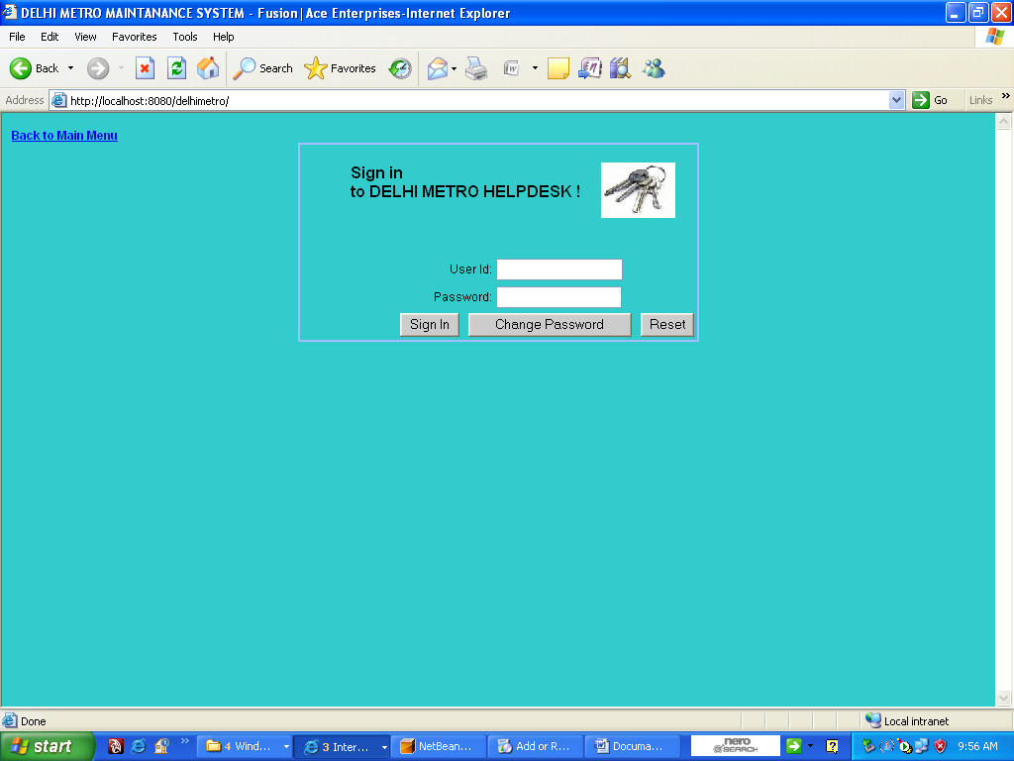
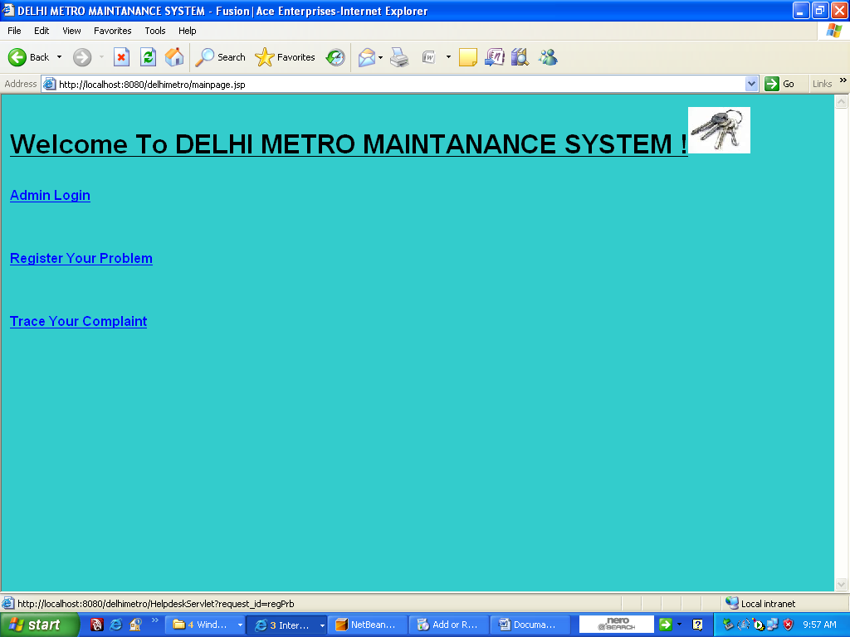

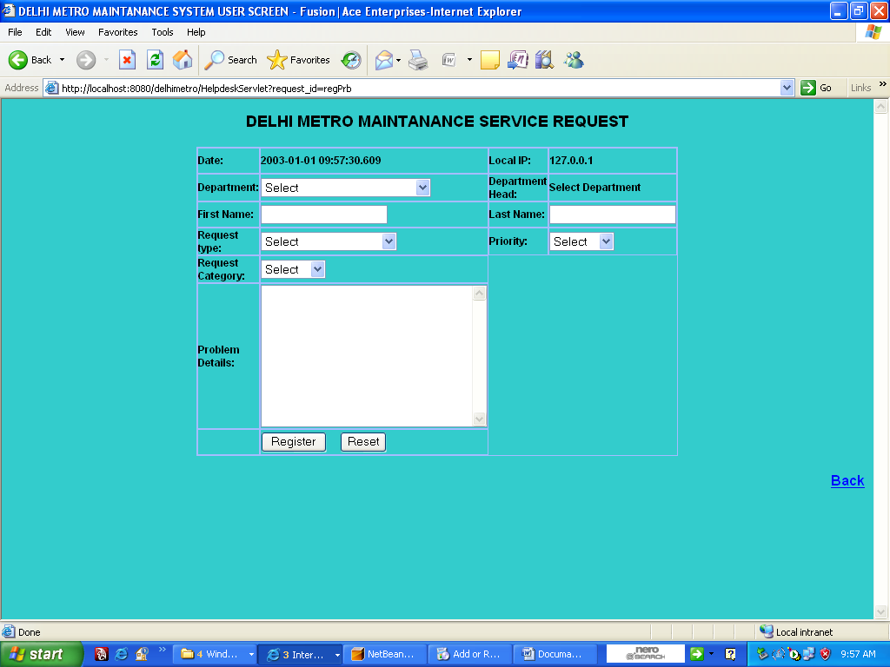
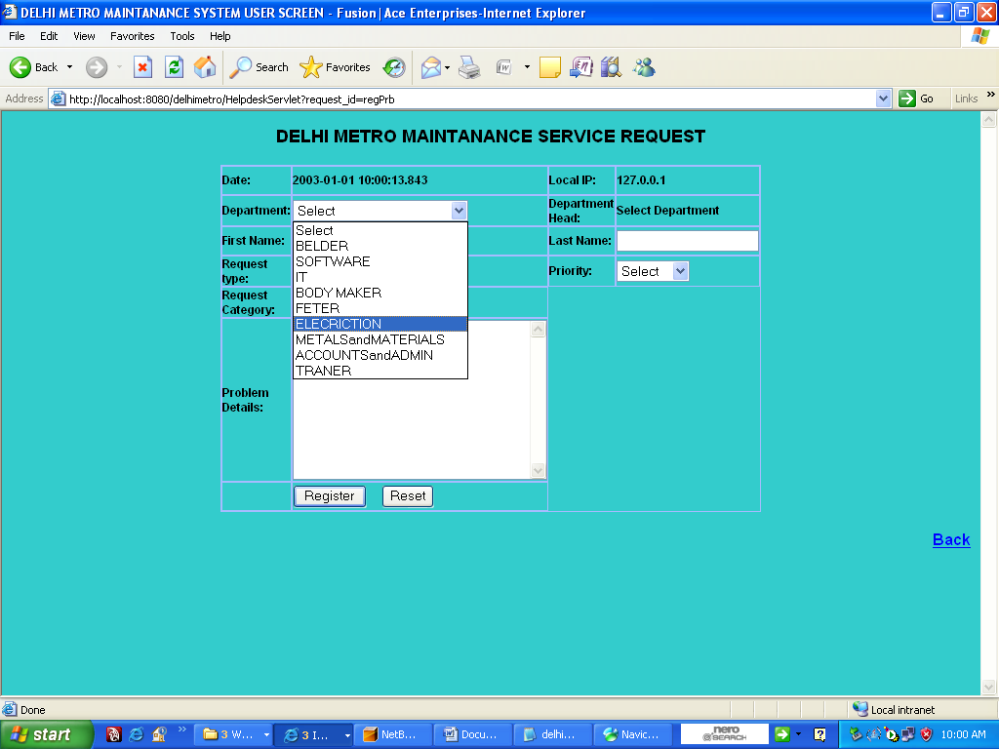

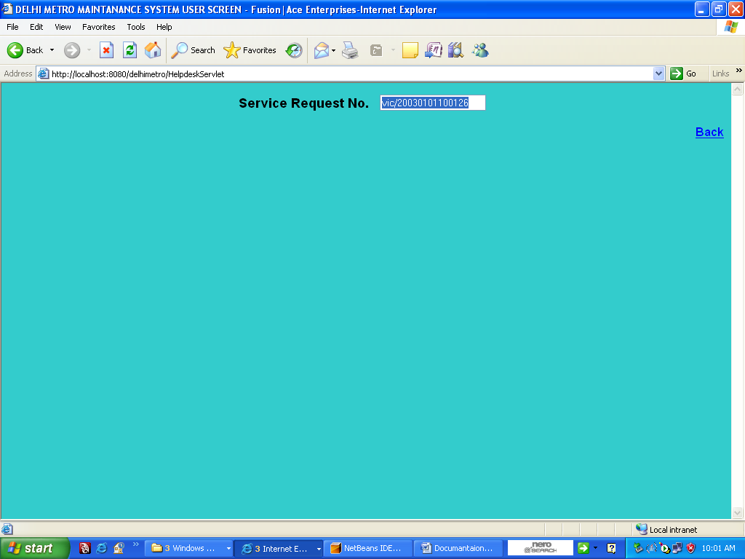
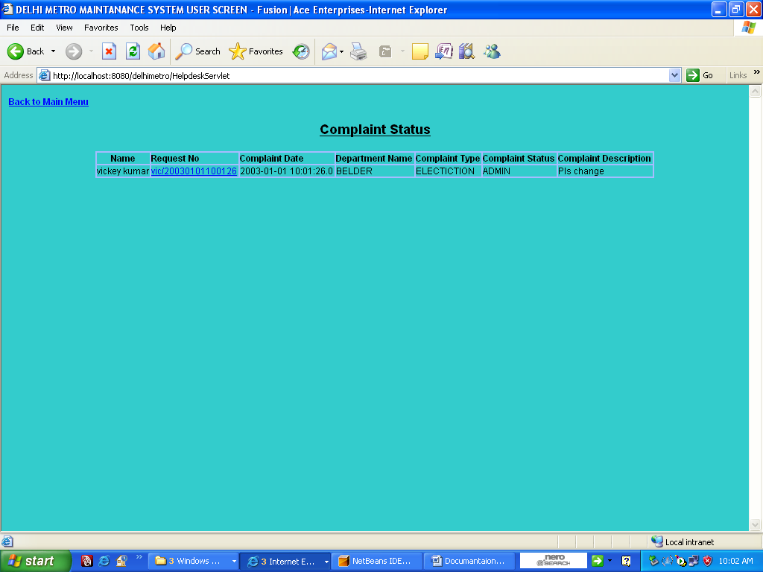

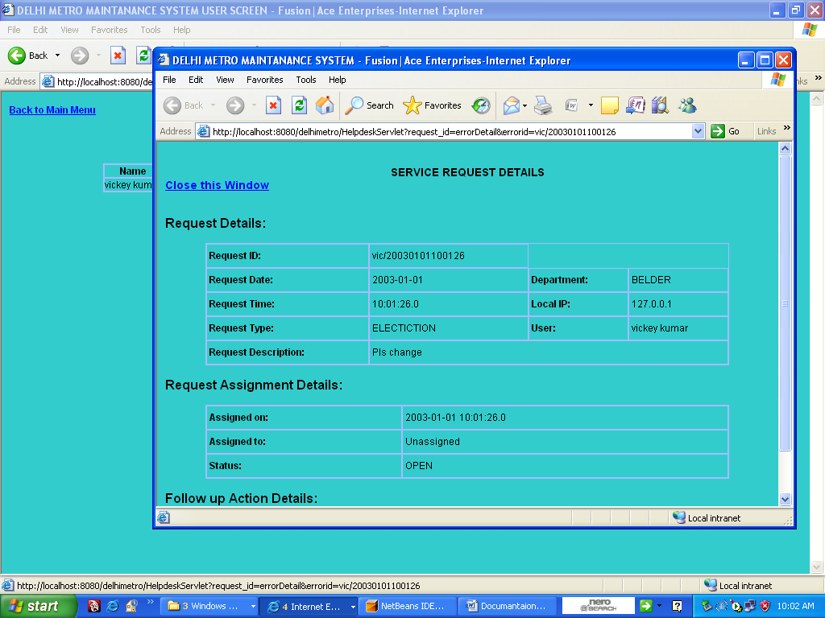
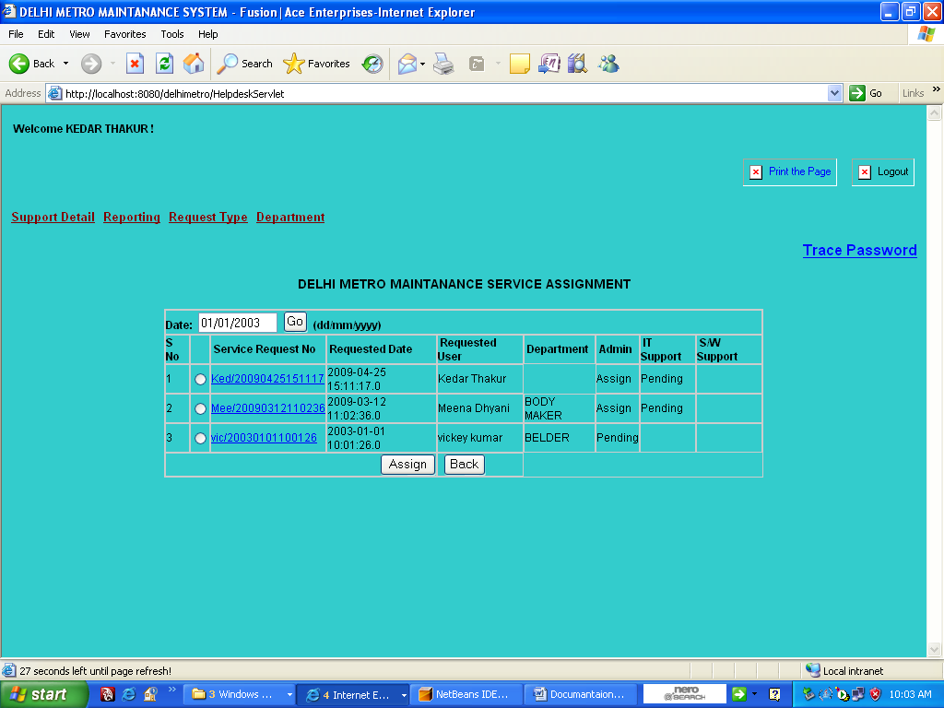

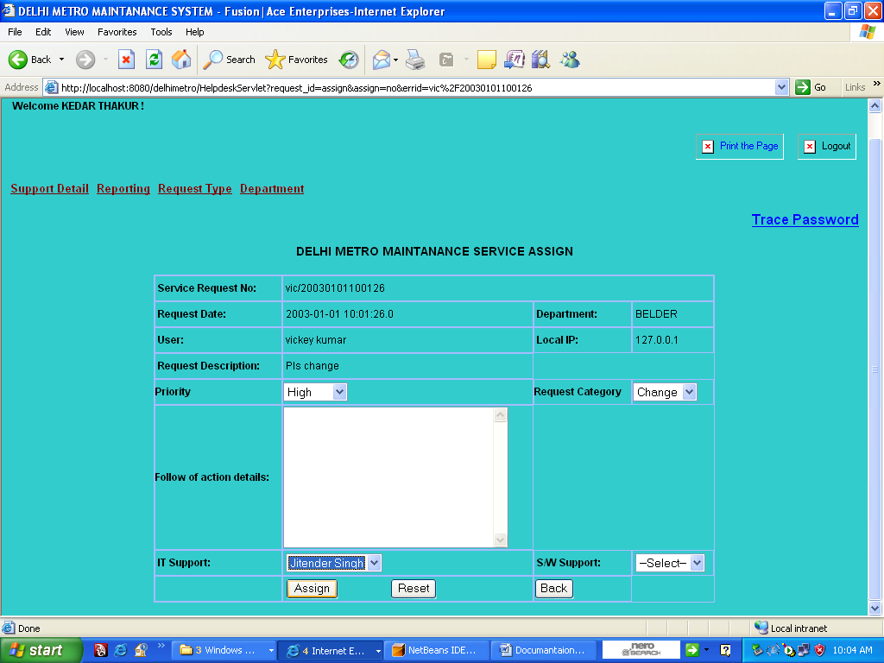

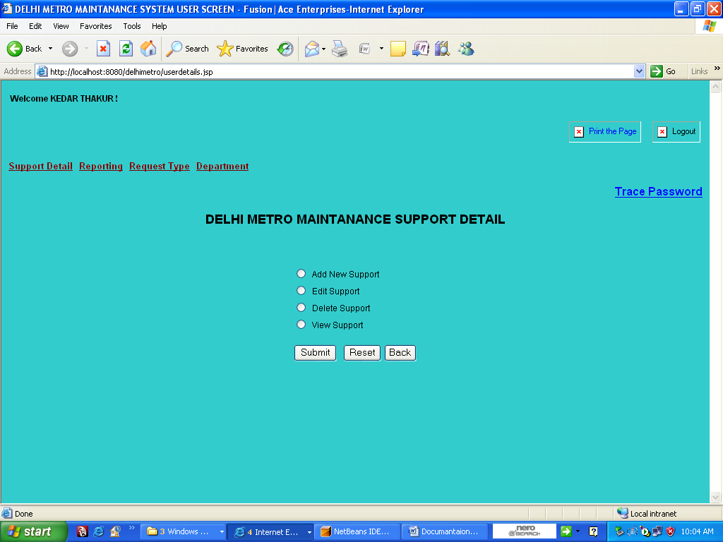

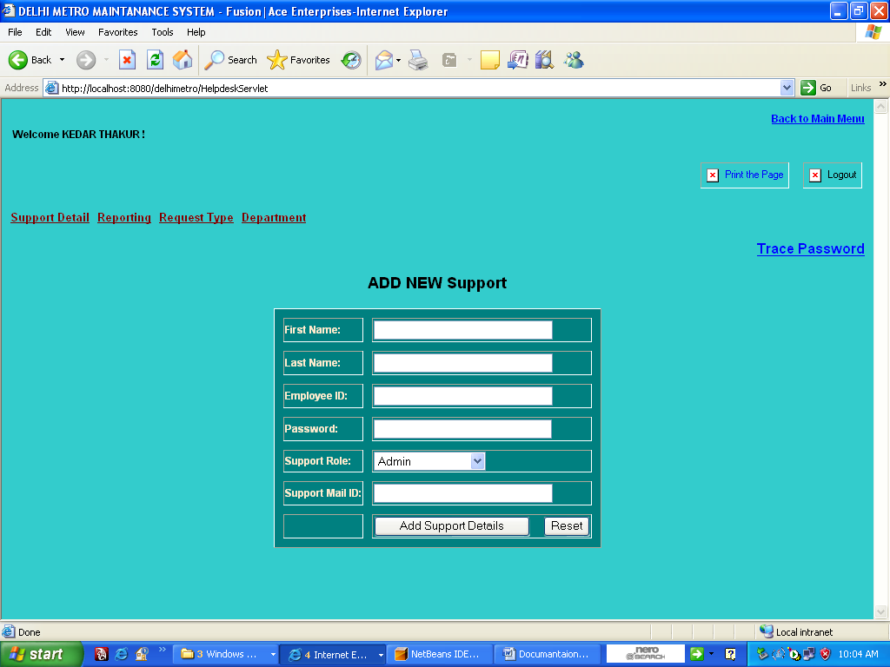

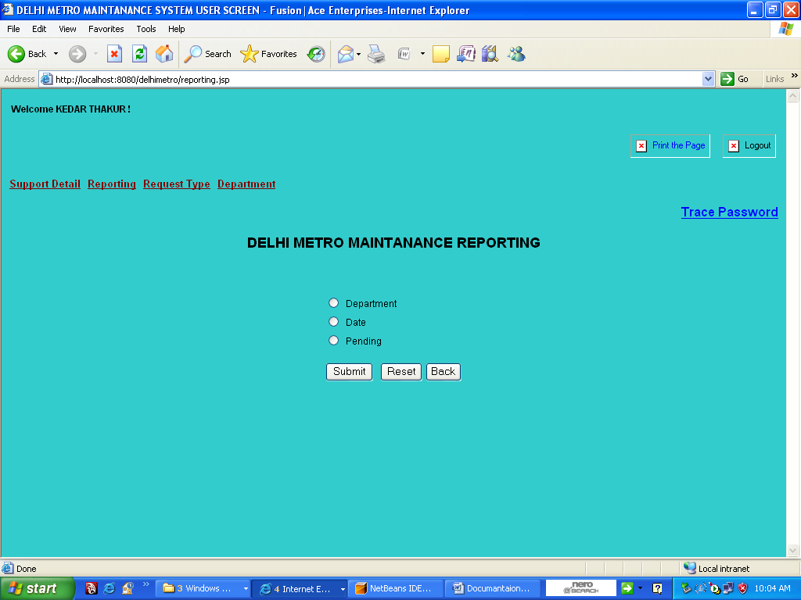

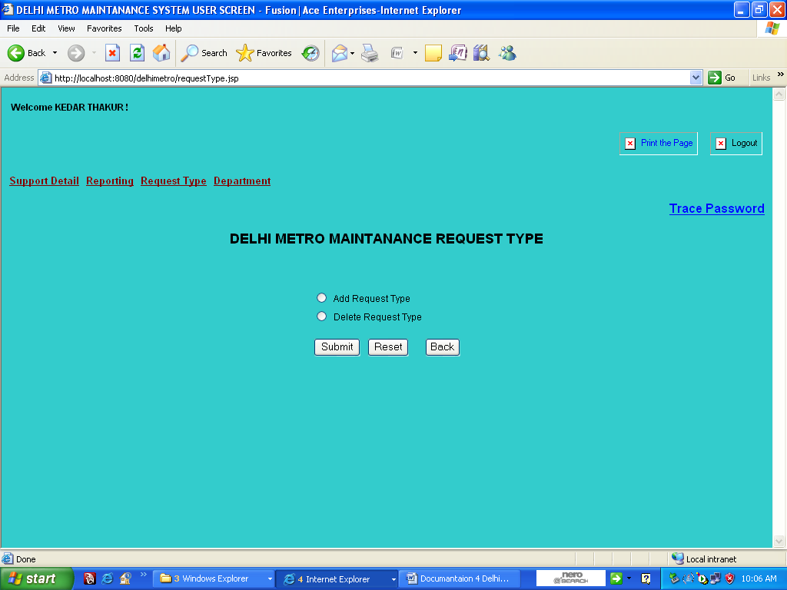

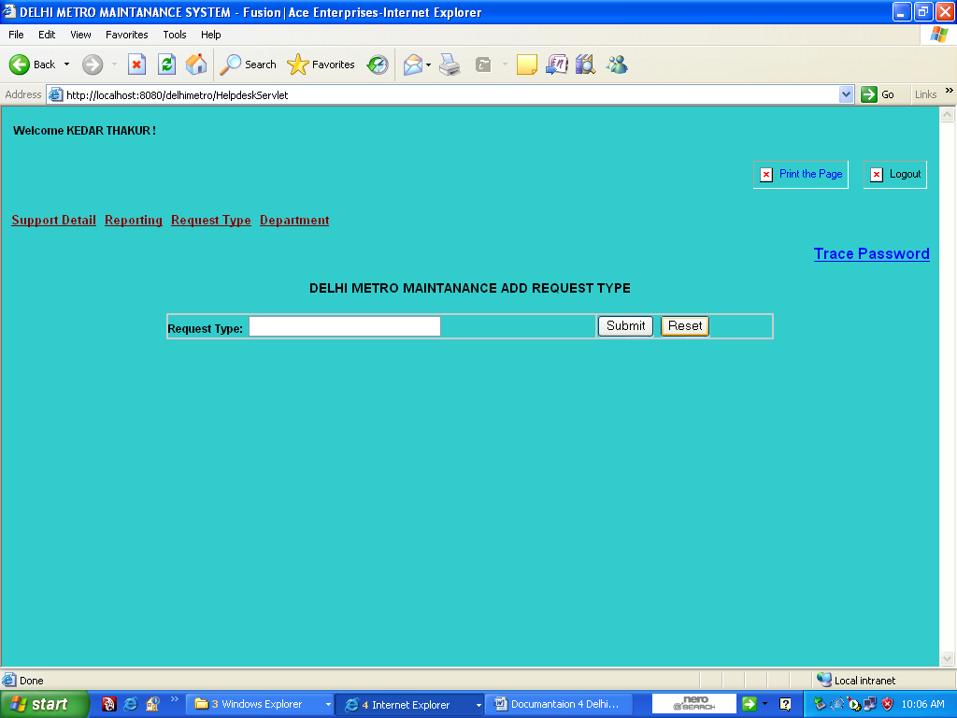

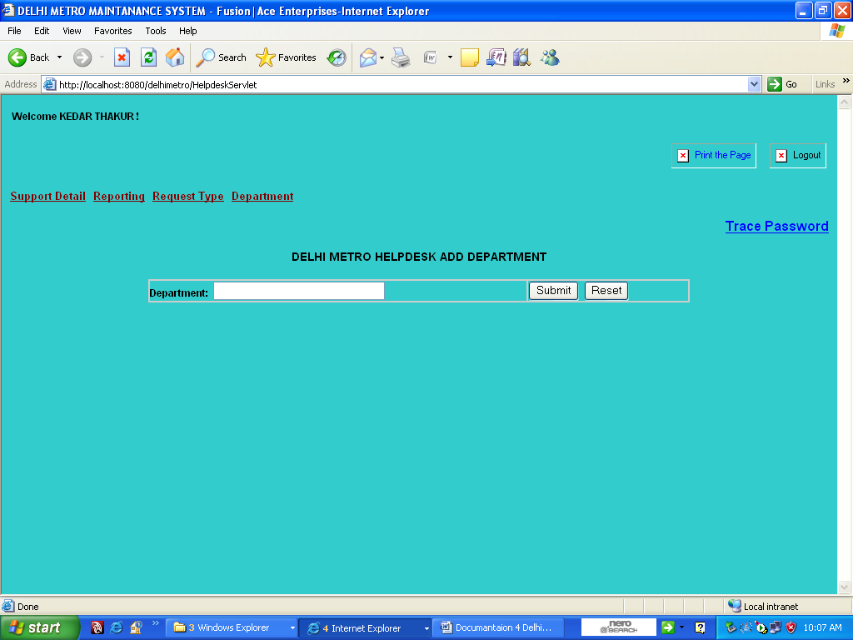

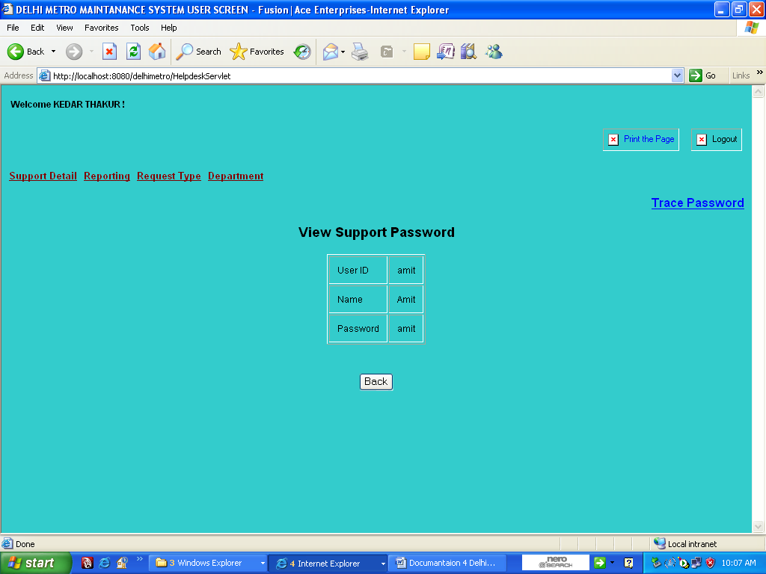

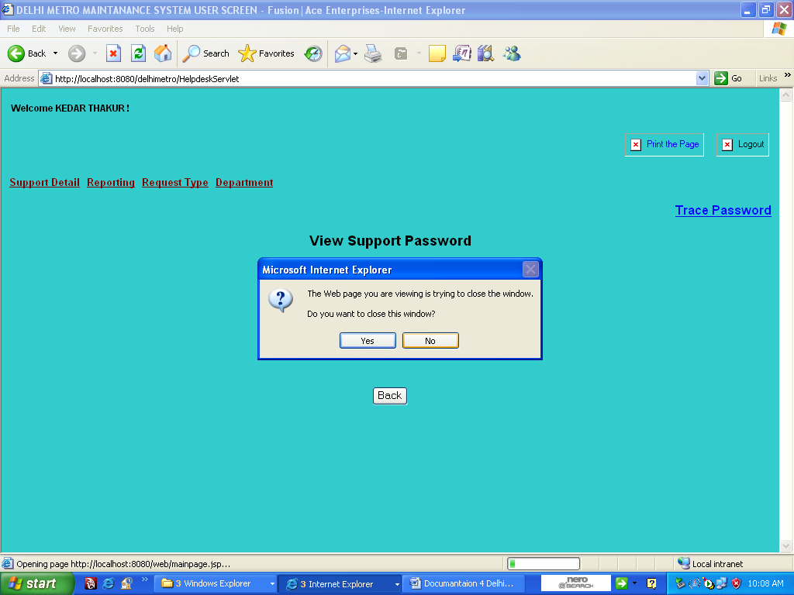

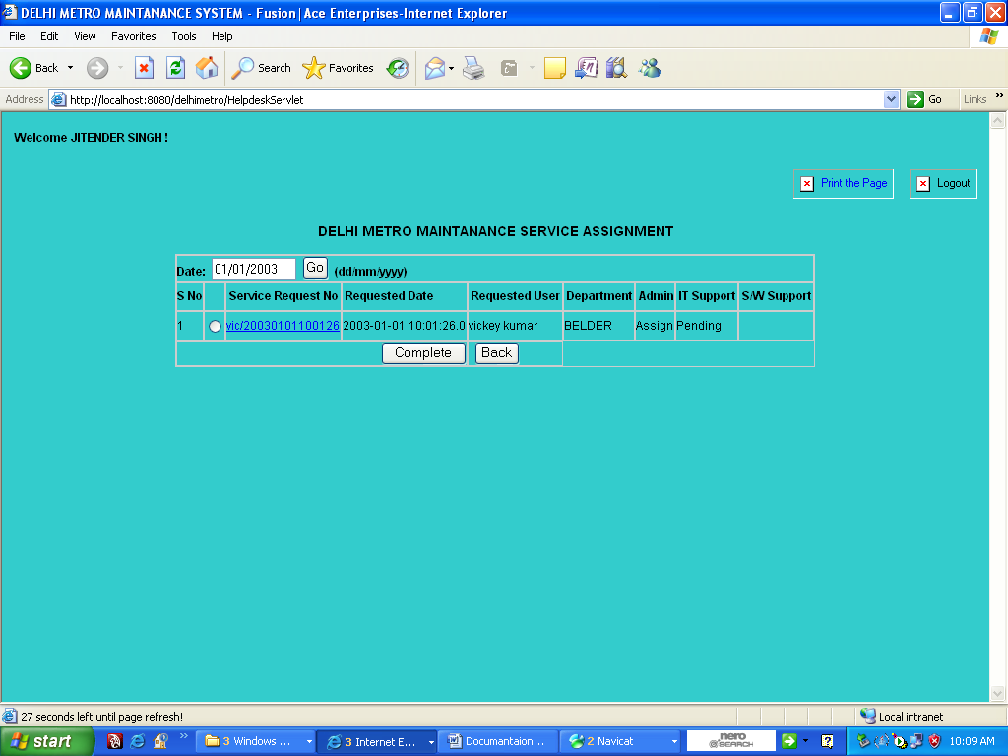

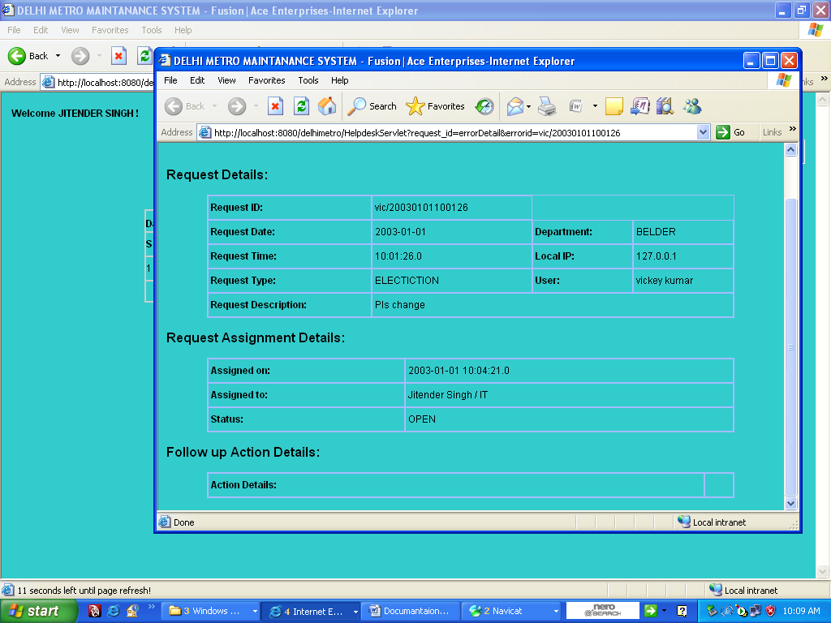

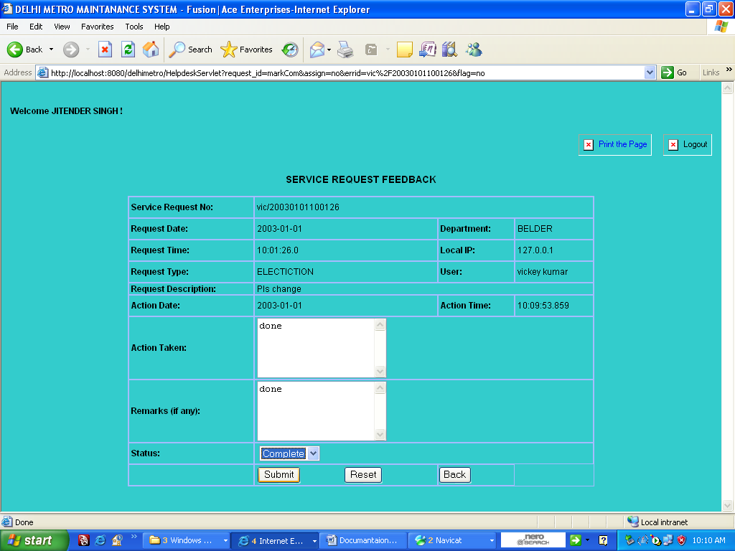

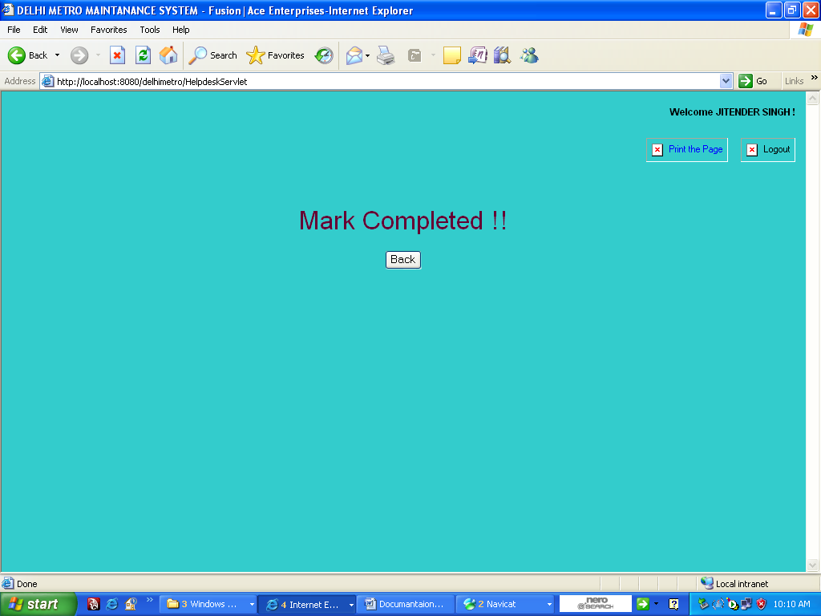

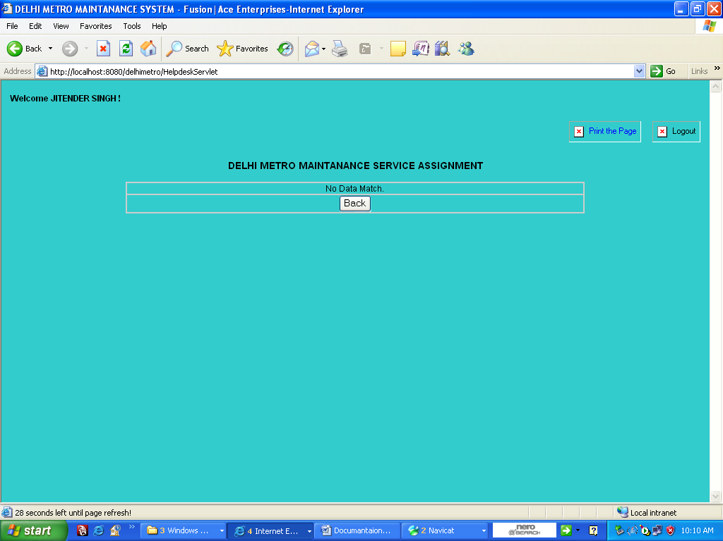

Scope of Future
Application
Features Of The Proposed System:-
The proposed system aims at providing the user a user-friendly environment, which can effectively handle the addition, updating and deletion of transactions of data taking place in the system throughout the year. Explained below are the varied features of the proposed system:

a) User-friendly package:- Incorporating in it GUI features, the proposed system provides reliable and easy-to-use friendly interface to the user to work with.

b) Software Security:- The software developed has been protected by the use of passwords at appropriate points. The system has been properly deployed and packaged. The setup contains the associated source code, complied files and the application related .dll files.

c) Linkage of information:- The information in the processes concerned has been accurately stored in the back-end application. No direct access to the back-end has been keyed in the hands of the user. The forms and reports can be viewed in the front–end.
d) Accuracy of data through validation checks: - Data entry has been validated to let the user impart correct type of specifications in the correct format suited to the system.
e) Easy information access: - All the master and transaction forms can be easily viewed, edited and navigated. The queries can be used to retrieve information from the existing data. Quick generation of reports help the user or higher authorities to make positive decisions relating to the improvements in the institute.

f) Elimination of paper work: - The system involves zero handwritten work. Once the data has been entered into the system, all modules of the system thereby eliminating the redundancy of data can use it.

g) Informative Reporting:- Reports can be quickly generated in the proposed system which obviously leads to a better functioning of the institute

METHODOLOGY
VALIDATION CHECKS
Validation and verification are the two most important checking processes which ensure that software conforms to its specification and meets the needs of the user or organization for which the software is built. The system should be verified and validated at each stage of the software process. The process of validation starts with the requirement reviews and continues through design and code reviews to product testing.
Validation involves checking that the program as implemented meets the expectations and serves the purpose for which it is built. There are two types of techniques employed for the validation checks namely static technique and dynamic technique of system checking and analysis.
Validation refers to the process of using software in a live environment in order to find errors. The feedback from the validation phase generally produces changes in the software to deal with errors and failures that were uncovered. The process of validation may continue for several months.

STATIC VERIFICATION
REQUIREMENTS SPECIFICATION
HIGH-LEVEL DESIGN
FORMAL SPECIFICATION

PROGRAM
DETAILED DESIGN

DYNAMIC VALIDATION

PROTOTYPE

THE PROCESS OF STATIC VERIFICATION AND DYNAMIC VALIDATION
Validation checks performed for the project Delhi Metro Maintainance System are:-
- Checking for essential date that is required.
- Making sure that only correct data is accepted by the system
- Making sure that either all transactions are carried out or none.
- Based on the entries done in the application, an appropriate report should be generated with all the relevant information
- To make sure that all the calculations are consistent both at the front end and as well as the backend

Tools and Techniques used
There are various tools and techniques that can be used to develop software,
The advantages of this approach are: -
- Use of techniques which allow for rapid system iterations
- Suggested changes may be incorporated and demonstrated as quickly as possible
- Verification and validation can be done at various stages so that the program can be compared to its specification
- Allows the system to be developed and delivered rapidly
- System development costs are minimized
The system being developed in the intended implementing environment, also provides the opportunity for the users to state their real needs
LISTEN TO CUSTOMER
BUILD / REVERSE MOCK UP
CUSTOMER TESTS MOCK UP
LISTEN TO CUSTOMER

Build/Reverse Mock Up

Customer Tests Mock

The following are the reasons for adopting the prototyping methodology over other software methodologies for the project
- Prototyping process allows systems to be developed and delivered rapidly which is certainly an advantage over the waterfall model’s approach of sluggish development.
- System development costs are reduced as compared to the linear sequential model
- Whatever the objectives may be they are made explicit at the start of the process and here this process scores over the approach of incremental development.
The prototyping first priority is to incorporate well understood requirements in the prototype then move on to those requirements that are unclear. In the incremental development there is no clear demarcation of well-understood or unclear requirements.
Boehm’s spiral model has fixed phases. It is the management that must decide about the structuring of the project into phases. Furthermore, the spiral model encompasses other process models making it complex to adopt and at the same time increasing the cost.
ESTABLISH SPECIFICATION
DEVELOP PROTOTYPE

EVALUATE PROTOTYPE

SPECIFY SYSTEM

DEVELOP SOFTWARE

VALIDATE SYSTEM

DELIVERED SOFTWARE SYSTEM

Delhi Metro Maintainance System design strategy deals with identifying the components in the system. The design strategy involves decomposing the design into functional components with system state information held in a shared data area.
Functional model, which consists of Data Flow Diagrams, which represents the system of Delhi Metro Maintainance System at various levels. The decomposing of the system is done as we proceed from one level to another level and we continue this process till the system is fully decomposed with all the subsystems of the system being completely identified.

SYSTEM TESTING PLAN

UNIT TEST PLAN
1. The test plan:

This test plan aims at testing each file separately on an individual basis. The testing technique used will be beta testing where the actual users of the system will provide the test data. This data will aim at checking whether the system is accepting data the way it would be.
There is a stress test plan for this system at the unit testing level. Under this test plan the user will attempt to check the accuracy of the validations implemented by the system.

Testing the user profile operations:

Testing the login section will involve testing if any processing takes place if the user does not input either user-id or password or both

Testing the registration section and edit user profile will involve testing whether the system gives an alert message if any mandatory field is left blank and if the system accepts an e-mail id that is not of the format. The phone number fields and pin-code fields are checked to see that they contain only digits and no characters.

Testing the forgot password section involves testing whether the user has input all the mandatory fields

Testing the Delhi Metro Maintainance System Operations:

Testing the new Delhi Metro Maintainance System module will include testing of all the sub-order types under it. It will test if the date fields accept invalid dates like 29 Feb. 2005 or 31 April 2005. It will also test for mandatory fields and the validity of the numeric fields. It will also check that the system does not accept a Tours date.
Testing the sub-order modules will also check for mandatory fields and numeric and date fields. The date of delivery of any sub-order cannot be less than the current date and the start date for the order cannot be greater than the end date. This shall also be checked.

Testing the open purchase order module will test for the same validations and checks as specified for the new purchase order module.

Testing for the search module will test if invalid values like characters in a numeric field, etc. is accepted by the system.

2. Requirement Trace ability:

The test plan basically aims at testing that all the system requirements requested by the user are satisfied. At the unit test level, this aims at testing that the specification documents and unit developed are in conformation with the requirement. Being a customized product, the beta technique is best suited for this purpose.

3. Test recording procedures:

Each independent component/file yields its own status information that is recorded in excel sheets for future reference. Each subsequent testing file will be named as per the pot_unit_test1 naming convention. The errors that did not exist at the unit level at the time of unit testing might crop up at the time of system level testing. These also have to be recorded.

4. Software/Hardware requirement for testing:

The software that is required is
- MySql 5.0
- VISUAL BASIC 6.0
SYSTEM TEST PLAN
1. Test Plan:

This test plan aims at testing the entire system as an aggregate. The testing technique used will be beta testing where the actual user of the system will provide the test data. This data will aim at checking whether the system is accepting data the way it would be. It also aims at testing whether the user-data input and stored in the database is inserted, retrieved and update properly. This aims at testing the integration of the front-end with the backend and the operation of the backend

There is a stress test plan for this system at the system testing level. Under this test plan the user will attempt to check the accuracy of the backend system and the response time

Test plan for the user Profile operations:
This aims at testing that the user id input by the user and the password allow the user to log in as administrator if the user is registered as a user only.
It checks to see that the registration module does not accept a user-id that already exists in the database.
The set plan aims at checking that the values retrieved in the edit user profile module are as they exist in the database and that the changes made are updated in the database.

Test plan for the Delhi Metro Maintainance System Module:
This test plan aims at testing that the Delhi Metro Maintainance System details are correctly inserted into the database when a new tour is generated.
It aims at testing that all details of a Tour that has been opened correspond to that particular Tour only.
It aims at testing whether the Tour is correctly updated when changes are made to the same
It aims at testing that when Tour is deleted that effect is cascaded for all the forms lower in the hierarchy

Test plan for Administrative Module:
This test plan aims at verifying that when the user is verified and authenticated by the administrator to use the Delhi Metro Maintainance System, a mail informing the user of the same is sent. It also aims at testing that a user whose profile is deleted receives a mail from the administrator informing him of the same.
It also aims at testing the service types that have been added by the administrator have been included in the database.

Test plan for the search module:
This aims at testing that the search results satisfy the search query and that the user search result only lists those Tour that have been created by the user.
2. Requirement Tractability:
The test plan basically aims at testing that the entire system requirements requested by the user are satisfied. At the unit test level, this aims at testing that the specification documents and units developed are in conformation with the requirement being a customized product, the beta testing technique is best suited for this purpose.

3. Test recording procedures
Each independent component/file yields its own status information that is recorded in excel sheets for future reference. Each subsequent testing file will be named as per the pot_module_test1 naming convention

4. Software/Hardware requirement for testing
The software that is required is
- MySql 5.0
- VISUAL BASIC 6.0

BIBLIOGRAPHY

- Evangelos Petroutsos, “Mastering Visual Basic Visual Basic 6.0”, and “Database Programming with Visual Basic Visual Basic 6.0”
- Gayle Coffman, “MySql 5.0: The Complete Reference”
- Roger S. Pressman, “Software Engineering – A Practioner’s Approach, 20th Edition”
- Elias M. Awad, “System Analysis and Design”
- Black Book for Visual Basic Visual Basic 6.0 ( BPB).
- Fundamentals of Database Systems – Elmasri / Navathe (Addison Wesley).
- www.msdn.microsoft.com

