If you want the list then you have to apply get method like this

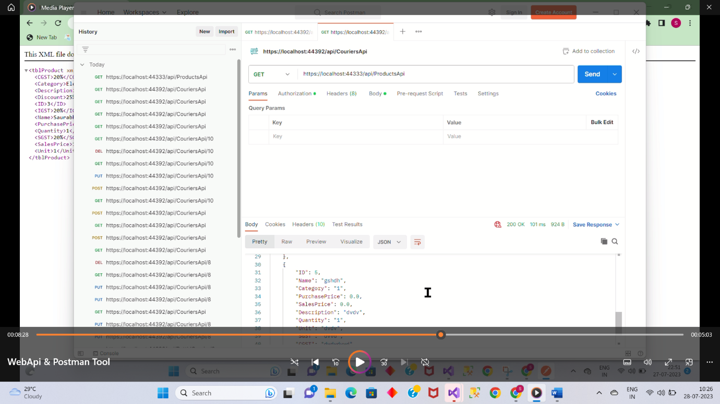

If you want the save/add data then you have to apply post method .

Add the fields in raw of body section in json format without id like this and then send.

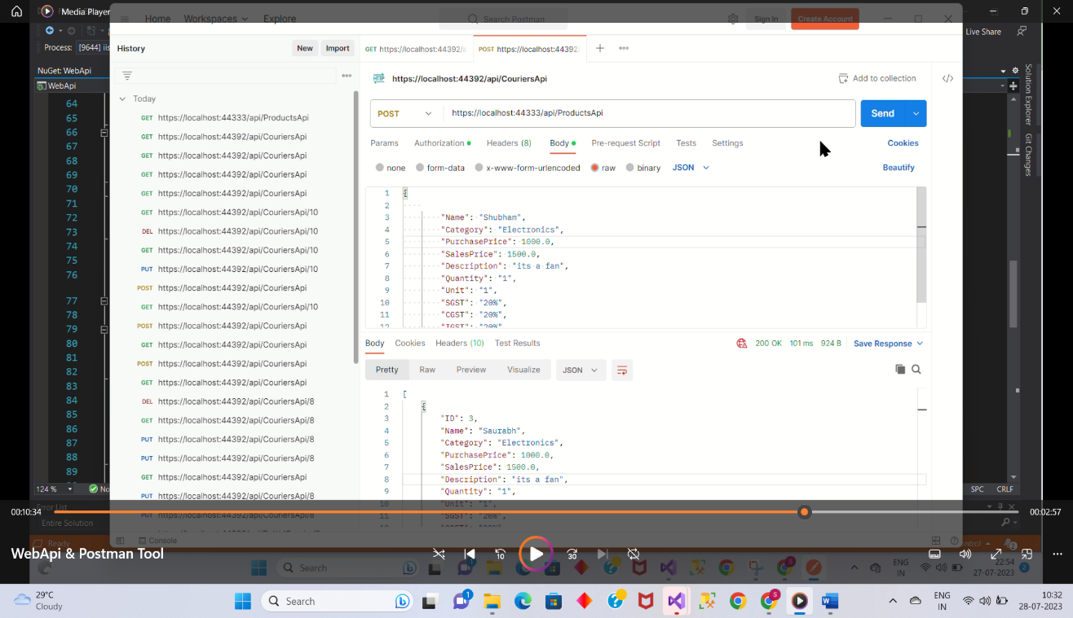

If you want to edit/update data then you have to apply put method.

Add the fields in raw of body section in json format with id like this and then send.

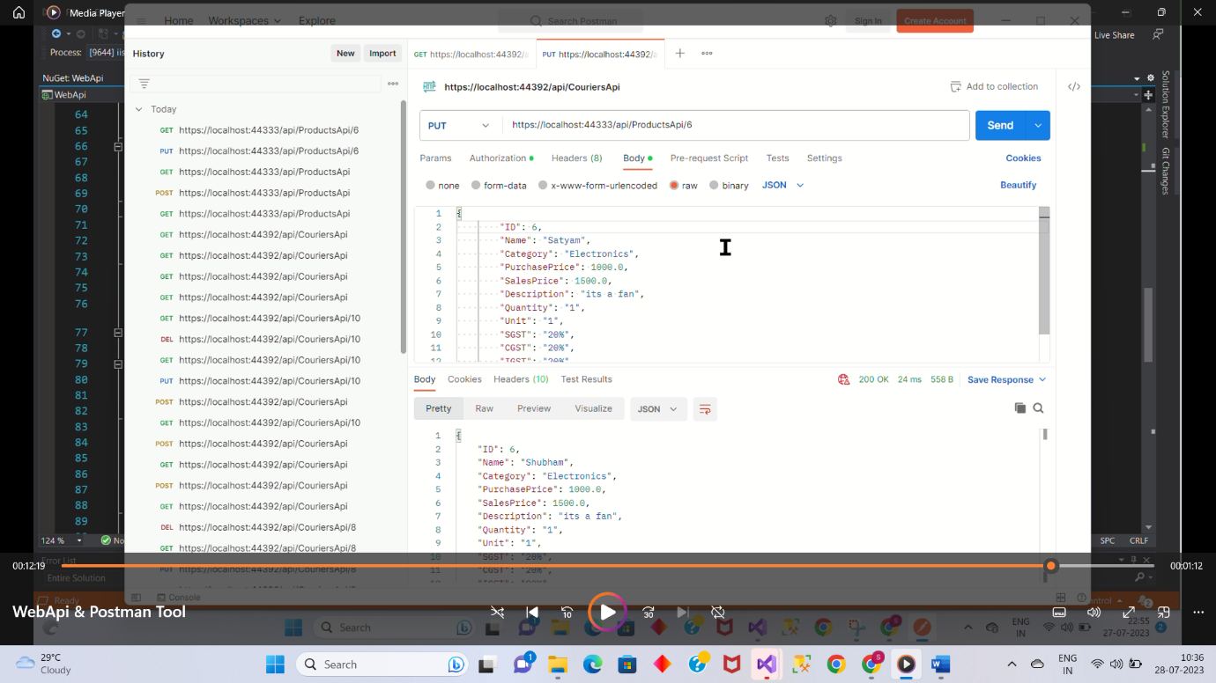

If you want to delete data.

Add the fields in raw of body section in json format without id like this and then send.

