1. Finding by country code

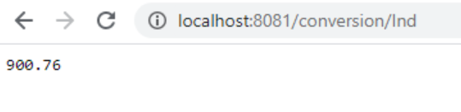

2. Adding the data

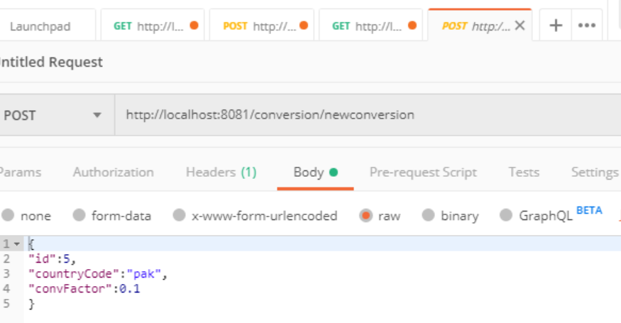

3. Finding all data

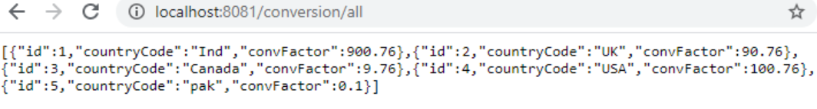

4. Updating the data

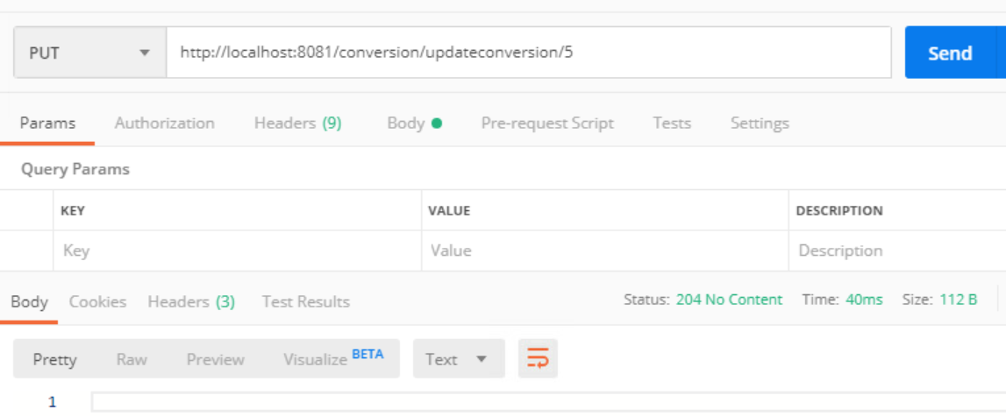

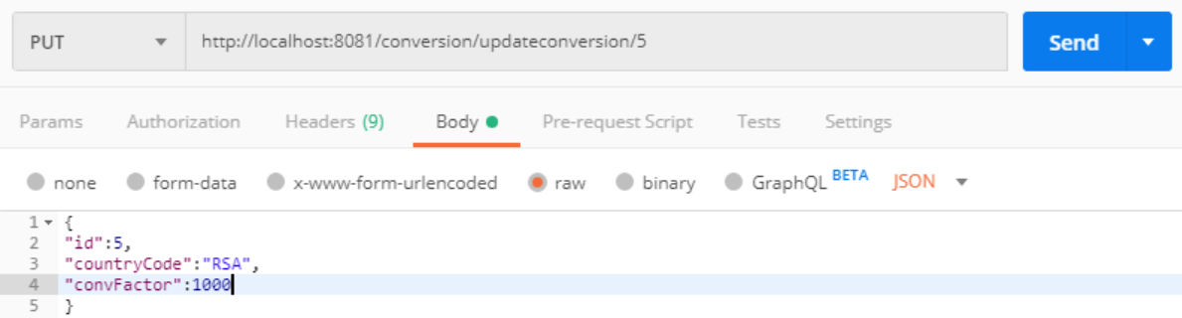

5. Feign client

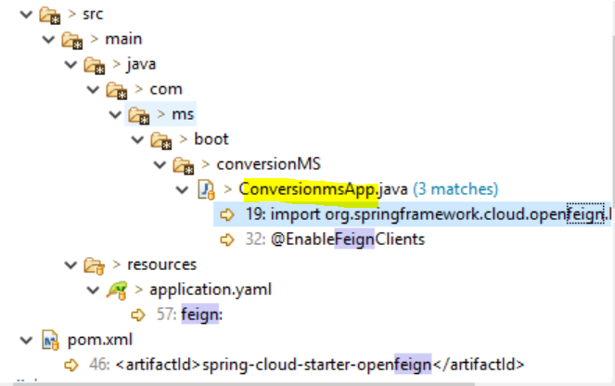

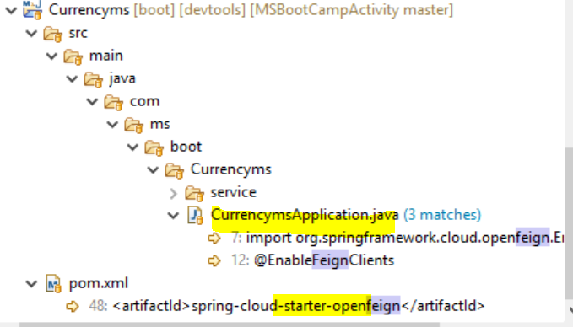

Feign Client Configuration

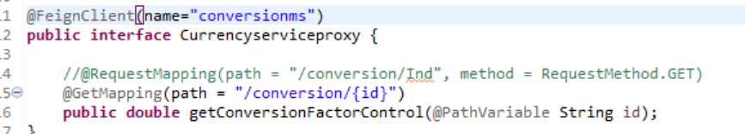

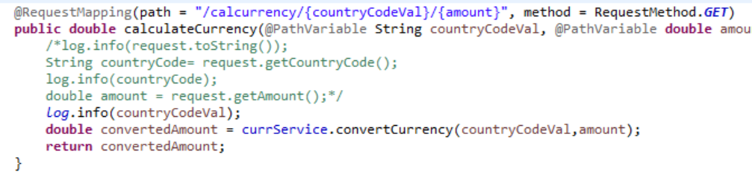

6. Eureka

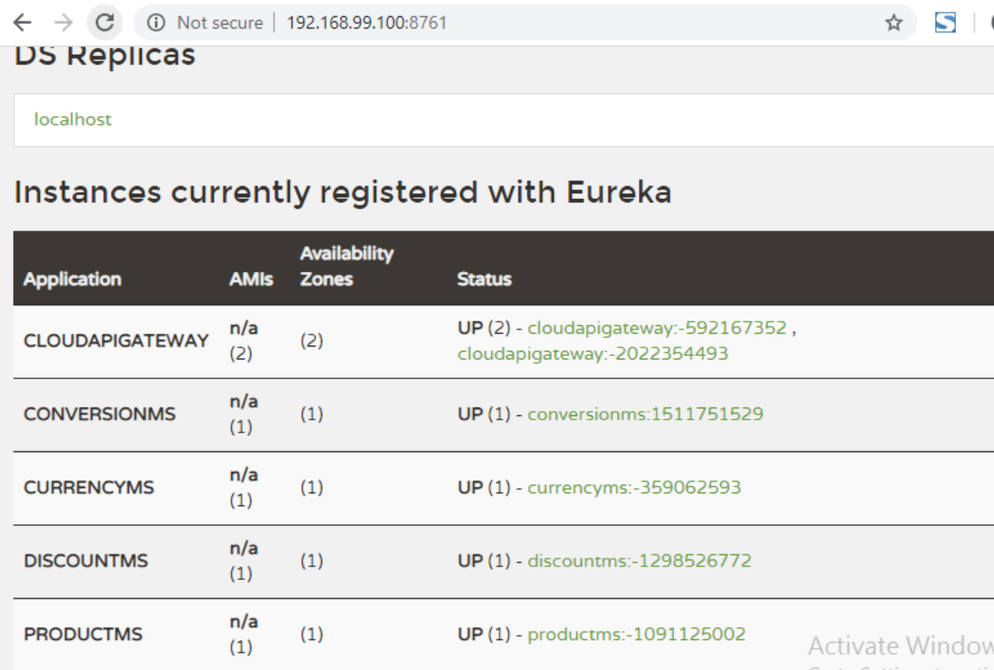

7. Calculating the currency

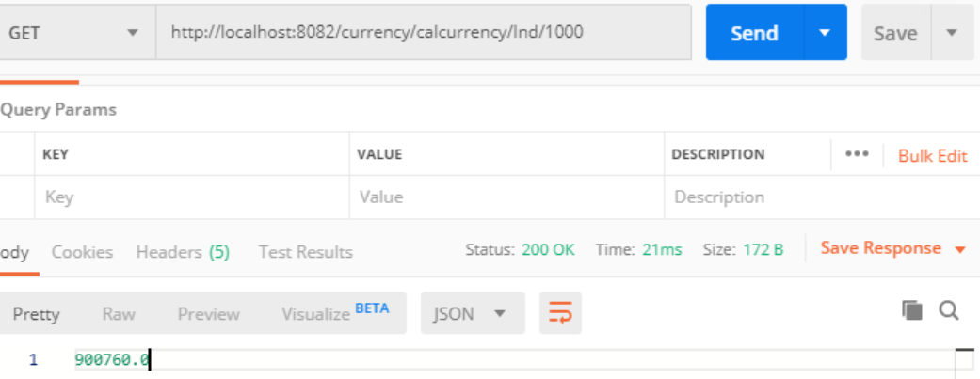

**RUNNING IN DOCKER**

docker-machine env docker-vm1

@FOR /f "tokens=*" %i IN ('docker-machine env docker-vm1') DO @%i

1. CONFIG SERVER Path

mvn clean install

docker build -t mkdockerhub1310/msbootcampactivity_2020:config1 .

docker run -p 8888:8888 -d --name configkol1 --network ms-chassis-nw mkdockerhub1310/msbootcampactivity_2020:config1

1. EUREKA SERVER path

mvn clean install

docker build -t mkdockerhub1310/msbootcampactivity_2020:eureka1 .

docker run -p 8761:8761 -d --name eurekaMs --network ms-chassis-nw mkdockerhub1310/msbootcampactivity_2020:eureka1

1. CLOUDAPI Path

mvn clean install

docker build -t mkdockerhub1310/msbootcampactivity_2020:cloudapigateway .

docker run -p 9092:9092 -d --name cloudapigatewaykol --network ms-chassis-nw mkdockerhub1310/msbootcampactivity_2020:cloudapigateway

1. CONVERSION MS

mvn clean install

docker build -t mkdockerhub1310/msbootcampactivity_2020:conversionms .

docker run -p 8081:8081 -d --name conversionmskol1 --network ms-chassis-nw mkdockerhub1310/msbootcampactivity_2020:conversionms

1. CURRENCY MS  
   mvn clean install

docker build -t mkdockerhub1310/msbootcampactivity_2020:currencyms .

docker run -p 8082:8082 -d --name currencymskol --network ms-chassis-nw mkdockerhub1310/msbootcampactivity_2020:currencyms

**docker ps**

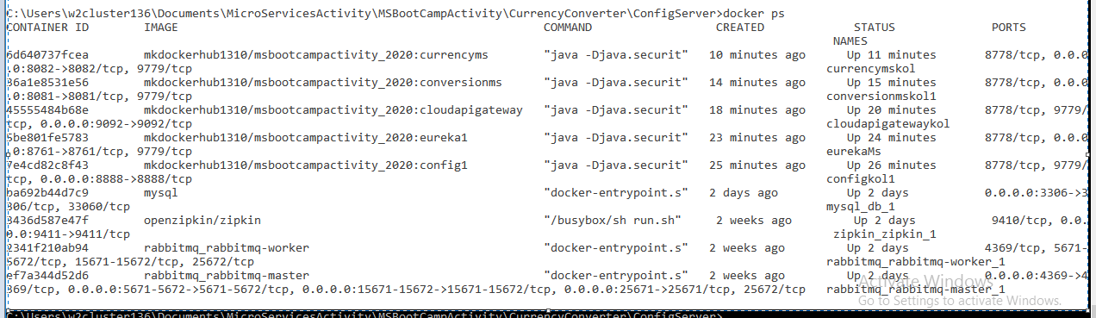

Eureka: <http://192.168.99.100:8761/>

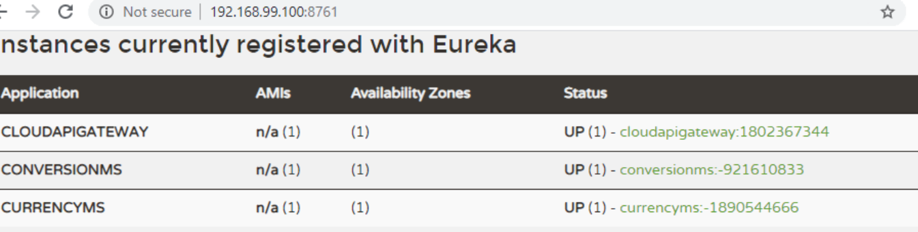

CONVERSIONMS: <http://192.168.99.100:8081/conversion/Ind>

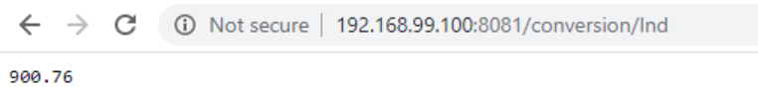

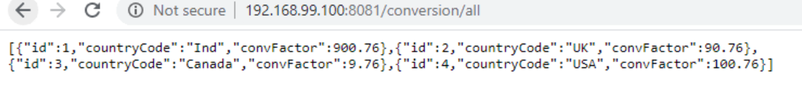

Currencyms: <http://192.168.99.100:8082/currency/calcurrency/UK/1000>

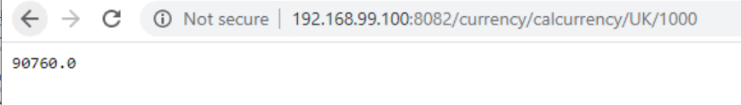

Fallback

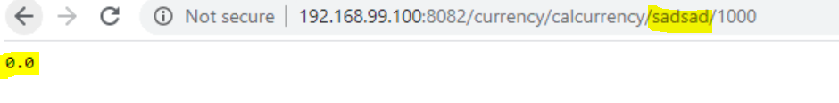

Zipkins

