**a. Run the Authms microservice.**

1. Signup

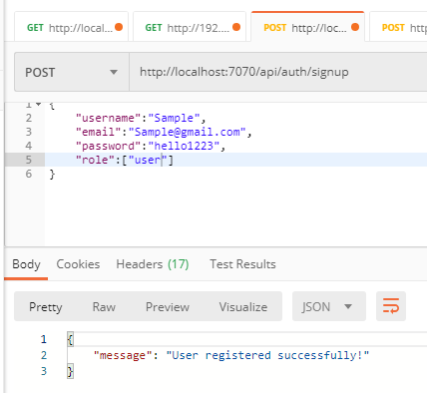

2. Database Snapshot

i) Users tables

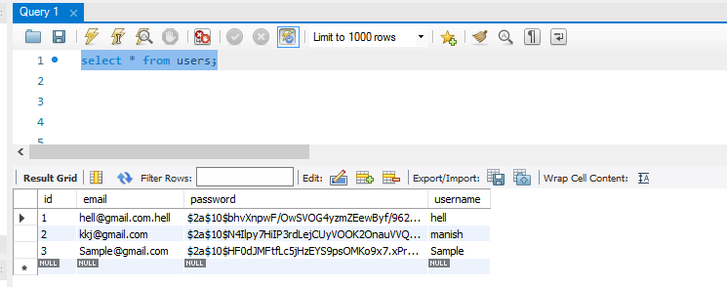

ii) Roles Table

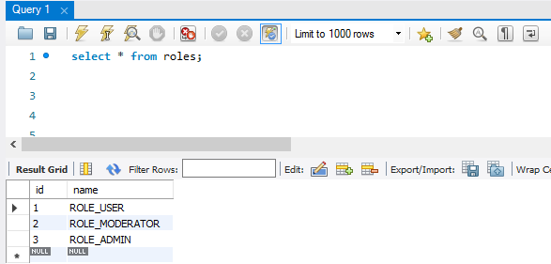

iii) user_roles table

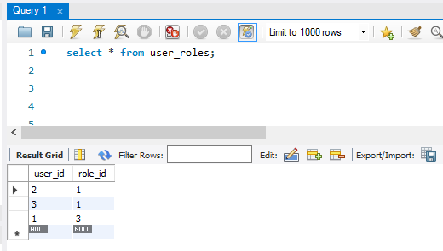

**3. Singin**

a. Successful login

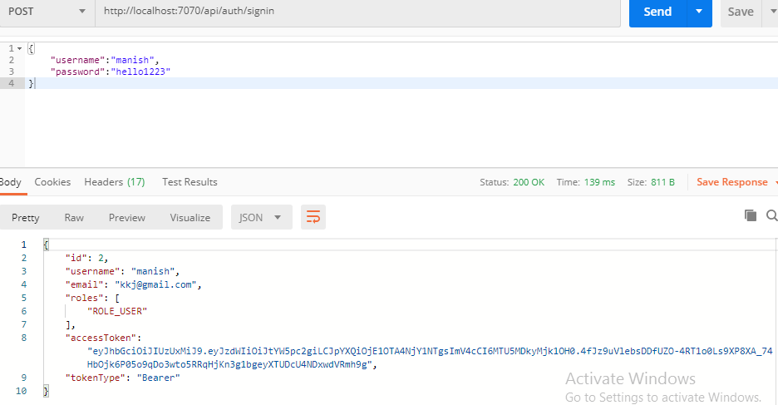  
Give the user name and password. It will give the access token and other user details.

b. Failed Login

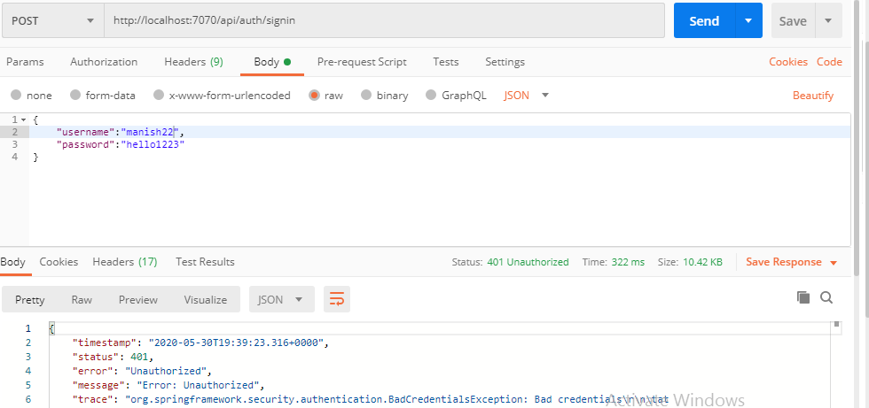

**b. Orderms**

i. Access token generated by the Authms will be used in the Orderms.

ii. Mozilla developer tool is used to display the webpage using the access token.

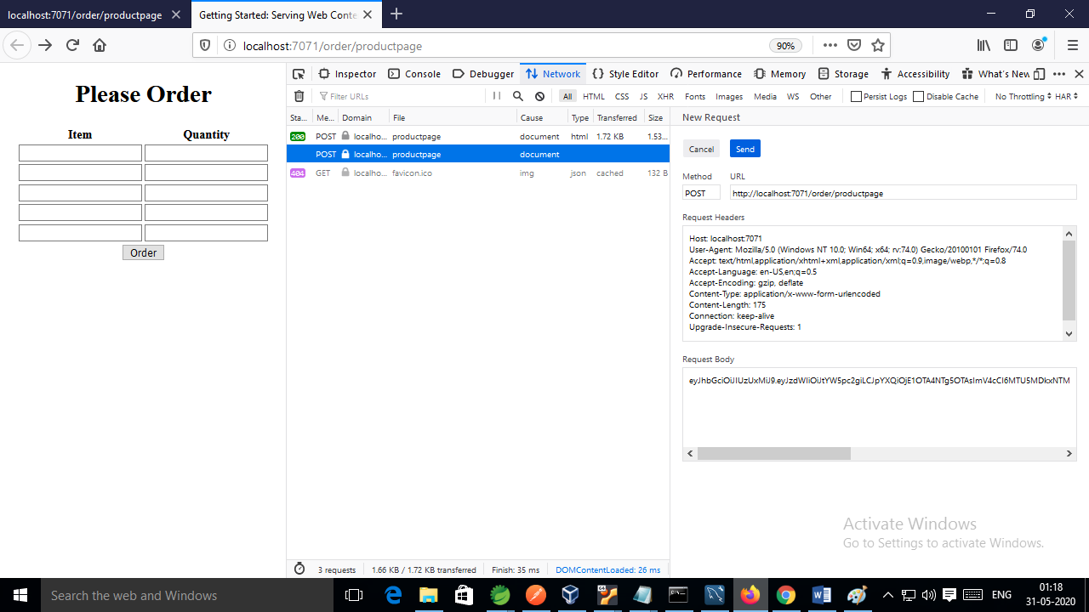

Access Token value is passed into the Request Body.

iii. Product Web Page.

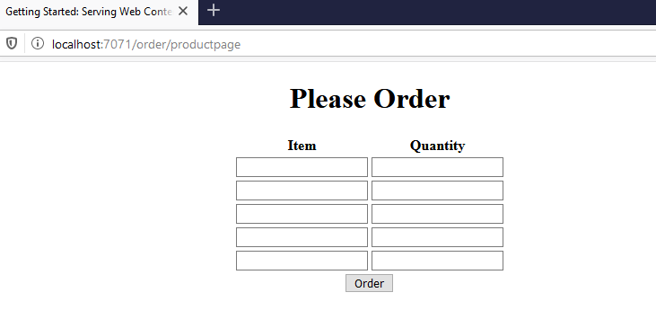

Product web page is displayed when the correct JWT token is passed in the request body.

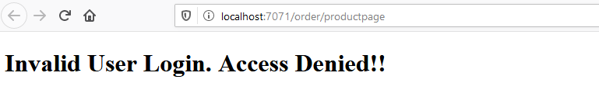

In case wrong JWT token passed above page will be displayed.

iv) Ordering the items

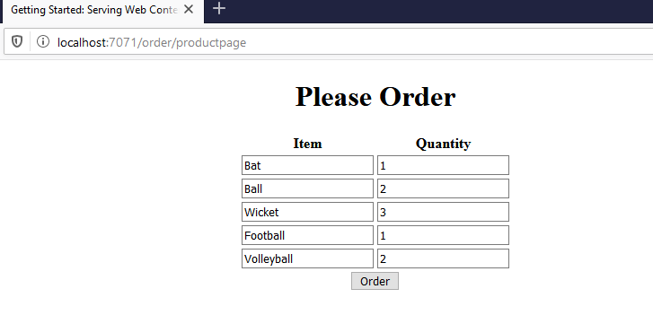

After clicking on the Order button.

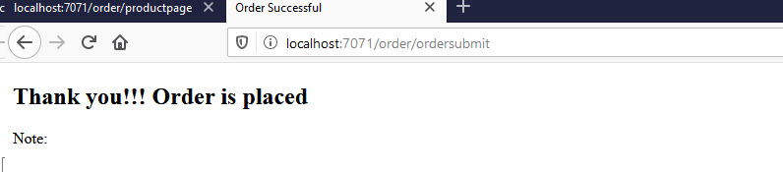

v. Database snapshot

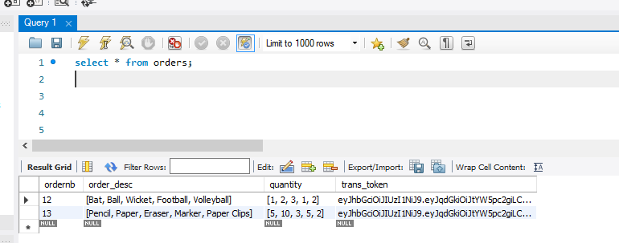

** Transaction token is stored in the orders table. Transaction token is generated once the user has successfully logged in.