* **Connection Diagram :**

In this system we have directly connected all the sensors on to the Microcontroller pins and powered the Microcontroller with the DC Adapters.

* At the Actual System :

|  |  |  |  |  |  |
| --- | --- | --- | --- | --- | --- |
| **S.No.** | **Arduino Pins**  **(as per code)** | **IR Sensor** | **Magnetic Sensor** | **LCD** | **Buzzer** |
| 1 | D3 | IR 1 (O/P) (Bin 1/100%) |  |  |  |
| 2 | D7 | IR 2(O/P) (Bin 1/50%) |  |  |  |
| 3 | A1 | IR 3 (O/P) (Bin 2/100%) |  |  |  |
| 4 | A5 | IR 4 (O/P) (Bin 2/50%) |  |  |  |
| 5 | A3 |  | Sensor (I/P)(Bin 1) |  |  |
| 6 | A0 |  | Sensor (I/P)(Bin 2) |  |  |
| 7 | A2 |  |  |  | I/P |
| 8 | D5 |  |  | D7 |  |
| 9 | D6 |  |  | D6 |  |
| 10 | D10 |  |  | D5 |  |
| 11 | D11 |  |  | D4 |  |
| 12 | D12 |  |  | EN |  |
| 13 | D13 |  |  | RS |  |
| 14 | +5V | VCC |  | VCC | VCC |
| 15 | Ground | GND | GND | GND | GND |

* At the Control Station :

|  |  |  |  |
| --- | --- | --- | --- |
| **S.No.** | **Arduino Pins** | **LCD** | **Buzzer** |
| 1 | D7 |  | I/P |
| 2 | D8 | D4 |  |
| 3 | D9 | D5 |  |
| 4 | D10 | D6 |  |
| 5 | D11 | D7 |  |
| 6 | D12 | EN |  |
| 7 | +5V | VCC | VCC |
| 8 | Ground | GND | GND |

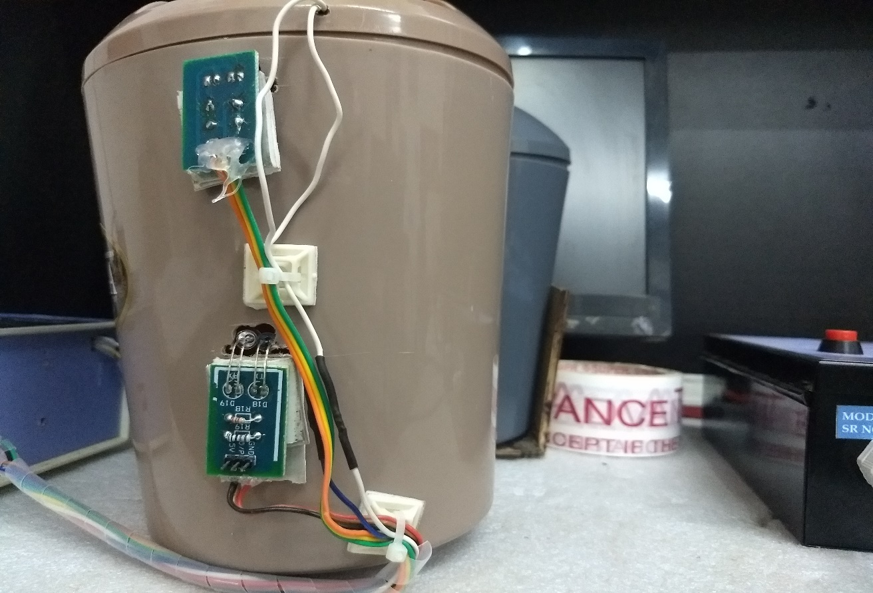

**IR 1 (BIN 1)**

**IR 2 (BIN 1)**

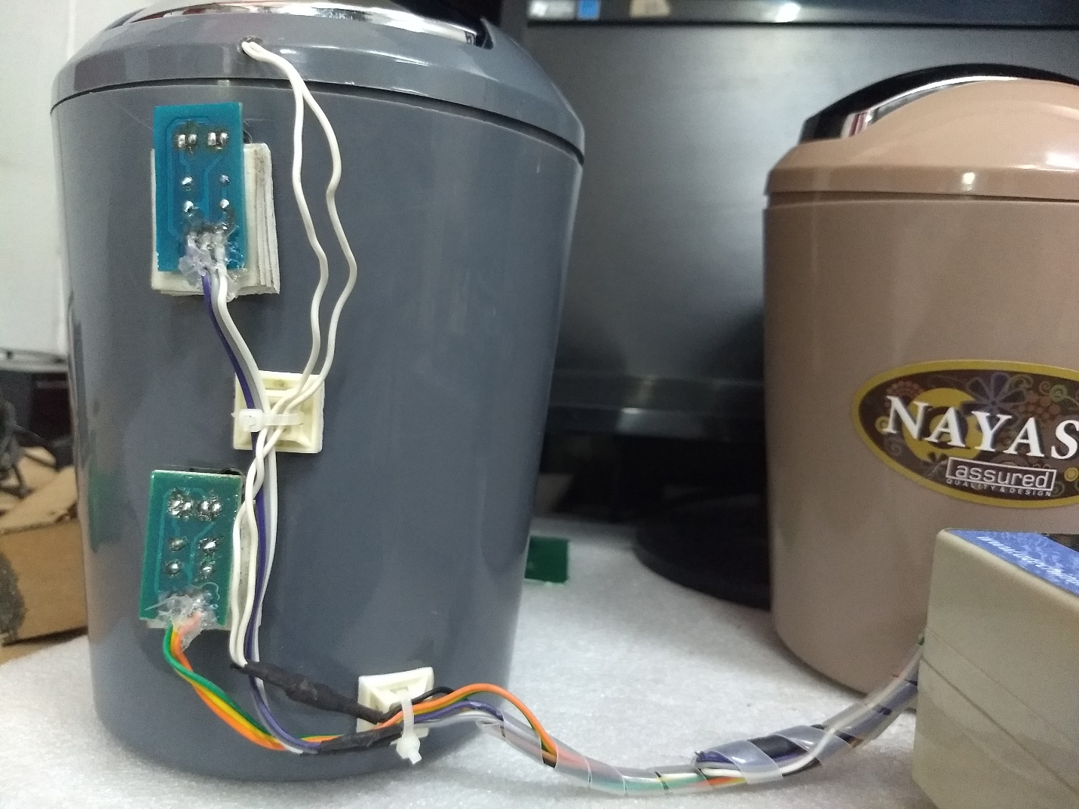

**IR 4 (BIN 2)**

**IR 3 (BIN 2)**

**SYSTEM**

