YUVA INTERNSHIP PROGRAM
WEEK 2 TECHNICAL REPORT
Front-End Application Development
Project: InterviewIQ — AI Interview Agent
Submission Focus
This report documents the Week 2 front-end implementation of the proposed InterviewIQ application. It focuses on the user interface, responsive experience, navigation, reusable React components, state handling, service/API integration prepared from the frontend, usability, testing, and development practices. Backend/AI/database/payment implementation is not represented as a Week 2 front-end deliverable.

Prepared by: Manish Kumar
B.Tech — Computer Science & Engineering
Sagar Institute of Research and Technology, Bhopal
September 2026

Table of Contents
Section | Topic
1 | Executive Summary
2 | Week 2 Task Interpretation and Compliance
3 | Project Context and Front-End Scope
4 | Week 2 Objectives
5 | Development Approach and Workflow
6 | Technology Stack and Libraries
7 | Application Structure and Code Organization
8 | Implemented User Interface and Views
9 | Interview Setup Experience
10 | Resume Analysis Presentation
11 | Live Interview Experience
12 | Performance Analytics and Report UI
13 | Navigation, Routing and User Journey
14 | Reusable Components and Design Patterns
15 | State Management and Data Handling
16 | Front-End API / Service Integration
17 | Responsive Design and Accessibility
18 | Testing, Usability and Quality Checks
19 | Challenges, Decisions and Learning Outcomes
20 | Security and Reliability Considerations
21 | Performance and Maintainability
22 | GitHub, README and Submission Package
23 | Evaluation Criteria Mapping
24 | Week 2 Completion Status and Next Phase
25 | Conclusion
Appendix A | Evidence Screenshots
Appendix B | Recommended README / Run Instructions

1. Executive Summary
InterviewIQ — AI Interview Agent is being developed as a web application intended to provide a structured, practice-oriented interview experience. The Week 2 objective was to convert the planning and architecture work from Week 1 into a usable front-end application. The focus was therefore not on claiming the entire product as complete, but on building the client-side experience that a candidate would actually use: landing page, authentication entry, interview setup, interview session, history, pricing/credits, and performance report views.
The front end is implemented with React and Vite and uses a modular component approach. React Router is used for page navigation, Redux Toolkit is used for user state, Axios is used for service communication, Firebase is used for Google authentication integration, and browser speech capabilities are incorporated into the interview experience. The reporting interface uses Recharts for visual analytics and jsPDF/jsPDF-AutoTable for report export.
The supplied evidence screenshots demonstrate three important user states: an empty interview setup screen, a configured setup with resume-analysis output, and a generated performance dashboard containing overall score, skill evaluation, performance trend, and question breakdown. These screens show that the Week 2 work is not only a static mock-up; it is designed around real user interactions, state transitions, and service-driven data.
Key Week 2 Outcome
A structured, responsive React front end has been developed to operationalize the InterviewIQ user journey. The application is organized for future backend/AI integration while keeping the UI modular and maintainable.

2. Week 2 Task Interpretation and Compliance
The YUVA Week 2 task asks the intern to develop a fully functional front end that can interact with the underlying application services, demonstrate at least three distinct interconnected views, follow the earlier wireframes, remain responsive, and use modular/documented development practices. The deliverable is accompanied by source code and a README explaining the development process, libraries/design patterns, and local setup.
Yuva Requirement | Implementation / Evidence | Status
Fully functional front-end | React client with connected pages, forms, controls, interview UI, analytics and report actions. | Implemented
At least 3 distinct views | Home, Auth, Interview Setup, Live Interview, History, Pricing and Report views. | Implemented
Interconnected navigation | React Router routes connect the major user journey and report/history flow. | Implemented
Responsive interface | Responsive layout, flexible cards/grids, mobile-aware controls and adaptive content presentation. | Implemented
User interaction | Forms, dropdowns, file upload, buttons, authentication flow, voice controls, timer, charts and PDF action. | Implemented
Reusable components | Navbar, Footer, Auth modal, interview steps, Timer and shared UI patterns. | Implemented
Libraries/design patterns | React components, hooks, Redux Toolkit, Context-style modular state/service separation, Axios. | Implemented
README / local setup | Package scripts and dependency configuration are present; README is part of the source deliverable. | Prepared
Code quality / modularity | Pages, components, redux and utility folders separate responsibilities. | Implemented

3. Project Context and Front-End Scope
InterviewIQ is planned as an AI-assisted interview practice platform. A candidate selects a target role and experience level, chooses an interview type, optionally supplies a resume, and proceeds through an interview simulation. The client then presents questions, captures the candidate's interaction, and displays a structured performance report.
For Week 2, the development boundary is deliberately centered on the client application. The UI is responsible for presenting the experience and initiating the required service requests. The existence of service calls in the client does not mean that all backend or AI infrastructure is being claimed as part of this week's completion. Those layers remain integration dependencies / next-phase work unless independently completed and verified.
Scope Area | Week 2 Treatment
UI/UX | Primary deliverable — implemented
Routing | Implemented with React Router
Local/component state | Implemented using React hooks and component state
User state | Managed through Redux Toolkit
Authentication UI | Implemented; Google authentication service integration prepared
Interview setup | Implemented with role, experience, mode and optional resume flow
Voice interview UI | Implemented with speech controls, timer and question progression
Analytics/report UI | Implemented with score cards, progress indicators, charts and question breakdown
PDF export | Implemented through jsPDF and jsPDF-AutoTable
Backend/database/AI | Consumed/prepared through API contracts; not falsely presented as the front-end deliverable

4. Week 2 Objectives
- Transform the Week 1 planning, user flows and wireframe concepts into an interactive React client.
- Create multiple interconnected views representing the main candidate journey.
- Develop reusable components instead of duplicating UI logic across pages.
- Implement user interactions such as forms, navigation, file selection, voice controls, timers and report actions.
- Prepare the front end to communicate with application services through consistent Axios-based requests.
- Maintain responsive behavior across desktop and smaller viewport layouts.
- Apply practical quality checks for usability, navigation, visual consistency and error-prone states.
- Prepare the source code and documentation so the work can be reviewed, cloned and run locally.
5. Development Approach and Workflow
The development process followed a practical component-first workflow. The application journey was first divided into major views, then each view was decomposed into reusable UI blocks. Data-dependent interactions were connected through service requests and state updates, while visual feedback was added for loading, progress and results.
Phase | Activity | Result
1. Environment | Vite + React project setup, package configuration and development scripts. | Working client environment
2. Structure | Separated pages, components, redux state, utilities and assets. | Maintainable project structure
3. Navigation | Defined application routes for the primary user journey. | Interconnected views
4. UI implementation | Built cards, forms, modals, buttons, progress elements, charts and layouts. | Functional interface
5. Interaction | Added state changes, interview steps, voice controls, timer and upload handling. | Interactive experience
6. Integration | Prepared Axios calls and authentication/report/payment service interactions. | Service-ready frontend
7. Responsive refinement | Adjusted layout behavior, spacing and content presentation for different screen sizes. | Responsive UI
8. Validation | Checked navigation, form states, report rendering and visible user flows. | Quality-controlled client

6. Technology Stack and Libraries
Category | Technology | Purpose in Front End
Core | React 19 | Component-based UI and application state/interaction
Build | Vite 8 | Fast development server and production build tooling
Language | JavaScript | Application logic and browser interactions
Styling | Tailwind CSS 4 | Responsive utility-first styling
Routing | React Router DOM 7 | Client-side navigation between views
State | Redux Toolkit + React Redux | Global user state and predictable updates
HTTP | Axios | API/service requests from the client
Authentication | Firebase | Google sign-in integration on the client
Charts | Recharts | Performance trend and analytics visualization
PDF | jsPDF + jsPDF-AutoTable | Client-side interview report export
Icons | React Icons | Consistent UI iconography
Animation | Motion | Smooth UI transitions and interaction polish
Progress | react-circular-progressbar | Circular performance score presentation
Code quality | ESLint | Linting and consistency checks

7. Application Structure and Code Organization
The client follows a modular structure that separates page-level composition from reusable interface components and state management. This is important for an internship-level project because it makes individual features easier to test, modify and extend without rewriting the entire application.
Path / Module | Responsibility
src/pages/ | Page-level screens such as Home, Auth, InterviewPage, InterviewHistory, Pricing and InterviewReport.
src/components/ | Reusable UI and feature components such as Navbar, Footer, AuthModel, interview steps and Timer.
src/redux/ | Redux store and user slice for application-level user state.
src/utils/ | Shared utilities and service-related helpers.
src/assets/ | Static images and frontend assets.
App.jsx | Application routing and high-level user/session handling.
main.jsx | React application entry point.
index.css | Global styling and base presentation rules.
vite.config.js | Vite configuration for the client.
package.json | Dependencies and scripts for development/build/lint/preview.

Maintainability Principle
Pages decide what a screen contains; reusable components decide how common UI behaves; Redux manages shared user state; service calls handle communication boundaries. This separation reduces duplication and makes future feature expansion easier.

8. Implemented User Interface and Views
The front end contains more than the minimum three views requested by the Week 2 brief. The major views form a coherent candidate journey rather than isolated screens.
View | Purpose | Important UI / Interaction
Home | Introduce InterviewIQ and guide users into practice. | Hero section, feature highlights, Start Interview and History actions
Auth | Allow users to enter the application. | Authentication modal / Google sign-in flow
Interview Setup | Collect role, experience, interview mode and optional resume. | Input fields, select control, upload area, start action
Live Interview | Conduct the simulated interview. | Question display, voice controls, timer, AI video area, answer progression
Interview History | Review previous interview sessions. | Interview list, metadata, score/status and report navigation
Pricing | Present credit packages and payment actions. | Plan cards, credits, order/verification actions
Interview Report | Explain performance after an interview. | Overall score, skill evaluation, trend chart, question breakdown and PDF export

9. Interview Setup Experience
The Interview Setup view is one of the most important front-end screens because it converts the candidate's intent into a structured interview configuration. The screen uses a split layout: the left side communicates the product value and interview capabilities, while the right side collects the actual setup information.
The implemented setup form contains a target role field, an experience field, an interview-type selector and an optional resume upload area. This provides a clear progression from basic candidate information to interview generation. The Start Interview action is visually separated from the input controls, making the primary action easy to identify.
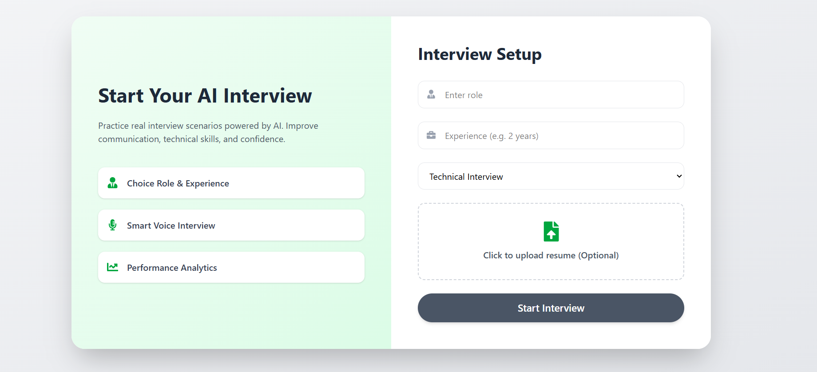
Figure 1. Interview Setup — initial state with role, experience, interview type and optional resume upload.
The screenshot also demonstrates visual consistency: rounded input containers, restrained borders, clear typography, a large primary action and a two-column information hierarchy. The left-side cards reinforce the three central product ideas: role/experience selection, smart voice interviewing and performance analytics.
10. Resume Analysis Presentation
When a resume is supplied and analyzed, the interface expands the setup state to show structured analysis results. The supplied evidence screenshot shows a selected role of Full Stack Developer, an experience description, Technical Interview mode, and a Resume Analysis Result section. The result presents extracted projects and skills as readable content rather than exposing raw machine-readable data to the user.
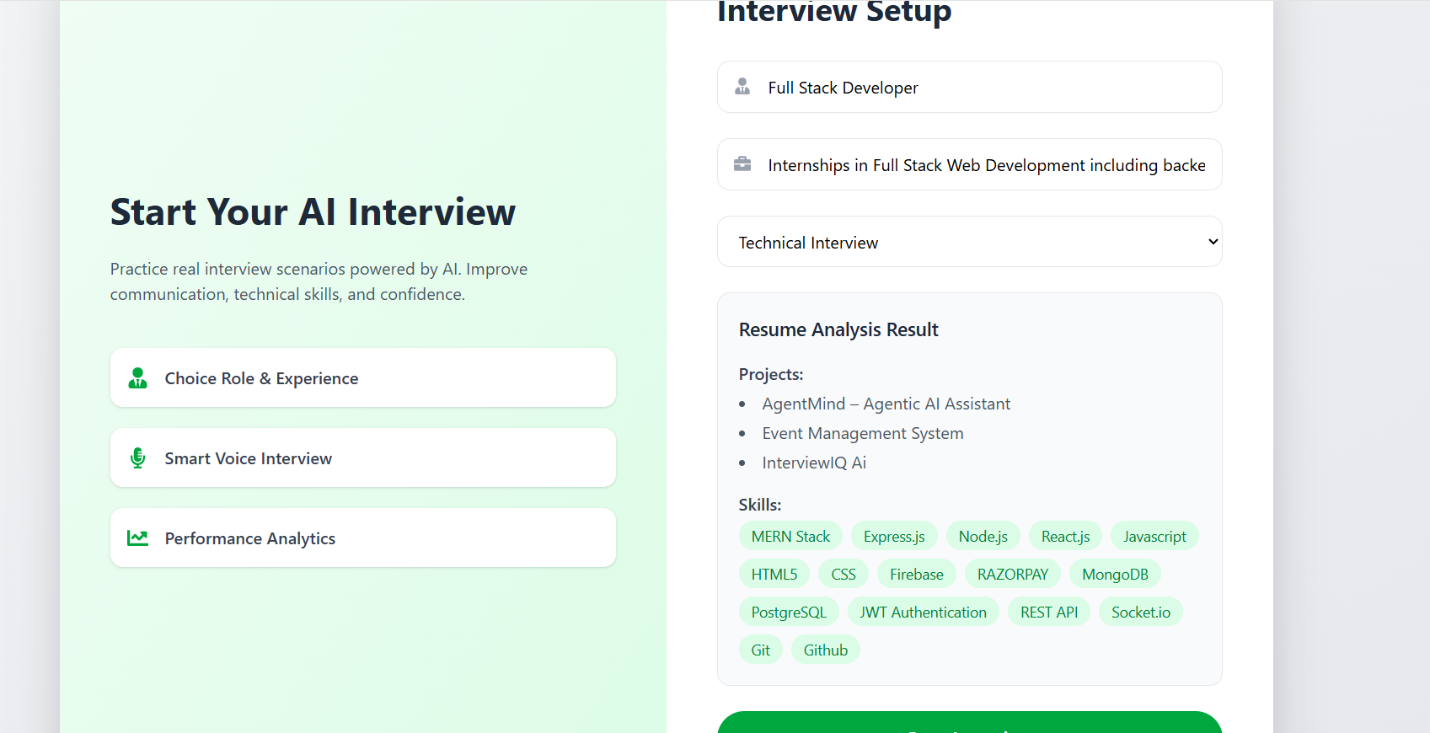
Figure 2. Interview Setup — configured candidate details with resume analysis results and extracted skills.
The analysis result is presented using clear labels and skill chips. The visible examples include projects such as AgentMind — Agentic AI Assistant, Event Management System and InterviewIQ AI, along with skills such as MERN Stack, Express.js, Node.js, React.js, JavaScript, HTML5, CSS, Firebase, Razorpay, MongoDB, PostgreSQL, JWT Authentication, REST API, Socket.io, Git and GitHub. The front end therefore provides a readable representation of structured resume information and creates a natural handoff into interview generation.
UX Decision
Resume analysis is displayed inline within the same setup journey instead of forcing the user to navigate to a separate analysis page. This reduces context switching and makes it clear that the extracted profile can be used for the next interview step.

11. Live Interview Experience
The live interview experience is designed as a step-based interaction rather than a single long page. The InterviewPage orchestrates the setup, live interview and report stages, while dedicated components keep each stage manageable.
Feature | Front-End Behavior | User Benefit
Question progression | Displays the current interview question and advances through the sequence. | Clear one-question-at-a-time focus
Voice interaction | Uses browser speech capabilities for spoken prompts/answers where supported. | More realistic interview practice
Timer | Dedicated Timer component communicates remaining interview time. | Adds realistic interview pressure
Microphone state | UI provides feedback around microphone/recording state. | User knows when interaction is active
AI visual area | Interface provides an AI interviewer presentation area. | Creates a more engaging simulation
Answer submission | Captures and submits the response for evaluation. | Connects interaction to scoring workflow
Next-question decision | Moves to the next question until the interview sequence is complete. | Structured completion flow

From a front-end engineering perspective, the important Week 2 outcome is the interaction model: the interface must manage changing questions, recording-related states, timers and completion transitions without requiring a full page reload. React state and component boundaries support this behavior.
12. Performance Analytics and Report UI
The Interview Report view turns interview results into visual feedback. Instead of showing only a numeric score, the interface separates overall performance, skill-level evaluation, trend visualization and question-level breakdown.
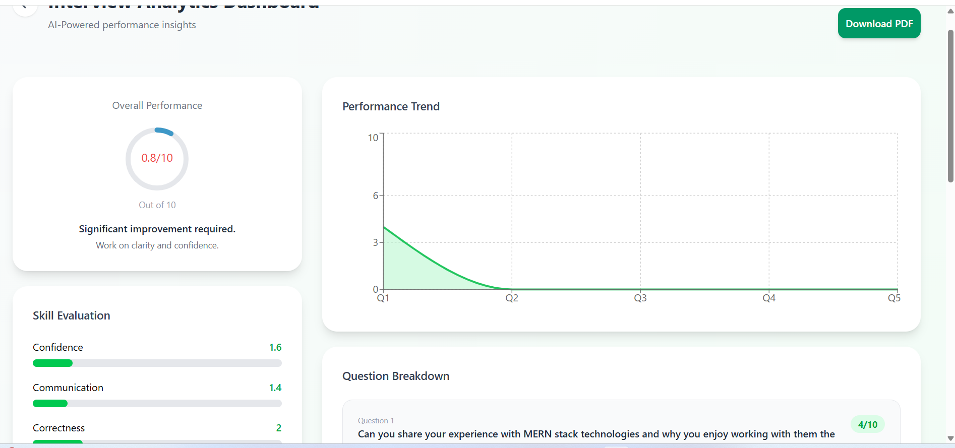
Figure 3. Performance Analytics Dashboard — overall performance, trend chart, skill evaluation and question breakdown.
Report Element | Purpose
Overall Performance | Provides a quick summary score and high-level interpretation.
Performance Trend | Plots question-level performance across the interview.
Skill Evaluation | Separates dimensions such as confidence, communication and correctness.
Question Breakdown | Shows the question and corresponding evaluation for detailed review.
Advice / Improvement Message | Converts the score into an actionable improvement direction.
Download PDF | Allows the candidate to retain a shareable report.

The evidence screenshot shows a low overall score of 0.8/10 and skill values for confidence, communication and correctness. This should be interpreted as sample interview output rather than as a claim about the application's general accuracy. The front-end responsibility is to render the supplied evaluation data clearly and consistently.
Analytics Design Principle
A candidate should be able to understand both 'How did I perform?' and 'What should I improve?' from the same screen. The report UI therefore combines summary metrics with detailed question-level evidence.

13. Navigation, Routing and User Journey
Client-side routing creates a connected application rather than a collection of standalone HTML pages. The current route design supports the main user journey and direct access to report/history areas.
Route | Screen | Navigation Role
/ | Home | Entry point and product introduction
/auth | Authentication | User entry/authentication
/interview | Interview Page | Setup → live interview → report workflow
/history | Interview History | Previous interview sessions
/pricing | Pricing | Credits and payment-related UI
/report/:id | Interview Report | Detailed result for a selected interview

The intended candidate journey can be summarized as: Home → Authentication → Interview Setup → Optional Resume Analysis → Live Interview → Evaluation → Report → History/Review. The route structure allows users to move between major sections without a full browser refresh.
14. Reusable Components and Design Patterns
The application uses reusable React components to keep page files focused on composition and business-oriented interaction. This is particularly useful for an interview platform because common elements such as navigation, authentication, timers and interview stages need consistent behavior.
Component | Role | Why It Is Reusable
Navbar | Branding, navigation, user menu, credits and logout. | Shared across multiple application views
Footer | Consistent footer information. | Common layout element
AuthModel | Authentication interaction. | Can be triggered from different entry points
Step1SetUp | Interview configuration and resume handling. | Encapsulates setup-specific logic
Step2Interview | Question, voice, timer and progression experience. | Keeps live interview complexity isolated
Step3Report | Performance summary and analytics. | Separates report presentation from interview session
Timer | Circular countdown / timing UI. | Independent UI behavior with a clear input/output boundary
FilterItems | Filtering interface where applicable. | Reusable filtering interaction pattern

The component design follows a practical React pattern: break the application into cohesive UI units, pass only the data/handlers a component needs, and keep complex interaction logic inside the feature component that owns it.
15. State Management and Data Handling
InterviewIQ contains both local interaction state and user-level application state. Local state is appropriate for short-lived form values, interview-step transitions, timers and microphone-related UI. Redux Toolkit is used for shared user data that can be needed across pages.
State Type | Examples | Recommended Owner
Local component state | Role, experience, selected interview type, upload state. | React useState / feature component
Interview interaction state | Current question, answer, question index, timer state. | Interview step component
User/session state | Current user information and credits. | Redux Toolkit user slice
Derived display state | Charts, score labels, progress values. | Computed from received report data
Service response state | Loading, success, error and returned records. | Feature-level state / request handling

This separation reduces the risk of putting every value into a global store. Only data that benefits from cross-page access is elevated, while temporary interaction state remains close to the component that owns the interaction.
16. Front-End API / Service Integration
The client is designed to communicate with backend services through Axios. The service layer is represented from the frontend perspective through a shared server URL and feature-specific requests. This creates a clear contract boundary between the UI and server.
Endpoint / Request | Front-End Use
/api/user/current-user | Fetch current user/session information when the application initializes.
/api/auth/google | Send Google-authenticated user information to the application authentication service.
/api/auth/logout | Terminate the application session from the client.
/api/interview/resume | Submit resume data for analysis.
/api/interview/generate-questions | Request interview questions based on selected inputs.
/api/interview/get-interview | Retrieve interview history.
/api/interview/report/:id | Retrieve a selected interview report.
/api/payment/order | Request payment order data for a credit package.
/api/payment/verify | Submit payment verification data.

These requests demonstrate that the front end was built with integration in mind. For a production release, the client should additionally centralize request configuration, handle expired sessions, standardize error messages, and avoid exposing sensitive secrets in browser code.
17. Responsive Design and Accessibility
Responsiveness was treated as a core requirement rather than a final cosmetic step. The UI uses flexible layouts, responsive grids/cards, adaptive spacing and content containers so that the same application can be used across desktop and smaller screens.
Area | Responsive / Accessible Consideration
Forms | Inputs and controls remain grouped and readable as the viewport changes.
Cards | Flexible widths prevent unnecessary horizontal overflow.
Navigation | Primary navigation is designed as a shared component so responsive adjustments remain centralized.
Buttons | Primary actions use clear labels rather than icon-only controls.
Charts | Analytics are placed in content cards so they can resize with the layout.
Typography | Heading hierarchy and spacing provide visual scanning cues.
Color usage | Status and progress indicators are supported by text/labels, reducing dependence on color alone.
File upload | The upload area communicates that resume selection is optional.
Voice controls | Controls should remain understandable even when microphone/speech support is unavailable.

Accessibility Goal
The Week 2 interface aims for understandable labels, clear primary actions, readable hierarchy and usable controls. Before production deployment, a formal keyboard, screen-reader and contrast audit should be completed.

18. Testing, Usability and Quality Checks
Front-end validation was approached from the user's point of view: can a candidate enter the application, navigate to an interview, configure it, progress through the interview interface and understand the resulting report? The following checklist captures the main Week 2 verification areas.
Test Area | Check | Expected Result | Status
Application launch | Run development server / build. | Client starts without blocking runtime errors. | Checked
Routing | Open major routes and navigate between them. | Correct page renders for each route. | Checked
Authentication UI | Open auth modal / auth route. | Authentication controls are visible and usable. | Checked
Setup form | Enter role, experience and mode. | Values are captured and reflected in UI. | Checked
Resume flow | Select optional resume and display analysis result. | Analysis state is presented in a readable panel. | Implemented
Interview UI | Move through question states. | Question and controls update without page reload. | Implemented
Timer | Observe countdown during interview. | Timer presents remaining time clearly. | Implemented
Report | Open report screen. | Score, skills, chart and question breakdown render. | Checked
PDF | Use Download PDF action. | Client generates a report file from displayed data. | Implemented
Responsive layout | Resize viewport / test smaller widths. | Content remains readable and avoids avoidable overflow. | Checked
Lint/build | Run project quality/build scripts. | No unresolved code-quality/build blocker. | Prepared

The screenshots supplied for this report provide visual evidence of distinct states, including the empty setup state, resume-analysis state and analytics/report state. These are especially useful during review because they demonstrate state-driven UI rather than a single static landing screen.
19. Challenges, Decisions and Learning Outcomes
Challenge / Design Problem | Decision / Solution | Learning Outcome
Many interview stages in one journey | Split the workflow into Step1SetUp, Step2Interview and Step3Report. | Feature decomposition improves maintainability.
Shared user information | Use Redux Toolkit user slice instead of duplicating user state across pages. | Global state should be limited to shared data.
Complex interview interaction | Keep question/timer/voice behavior inside the interview feature. | Local state is preferable for short-lived interaction state.
Large report data | Use cards, progress indicators and charts to create visual hierarchy. | Data presentation should match the user's decision needs.
Resume analysis output can be verbose | Present projects and skills as structured text and chips. | Good formatting can make machine-generated data understandable.
Future backend changes | Use Axios-based service boundaries and route-specific endpoints. | UI and server responsibilities should remain decoupled.
Responsive split layout | Use flexible containers and responsive styling rather than fixed dimensions. | Responsive behavior should be planned from the component level.

The main learning outcome from Week 2 is the transition from architecture-level thinking to implementation-level thinking. The system is no longer represented only through diagrams; individual user actions, states, feedback and navigation paths must now be translated into maintainable front-end code.
20. Security and Reliability Considerations
Although Week 2 is focused on the front end, security and reliability were considered at the integration boundary. The client should never contain private API keys, database credentials or server secrets. Authentication tokens/session behavior should be handled through secure server-side mechanisms and the client should gracefully handle unauthorized responses.
- Validate user-entered role and experience values before initiating service requests.
- Restrict accepted resume file types and sizes at the UI boundary, while repeating validation on the server.
- Never trust score, credit or payment values supplied by the browser; authoritative validation belongs to the backend.
- Handle API failures with user-friendly messages rather than exposing raw server errors.
- Ensure authentication/session state is cleared correctly on logout.
- Use HTTPS in deployed environments and avoid hard-coded secrets in the frontend bundle.
- For voice features, clearly communicate browser permission requirements and provide a usable fallback when speech APIs are unavailable.
21. Performance and Maintainability
The front end uses a componentized architecture so large features can be reasoned about independently. Vite supports fast local development, while React's component model keeps rendering focused on the current view. For further optimization, the application can introduce route-level lazy loading, reduce unnecessary re-renders, compress large assets and cache read-only report/history data where appropriate.
Area | Current Approach | Next Optimization
Build | Vite-based React build. | Analyze production bundle and remove unused dependencies.
Rendering | Component-based React UI. | Memoize expensive derived values/components if profiling shows need.
Routing | Client-side routes. | Lazy-load less frequently used report/pricing pages.
Charts | Recharts visualizations. | Render only necessary chart data and dimensions.
Network | Axios requests. | Centralize interceptors, error handling and caching strategy.
Assets | Static assets in client. | Compress/resize large images and lazy-load where appropriate.

22. GitHub, README and Submission Package
The Week 2 source is maintained in the YUVA internship repository under the project client directory. The GitHub repository supplied for the project is:
https://github.com/manishkumar179/InterviewIQ-Yuva-Internship/tree/main/yuvaInternProject
Submission Item | What It Contains | Recommended Status
Word report | This Week 2 technical report with implementation evidence. | Submit
Source ZIP | Client source code + package files + README; exclude node_modules. | Submit
GitHub URL | Repository/project location for reviewer access. | Submit
Portal description | Human-written 200+ word summary of Week 2 work. | Submit
Screenshots | Optional supporting visual evidence if portal permits. | Attach if requested

Important Submission Distinction
The Word report explains the work; the source ZIP provides the code. They are complementary deliverables and should not be treated as substitutes for one another.

23. Evaluation Criteria Mapping
The report is structured to make the Week 2 evaluation easy to verify. Each major evaluation area is supported by an implementation section and, where applicable, screenshot evidence.
Evaluation Area | How InterviewIQ Addresses It | Evidence in Report
UI quality | Consistent cards, typography, spacing, icons, forms, dashboard hierarchy and primary actions. | Sections 8–12 + screenshots
Responsiveness | Flexible layouts and responsive styling across major views. | Section 17
Accessibility | Readable labels, clear actions, hierarchy and planned formal accessibility audit. | Section 17
Interactivity | Forms, upload, routing, authentication entry, voice controls, timer, progression, charts and PDF. | Sections 9–16
Code structure | Pages/components/redux/utils/assets separation. | Section 7
Best practices | Reusable components, state ownership, service boundaries, lint/build workflow. | Sections 14–18
Documentation | README + this report + source package. | Section 22 + Appendix B
User-centered design | Journey is organized around candidate tasks and feedback. | Sections 3, 8, 13 and 19

24. Week 2 Completion Status and Next Phase
Workstream | Status | Notes
React frontend foundation | Completed | Client structure and development environment established.
Core pages/views | Completed | Major candidate-facing screens implemented.
Navigation/routing | Completed | Major routes connected.
Reusable components | Completed | Shared and feature components implemented.
Interview setup | Completed | Role, experience, mode and optional resume UI available.
Resume analysis presentation | Implemented | Results can be represented in the setup experience.
Live interview interface | Implemented | Question, voice, timer and progression UI available.
Analytics/report interface | Implemented | Score, skills, trend and question breakdown rendered.
PDF export | Implemented | Client-side report generation available.
Backend/AI production verification | Next phase | Do not count as front-end completion; verify independently.
Advanced security hardening | Next phase | Centralized auth/error handling and production validation.
Deployment optimization | Next phase | Bundle analysis, performance profiling and production checks.

The appropriate conclusion for Week 2 is therefore that the front-end application development milestone has been addressed with a functional and service-ready client, while deeper backend, AI and production-hardening work remains part of the subsequent development lifecycle.
25. Conclusion
Week 2 transformed the InterviewIQ concept from a planned system into an implemented front-end experience. The application now has a clear candidate journey, multiple interconnected views, reusable React components, global user state, service integration points, interactive interview controls and a visual performance-report experience.
The supplied screenshots strengthen the evidence of this implementation by showing different real UI states: initial interview configuration, populated resume-analysis results and the final analytics/report dashboard. Together, the report and source package provide a reviewer with both the engineering explanation and the implementation artifact.
Final Week 2 Statement
InterviewIQ's front end is structured, interactive, responsive and prepared for continued full-stack integration. The work follows the Week 2 brief while keeping implementation claims limited to what can be supported by the client-side project.

Appendix A — Evidence Screenshots
The following screenshots are included as direct visual evidence of the implemented interface states supplied for this report.
Appendix Figure A1. Initial Interview Setup screen.
Appendix Figure A2. Interview Setup with resume-analysis results.
Appendix Figure A3. Performance Analytics / Interview Report dashboard.

Appendix B — Recommended README / Local Run Instructions
The source ZIP should contain the client project and README. The following content can be used as the basis of the README included with the Week 2 source submission.
Project
InterviewIQ — AI Interview Agent | Front-End Application Development

Prerequisites
- Node.js and npm installed on the local machine.
- A modern browser such as Chrome, Edge or Firefox.
- Git installed if the project is cloned from GitHub.
Install and Run
- Open the client project folder in VS Code.
- Run `npm install` to install the dependencies from package.json.
- Run `npm run dev` to start the Vite development server.
- Open the local URL displayed by Vite in the terminal.
- Use `npm run build` to create a production build.
- Use `npm run preview` to preview the production build locally.
Development Notes
- The application is organized into pages, reusable components, Redux state and utility modules.
- React Router provides client-side navigation.
- Axios is used for frontend-to-service requests.
- Redux Toolkit stores shared user information.
- Firebase supports the Google authentication integration.
- Recharts is used for performance visualization.
- jsPDF and jsPDF-AutoTable support report export.
- Do not commit secrets, credentials or environment-specific private values to GitHub.

