YUVA INTERNSHIP
WEEK 4 REPORT
Integrating Front-End with Back-End
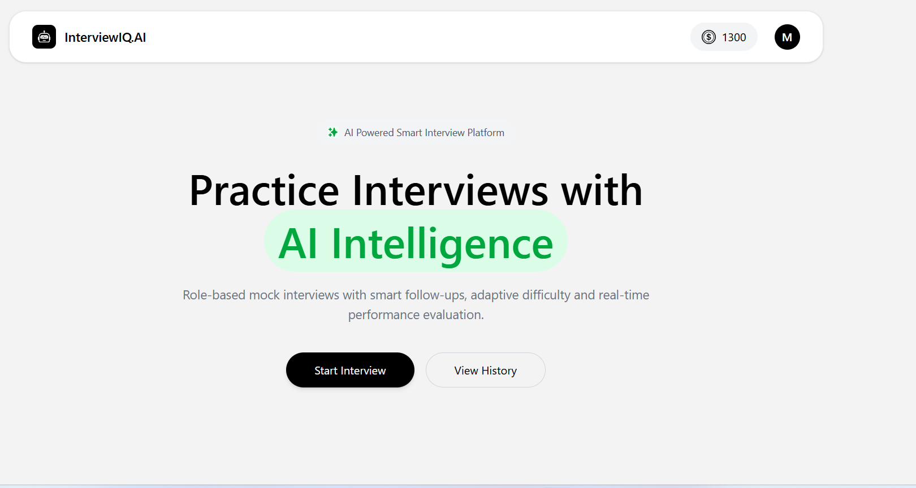
InterviewIQ.AI integrated application — representative application screen.
Project: InterviewIQ.AI — AI Interview Agent
Intern: Manish Kumar
Focus: End-to-end client–server integration, authentication, AI services, payments, data flow and testing
GitHub: https://github.com/manishkumar179/InterviewIQ-Yuva-Internship
Live Application: https://ai-interview-agent-client-hb8r.onrender.com
Submission status: Integration completed and demonstrated through UI + API evidence

1. Week 4 Submission Summary
Week 4 focused on connecting the React front end developed in earlier weeks with the Node.js/Express back end and MongoDB-based application services. The goal was to move from independently developed layers to a cohesive full-stack workflow in which user actions in the browser trigger authenticated API requests, server-side processing, database operations and third-party services, followed by state updates in the user interface.
Area | Integrated implementation | Evidence
Frontend | React, React Router, Redux Toolkit, Axios, responsive UI components | Application screenshots + source inspection
Backend | Express routes, controllers, middleware, MongoDB/Mongoose models | Server source + API evidence
Authentication | Google sign-in handoff → backend user lookup/creation → JWT HttpOnly cookie | Auth + current-user + logout API evidence
Interview | Resume upload, AI question generation, answer submission, finish, report/history | UI flow + Postman evidence
AI | OpenRouter chat-completion service using configured model | Source evidence + generated-question response
Payments | Razorpay order creation and signature verification | Pricing, loading and success screenshots
Reliability | CORS, credentials, URL/port alignment, validation and error handling | Troubleshooting panels + 401 evidence

2. Project Overview
InterviewIQ.AI is an AI-powered mock interview platform designed to simulate interview preparation through role and experience selection, optional resume analysis, AI-generated interview questions, timed voice interaction, answer evaluation and performance reporting. The application also maintains interview history and uses a credit-based model supported by Razorpay payments. Week 4 concentrated on making these capabilities work as one integrated application rather than as isolated front-end and back-end modules.

Core integrated capabilities
- Google-based sign-in with backend user creation/lookup and JWT session cookie.
- Protected interview, history, report and payment APIs using authentication middleware.
- PDF resume upload through multipart/form-data and server-side text extraction.
- AI-assisted interview question generation and answer evaluation through the OpenRouter service.
- Question-by-question interview flow with timers, browser speech features and asynchronous answer submission.
- MongoDB persistence for users, interviews, questions and payment records.
- Razorpay order creation, client checkout, server-side signature verification and credit updates.
- Performance report generation, question-level feedback and downloadable PDF support on the frontend.

3. Week 4 Objective and Scope
- Connect the previously developed React frontend to the REST APIs exposed by the Express backend.
- Implement reliable asynchronous requests and authenticated credential handling.
- Validate end-to-end data movement from browser → API → database/AI/payment service → API response → UI.
- Handle integration failures such as unauthorized requests, invalid input, upload problems, wrong API URL/port and third-party service errors.
- Verify the application from both an end-user perspective and a developer/API-testing perspective.
- Document integration decisions, testing evidence, challenges and solutions.

4. Integrated Full-Stack Architecture
The integrated architecture follows a layered request/response flow. The React client is responsible for presentation, local component state and Redux user state. Axios sends requests to Express routes. Authentication middleware verifies the JWT stored in an HttpOnly cookie before protected operations continue. Controllers coordinate business logic, MongoDB operations, PDF parsing, OpenRouter requests and Razorpay operations. The resulting JSON response is consumed by the React components and used to update the UI.
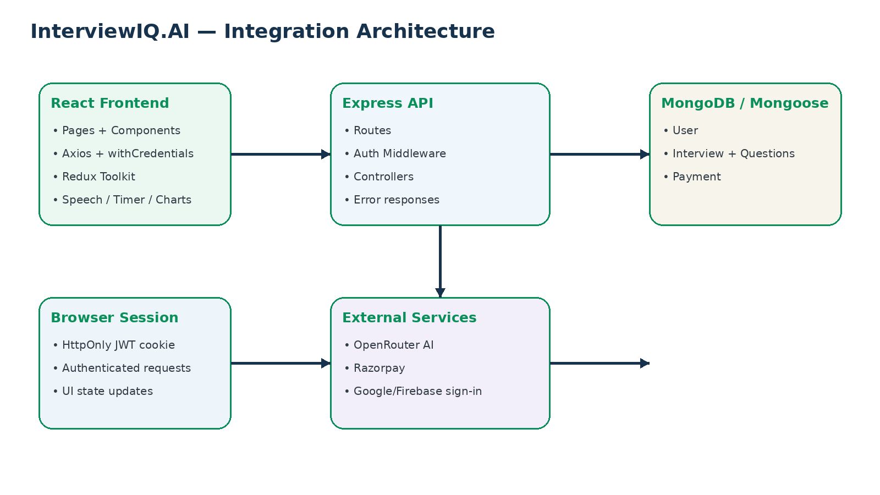
Integrated request/data flow used for the Week 4 full-stack application.
Key integration principle: every protected request carries browser credentials, the server authenticates the request, performs the required operation, and returns a structured response that drives the next UI state.

5. Frontend–Backend API Integration Map
Method | Endpoint | Purpose | Frontend usage | Auth
POST | /api/auth/google | Create/find user and issue JWT cookie | Auth.jsx | Public
GET | /api/auth/logout | Clear JWT cookie | Navbar.jsx | Cookie-aware
GET | /api/user/current-user | Restore logged-in user on app load | App.jsx | Protected
POST | /api/interview/resume | Upload and analyze PDF resume | Step1SetUp.jsx | Protected + multipart
POST | /api/interview/generate-questions | Generate and store interview questions | Step1SetUp.jsx | Protected
POST | /api/interview/submit-answer | Evaluate/store current answer | Step2Interview.jsx | Protected
POST | /api/interview/finish | Finalize interview/report data | Step2Interview.jsx | Protected
GET | /api/interview/get-interview | Fetch interview history | InterviewHistory.jsx | Protected
GET | /api/interview/report/:id | Fetch a specific report | InterviewReport.jsx | Protected
POST | /api/payment/order | Create Razorpay order | Pricing.jsx | Protected
POST | /api/payment/verify | Verify payment and add credits | Pricing.jsx | Protected

6. Authentication and JWT Cookie Integration
The authentication flow combines Google sign-in on the client with a server-side session mechanism. After Google identity information is received by the React application, the client posts the name and email to /api/auth/google. The backend validates the required fields, finds or creates the MongoDB user, signs a JWT containing the user ID, and sends it in an HttpOnly cookie.
- JWT is generated by config/token.js with a seven-day expiry.
- The cookie is HttpOnly, reducing direct JavaScript access to the token.
- Production configuration uses secure cookies and SameSite=None; local development uses SameSite=lax.
- Protected routes use isAuth middleware to read req.cookies.token, verify the JWT and set req.userId.
- Axios requests that require the session explicitly use withCredentials:true.
- App.jsx calls /api/user/current-user on startup so Redux user state can be restored after refresh.
- Logout clears the token cookie through /api/auth/logout.
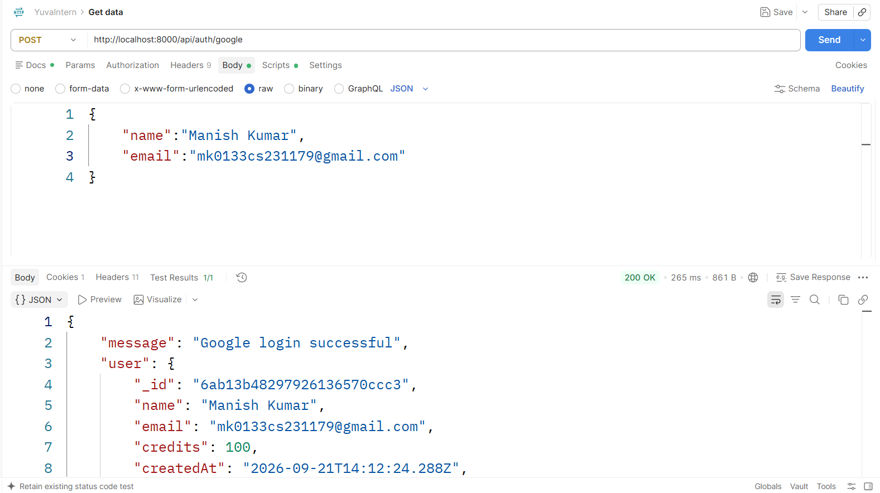
Postman evidence: Google authentication returned a successful response and user data.
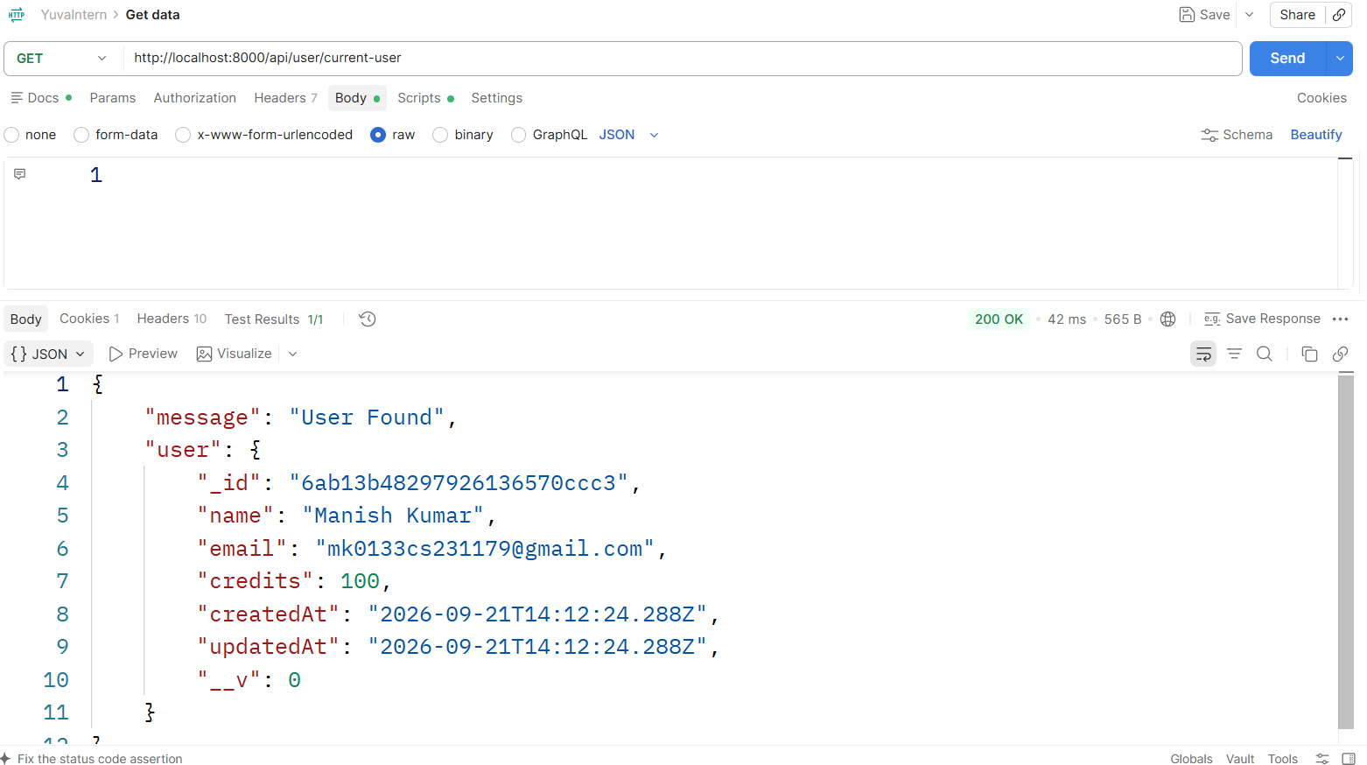
Postman evidence: protected current-user endpoint returned the authenticated user.
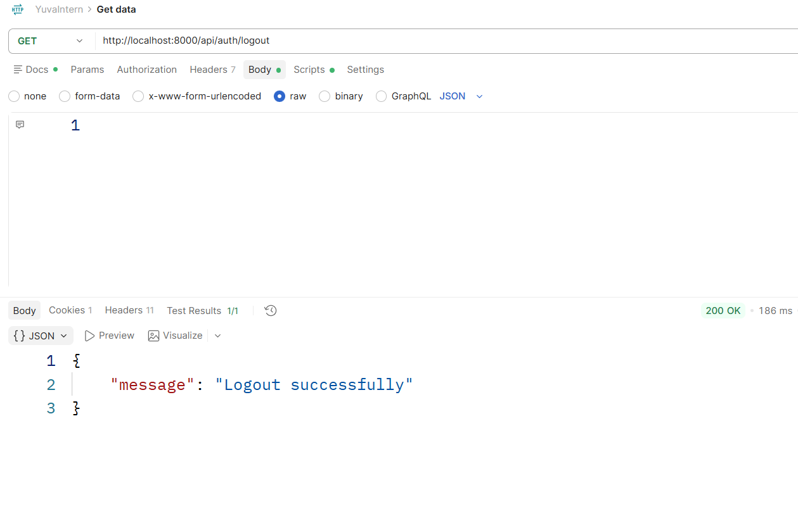
Postman evidence: logout endpoint successfully cleared the session.

7. Resume Upload and AI Processing Integration
Resume analysis is a multi-stage integration point. The browser selects a PDF, creates FormData and posts the file using the field name resume. The backend uses Multer with a 5 MB file-size limit and stores the uploaded file temporarily in the public directory. pdfjs-dist is used to extract text from the PDF. The extracted resume content is passed to the OpenRouter AI service, which returns structured candidate information such as role, experience, projects and skills. The response is mapped back into the React setup form.
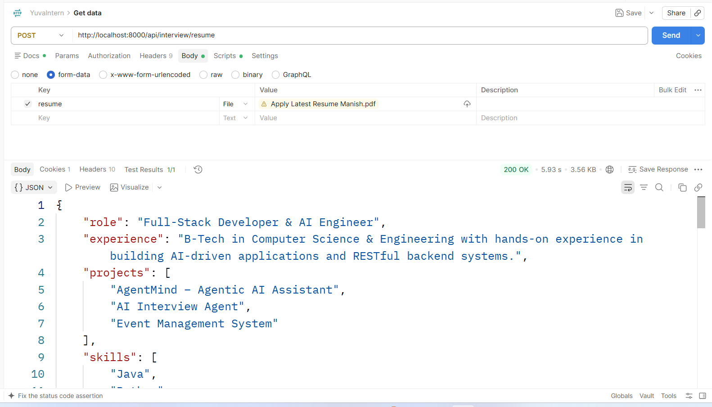
Postman evidence: multipart resume upload returned structured role, experience, projects and skills.
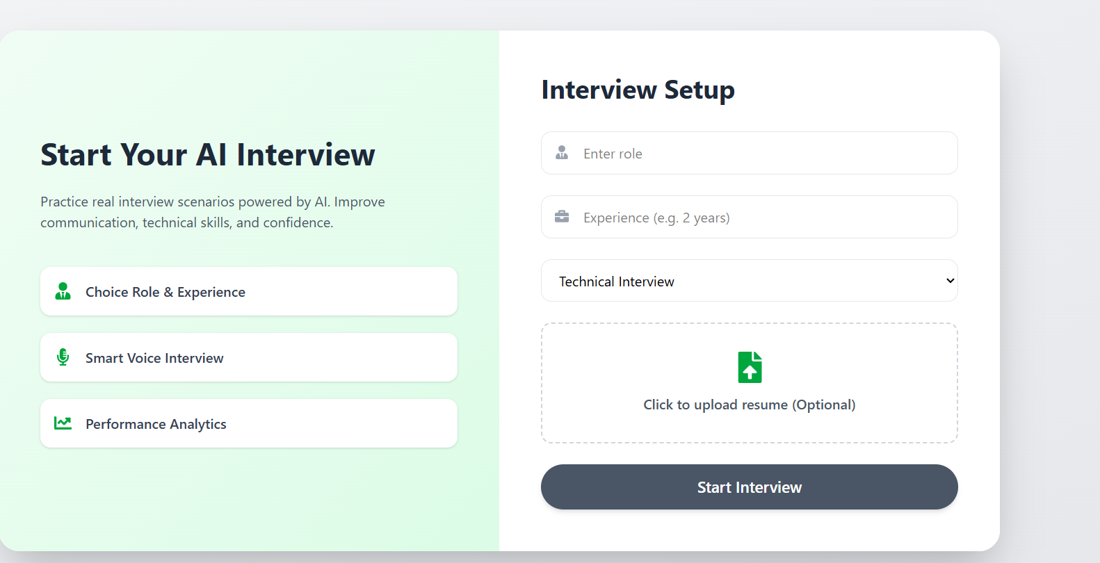
Frontend evidence: resume analysis results are displayed inside the interview setup screen.

8. AI Question Generation and Interview Data Flow
After resume processing or manual setup, the frontend sends role, experience, mode, resumeText, projects and skills to /api/interview/generate-questions. The backend checks the authenticated user and available credits before constructing the AI prompt. Generated questions are stored in the Interview document, 50 credits are deducted for the generation operation, and the API returns the interview ID, remaining credits and questions. Redux is then updated with the remaining credit balance.
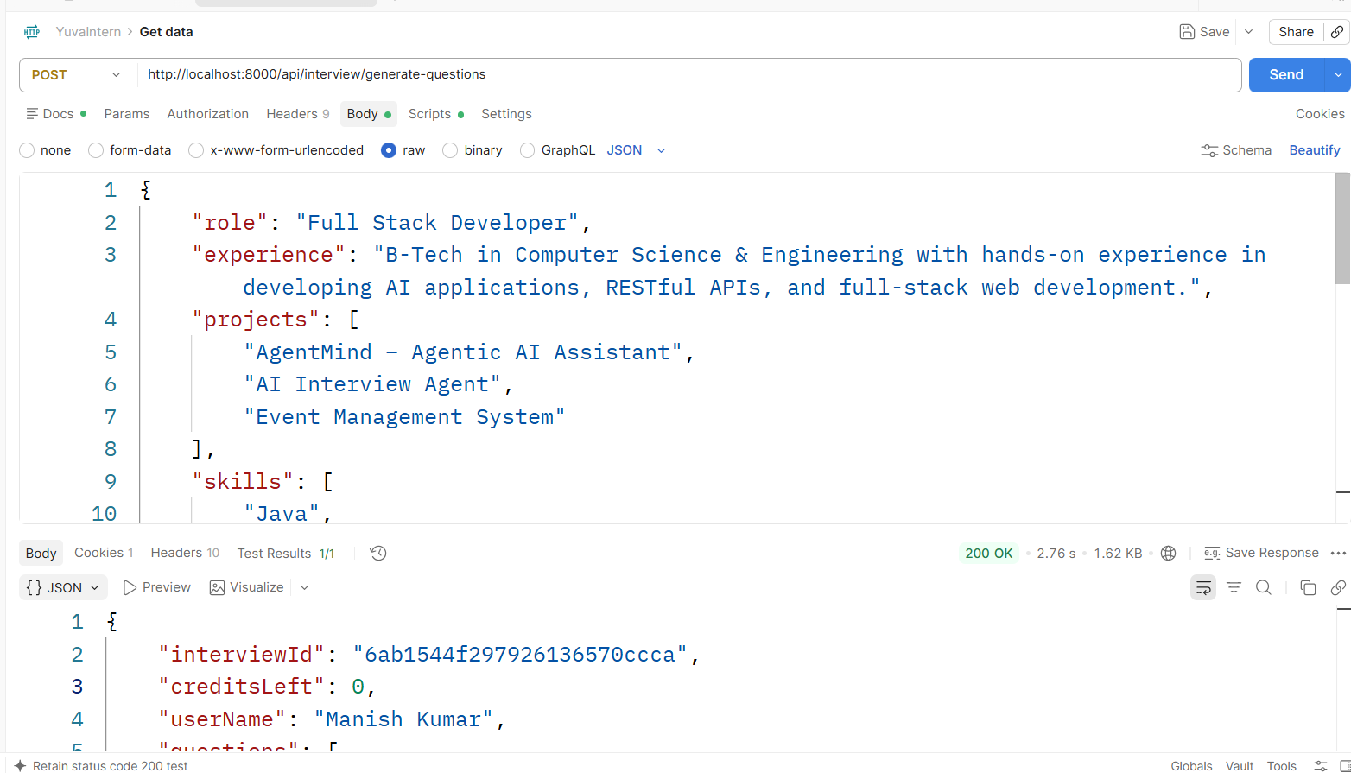
Postman evidence: question-generation request returned an interview ID, remaining credits and generated questions.
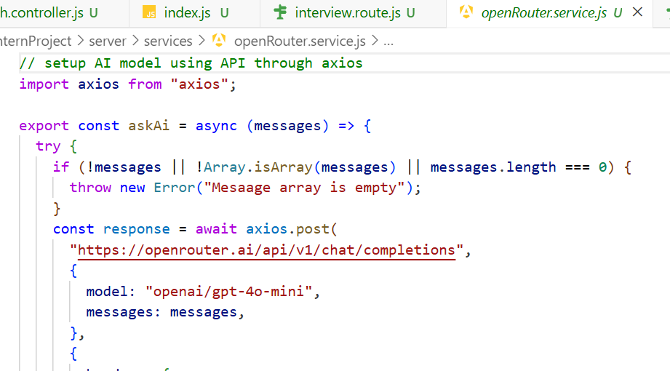
Source evidence: OpenRouter service sends chat-completion requests using the configured AI model.

9. Live Interview, Answer Submission and Report Integration
The live interview screen consumes the generated question array and manages the current question, answer text, timer, microphone state and feedback. Submitting an answer posts the interview ID, question index, answer and time taken to the backend. The backend evaluates the answer through the AI service, stores the answer and feedback, and returns feedback to the client. When all questions are completed, /api/interview/finish finalizes the interview and the report page retrieves persisted results using /api/interview/report/:id.
- The timer can trigger answer submission when time reaches zero.
- Speech recognition is used to capture voice answers in supported browsers.
- Speech synthesis reads interview prompts and feedback to the user.
- Question-level scores, confidence, communication and correctness are persisted in the interview record.
- The report page visualizes overall performance and question-level feedback using charts and progress indicators.
- Interview history is retrieved from /api/interview/get-interview and links completed interviews to reports.
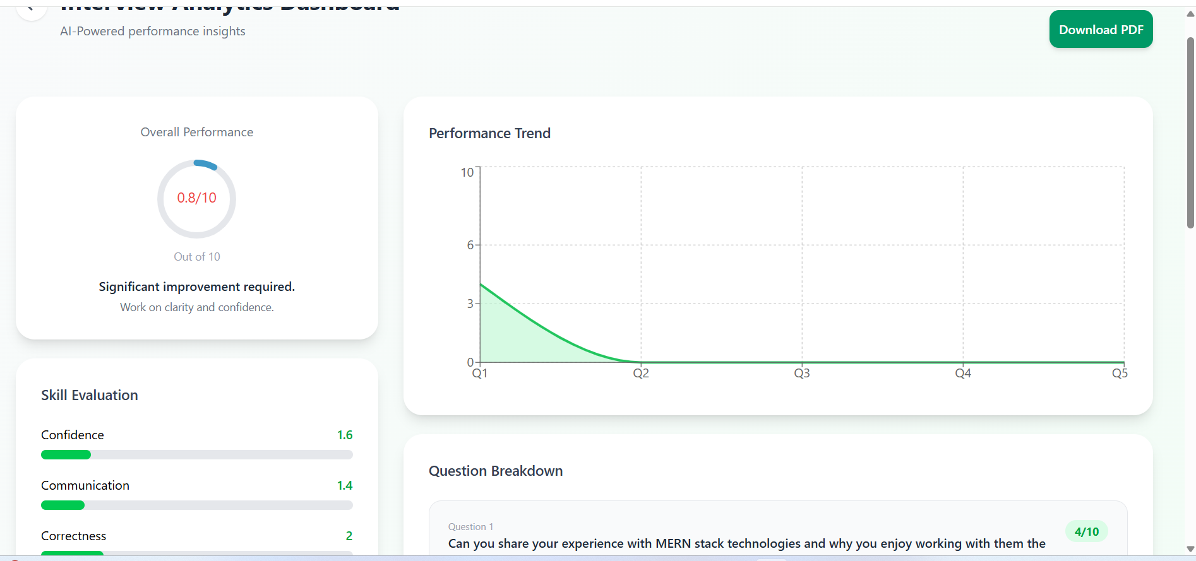
Frontend evidence: integrated interview analytics dashboard with performance trend and skill evaluation.

10. Payment and Credit Integration
The pricing page is connected to the backend payment APIs. The user selects a plan, the client posts planId, amount and credits to /api/payment/order, the backend creates a Razorpay order and stores a Payment record. Razorpay checkout is opened in the browser. After payment, the client posts the returned Razorpay identifiers to /api/payment/verify. The server computes an HMAC SHA-256 signature using the Razorpay secret, compares it with the supplied signature, marks the payment as paid and increments the user's credits.
Plan | Price | Credits | Integration behavior
Free | ₹0 | 100 | Default account allowance
Starter Pack | ₹100 | 150 | Razorpay order + verified credit update
Pro Pack | ₹500 | 650 | Razorpay order + verified credit update

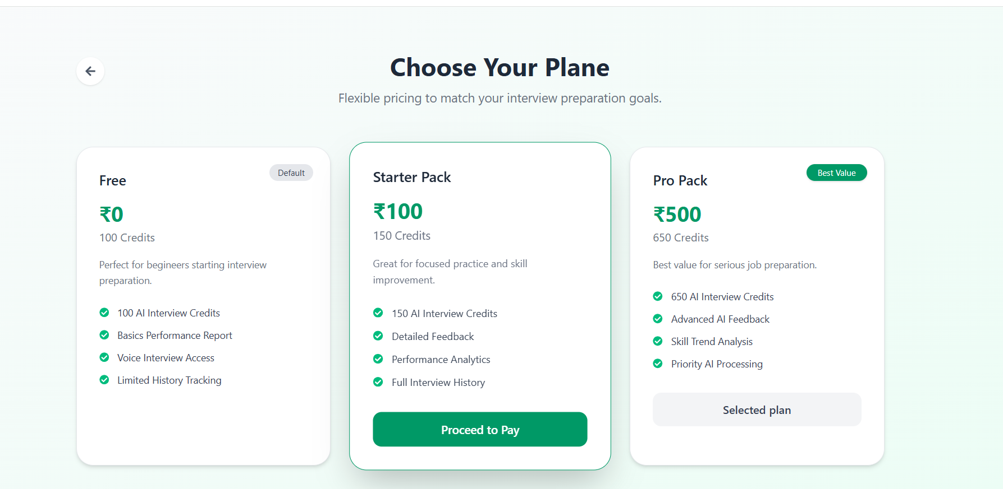
Frontend evidence: credit-based pricing plans integrated with Razorpay checkout.
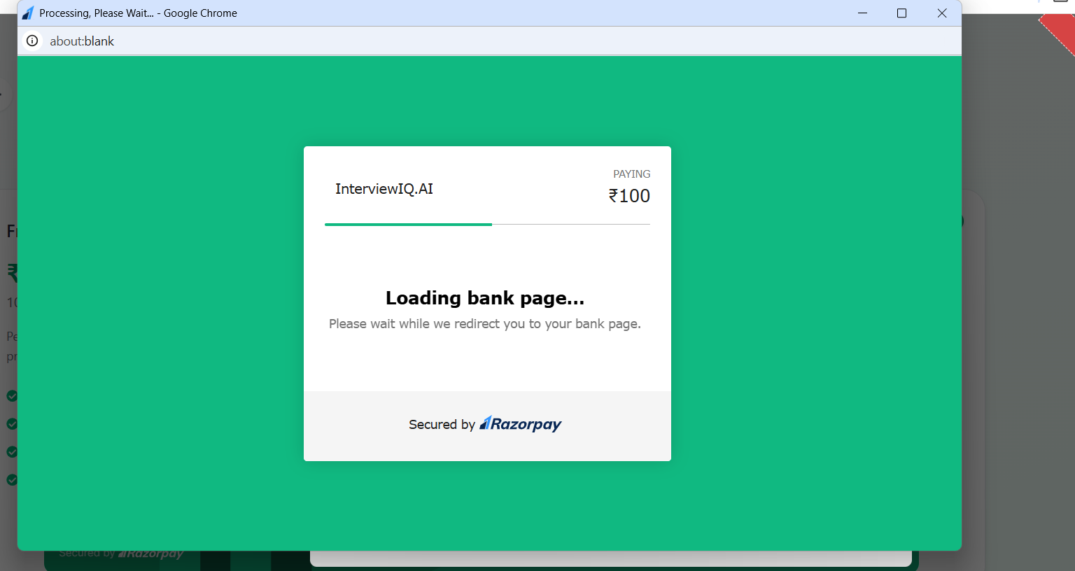
Frontend evidence: Razorpay checkout loading after an order is created.
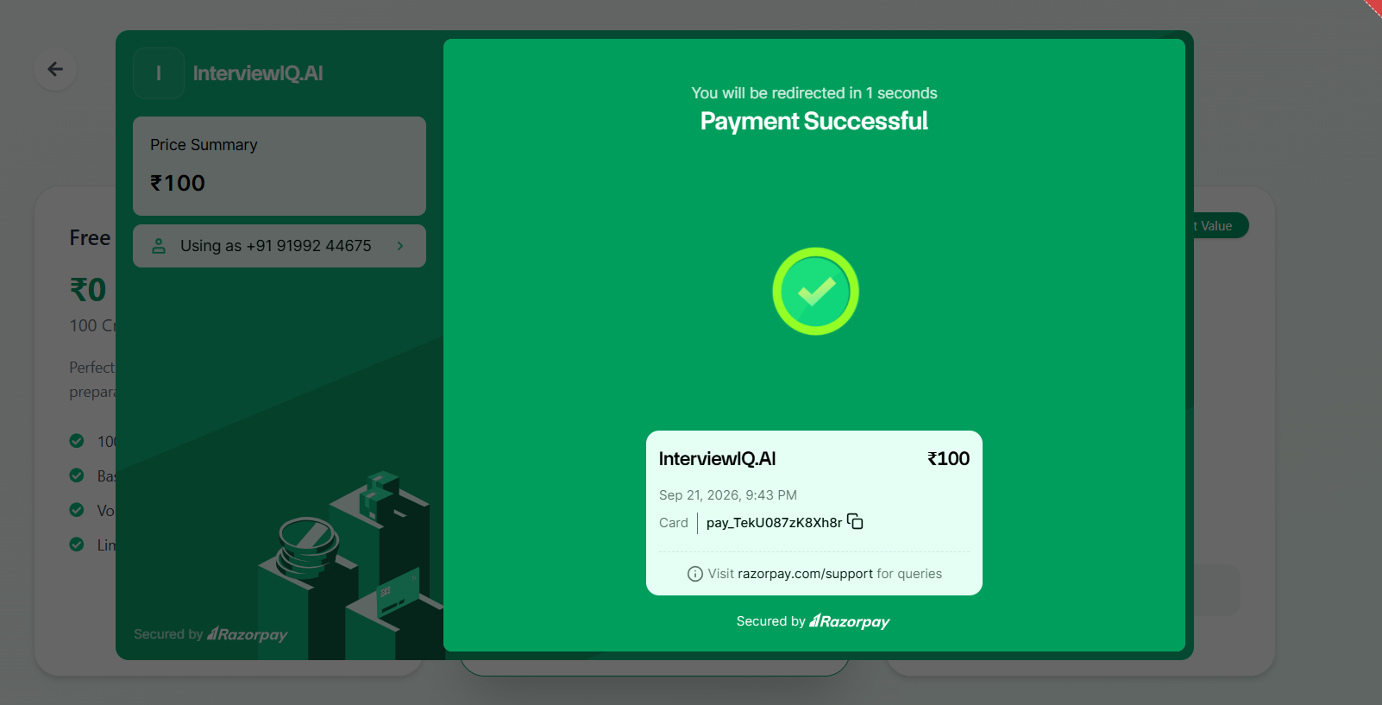
Frontend evidence: successful payment flow and updated credit balance.

11. Integration Challenges and Solutions
The integration work required alignment between browser requests, Express middleware, authentication cookies, endpoint paths, multipart uploads and third-party services. The following visual panels document common integration troubleshooting patterns used for this project. They are explicitly marked as illustrative troubleshooting evidence rather than captured production errors.
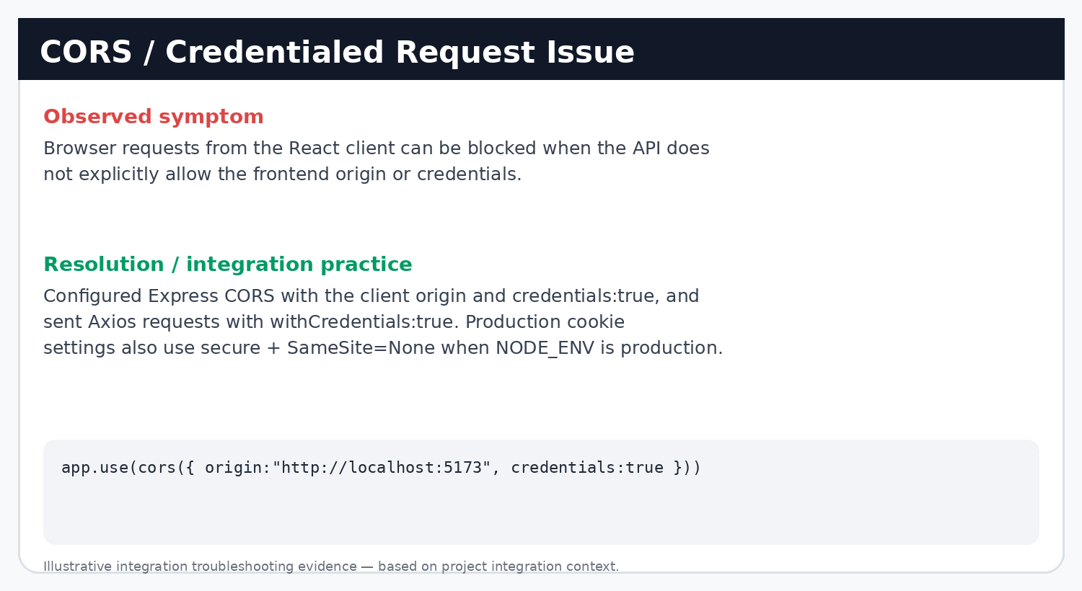
Illustrative troubleshooting evidence: CORS and credential configuration.
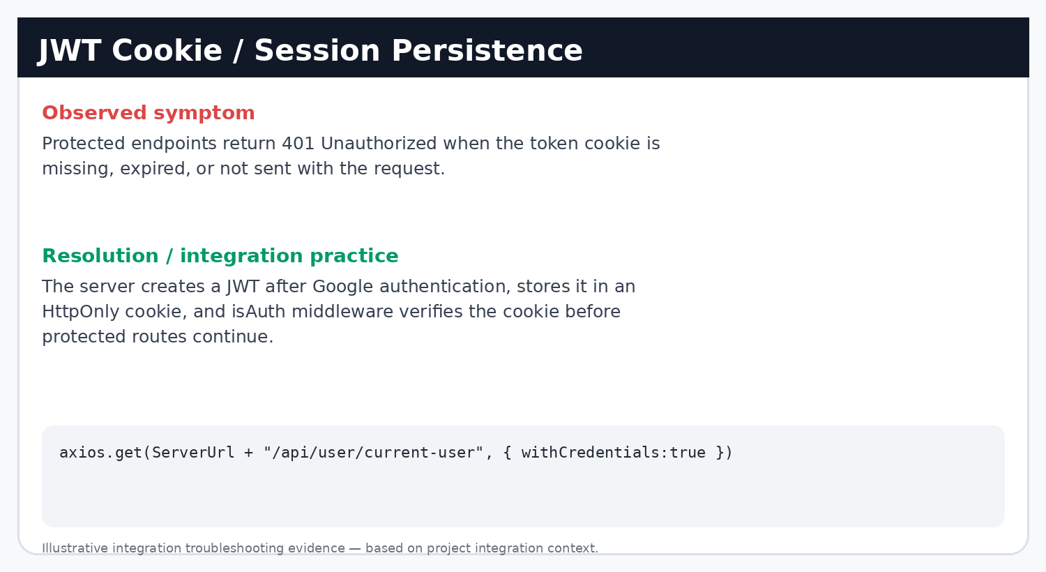
Illustrative troubleshooting evidence: JWT cookie/session handling.
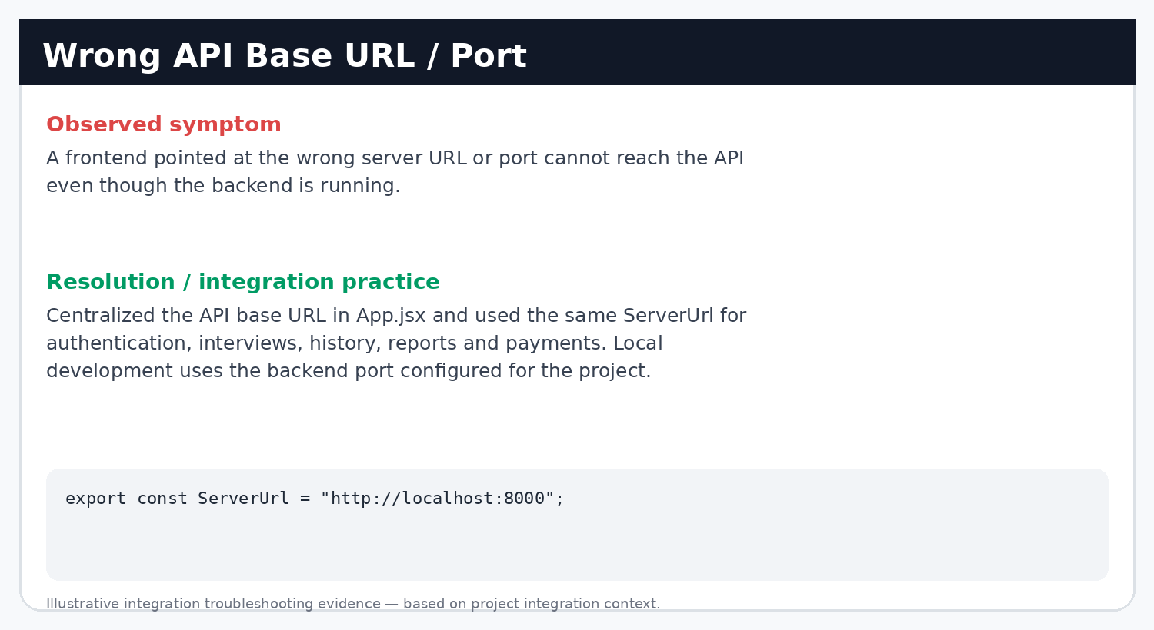
Illustrative troubleshooting evidence: API URL and port alignment.
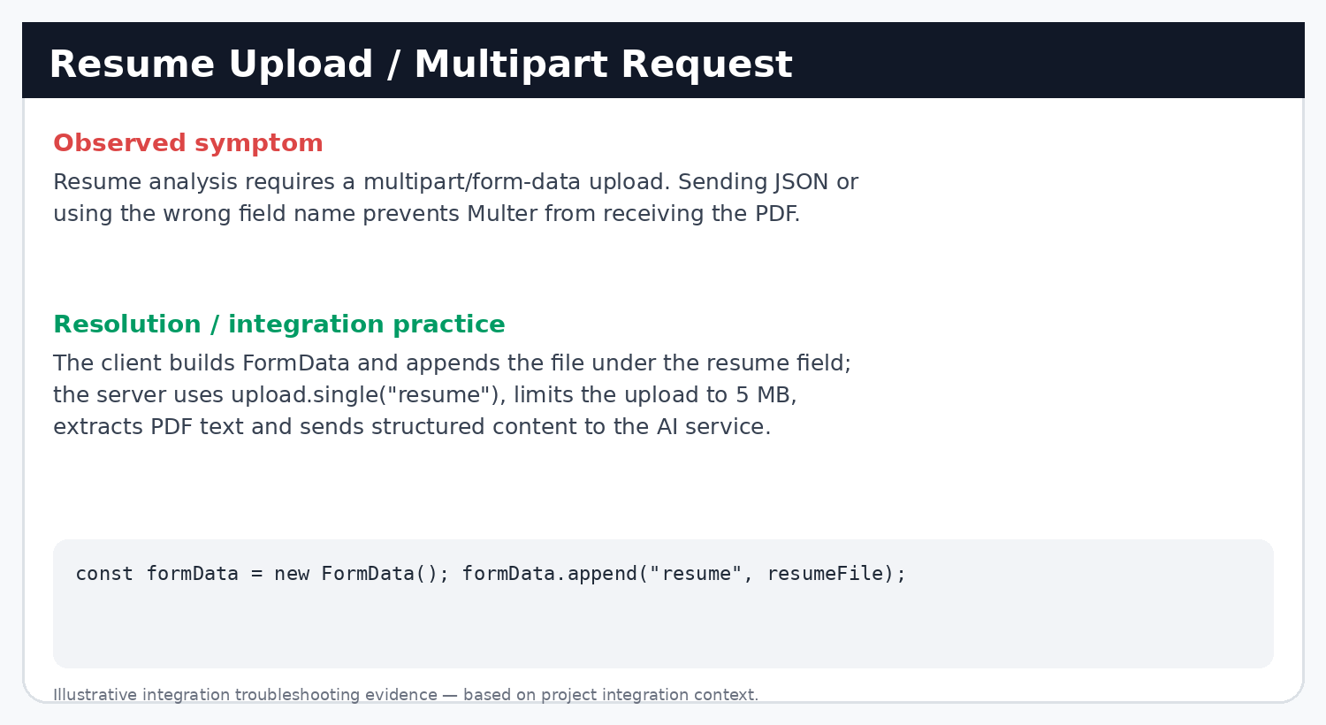
Illustrative troubleshooting evidence: Multipart resume upload.
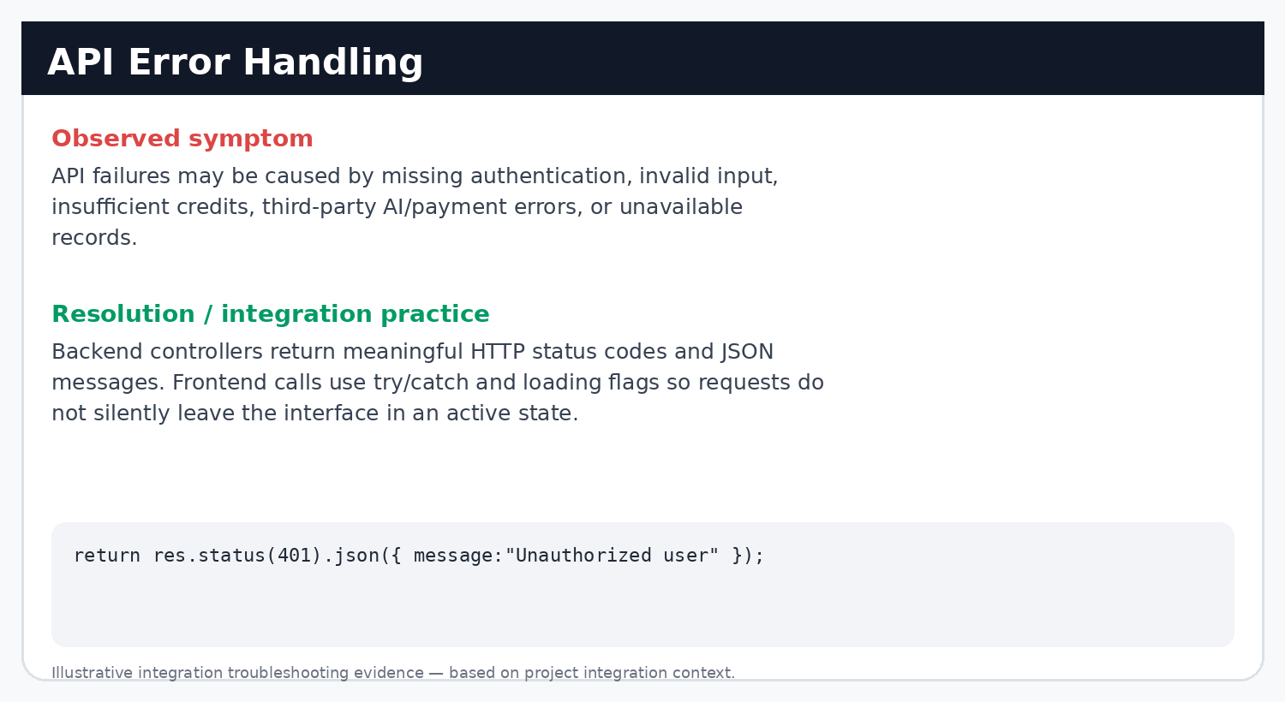
Illustrative troubleshooting evidence: API error handling.

12. Concrete Error Evidence
The provided Postman evidence includes a real protected-endpoint failure: a request to /api/interview/generate-questions returned HTTP 401 with the message "Unauthorized user". This is useful integration evidence because it demonstrates that authentication middleware is guarding protected APIs when credentials are not accepted.
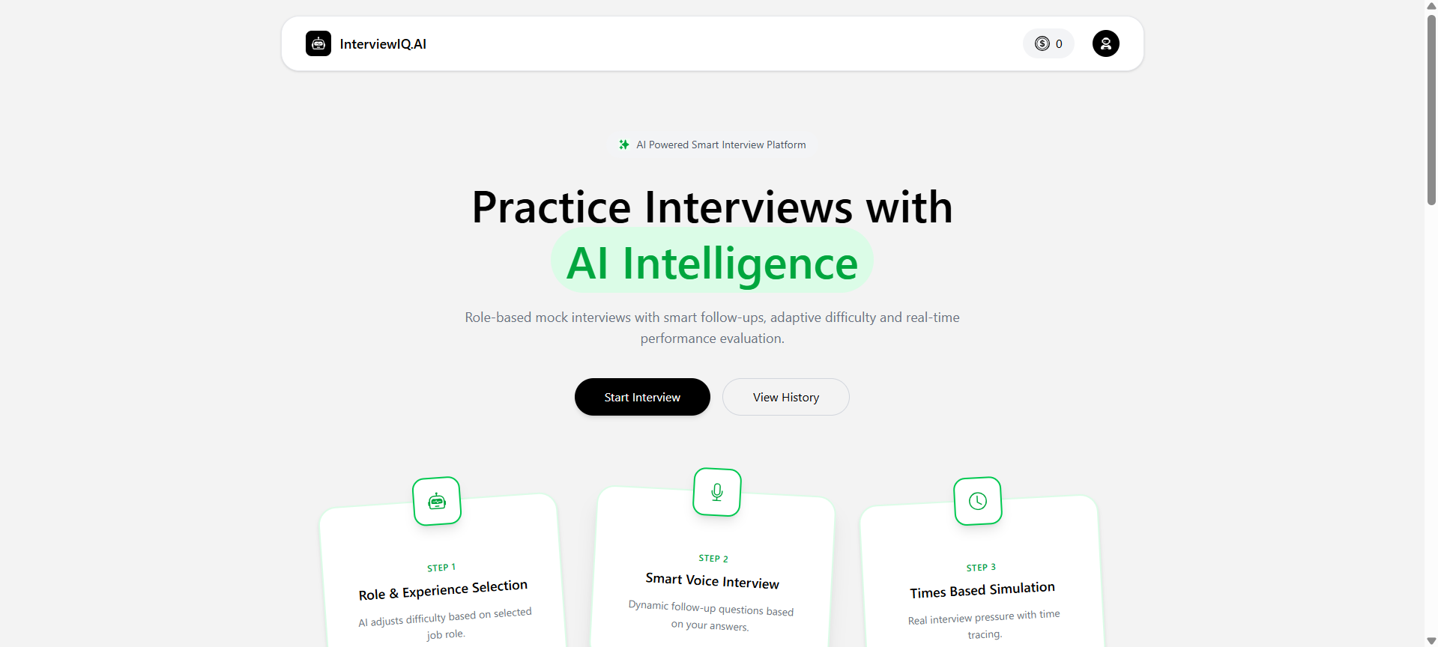
Actual Postman evidence: protected API returned HTTP 401 Unauthorized when authentication credentials were not accepted.

13. Error Handling and Validation
Error handling was implemented at both layers. On the server, controllers use try/catch blocks and return JSON responses with status codes for common failures. Examples include missing resume (400), insufficient credits (400), missing user/interview records (404), invalid payment signature (400), unauthorized access (401), and unexpected server/third-party failures (500). On the client, Axios calls use try/catch and loading flags to prevent duplicate actions and to restore UI state after failures.
Scenario | Backend behavior | Frontend response
Missing authentication | 401 Unauthorized | Request fails; user state can be cleared
Missing resume | 400 Resume required | Upload flow remains incomplete
Insufficient credits | 400 Not enough credits | Interview generation does not proceed
Missing interview | 404 response | Report/history operation cannot continue
Invalid payment signature | 400 Invalid payment signature | Payment verification does not add credits
AI/third-party failure | 500 response from controller/service | Loading state is reset and error is logged

14. Data and Database Integration
MongoDB is the persistence layer accessed through Mongoose. The user document stores name, email and credits. The interview document stores the authenticated user reference, role, experience, mode, resume text, questions and final score/status. Each question stores its answer, feedback and evaluation dimensions such as score, confidence, communication and correctness. Payment documents link a user to a Razorpay order and store the plan, amount, credits and payment status.
Collection / Model | Key fields | Used by
User | name, email, credits, timestamps | Auth, current user, credit updates
Interview | userId, role, experience, mode, resumeText, questions, finalScore, status | Generation, evaluation, history, report
Question (embedded) | question, difficulty, timeLimit, answer, feedback, score, confidence, communication, correctness | Live interview + analytics
Payment | userId, planId, amount, credits, Razorpay IDs, status | Order creation + verification

15. Asynchronous State Management
- Axios is used for browser-to-server communication.
- withCredentials:true is applied on authenticated requests so the JWT cookie participates in the session.
- Redux Toolkit stores user information and credit balance across pages.
- Local React state controls request loading, resume analysis, question progression, timer, answer text and payment state.
- The UI updates after successful server responses instead of assuming that a local action succeeded.
- The current-user bootstrap request allows the application to recover authentication state after page refresh.

16. End-to-End Integrated User Flow
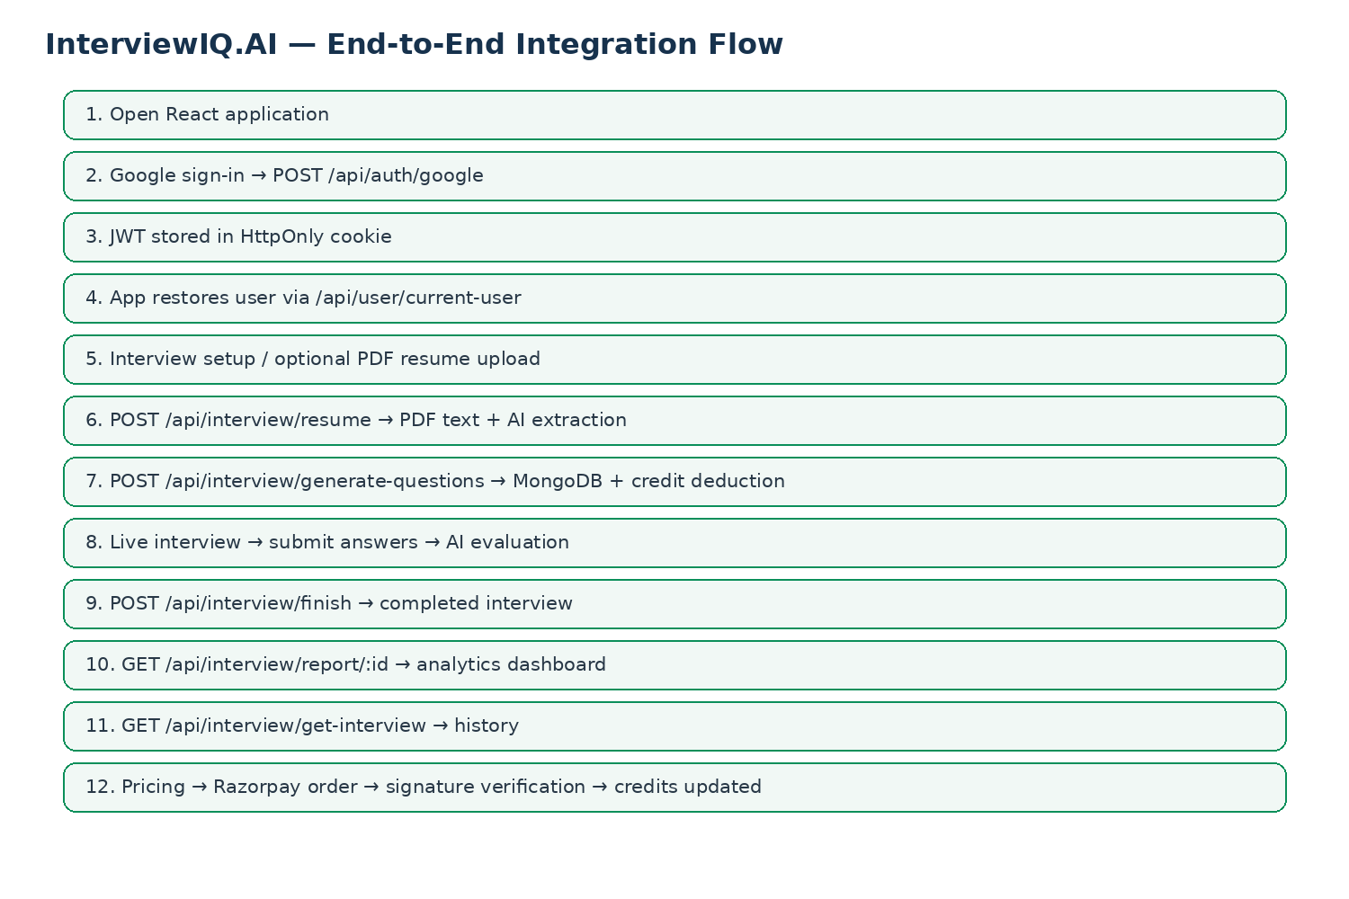
End-to-end browser-to-backend-to-service data flow used for integration verification.

17. Testing and Verification Performed
Testing for Week 4 was performed at two levels: API-level verification with Postman and UI-level verification through the browser. The supplied evidence demonstrates successful authentication, logout, current-user retrieval, resume upload and AI question generation. The application screenshots demonstrate integrated setup, interview/report and payment flows.
Test area | Verification | Observed result
Google authentication | POST /api/auth/google | 200 response with user data; session cookie created
Logout | GET /api/auth/logout | 200 response; cookie cleared
Session restoration | GET /api/user/current-user | 200 response for authenticated user
Resume upload | POST /api/interview/resume | 200 response with structured resume data
Question generation | POST /api/interview/generate-questions | 200 response with interviewId, questions and creditsLeft
Protected route | Request without valid session | 401 Unauthorized — middleware correctly blocks access
Interview UI | Setup → live interview → report | Integrated screen-to-API workflow
Payment UI | Pricing → Razorpay → verification | Order/checkout/success flow demonstrated

No automated unit/integration test suite is claimed in this report because no such test suite was identified in the supplied project structure. API and browser verification are reported as performed evidence.

18. Local Setup and Execution
The repository contains separate client and server applications. Keep API secrets out of source control and create local environment files using the required variable names.

Server
- Open a terminal in yuvaInternProject/server.
- Install dependencies: npm install
- Create .env with the required MongoDB, JWT, OpenRouter and Razorpay credentials.
- Start the development server: npm run dev
- The server uses process.env.PORT; the current client integration points to http://localhost:8000.

Client
- Open another terminal in yuvaInternProject/client.
- Install dependencies: npm install
- Configure the Firebase and Razorpay frontend environment values required by the project.
- Start Vite: npm run dev
- Open the local Vite application in the browser.

Environment variable names used by the project
Variable | Purpose
PORT | Express server port
MONGODB_URL | MongoDB connection string used by database configuration
JWT_SECRET | JWT signing and verification secret
OPENROUTER_API_KEY | OpenRouter authentication
RAZORPAY_KEY_ID | Razorpay client key
RAZORPAY_KEY_SECRET | Razorpay server-side signature verification
VITE_RAZORPAY_KEY_ID | Razorpay key exposed to the Vite client
Firebase variables | Google/Firebase client configuration

Security note: actual secret values are intentionally not included in this report.

19. GitHub and Live Demonstration
Repository: https://github.com/manishkumar179/InterviewIQ-Yuva-Internship
Live application: https://ai-interview-agent-client-hb8r.onrender.com
Recommended demonstration sequence: open the application → authenticate → open interview setup → upload/analyze resume → generate questions → complete interview interaction → view report/history → open pricing → demonstrate the payment flow. This sequence directly maps to the Week 4 integration objective.

20. Week 4 Evaluation Criteria Mapping
Evaluation criterion | Evidence in this report
Successful frontend/backend integration | Architecture, endpoint map, UI/API screenshots and end-to-end flow
Documentation quality and clarity | Structured sections, API map, setup instructions, challenges and solutions
Application performance / reliability | Loading states, credential handling, validation, protected routes and error responses
Full-stack best practices | Layered routes/controllers/models/services, JWT cookie auth, CORS configuration, multipart handling, payment signature verification
Testing and verification | Postman results, browser workflow evidence and 401 protected-route test

21. Key Learning Outcomes
- Learned how a React UI consumes REST endpoints and transforms JSON responses into application state.
- Understood why credentialed CORS and withCredentials are both required when using cookie-based authentication across origins.
- Strengthened understanding of JWT lifecycle: issue → cookie → middleware verification → user context → logout.
- Practiced multipart/form-data integration for PDF uploads and server-side file processing.
- Connected AI, database and payment services through backend controllers instead of exposing secrets in the browser.
- Learned to diagnose integration problems by checking browser requests, API URLs, status codes, cookies, request bodies and server logs.
- Improved understanding of end-to-end validation: a feature is integrated only when the UI action, API response and persisted state agree.

22. Conclusion
Week 4 completed the transition of InterviewIQ.AI from separate frontend and backend modules into an integrated full-stack application workflow. The React client communicates with Express APIs for authentication, user state, resume analysis, AI question generation, interview evaluation, history, reporting and payments. JWT cookies and protected middleware establish the authenticated request path, while Axios and Redux coordinate asynchronous data and user state on the client. The integration was verified through browser workflows and API testing evidence, including successful responses and a controlled 401 unauthorized case. The work also highlighted practical full-stack concerns such as CORS, cookie configuration, endpoint consistency, multipart upload handling, validation and third-party service failures.

Appendix A — Evidence Index
Evidence | What it demonstrates
Home + Auth modal | Frontend entry point and Google sign-in UX
Interview setup | Resume analysis data returned to the UI
Live interview screens | Question delivery, timer, speech/answer interaction
Analytics report | Backend-persisted evaluation rendered by frontend
Pricing + Razorpay loading/success | Payment integration and credit workflow
Postman auth/current-user/logout | Cookie/JWT session integration
Postman resume upload | Multipart API + PDF analysis
Postman question generation | AI integration + interview creation + credit deduction
401 Unauthorized | Protected API behavior when credentials are absent/invalid
Integration troubleshooting panels | CORS, cookies, URL, upload and error-handling practices

