YUVA INTERNSHIP
WEEK 3 TECHNICAL REPORT
Back-End API Development
InterviewIQ.AI — AI Interview Agent

Internship Task | Week 3: Back-End API Development
Application | InterviewIQ.AI
Backend | Node.js + Express.js
Database | MongoDB + Mongoose
AI / Payments | OpenRouter (GPT-4o-mini) + Razorpay
Report Date | 21 September 2026

Prepared as evidence-based documentation of the completed backend/API work.

1. Executive Summary
Week 3 focused on implementing the server-side foundation of InterviewIQ.AI, an AI-powered mock interview platform. The backend was developed as a RESTful service using Node.js and Express.js, with MongoDB accessed through Mongoose for persistent user, interview and payment data. The application exposes authentication, user, interview, resume-processing and payment endpoints that are consumed by the React frontend.
The implementation follows a modular structure in which routes receive HTTP requests, controllers handle business logic, models define persistent data structures, middleware protects authenticated resources and service modules isolate external integrations. JWT-based authentication is stored through cookies and verified by a custom authentication middleware. Resume files are accepted through Multer, AI requests are sent through an OpenRouter service using Axios, and Razorpay is integrated for credit purchases.
Concrete API verification evidence was captured using an HTTP client. The supplied evidence shows successful HTTP 200 responses for Google authentication, logout, current-user retrieval, resume analysis and AI interview-question generation. The report also documents the MongoDB schemas, API contracts, security approach, external-service integrations, project structure and implementation challenges.
- Evidence-first documentation: API screenshots are embedded with captions and interpreted against the actual endpoint behavior.
- Modular backend: routes, controllers, models, middleware, configuration and services are separated by responsibility.
- Authentication: JWT token verification through an authentication middleware and cookie-based session state.
- AI workflow: resume data can be processed and interview questions generated through OpenRouter/GPT-4o-mini.
- Payments: Razorpay order and verification services support purchasing additional interview credits.

2. Week 3 Objective and Requirement Mapping
The YUVA Week 3 task asks for RESTful APIs supporting the web application, CRUD-oriented database interaction, server-side programming, secure authentication, validation/error handling, database schema design, API verification and professional API documentation.
Requirement | Status | Evidence / Implementation
Build RESTful APIs | Implemented | Express routes under /api/auth, /api/user, /api/interview and /api/payment.
CRUD/data operations | Implemented where required | Create/read/update-style interview and user operations support the application flow; destructive CRUD is not exposed where it is not required by the product.
Database interaction | Implemented | MongoDB with Mongoose models for User, Interview and Payment.
Secure authentication | Implemented | JWT generated/verified through cookies and isAuth middleware.
Error handling | Implemented | Controllers return HTTP status codes and JSON messages for invalid/unauthorized cases.
Data validation | Implemented at schema/request level | Required fields, enum constraints and controlled request handling are used in the supplied backend design.
API verification | Performed | Postman-style evidence supplied for core endpoints, with HTTP 200 responses.
API documentation | Included in this report | Endpoint inventory, purpose, inputs, outputs and authentication expectations are documented.
Security/best practices | Implemented | Secrets are intended for environment variables; auth is centralized in middleware; external integrations are isolated in services.
Automated test suite | Not claimed | Week 3 evidence uses endpoint verification. Detailed automated/debugging coverage can be expanded in the dedicated testing/debugging phase.

3. Backend Architecture
The backend uses a layered Express architecture. The React client communicates with REST endpoints. Route modules map HTTP methods and paths to controllers. Controllers contain application-specific business logic and call Mongoose models or external services. Authentication middleware runs before protected handlers. Third-party integrations are isolated in service modules so API credentials and provider-specific logic are not mixed into route definitions.
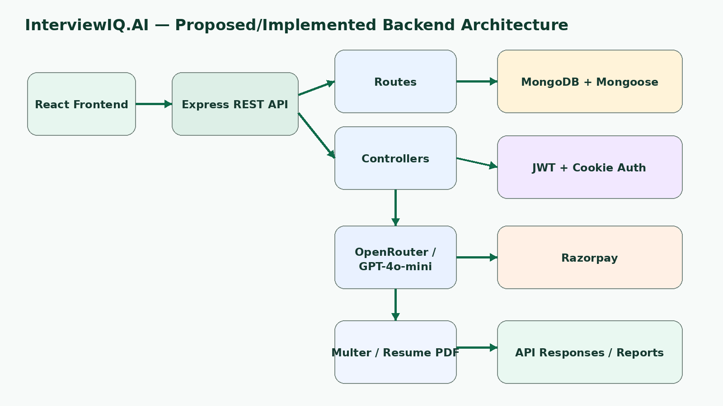
Figure 1. InterviewIQ.AI backend architecture and external service boundaries.
The architecture also supports clear separation of concerns: database operations remain in model/controller logic, JWT verification remains in middleware, AI communication is isolated in openRouter.service.js, and payment provider initialization is isolated in razorpay.service.js.

4. Backend Project Structure
The supplied backend structure is organized as follows:
server/
├── .env
├── .gitignore
├── index.js
├── package.json
├── package-lock.json
├── config/
│ ├── connectDb.js
│ └── token.js
├── controllers/
│ ├── auth.controller.js
│ ├── interview.controller.js
│ ├── payment.controller.js
│ └── user.controller.js
├── middlewares/
│ ├── isAuth.js
│ └── multer.js
├── models/
│ ├── interview.model.js
│ ├── payment.model.js
│ └── user.model.js
├── public/
├── routes/
│ ├── auth.route.js
│ ├── interview.route.js
│ ├── payment.route.js
│ └── user.route.js
└── services/
├── openRouter.service.js
└── razorpay.service.js
Folder/File | Responsibility
index.js | Application entry point; Express setup, middleware, routes and server launch.
config/ | Database connection and JWT token helper configuration.
controllers/ | Business logic for authentication, users, interviews and payments.
middlewares/ | Authentication guard and resume file-upload handling.
models/ | Mongoose schemas/models for persistent application data.
routes/ | HTTP endpoint definitions grouped by feature.
services/ | External integrations for OpenRouter AI and Razorpay.
public/ | Static/temporary assets including the resume upload location.

5. REST API Inventory
The following inventory is based on the supplied backend structure and the endpoints visible in the API verification screenshots. The report intentionally distinguishes verified endpoints from endpoint families inferred from the route/controller structure.
Method | Endpoint | Purpose | Auth | Evidence
POST | /api/auth/google | Authenticate/create Google user and establish JWT cookie | No | Verified: 200 OK
GET | /api/auth/logout | Clear authentication state / logout | Auth context | Verified: 200 OK
GET | /api/user/current-user | Return authenticated user's profile and credits | Yes | Verified: 200 OK
POST | /api/interview/resume | Upload/process a resume for analysis | Yes | Verified: 200 OK
POST | /api/interview/generate-questions | Generate interview questions using role/experience/resume context | Yes | Verified: 200 OK
POST | /api/interview/* | Interview submission/evaluation operations | Yes | Route family present; detailed request contract should follow current route implementation
GET | /api/interview/* | Interview history/report retrieval | Yes | Route family present
POST | /api/payment/order | Create a Razorpay order for a credit plan | Yes | Backend route/service present
POST | /api/payment/verify | Verify payment and apply purchased credits | Yes | Backend route/service present

Note: endpoint paths marked as route families are not represented as invented exact paths in this report. The final submission ZIP/README should be treated as the source of truth for any additional endpoint names.

6. Authentication and Authorization
InterviewIQ.AI uses JWT-based authentication. After Google authentication, the backend creates or retrieves the user and uses a JWT token stored in a cookie. Protected requests pass through isAuth middleware, which reads the token from req.cookies and verifies it using the JWT secret stored in the environment.
const isAuth = async (req, res, next) => {
try {
let { token } = req.cookies;
if (!token) {
return res.status(401).json({
message: "Unauthorized user"
});
}
const verifyToken = jwt.verify(token, process.env.JWT_SECRET);
// authenticated request continues to the protected controller
} catch (error) {
// authentication failure is handled as an unauthorized request
}
};
The middleware centralizes authentication checks instead of duplicating token validation in every protected controller. This makes protected API behavior more consistent and keeps authorization concerns separate from business logic.
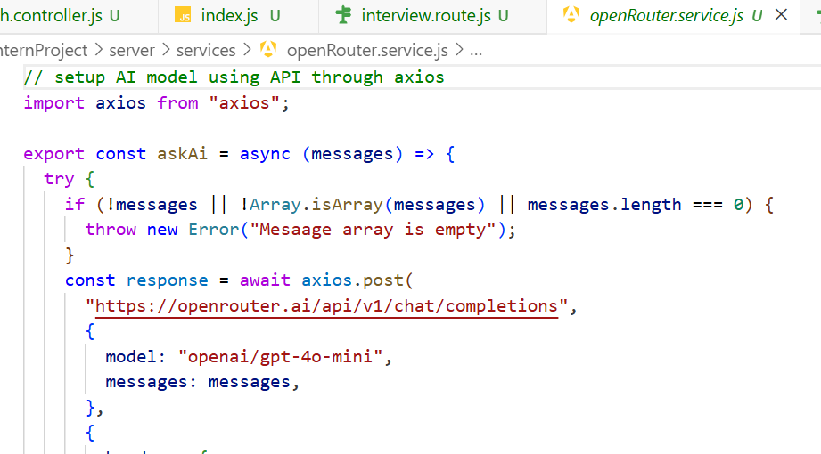
Figure 2. Evidence of JWT cookie verification in the authentication middleware.

7. Authentication API Verification Evidence
The supplied API client screenshot demonstrates a successful POST request to the Google authentication endpoint. The response returned HTTP 200 OK and a success message with user information, confirming that the request reached the backend controller and completed the authentication flow.
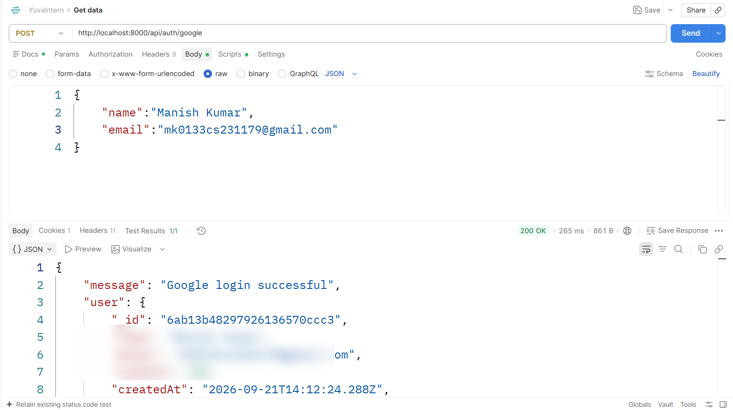
Figure 3. Google authentication endpoint — POST /api/auth/google — HTTP 200 OK.
The logout endpoint was also verified successfully. The backend returned HTTP 200 OK with a logout confirmation message, demonstrating that the logout route is reachable and returns a successful JSON response.
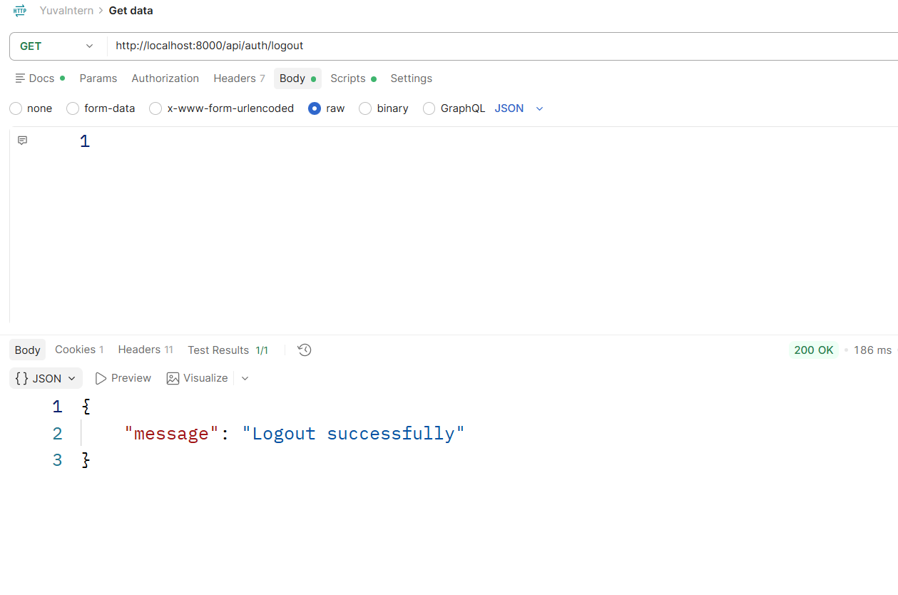
Figure 4. Logout endpoint — GET /api/auth/logout — HTTP 200 OK.

8. User API and Database Interaction
The user module stores the minimum persistent information required by the application: name, unique email and interview credits. Mongoose timestamps automatically maintain createdAt and updatedAt values.
const userSchema = new mongoose.Schema({
name: { type: String, required: true },
email: { type: String, unique: true, required: true },
credits: { type: Number, default: 100 }
}, {
timestamps: true
});
The current-user endpoint is protected and returns the authenticated user's application profile. The supplied API response shows a successful HTTP 200 response with the user record and credit balance.
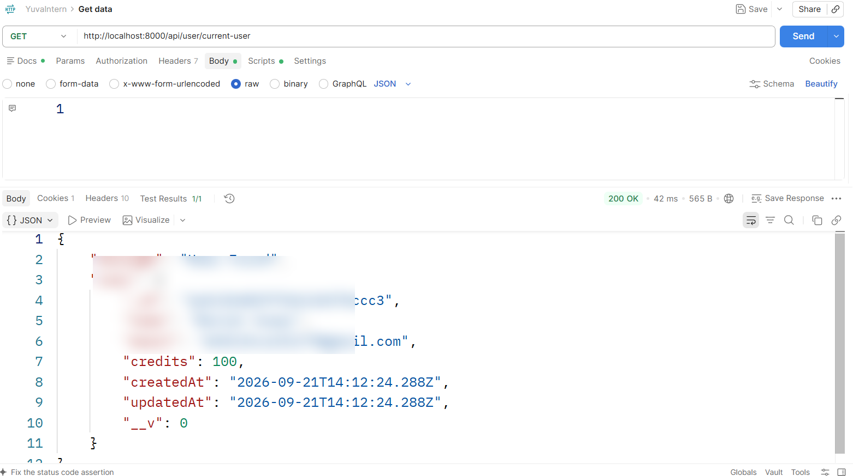
Figure 5. Current-user endpoint — GET /api/user/current-user — HTTP 200 OK.

9. Resume Upload and Analysis API
The interview module accepts a resume through a multipart/form-data request. Multer is used as the file-upload middleware, with the supplied request using a PDF resume under the field name 'resume'. The backend then processes the resume and returns structured information that can be used by the interview-generation workflow.
POST /api/interview/resume
Content-Type: multipart/form-data
Field:
resume = <PDF file>
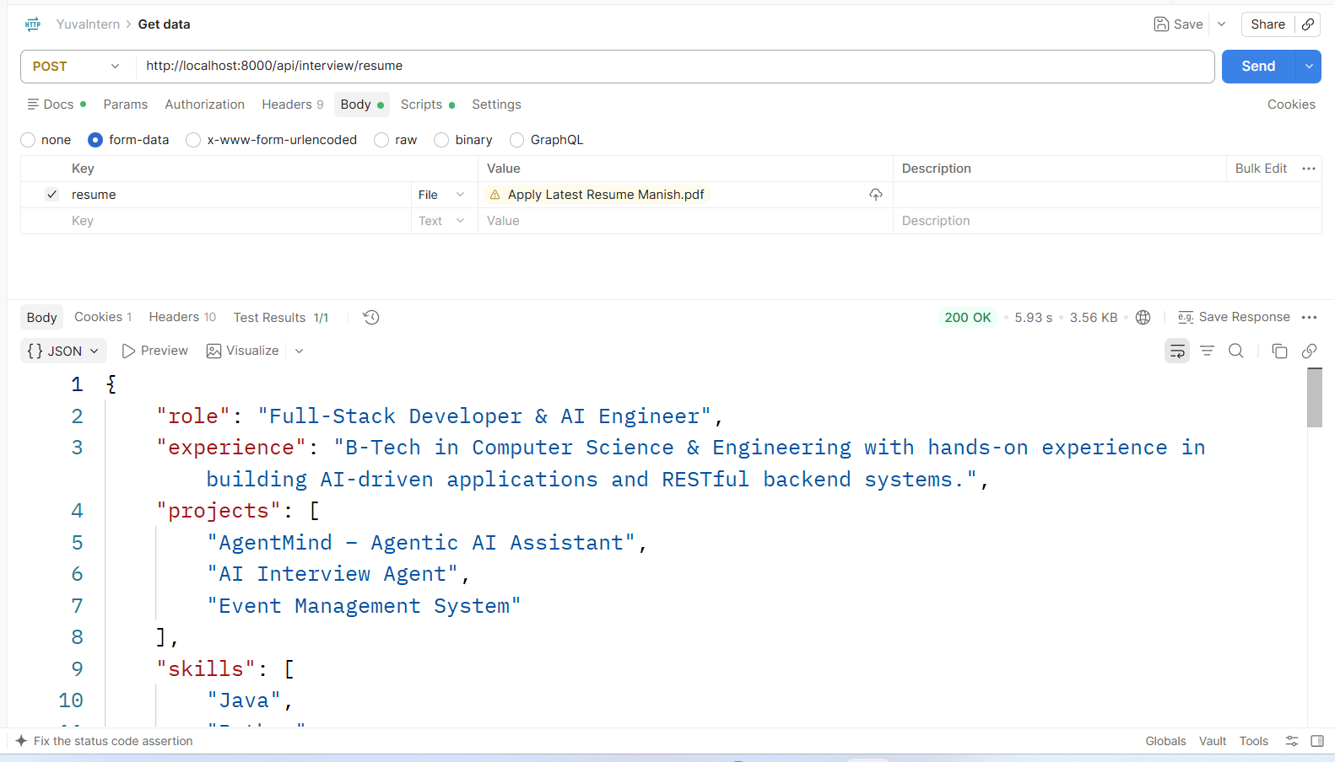
Figure 6. Resume analysis endpoint — multipart/form-data upload — HTTP 200 OK.
The response evidence contains structured fields such as role, experience, projects and skills. This demonstrates a concrete backend capability rather than only a UI placeholder.

10. AI-Powered Interview Question Generation
The AI integration is isolated in services/openRouter.service.js. Axios sends a chat-completion request to OpenRouter, using the configured model name and the supplied message array. The service first validates that a non-empty message array is provided, reducing the chance of sending an invalid request to the external provider.
import axios from "axios";
export const askAi = async (messages) => {
if (!messages || !Array.isArray(messages) || messages.length === 0) {
throw new Error("Message array is empty");
}
const response = await axios.post(
"https://openrouter.ai/api/v1/chat/completions",
{
model: "openai/gpt-4o-mini",
messages: messages,
}
);
return response;
};
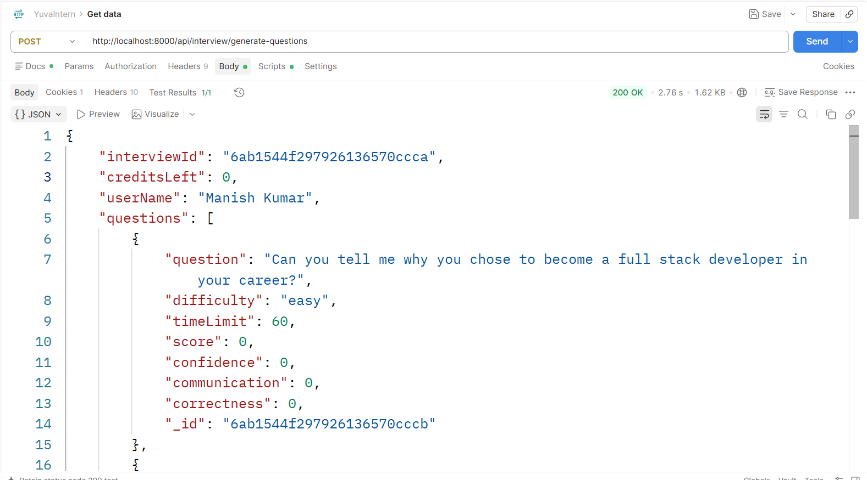
Figure 7. OpenRouter service implementation using Axios and GPT-4o-mini.

11. AI Question Generation API — Verification Evidence
The supplied API evidence shows a POST request to /api/interview/generate-questions returning HTTP 200 OK. The response includes an interviewId, remaining credits, username and an array of generated questions. Each question contains fields such as question text, difficulty, timeLimit, score, confidence, communication and correctness.
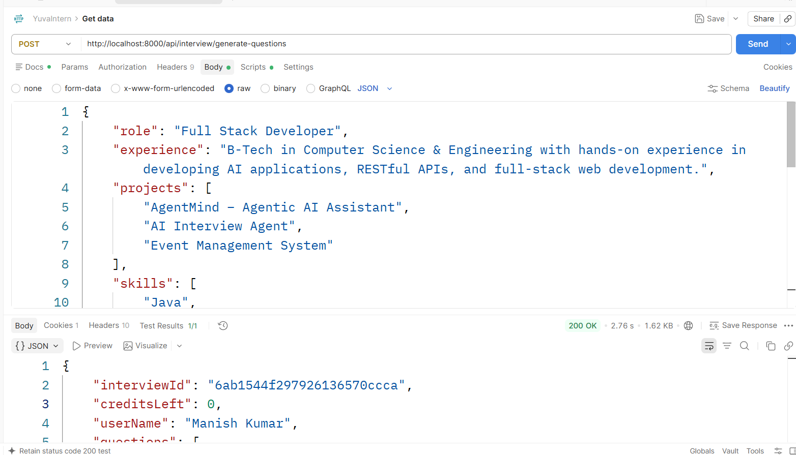
Figure 8. AI question generation endpoint — POST /api/interview/generate-questions — HTTP 200 OK.
This response provides direct evidence that the backend is not simply forwarding static frontend content: it creates an interview record/reference and returns structured question objects suitable for the live interview and later performance evaluation.

12. Database Schema Design

12.1 User Schema
User
├── name: String (required)
├── email: String (required, unique)
├── credits: Number (default: 100)
└── timestamps: createdAt, updatedAt

12.2 Interview Schema
Interview
├── userId: ObjectId → User (required)
├── role: String (required)
├── experience: String (required)
├── mode: "HR" | "Technical" (required)
├── resumeText: String (optional)
├── questions: [Question]
├── finalScore: Number (default: 0)
├── status: "Incompleted" | "completed"
└── timestamps: createdAt, updatedAt

12.3 Question Subdocument
Question
├── question: String
├── difficulty: String
├── timeLimit: Number
├── answer: String
├── feedback: String
├── score: Number
├── confidence: Number
├── communication: Number
└── correctness: Number
Embedding questions inside an interview document keeps the question-level evaluation closely associated with its parent interview. The userId reference creates a relationship between the authenticated user and their interview records.

13. Data Relationships and Persistence Flow
Entity | Relationship | Implementation
User | One user can have multiple interviews | userId reference in Interview
User | One user can have multiple payment records | userId reference in Payment model (as described by backend structure)
Interview | Contains multiple Question subdocuments | questions array embedded in Interview
Interview | Stores aggregate performance | finalScore + status
Question | Stores detailed evaluation | score + confidence + communication + correctness + feedback

Persistence flow:
Authenticated User
↓
Interview request
↓
Interview Controller
↓
Mongoose Interview Model
↓
MongoDB
↓
Interview ID / structured response
↓
Frontend interview/report experience
The model design supports the product workflow from interview creation to question-by-question evaluation and final performance reporting.

14. Payment and Credit Management Integration
The backend contains a dedicated payment controller, payment route and Razorpay service. The frontend pricing flow uses credit-based plans, while the backend provides endpoints for creating a Razorpay order and verifying payment.
Component | Role
Payment controller | Creates payment orders and verifies payment results.
Payment model | Stores payment history/transaction information.
Razorpay service | Initializes the Razorpay integration separately from controllers.
Credit model behavior | User credits are represented in the User schema and are used by interview generation.

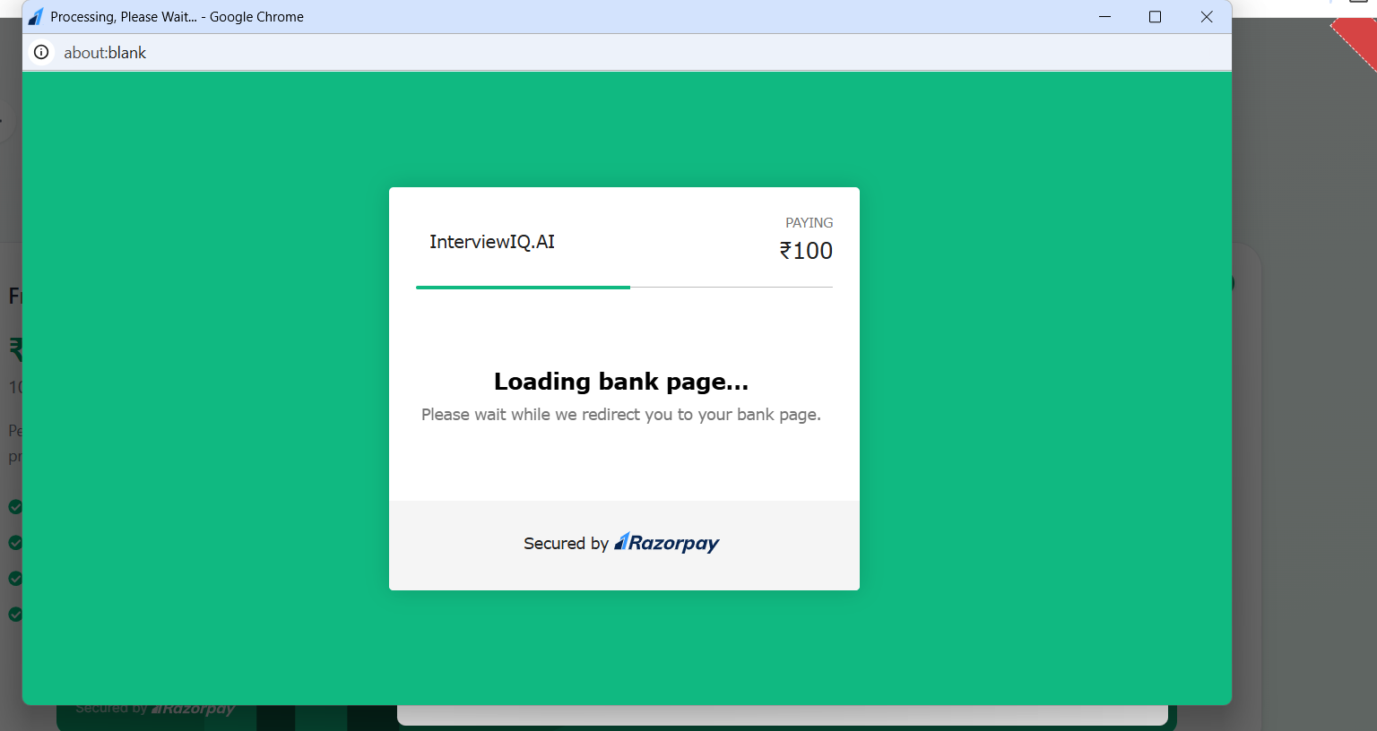
Figure 9. InterviewIQ.AI pricing/credit interface connected to the backend payment flow.
A successful Razorpay payment screen was also supplied as project evidence. For the report, payment identifiers are treated as transactional evidence only; sensitive payment/account details should not be exposed in the source repository or documentation.

15. Security and Backend Best Practices
Practice | Implementation Evidence
JWT secret protection | JWT_SECRET is read from process.env rather than hard-coded in the authentication middleware.
Cookie-based authentication | The authentication middleware reads the JWT from the request cookie before allowing protected operations.
Centralized auth guard | isAuth.js provides one reusable authentication gate for protected routes.
Environment-based secrets | Database, AI and payment credentials are intended to be supplied through environment variables.
File upload isolation | Multer handles resume uploads through a dedicated middleware instead of mixing file parsing into every controller.
External service isolation | OpenRouter and Razorpay integrations are placed under services/ to separate provider-specific code from route definitions.
Schema constraints | Required fields, unique email and interview-mode/status enums provide database-level consistency.
Minimal user model | The User schema stores only application-specific fields such as name, email and credits.

Security note: the final GitHub repository should never contain the actual .env file, API keys, JWT secrets or payment secrets. A sanitized .env.example should be used for documentation and setup.

16. Error Handling and Validation Approach
The backend follows a JSON API response pattern and uses HTTP status codes to distinguish successful requests from authentication or processing failures. The supplied isAuth middleware explicitly returns HTTP 401 when the JWT cookie is absent or invalid.
if (!token) {
return res.status(401).json({
message: "Unauthorized user"
});
}
const verifyToken = jwt.verify(
token,
process.env.JWT_SECRET
);
The data models also provide schema-level validation. For example, User.name and User.email are required, User.email is unique, Interview.userId/role/experience/mode are required, and Interview.mode/status use controlled enum values. The AI service checks that its message input is a non-empty array before making the external request.
- Authentication failure → HTTP 401 with a JSON message.
- Missing AI message array → service-level validation error before external API call.
- Required Mongoose fields → schema validation protects incomplete records.
- Enum fields → restrict interview mode and status to known values.

17. Detailed API Documentation

17.1 Google Authentication
POST /api/auth/google
Content-Type: application/json
{
"name": "Example User",
"email": "example@email.com"
}
Expected successful behavior: HTTP 200 response with a success message and user information; authentication state is established through the backend cookie flow.

17.2 Logout
GET /api/auth/logout
Expected successful behavior: HTTP 200 response confirming logout and clearing the authentication state.

17.3 Current User
GET /api/user/current-user
Cookie: <JWT authentication cookie>
Expected successful behavior: HTTP 200 response containing the authenticated user's profile and credits.

17.4 Resume Analysis
POST /api/interview/resume
Content-Type: multipart/form-data
resume = <PDF file>
Expected successful behavior: structured resume information such as role, experience, projects and skills.

17.5 Generate Questions
POST /api/interview/generate-questions
Content-Type: application/json
{
"role": "Full Stack Developer",
"experience": "B-Tech in Computer Science & Engineering...",
"projects": ["Project A", "Project B"],
"skills": ["React", "Node.js", "MongoDB"]
}
Expected successful behavior: HTTP 200 response containing interviewId, remaining credits, userName and generated question objects.

17.6 Payment APIs
POST /api/payment/order
POST /api/payment/verify
These endpoints support the credit-purchase workflow. Exact request fields should be taken from the current payment controller/route implementation when the backend README is finalized.

18. API Verification Summary
API / Flow | Observed Result | Evidence | Status
POST /api/auth/google | 200 OK | Successful Google login response with user data | Verified
GET /api/auth/logout | 200 OK | Logout successfully confirmed | Verified
GET /api/user/current-user | 200 OK | Authenticated user and credits returned | Verified
POST /api/interview/resume | 200 OK | Resume data returned as structured fields | Verified
POST /api/interview/generate-questions | 200 OK | Interview ID and generated questions returned | Verified
Razorpay payment flow | Success screen supplied | Payment UI confirms successful transaction flow | Evidence supplied

These are functional verification observations from the supplied API-client and application screenshots. They should not be interpreted as a complete automated test suite. Detailed regression, edge-case and debugging coverage can be expanded in the later testing/debugging task.

19. Development Challenges and Solutions
Challenge | Problem | Solution | Result
Keeping authentication reusable across protected APIs | Repeating token verification in every controller would make authentication inconsistent and harder to maintain. | Created isAuth middleware to read the JWT cookie, verify it using JWT_SECRET and stop unauthorized requests with HTTP 401. | Protected API logic can remain focused on business functionality.
Connecting AI generation to application data | Interview questions must reflect role, experience and resume-derived information rather than being hard-coded in the frontend. | Introduced openRouter.service.js and sent structured messages to OpenRouter through Axios using the configured GPT-4o-mini model. | The question-generation endpoint returns structured question objects and an interview ID.
Handling resume input | Resume files need multipart handling before analysis. | Introduced Multer middleware and a dedicated resume upload field. | The resume endpoint can receive a PDF and return structured extracted information.
Maintaining interview evaluation data | The platform needs to preserve question text, answers, feedback and multiple performance dimensions. | Embedded a questions subdocument schema inside Interview with score, confidence, communication and correctness fields. | A single interview document can retain both question-level and final performance information.
Separating external integrations | AI and payment providers have different SDK/API requirements and should not be tightly coupled to route definitions. | Placed OpenRouter and Razorpay integrations in services/. | Provider-specific code is isolated and easier to maintain or replace.
Managing application credits | Interview generation and paid plans depend on a user credit balance. | Stored credits in the User schema and connected interview/payment workflows to the credit concept. | The application can represent free and purchased interview capacity.

This section is intentionally concrete: each challenge is tied to an actual file/module or data field visible in the supplied project information rather than generic statements about backend development.

20. Code Quality and Maintainability
- Feature-based route separation keeps authentication, users, interviews and payments independently organized.
- Controllers centralize business logic and keep route declarations concise.
- Mongoose models define data rules close to persistence operations.
- Middleware isolates cross-cutting concerns such as authentication and file uploads.
- Service modules isolate OpenRouter and Razorpay integrations.
- Environment variables are used for secrets and provider configuration.
- The package-lock file provides reproducible dependency resolution.
Recommended maintainability improvements for subsequent iterations:
- Add a dedicated centralized error-handling middleware with consistent error codes.
- Add request validation using a schema-validation library for complex JSON payloads.
- Add automated unit/integration tests for controllers and protected routes.
- Add rate limiting and request-size restrictions to public/authentication endpoints.
- Move temporary resume processing to a controlled storage lifecycle and delete files after processing when no longer needed.

21. End-to-End Backend Flow
1. User signs in through Google
↓
2. POST /api/auth/google
↓
3. User is created/retrieved in MongoDB
↓
4. JWT is established in the authentication cookie
↓
5. GET /api/user/current-user
↓
6. User selects role, experience and interview mode
↓
7. Optional POST /api/interview/resume
↓
8. POST /api/interview/generate-questions
↓
9. Controller calls OpenRouter service
↓
10. Interview + question data is stored/returned
↓
11. Frontend conducts interview and submits answers
↓
12. Backend evaluation/report operations update interview data
↓
13. User can retrieve history/report information
↓
14. Optional payment flow adds interview credits
This flow connects the supplied API evidence with the project's database models and service modules, demonstrating how the backend supports the complete application lifecycle.

22. Evaluation Criteria Mapping
Evaluation Area | Evidence in Report
Code quality | Modular folders for routes/controllers/models/middleware/services; clear separation of concerns.
API correctness | Core supplied API evidence shows HTTP 200 responses for authentication, user, resume and question-generation flows.
API completeness | Feature groups cover authentication, user data, interviews, resume processing and payments.
API documentation | Endpoint inventory, request examples, response expectations and authentication requirements are included.
Database design | Mongoose schemas for User and Interview define required fields, relationships, enums and timestamps.
Error handling | JWT middleware returns 401 for missing/invalid authentication; AI service validates input before external calls.
Security | JWT verification, environment secrets, authentication middleware and isolated provider services are used.
Practical backend experience | Actual Express controllers, Mongoose models, file uploads, AI integration and Razorpay integration are documented.
Evidence | API-client screenshots, code screenshots, architecture diagram and application/payment evidence are embedded.
Testing/verification | Core endpoints were verified through an HTTP client; comprehensive automated debugging is intentionally separated from this Week 3 scope.

23. Backend Setup and README Content
The Week 3 ZIP should contain the backend source and a README that allows an evaluator to understand and run the project. The README should document prerequisites, installation, environment variables, database setup, server startup and endpoint groups.
# Install dependencies
npm install
# Start the backend in development mode
npm run dev
# or use the project's configured start command
npm start
Suggested .env.example:
MONGODB_URI=your_mongodb_connection_string
JWT_SECRET=your_jwt_secret
OPENROUTER_API_KEY=your_openrouter_key
RAZORPAY_KEY_ID=your_razorpay_key_id
RAZORPAY_KEY_SECRET=your_razorpay_secret
Actual script names should match package.json in the submitted backend. The real .env file must not be committed. The GitHub repository should contain only safe placeholders in .env.example.
Backend GitHub repository: InterviewIQ-Yuva-Internship / server

24. Evidence Index
Figure | Evidence | Purpose
Figure 1 | Backend architecture diagram | Architecture section
Figure 2 | JWT authentication middleware | Authentication/security section
Figure 3 | Google authentication API — 200 OK | Authentication verification
Figure 4 | Logout API — 200 OK | Authentication verification
Figure 5 | Current-user API — 200 OK | User/database interaction
Figure 6 | Resume upload/analysis API — 200 OK | Resume processing
Figure 7 | OpenRouter service implementation | AI integration
Figure 8 | AI question generation API — 200 OK | AI verification
Figure 9 | Pricing/payment application evidence | Payment integration

The evidence index is included so an evaluator can quickly locate concrete proof for the claims made in the report.

25. Conclusion
The Week 3 backend implementation establishes the server-side foundation required by InterviewIQ.AI. The completed work connects a React client to RESTful Express APIs, MongoDB persistence, JWT authentication, resume processing, AI question generation and payment services. The modular project structure separates routes, controllers, models, middleware and third-party services, improving maintainability and making the application easier to extend.
The strongest evidence of implementation is provided by the supplied API verification screenshots: Google authentication, logout, current-user retrieval, resume analysis and AI question generation all returned successful HTTP 200 responses. The database schemas further demonstrate how users, interviews, questions, scores and credits are represented persistently.
The report deliberately separates Week 3 backend/API verification from the later detailed testing and debugging phase. This keeps the submission aligned with the task while still providing concrete evidence that the core APIs and integrations were executed successfully.
For the next development phase, the project can be strengthened with a centralized error handler, formal request validation, automated controller/integration tests, rate limiting, structured logging and a more formal API specification such as OpenAPI/Swagger.
— End of Week 3 Report —

