SQL Files Development Automation Tool

Steps:

1. Download excel from GitHub repository which has mentioned in the link. Add Db objects details as mentioned in excel based on headers. Make sure that basic fields should not empty cells except default values, PK,FK fields

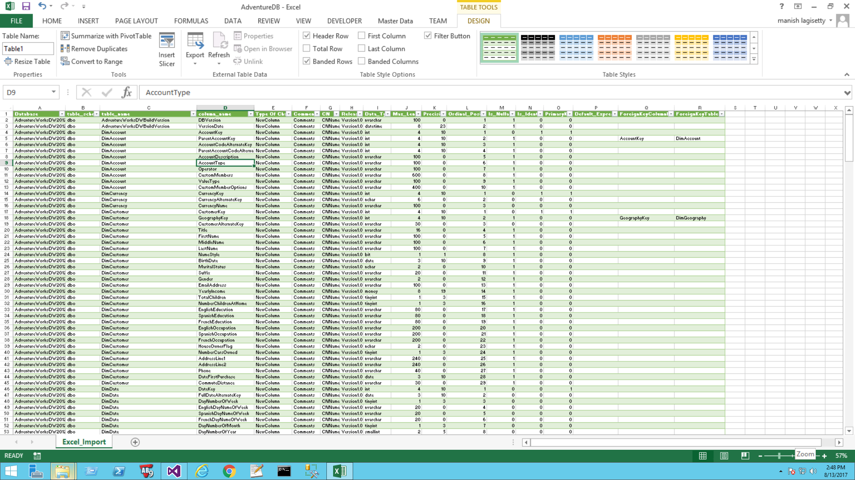

1. Open the configuration sheet from **sql automation tool** folder go to **ConfigFiles** folder, add all necessary details, which need to perform the operation on desire output.

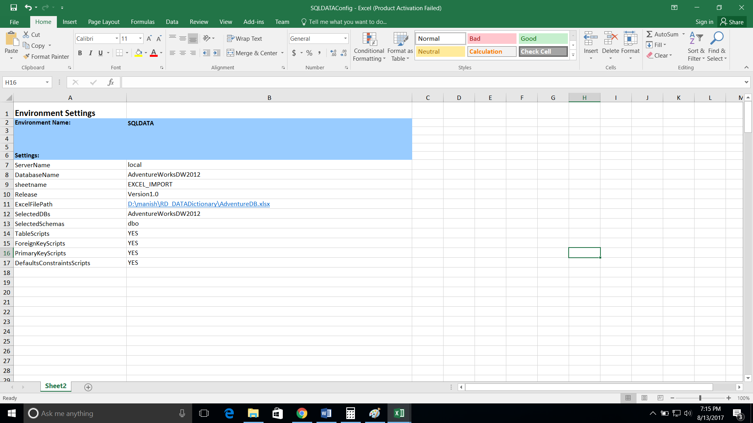

1. Go to automation project folder, right click the **Invoke-localization.ps1** file, and run with PowerShell ISE mode.

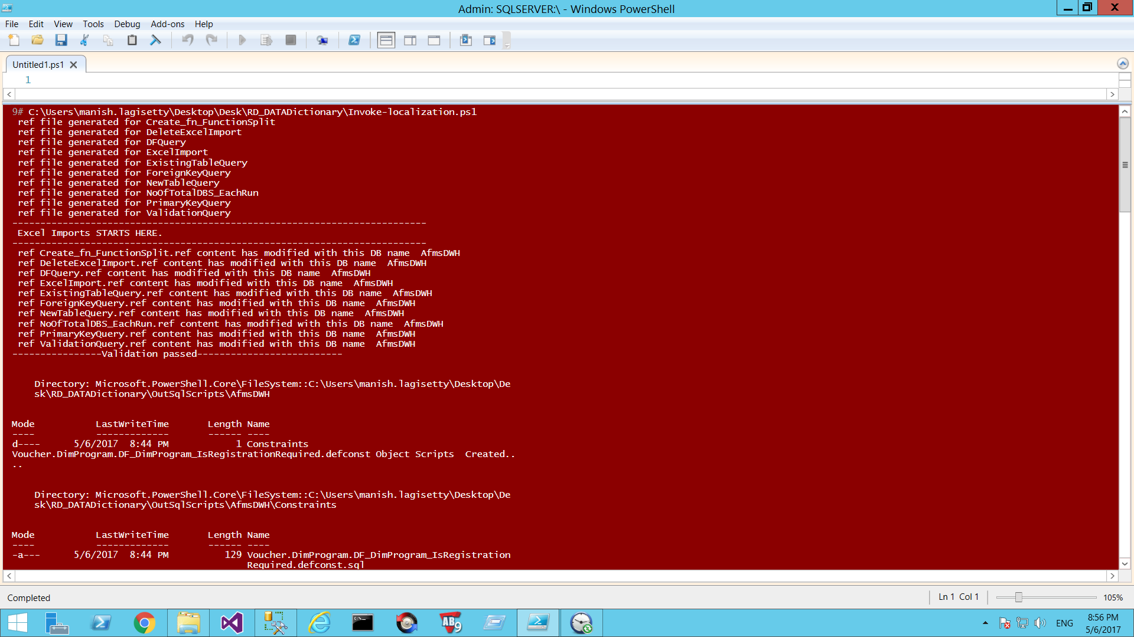

1. Automatically it will create all DB objects based on Input in the config sheet.

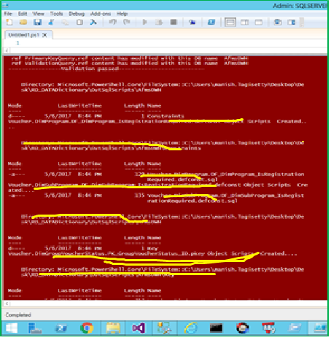

1. Go to **EventLogs** folder and check if any errors are present

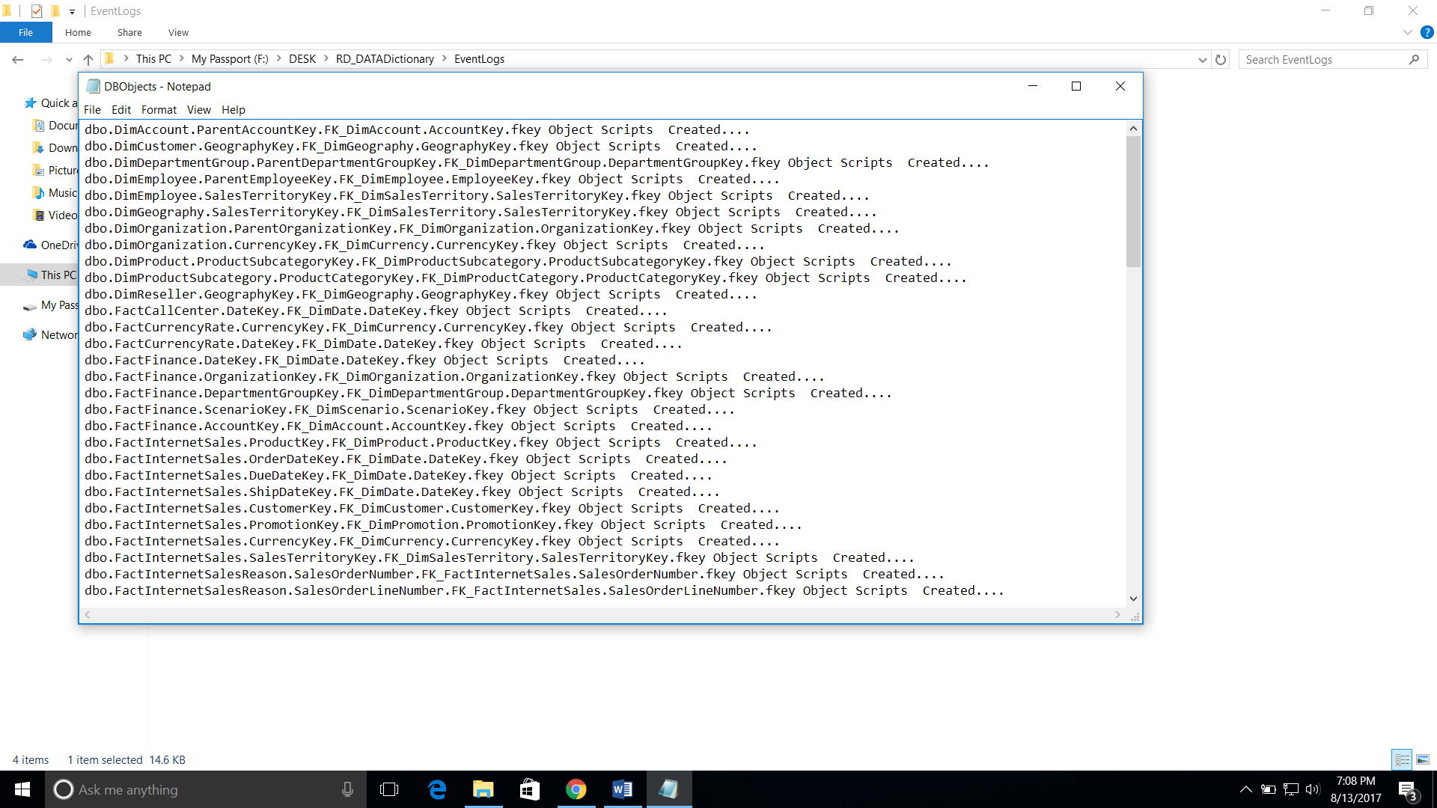

1. Go to **OutSqlScripts** folder and check folder structure will be appear as per database wise, it is based on selected Database which will be present in config sheet.

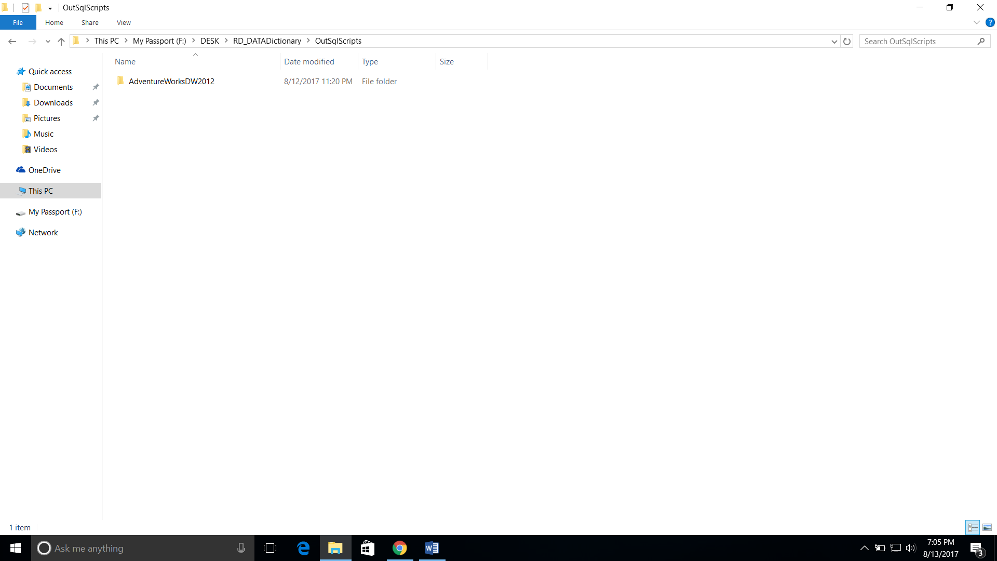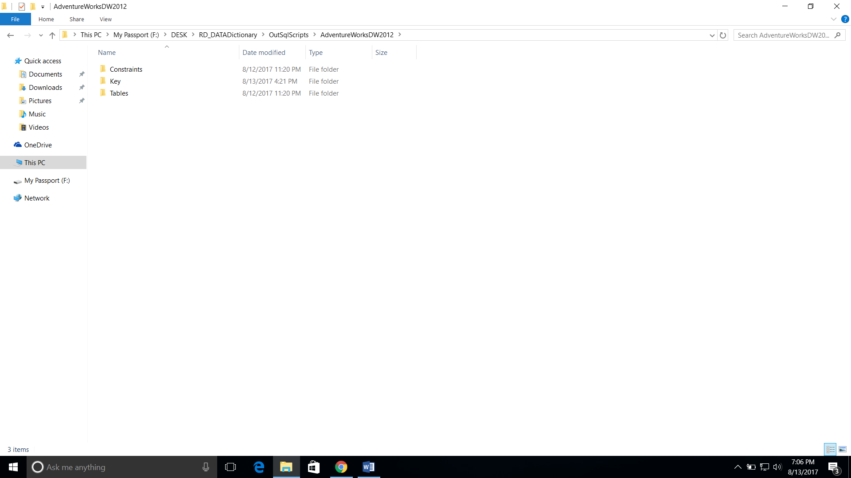

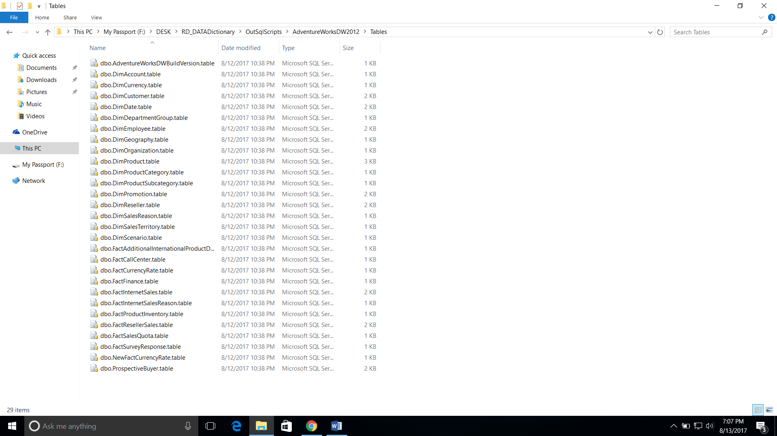

1. Place these DB objects directly into the respective TFS DB solution project.

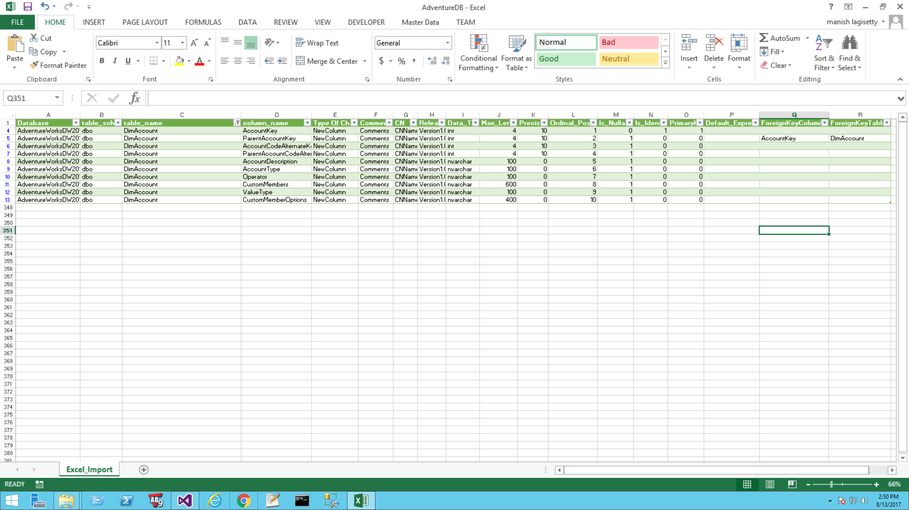

(Text 🡪 Code)

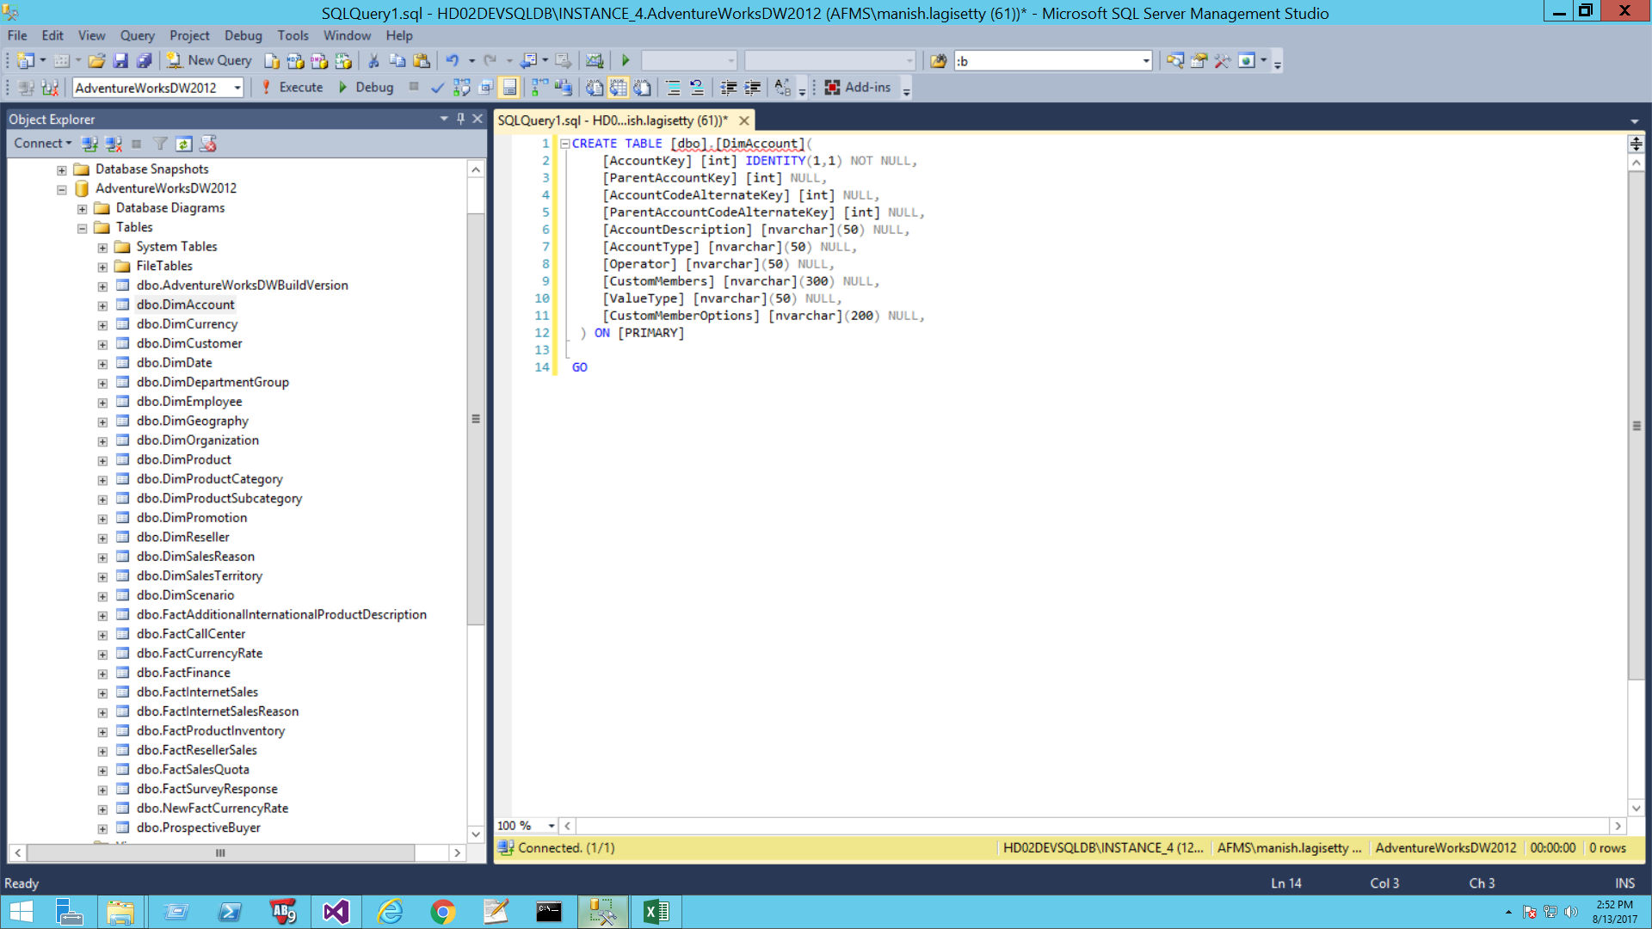

From this tool, below are the statistics.

|  |  |
| --- | --- |
| Total no of Files | =100 |
| Total Execution of time | 40Sec |
|  |  |

For manual effort will be like this.

Total files = 100

Each file will be take on average of 20min including verification (testing). So total would be 100*20min = 33.30 Hrs.

This tools will be doing including end-to-end testing based on input from the excel sheet.

|  |
| --- |
| 33.30hrs 40 Secs |