Table of Contents
Developer Documentation — Solventek Silverwind 2
1. System Architecture 2
1.1 High-Level Overview 2
1.2 Technology Stack 2
2. Backend Package Structure 3
3. Key Design Patterns 6
3.1 BaseEntity 6
3.2 Uniform API Response 6
3.3 RBAC Architecture 6
3.4 Storage Abstraction 6
4. AI/Chat Subsystem Deep Dive 6
4.1 Intent Classification Flow 6
4.2 RAG Pipeline (Policy Intent) 7
4.3 Function Calling (Action Intent) 7
4.4 ToolRegistry Methods Summary 7
5. Security Configuration 7
5.1 Filter Chain 7
5.2 JWT Flow 8
6. Frontend Architecture 8
6.1 Module Structure 8
6.2 AuthStore (Signal-Based State) 9
6.3 Route-Level Access Control 9
6.4 Key Frontend Routes 9
7. Data Seeding 11
8. Environment Setup 11
8.1 Backend 11
8.2 Frontend 11
8.3 Configuration Properties 11
9. API Endpoint Summary 11

Developer Documentation — Solventek Silverwind
Version: 2.0 | Date: 2026-02-17

1. System Architecture

1.1 High-Level Overview
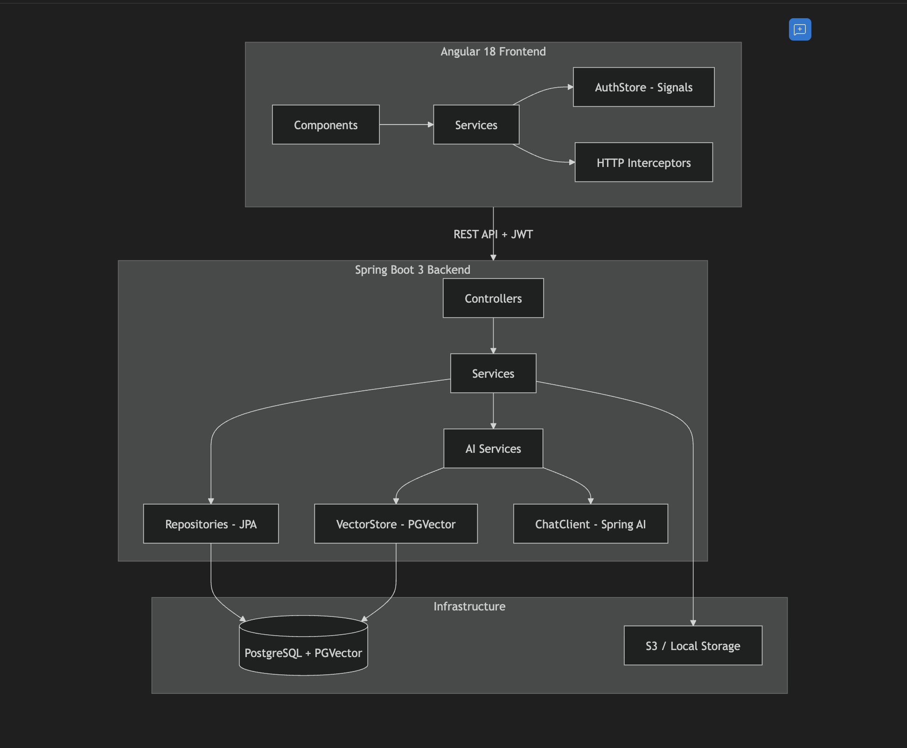

1.2 Technology Stack
Layer | Technology | Details
Backend Framework | Spring Boot 3.x | Java 17+, Spring Security, Spring AI
ORM | Spring Data JPA + Hibernate | UUID primary keys, BaseEntity auditing
Database | PostgreSQL + PGVector | Vector similarity search for AI
Auth | JWT + BCrypt | Stateless, method-level @PreAuthorize
AI/ML | Spring AI | ChatClient, VectorStore, Function Calling
Frontend | Angular 18 | Standalone components, Signals-based store
Build | Maven (Backend) / Angular CLI (Frontend)

2. Backend Package Structure
com.solventek.silverwind/
├── SilverwindApplication.java # Main entry point
├── ai/ # AI services (enrich, ingest, match)
│ ├── AiController.java
│ └── AiService.java
├── applications/ # Job applications
│ ├── ApplicationController.java # 9 endpoints
│ ├── ApplicationService.java
│ ├── JobApplication.java # Entity
│ ├── JobApplicationRepository.java
│ ├── ApplicationStatus.java # Enum
│ ├── ApplicationDocuments.java # Entity
│ ├── ApplicationDocumentsRepository.java
│ ├── ResumeAnalysis.java # Entity
│ ├── ResumeAnalysisRepository.java
│ ├── ResumeAnalysisOrchestratorService.java
│ ├── ResumeIngestionService.java
│ ├── HiringRubricService.java
│ └── dtos/AnalysisResultDTO.java
├── auth/ # Authentication & employees
│ ├── AuthController.java # Login, register, me
│ ├── AuthResponse.java # DTO
│ ├── Employee.java # Entity (175 lines)
│ ├── EmployeeController.java # 15 endpoints
│ ├── EmployeeService.java
│ ├── EmployeeRepository.java
│ ├── EmployeeDto.java
│ ├── dto/
│ │ ├── EmployeeResponse.java
│ │ ├── EmployeeMapper.java
│ │ ├── BankDetailsDto.java
│ │ ├── ManagerSummary.java
│ │ ├── OrganizationDto.java
│ │ └── RoleDto.java
│ └── embeddable/
│ ├── Address.java
│ ├── BankDetails.java
│ └── EmergencyContact.java
├── chat/ # AI Chatbot
│ ├── ChatController.java # chat, clear-history
│ ├── AiOrchestratorService.java # Intent routing
│ ├── RagService.java # Hybrid RAG search
│ ├── ToolRegistry.java # 12 @Tool methods
│ ├── TableGenerator.java # Markdown table formatting
│ └── VectorStoreConfig.java
├── client/ # CRM clients
│ ├── Client.java, ClientController.java, ClientService.java, ClientRepository.java
│ └── submission/
│ ├── ClientSubmission.java
│ ├── ClientSubmissionController.java # 6 endpoints
│ ├── ClientSubmissionService.java
│ ├── ClientSubmissionComment.java
│ ├── ClientSubmissionCommentRepository.java
│ ├── ClientSubmissionRepository.java
│ └── ClientSubmissionStatus.java # Enum
├── common/ # Shared utilities
│ ├── ApiResponse.java # Uniform { success, message, data }
│ ├── ApiErrorResponse.java
│ ├── BaseEntity.java # id(UUID), createdAt, updatedAt, createdBy, updatedBy
│ ├── FileController.java # Public file access
│ └── GlobalExceptionHandler.java
├── config/
│ ├── SecurityConfig.java # Filter chain, CORS, public paths
│ ├── DataSeeder.java # Seeds org + super admin
│ ├── AsyncConfig.java
│ ├── JacksonConfig.java
│ ├── JwtProperties.java
│ ├── AwsProperties.java
│ └── StorageProperties.java
├── enums/
│ ├── AssetAssignmentStatus.java
│ ├── AssetCondition.java
│ ├── EmploymentStatus.java
│ ├── EmploymentType.java
│ └── Gender.java
├── feature/
│ ├── leave/
│ │ ├── controller/
│ │ │ ├── LeaveConfigController.java # 3 endpoints
│ │ │ └── LeaveOperationController.java # 8 endpoints
│ │ ├── dto/ (LeaveActionDTO, LeaveBalanceDTO, LeaveRequestDTO, LeaveResponseDTO, LeaveTypeDTO)
│ │ ├── entity/ (LeaveBalance, LeaveRequest, LeaveStatus, LeaveType, AccrualFrequency)
│ │ ├── repository/ (LeaveBalanceRepository, LeaveRequestRepository, LeaveTypeRepository)
│ │ └── service/ (LeaveConfigurationService, LeaveOperationService)
│ └── profile/
│ ├── controller/ProfileController.java # 16 endpoints
│ ├── entity/ (Certification, Document, Education, Skill, WorkExperience)
│ ├── repository/ (5 repositories)
│ └── service/ProfileService.java
├── interviews/
│ └── InterviewController.java # 3 endpoints
├── jobs/
│ ├── Job.java, JobController.java (10 endpoints), JobRepository.java
├── notifications/
│ └── NotificationController.java # 8 endpoints
├── onboarding/
│ └── OnboardingController.java # 4 endpoints
├── org/
│ ├── Organization.java, OrganizationController.java (9 endpoints)
│ ├── OrganizationService.java (505 lines)
│ ├── OrganizationRepository.java
│ ├── OrganizationType.java, OrganizationStatus.java
│ ├── AttendanceController.java # 12 endpoints
│ ├── PayrollController.java # 13 endpoints
│ └── AssetController.java # 11 endpoints
├── projects/
│ └── ProjectController.java # 10 endpoints
├── rbac/
│ ├── Role.java, RoleRepository.java, RbacService.java
│ └── RoleDefinitions.java # Role constants
├── recruitment/
│ └── CandidateController.java # 7 endpoints
├── security/
│ ├── CustomUserDetailsService.java
│ ├── JwtAuthenticationFilter.java
│ ├── JwtTokenProvider.java
│ └── UserPrincipal.java
├── storage/
│ ├── StorageService.java # Interface
│ ├── LocalStorageService.java
│ └── S3StorageService.java
├── ticket/
│ └── TicketController.java # 9 endpoints
├── timeline/
│ ├── TimelineController.java # 5 endpoints
│ ├── TimelineEvent.java, TimelineRepository.java, TimelineService.java
└── tracking/
└── TrackingController.java # 4 endpoints (public)
Total: 119 Java files | ~150+ REST API endpoints

3. Key Design Patterns

3.1 BaseEntity
All entities extend BaseEntity:
@MappedSuperclass
public abstract class BaseEntity {
@Id @GeneratedValue private UUID id;
private Instant createdAt;
private Instant updatedAt;
private String createdBy;
private String updatedBy;
}

3.2 Uniform API Response
public class ApiResponse<T> {
boolean success;
String message;
T data;
String errorCode;
// Factory: ApiResponse.success(data), ApiResponse.error(code, msg)
}

3.3 RBAC Architecture
- Roles are org-scoped: each org has its own Role entities (initialized by RbacService.initializeOrgRoles())
- Method-level: @PreAuthorize("hasAnyRole('SUPER_ADMIN', 'HR_ADMIN')") on every endpoint
- Frontend guard: roleGuard checks data.roles[] and data.orgTypes[] on routes

3.4 Storage Abstraction
interface StorageService {
String upload(MultipartFile file, String path);
Resource download(String path);
void delete(String path);
}
// Two implementations: LocalStorageService (dev), S3StorageService (prod)

4. AI/Chat Subsystem Deep Dive

4.1 Intent Classification Flow
Message received → AiOrchestratorService.handleRequest()
1. Check explicitIntent from frontend → use directly if provided
2. Check ragService.hasMatches(message) → POLICY if matches found
3. Default → ACTION

4.2 RAG Pipeline (Policy Intent)
Question → Vector Similarity Search (top-K)
→ Keyword Search (ts_rank via native SQL)
→ Merge + De-duplicate by chunk ID
→ Re-rank with literalOverlapBonus()
→ Top chunks as context → ChatClient prompt
→ LLM response with citations

4.3 Function Calling (Action Intent)
Message → Build system prompt (with today's date, userId, history)
→ ChatClient with ToolRegistry
→ Spring AI discovers @Tool methods
→ LLM decides which tool(s) to call
→ Tool executes against real services/repositories
→ Response returned to user

4.4 ToolRegistry Methods Summary
Tool | Repositories Used
getMyProfile | EmployeeRepository
getLeaveBalance | LeaveBalanceRepository
getMyLeaves | LeaveRequestRepository
applyForLeave | LeaveOperationService
getAttendanceSummary | AttendanceRepository
getUpcomingHolidays | HolidayRepository
getMyPayslips | PayrollRepository
getMyTickets | TicketRepository
createTicket | TicketService
getMyProjects | ProjectRepository
getAllProjects | ProjectRepository

5. Security Configuration

5.1 Filter Chain
http.csrf(disable)
.cors(corsConfigurationSource())
.authorizeHttpRequests(auth -> auth
.requestMatchers("/api/auth/**", "/swagger-ui/**",
"/v3/api-docs/**", "/api/public/**",
"/actuator/**", "/api/files/**",
"/api/tracking/**").permitAll()
.requestMatchers(GET, "/api/organizations/*/logo").permitAll()
.anyRequest().authenticated())
.sessionManagement(STATELESS)
.addFilterBefore(jwtAuthenticationFilter, UsernamePasswordAuthenticationFilter)

5.2 JWT Flow
Login → JwtTokenProvider.generateToken(UserPrincipal) → accessToken + refreshToken
Request → JwtAuthenticationFilter extracts Bearer token
→ JwtTokenProvider.validateToken()
→ CustomUserDetailsService.loadUserByUsername()
→ SecurityContext populated

6. Frontend Architecture

6.1 Module Structure
silverwind-frontend/src/app/
├── app.routes.ts # 30+ routes with role/orgType guards
├── core/
│ ├── guards/
│ │ ├── auth.guard.ts # Checks isAuthenticated
│ │ └── role.guard.ts # Checks route data.roles + data.orgTypes
│ ├── interceptors/
│ │ ├── auth.interceptor.ts # Attaches Bearer token
│ │ ├── error.interceptor.ts # Handles HTTP errors
│ │ ├── loading.interceptor.ts # Sets loading state
│ │ ├── success.interceptor.ts # Handles success responses
│ │ └── unauthorized.interceptor.ts # 401 → logout
│ ├── models/ (15 model files)
│ ├── services/ (25+ service files)
│ └── stores/
│ └── auth.store.ts # Signal-based state management
├── features/
│ ├── admin/ # User management, role simulation
│ ├── applications/ # Application list, detail, vendor view, tracking
│ ├── assets/ # Asset list (admin), my-assets (employee)
│ ├── attendance/ # Attendance management (admin), my-attendance
│ ├── auth/ # Login page
│ ├── candidates/ # Candidate list, detail
│ ├── clients/ # Client list, detail, submissions
│ ├── dashboard/ # Role-based dashboard
│ ├── holidays/ # Holiday list
│ ├── jobs/ # Job list, detail, create/edit
│ ├── leave/ # My leaves, leave management, leave configuration
│ ├── notifications/ # Notification center
│ ├── organization/ # My organization view
│ ├── payroll/ # Payroll management (admin), my payslips
│ ├── portal/ # Ticket management (list, detail, create)
│ ├── projects/ # Project list, detail
│ └── vendors/ # Vendor list, vendor detail
├── layout/ # Main layout (sidebar + header + content)
├── public/ # Public pages (login, vendor registration, VMS)
└── shared/
├── chatbot/ # AI chatbot widget
└── components/ # Reusable UI components

6.2 AuthStore (Signal-Based State)
// State: user, accessToken, refreshToken, isAuthenticated, isLoading, error
// Computed: actualRole, userRole (supports view-role simulation), orgType, organizationId
// Methods: login(), updateUser(), setViewRole(), logout()
// Storage: sessionStorage (access_token, refresh_token, user JSON)
// Role Helpers: isSuperAdmin(), isHRAdmin(), isTA(), isEmployee(), isVendor(), isAdmin()

6.3 Route-Level Access Control
Every authenticated route specifies:
{
path: 'admin/payroll',
loadComponent: () => import('...'),
canActivate: [roleGuard],
data: {
roles: ['SUPER_ADMIN', 'HR_ADMIN'], // Allowed roles
orgTypes: ['SOLVENTEK'], // Allowed org types
}
}

6.4 Key Frontend Routes
Path | Component | Roles | Org Type
/dashboard | RoleDashboardComponent | All | All
/profile | UserDetailsComponent | All | All
/notifications | NotificationsComponent | All | All
/vendors | VendorListComponent | SUPER_ADMIN | SOLVENTEK
/jobs | JobRoutes (lazy) | SA, TA, EMP, VENDOR | All
/applications | ApplicationListComponent | SA, HR, TA, VENDOR | All
/applications/:id | ApplicationDetailComponent | SA, HR, TA, VENDOR | All
/vendor-applications | VendorApplicationListComponent | VENDOR | VENDOR
/candidates | CandidateRoutes (lazy) | SA, TA, VENDOR | All
/admin | AdminRoutes (lazy) | SA, HR | SOLVENTEK
/organization | OrganizationRoutes (lazy) | All | All
/projects | ProjectRoutes (lazy) | SA, TA | SOLVENTEK
/clients | ClientRoutes (lazy) | SA, TA | SOLVENTEK
/portal/tickets | TicketListComponent | SA, HR, TA, EMP | SOLVENTEK
/holidays | HolidayListComponent | SA, HR, TA, EMP | SOLVENTEK
/admin/assets | AssetListComponent | SA, HR | SOLVENTEK
/my-assets | MyAssetsComponent | SA, HR, TA, EMP | SOLVENTEK
/admin/payroll | PayrollManagementComponent | SA, HR | SOLVENTEK
/my-payslips | MyPayslipsComponent | SA, HR, TA, EMP | SOLVENTEK
/admin/attendance | AttendanceManagementComponent | SA, HR | SOLVENTEK
/my-attendance | MyAttendanceComponent | SA, HR, TA, EMP | SOLVENTEK
/my-leaves | MyLeavesComponent | SA, HR, TA, EMP | SOLVENTEK
/admin/leave-management | LeaveManagementComponent | SA, HR | SOLVENTEK
/admin/leave-configuration | LeaveConfigurationComponent | SA, HR | SOLVENTEK
/vms | VMS Routes (public) | — | —

7. Data Seeding
On first startup, DataSeeder runs:
Step | Action | Details
1 | Create Solventek Org | name=Solventek, type=SOLVENTEK, status=APPROVED
2 | Initialize Roles | SUPER_ADMIN, HR_ADMIN, TA, EMPLOYEE for Solventek org
3 | Create Super Admin | email=superadmin@solventek.com, password=password, role=SUPER_ADMIN

8. Environment Setup

8.1 Backend
cd silverwind-backend
# Required: Java 17+, PostgreSQL with pgvector extension
# Configure application.properties/yml for DB, JWT secret, storage mode, AI API keys
mvn spring-boot:run

8.2 Frontend
cd silverwind-frontend
npm install
ng serve # Runs on http://localhost:4200

8.3 Configuration Properties
Property | Description
jwt.secret, jwt.expiration | JWT configuration
storage.type | local or s3
aws.accessKey, aws.secretKey, aws.bucket | S3 config (if storage.type=s3)
spring.ai.openai.api-key | AI/LLM API key
spring.datasource.* | PostgreSQL connection

9. API Endpoint Summary
Module | Controller | Endpoints | Base Path
Auth | AuthController | 3 | /api/auth
Employee | EmployeeController | 15 | /api/employees
Organization | OrganizationController | 9 | /api/organizations
Leave Config | LeaveConfigController | 3 | /api/v1/admin/leave-types
Leave Ops | LeaveOperationController | 8 | /api/v1/leaves
Attendance | AttendanceController | 12 | /api/attendance
Payroll | PayrollController | 13 | /api/payroll
Assets | AssetController | 11 | /api/assets
Profile | ProfileController | 16 | /api/employees/{id}/*
Jobs | JobController | 10 | /api/jobs
Applications | ApplicationController | 9 | /api/applications
Candidates | CandidateController | 7 | /api/candidates
Interviews | InterviewController | 3 | /api/interviews
Onboarding | OnboardingController | 4 | /api/onboarding
Tracking | TrackingController | 4 | /api/tracking
Clients | ClientController | 5 | /api/clients
Client Submissions | ClientSubmissionController | 6 | /api/client-submissions
Projects | ProjectController | 10 | /api/projects
Tickets | TicketController | 9 | /api/tickets
Notifications | NotificationController | 8 | /api/notifications
Chat | ChatController | 2 | /api/chat
AI | AiController | 3 | /api/ai
Timeline | TimelineController | 5 | /api/timeline
Files | FileController | 1 | /api/files
TOTAL | 24 Controllers | ~176

