Step 1: Open Windows Firewall
Step 2: View Current Firewall Rules
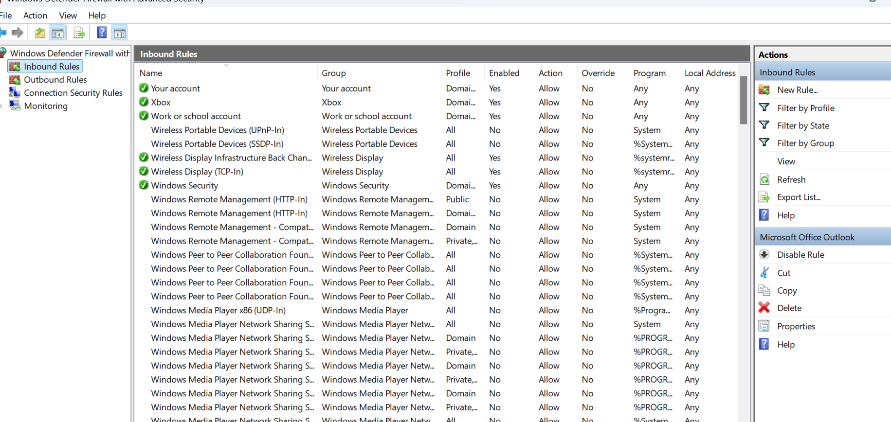

Step 3: Block a Port (Example: Port 23 – Telnet)
- Click Inbound Rules
- In right panel → click New Rule
- Select Port → Next
- Select TCP
- Enter 23
- Select Block the connection
- Apply to all profiles → Next
- Name: Block Telnet Port 23

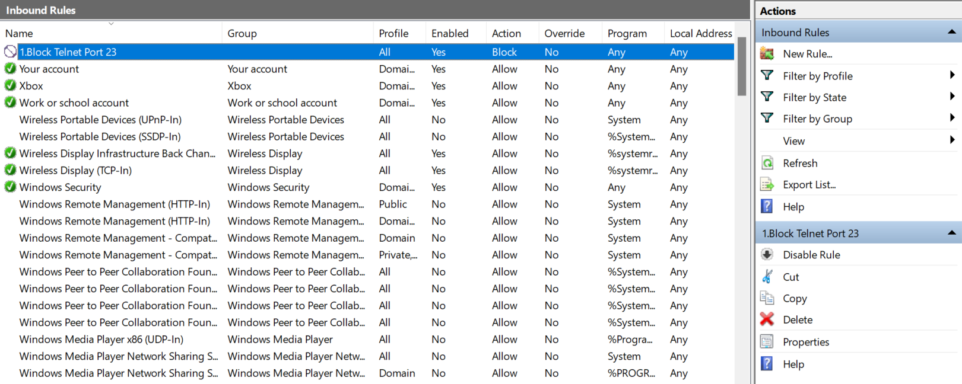

Step 4: Test if the Rule Works
- Open Command Prompt
- Type: telnet localhost 23

Step 5: Remove/Disable the Rule
- Go to Inbound Rules
- Find Block Telnet Port 23
- Right-click → Disable or Delete
